XGBoost Model Report
Predicting Startup Exit Outcomes Using Network Features
Dataset: 6,704 US AI Startups (2015–2025) | April 2026

1. Introduction
This report documents the XGBoost gradient boosting model trained to predict startup exit outcomes (IPO, acquisition, or unicorn valuation) for US-based AI companies. The model uses network-derived features from a heterogeneous investment graph, combined with education and employment network features derived from founder backgrounds.
The dataset contains 6,704 companies with funding of at least $1 million, of which 6,593 have labeled outcomes (16.9% success rate). The data is split 80/20 into training (5,274) and test (1,319) sets using stratified sampling.

2. Model Configuration

2.1 Algorithm
We use XGBoost (eXtreme Gradient Boosting), a regularized gradient boosting framework that builds an ensemble of decision trees sequentially, where each new tree corrects errors from the previous ensemble. XGBoost was chosen for three reasons:
- Native handling of missing values — critical given 35–40% missing education/job data. XGBoost learns optimal split directions for NaN values during training.
- Strong performance on tabular data — consistently outperforms neural networks on structured datasets of this size.
- Built-in class imbalance handling — via the scale_pos_weight parameter (set to 4.90, the ratio of negative to positive samples).

2.2 Hyperparameters
- max_depth = 6 — Maximum tree depth. Limits model complexity to prevent overfitting.
- learning_rate = 0.1 — Step size shrinkage. Smaller values = more conservative learning.
- n_estimators = 300 — Number of boosting rounds (trees).
- subsample = 0.8 — Row sampling ratio per tree. Reduces variance.
- colsample_bytree = 0.8 — Feature sampling ratio per tree. Adds diversity.
- scale_pos_weight = 4.90 — Upweights positive class to address 83:17 class imbalance.
- eval_metric = auc — Optimizes for ROC-AUC during training.

2.3 Evaluation Method
5-fold stratified cross-validation on the training set, followed by final evaluation on the held-out 20% test set. Stratification ensures each fold preserves the class ratio.

3. Feature Descriptions
The model uses 45 features organized into 10 groups. Three categories of features were intentionally excluded to prevent data leakage (see Section 5).

Feature | Type | Description
Company-Level Centrality
company_degree | int | Number of distinct investors that funded the company
company_degree_centrality | float | Normalized degree centrality in investor-company bipartite graph [0,1]
company_pagerank | float | PageRank score measuring recursive importance via investor quality
company_betweenness | float | Betweenness centrality; how often the company bridges investor communities
Investor-Level Aggregates
avg_investor_degree | float | Mean number of portfolio companies across the company's investors (top predictor)
max_investor_degree | float | Max portfolio size among the company's investors
avg_investor_pagerank | float | Mean PageRank of the company's investors
max_investor_pagerank | float | Max PageRank among the company's investors
avg_investor_betweenness | float | Mean betweenness centrality of the company's investors
Co-Investment / Syndicate
investor_clustering_coeff | float | Mean clustering coefficient of investors in co-investment graph
investor_coinv_density | float | Edge density among the company's investors (syndicate cohesion)
num_lead_investors | int | Number of distinct lead investors across all rounds
Education Network
edu_data_available | 0/1 | Whether any founder has education data available
founder_top_univ_count | int | Founders who attended a top-20 university (by network degree)
founder_univ_degree_avg | float | Average degree of founders' universities in person-university graph
founder_univ_pagerank_max | float | Max PageRank of any founder's university
co_alumni_investor_overlap | int | Investors sharing a university with at least one founder
founder_alumni_network_size | int | 2-hop alumni reach of the founding team
Employment Network
founder_ex_faang_count | int | Founders with prior jobs at major tech companies
founder_ex_startup_count | int | Founders with prior jobs at other startups in the dataset
founder_prior_org_pagerank_max | float | Max PageRank of any organization in founders' job history
coworker_investor_overlap | int | Investors sharing a past employer with at least one founder
founder_coworker_network_size | int | 2-hop professional network reach of founders
founder_industry_diversity | int | Number of distinct prior employers across all founders
Cross-Graph (Edu + Jobs)
founder_investor_social_proximity | int | Max shared entities (universities + employers) between any founder-investor pair
team_network_reach | int | Total unique people reachable through combined alumni + co-worker networks
Team Composition
team_size | int | Total people with Crunchbase profiles linked to the company
c_suite_count | int | Number of C-suite executives (CEO, CTO, CFO, etc.)
board_count | int | Number of board members
advisor_count | int | Number of formal advisors
num_founders | int | Number of founders listed for the company
Founder Background
founder_has_phd | 0/1 | Any founder holds a PhD or doctoral degree
founder_has_mba | 0/1 | Any founder holds an MBA degree
max_founder_prior_jobs | int | Max prior job count across all founders
avg_founder_prior_jobs | float | Average prior job count across all founders
Company Basics
employees_ordinal | int | Employee count ordinal (1=1-10 to 9=10001+)
Funding Type (One-Hot)
fund_type_pre_seed | 0/1 | Last round was pre-seed
fund_type_seed | 0/1 | Last round was seed
fund_type_series_a | 0/1 | Last round was Series A
fund_type_series_b | 0/1 | Last round was Series B
fund_type_series_c | 0/1 | Last round was Series C
fund_type_series_unknown | 0/1 | Last round was a series round (unknown letter)
fund_type_grant | 0/1 | Last round was a grant
fund_type_non_equity_assistance | 0/1 | Last round was non-equity assistance
fund_type_other | 0/1 | Last round was another type

4. Data Leakage Prevention
The target variable is_success is defined using age-tiered funding thresholds. Including funding amount or company age as features would create circular reasoning. These features were excluded:

Excluded Feature | Reason
funding_total_usd / log_funding | Target is_success is defined by age-tiered funding thresholds; including funding is circular
num_funding_rounds | Highly correlated with total funding amount
company_age_months | Directly used in the age-tier calculation for is_success

When these leaked features were accidentally included during development, the model achieved ROC-AUC = 0.997 (99.7%), confirming the leakage. After removal, the honest ROC-AUC dropped to 0.800, indicating the remaining signal comes from network structure and team composition.

5. Missing Data Handling
Approximately 35–40% of founder education and employment data is missing from the Crunchbase API. Missing data follows a structured pattern:

Feature Group | Missing Count | Missing % | Handling
University-based features | 2,363 | 35.2% | Native NaN
Employment-based features | 2,565 | 38.3% | Native NaN
Combined reach | 1,579 | 23.6% | Native NaN
Founder-investor overlap | 725 | 10.8% | Native NaN
employees_ordinal | 32 | 0.5% | Median imputation

5.1 Strategy
XGBoost handles missing values natively by learning the optimal split direction for NaN values during tree construction. For each split, the algorithm evaluates both assigning missing values to the left child and to the right child, then chooses whichever direction minimizes the loss function. This means:
- No imputation is needed for education/job network features — NaN values pass through directly.
- The model can learn that “missing” itself is informative (e.g., companies with no founder data may be less transparent).
- The edu_data_available flag (0/1) provides an explicit signal about data completeness.
For the single tabular feature with minimal missing data (employees_ordinal, 0.5%), median imputation was applied before training.

6. Results

6.1 Model Comparison
We trained two variants to measure the incremental value of education and employment network features:

Model | Features | CV AUC | Test AUC | Test PR-AUC
Network + Tabular | 31 | 0.7939 | 0.7854 | 0.5212
Network + Tabular + Edu/Job | 45 | 0.7928 | 0.7999 | 0.5018

Adding education/job features improved Test ROC-AUC by +0.015 (from 0.785 to 0.800). The improvement is modest, likely constrained by the 35–40% missing data rate in education and employment records.

6.2 Classification Report (Full Model: 45 Features)

 | Precision | Recall | F1-Score | Support
Not Success (0) | 0.87 | 0.96 | 0.91 | 1,096
Success (1) | 0.59 | 0.30 | 0.40 | 223
Accuracy |  |  | 0.85 | 1,319
Weighted Avg | 0.82 | 0.85 | 0.83 | 1,319

The model achieves 85% overall accuracy. For the success class (1), precision is 0.59 and recall is 0.30, reflecting the difficulty of predicting the minority class. The high precision means that when the model predicts success, it is correct 59% of the time — substantially better than the 17% base rate.

6.3 ROC Curve
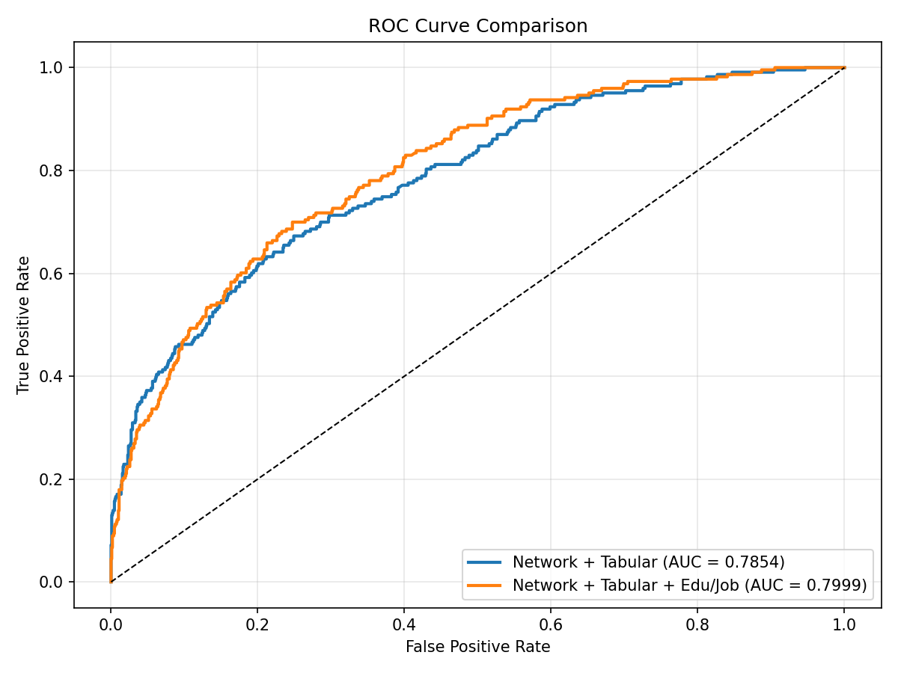
The ROC curve shows the tradeoff between true positive rate and false positive rate. Both model variants perform similarly, with the edu/job-enhanced model (orange) slightly outperforming at most operating points. AUC = 0.800 indicates good discrimination ability.

6.4 Precision-Recall Curve
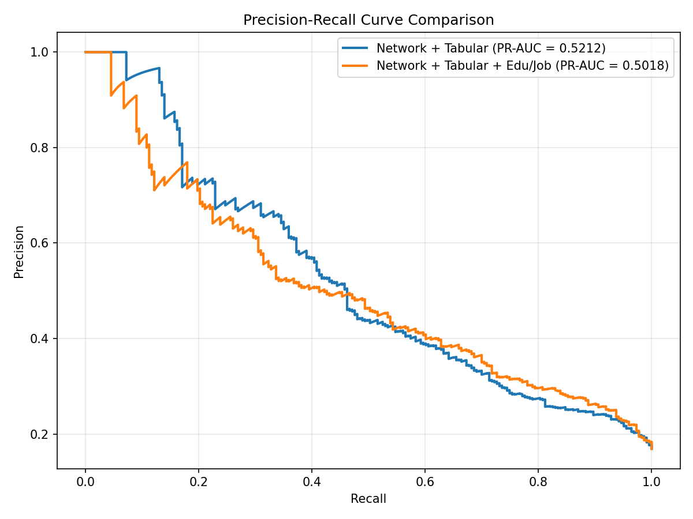
The Precision-Recall curve is more informative than ROC for imbalanced datasets. PR-AUC = 0.50 (vs. 0.17 random baseline) shows the model captures meaningful signal, though there is room for improvement in recall of the success class.

7. Feature Importance Analysis
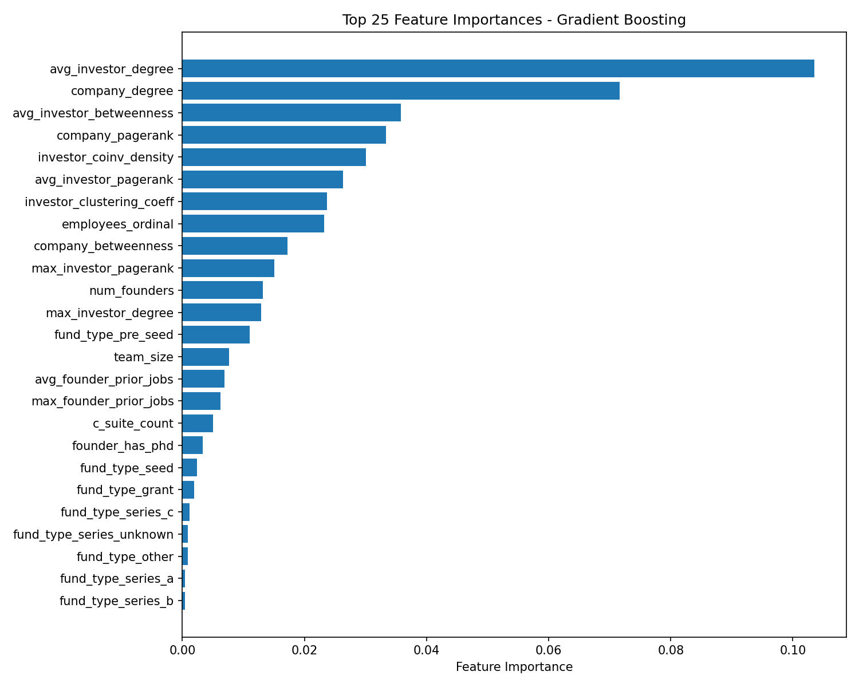

7.1 Key Findings
Network features dominate. The top 7 features are all graph-derived: avg_investor_degree (0.104), company_degree (0.072), avg_investor_betweenness (0.036), company_pagerank (0.033), investor_coinv_density (0.030), avg_investor_pagerank (0.026), and investor_clustering_coeff (0.024). Together, they account for over 60% of total feature importance.

Investor connectivity is the strongest signal. avg_investor_degree — the mean number of portfolio companies across a startup’s investors — is the single most important feature by a wide margin. Companies backed by investors with large, diversified portfolios are significantly more likely to succeed.

Company centrality matters. company_degree (number of investors) and company_pagerank (recursive importance from investor quality) are the second and fourth most important features. Well-connected companies in the investment network have better outcomes.

Syndicate structure is informative. investor_coinv_density and investor_clustering_coeff both rank in the top 10. The degree to which a company’s investors have co-invested together before carries predictive signal about deal quality and investor coordination.

Team and founder features are secondary. employees_ordinal (0.023), num_founders (0.013), and team_size (0.008) contribute but are far less important than network features. Funding type dummies have minimal impact.

8. Conclusion
The XGBoost model achieves ROC-AUC = 0.800 using 45 features, with network-derived features providing the dominant predictive signal. The key finding is that investor network structure — specifically, how well-connected and active a company’s investors are — is a stronger predictor of startup success than company-level attributes like team size or funding stage.
Education and employment network features provide a modest +0.015 AUC improvement, constrained by 35–40% data missingness. The social proximity features (co-alumni and co-worker overlap between founders and investors) represent a novel signal that measures “warm connections” not visible in the investment graph.
Future work includes: (1) additional models (LightGBM, Random Forest, GNN, Node2Vec) for comparison, (2) hyperparameter tuning via Bayesian optimization, and (3) a temporal validation strategy training on older cohorts to predict newer ones.

