XGBoost Model Comparison Report
V1 (Network + Tabular) vs V2 (+ Education/Employment Features)
6,704 US AI Startups | April 2026

1. Model Overview

1.1 Algorithm
XGBoost (eXtreme Gradient Boosting) is a regularized gradient boosting framework that builds an ensemble of 300 decision trees sequentially. Each tree corrects errors from the previous ensemble. It was chosen for its strong tabular data performance, native missing value handling, and built-in class imbalance support.

1.2 Configuration
- max_depth=6, learning_rate=0.1, n_estimators=300
- subsample=0.8, colsample_bytree=0.8
- scale_pos_weight=4.90 (auto-computed to handle 83:17 class imbalance)
- Excluded features: funding_total_usd, log_funding, num_funding_rounds, company_age_months (data leakage prevention — these define the target variable)

1.3 Evaluation Method
5-fold stratified cross-validation on 80% training set, final evaluation on 20% held-out test set (5,274 train / 1,319 test). Both sets preserve the 83:17 class ratio via stratified sampling.

1.4 Missing Data Handling
XGBoost handles NaN values natively by learning the optimal split direction for missing data during tree construction. Education/employment features (35–40% missing) are passed as NaN without imputation. Only employees_ordinal (0.5% missing) uses median imputation. An edu_data_available flag is included as an explicit missingness indicator.

2. V1: Network + Tabular Features (31 features)

2.1 Features and Importance
V1 uses 31 features: 12 network centrality/co-investment features, 9 funding type dummies, 5 team/founder features, 4 founder background features, and 1 company size feature.

Feature | Type | Description | Importance
avg_investor_degree | float | Mean portfolio size of company's investors | 0.1035
company_degree | int | Number of distinct investors | 0.0716
avg_investor_betweenness | float | Mean betweenness of investors | 0.0358
company_pagerank | float | PageRank in investor-company graph | 0.0334
investor_coinv_density | float | Co-investment density among investors | 0.0300
avg_investor_pagerank | float | Mean PageRank of investors | 0.0263
investor_clustering_coeff | float | Clustering coefficient of investors | 0.0237
employees_ordinal | int | Company size (1-9 ordinal) | 0.0233
company_betweenness | float | Betweenness centrality of company | 0.0173
max_investor_pagerank | float | Max PageRank among investors | 0.0151
num_founders | int | Number of founders | 0.0132
max_investor_degree | float | Max portfolio size among investors | 0.0129
fund_type_pre_seed | 0/1 | Last round was pre-seed | 0.0110
team_size | int | People linked to company (execs/board/advisors) | 0.0077
avg_founder_prior_jobs | float | Average prior jobs across founders | 0.0069
max_founder_prior_jobs | int | Max prior jobs across founders | 0.0063
c_suite_count | int | Number of C-suite executives | 0.0050
founder_has_phd | 0/1 | Any founder has a PhD | 0.0034
fund_type_seed | 0/1 | Last round was seed | 0.0024
fund_type_grant | 0/1 | Last round was a grant | 0.0019
fund_type_series_c | 0/1 | Last round was Series C | 0.0011
fund_type_series_unknown | 0/1 | Last round was series (unknown) | 0.0009
fund_type_other | 0/1 | Last round was other type | 0.0009
fund_type_series_a | 0/1 | Last round was Series A | 0.0004
fund_type_series_b | 0/1 | Last round was Series B | 0.0004
founder_has_mba | 0/1 | Any founder has an MBA | 0.0003
board_count | int | Number of board members | 0.0002
fund_type_non_equity_assistance | 0/1 | Last round was non-equity | 0.0001
advisor_count | int | Number of advisors | 0.0001
company_degree_centrality | float | Normalized degree centrality | 0.0000
num_lead_investors | int | Number of lead investors | 0.0000

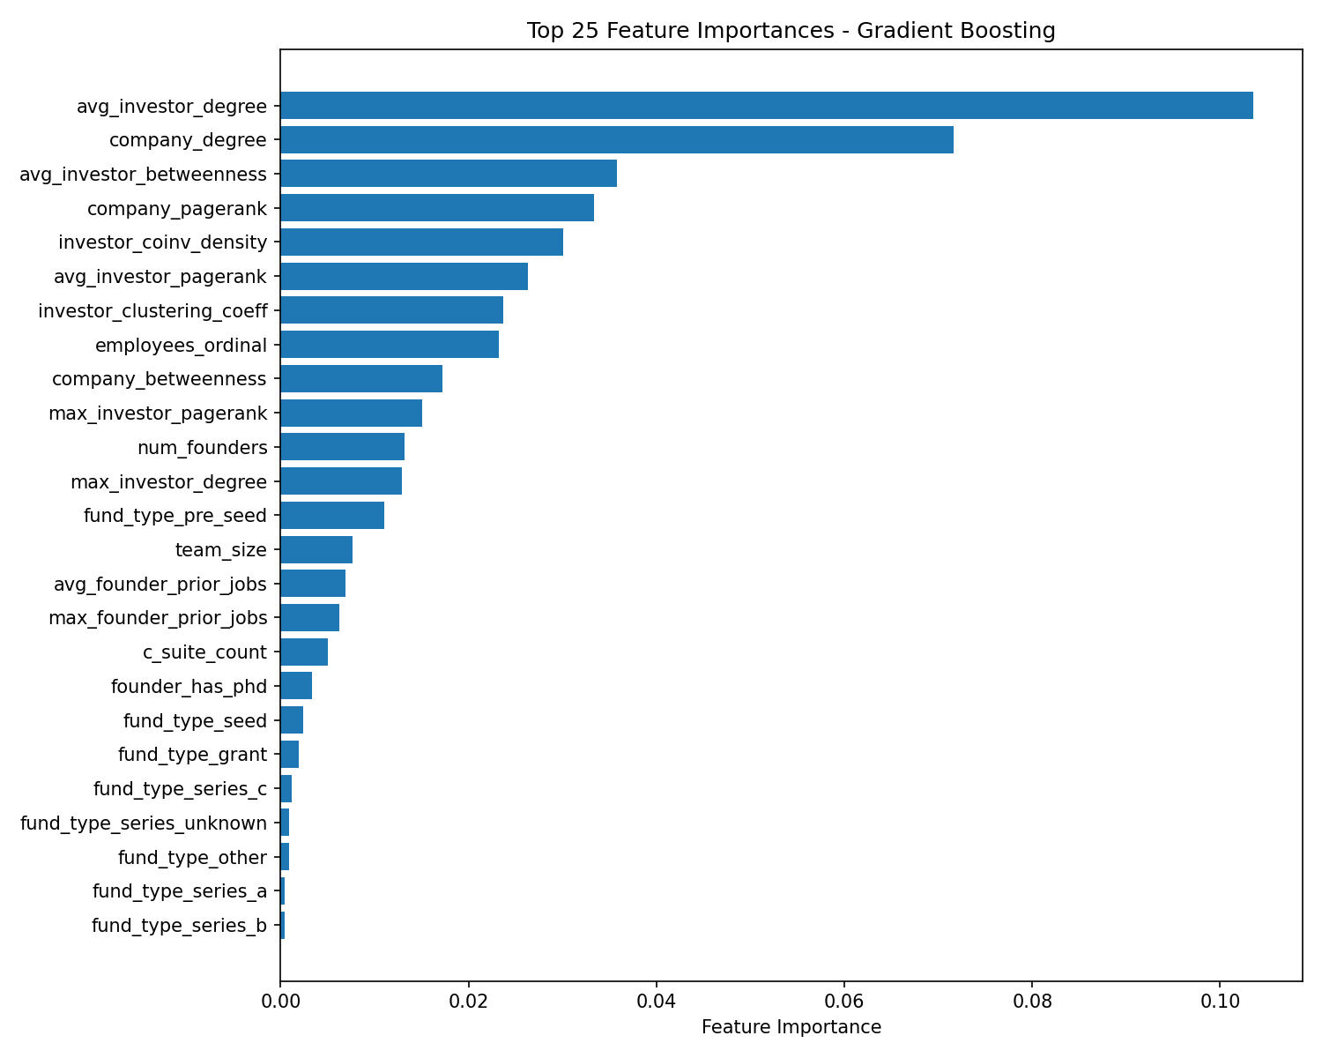

2.2 Results
ROC-AUC: 0.7854 (test) | 0.7939 ± 0.0228 (5-fold CV)
PR-AUC: 0.5212 (test) | Baseline: 0.169
Accuracy: 85.8%

 | Precision | Recall | F1-Score | Support
Not Success (0) | 0.88 | 0.96 | 0.92 | 1,096
Success (1) | 0.66 | 0.34 | 0.45 | 223
Accuracy |  |  | 0.86 | 1,319
Weighted Avg | 0.84 | 0.86 | 0.84 | 1,319

2.3 Analysis
Network features dominate the model. The top 7 features are all graph-derived, accounting for over 60% of total importance. avg_investor_degree (how many companies the investors have funded) is the single strongest predictor, nearly 50% more important than the second-ranked feature.
The model is conservative on the success class: high precision (0.66) but low recall (0.34). When it predicts success, it is right 66% of the time (vs. 17% base rate), but it only catches 34% of actual successes. This tradeoff favors avoiding false positives.
Funding type dummies and founder background features have minimal impact. The most important non-network feature is employees_ordinal (company size), ranked 8th.

3. V2: Network + Tabular + Edu/Job Features (45 features)

3.1 Additional Features (14 new)
V2 adds 14 education and employment network features to the 31 V1 features. These capture social capital and warm connections between founders and investors through shared universities and past employers.

Feature | Type | Description
edu_data_available | 0/1 | Whether any founder has education data
founder_top_univ_count | int | Founders attending a top-20 university
founder_univ_degree_avg | float | Average degree of founders' universities
founder_univ_pagerank_max | float | Max PageRank of any founder's university
co_alumni_investor_overlap | int | Investors sharing a university with a founder
founder_alumni_network_size | int | 2-hop alumni network reach
founder_ex_faang_count | int | Founders with prior FAANG/big-tech jobs
founder_ex_startup_count | int | Founders with prior startup experience in dataset
founder_prior_org_pagerank_max | float | Max PageRank of founders' prior employers
coworker_investor_overlap | int | Investors sharing a past employer with a founder
founder_coworker_network_size | int | 2-hop professional network reach
founder_industry_diversity | int | Distinct prior employers across all founders
founder_investor_social_proximity | int | Max shared entities (school+employer) between founder-investor
team_network_reach | int | Combined alumni + co-worker network reach

Key missing data rates: university features 35.2%, employment features 38.3%, cross-graph features 10.8–23.6%. All handled natively by XGBoost (no imputation).

3.2 Results
ROC-AUC: 0.7999 (test) | 0.7928 ± 0.0197 (5-fold CV)
PR-AUC: 0.5018 (test) | Baseline: 0.169
Accuracy: 84.6%

 | Precision | Recall | F1-Score | Support
Not Success (0) | 0.87 | 0.96 | 0.91 | 1,096
Success (1) | 0.59 | 0.30 | 0.40 | 223
Accuracy |  |  | 0.85 | 1,319
Weighted Avg | 0.82 | 0.85 | 0.83 | 1,319

3.3 Analysis
V2 improves test ROC-AUC by +0.015 (0.785 → 0.800), indicating better overall discrimination ability. However, PR-AUC decreases slightly (−0.019), and success precision drops from 0.66 to 0.59. This suggests the edu/job features help the model distinguish between classes overall but introduce some noise in the positive-class boundary.
The improvement is modest, likely constrained by 35–40% missing data in education and employment records. The social proximity features (co-alumni and co-worker overlap between founders and investors) represent a novel signal type, but their impact is diluted by the high missingness rate.

4. Comparison

4.1 Side-by-Side Metrics

Metric | # Features | V1 (Network) | V2 (+Edu/Job) | Delta | Improved?
CV ROC-AUC | 31 vs 45 | 0.7939 | 0.7928 | -0.0011 | No
Test ROC-AUC |  | 0.7854 | 0.7999 | +0.0145 | Yes
Test PR-AUC |  | 0.5212 | 0.5018 | -0.0194 | No
Accuracy |  | 0.86 | 0.85 | -0.01 | No
Success Precision |  | 0.66 | 0.59 | -0.07 | No
Success Recall |  | 0.34 | 0.30 | -0.04 | No

4.2 ROC Curve Comparison
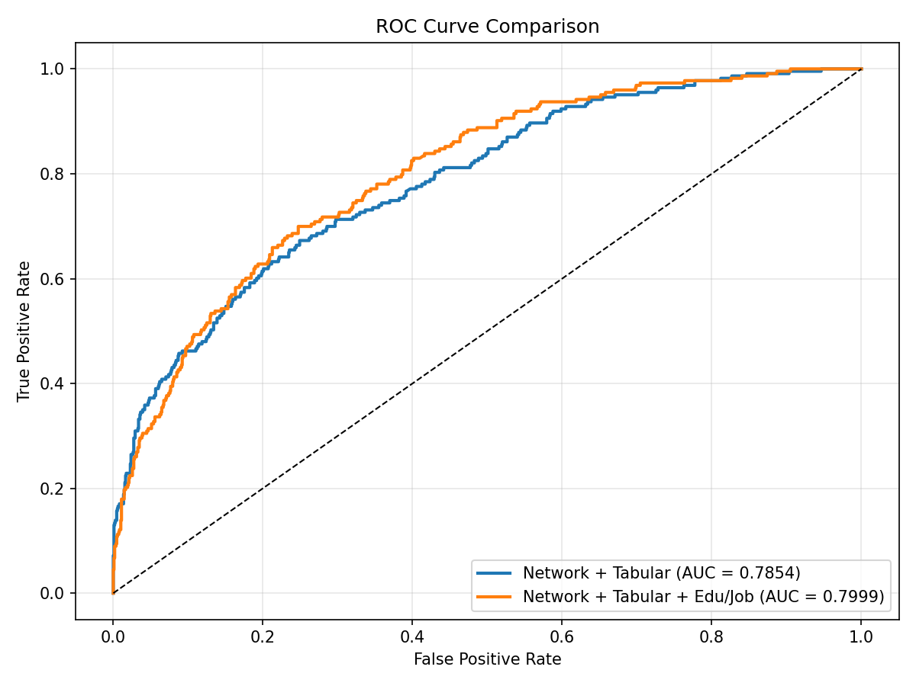

4.3 Precision-Recall Curve Comparison
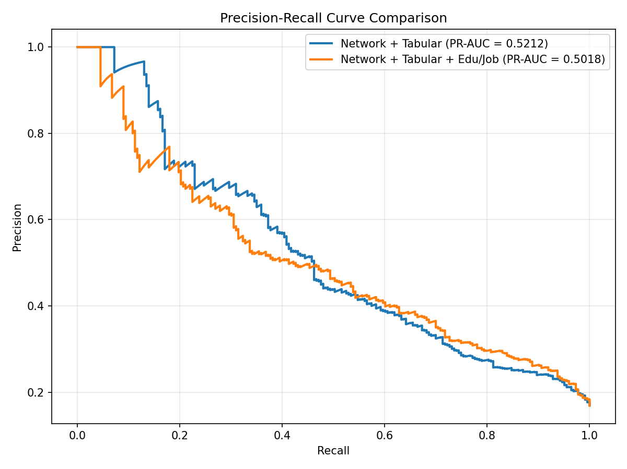

4.4 Key Takeaways
- ROC-AUC improves with edu/job features (+0.015). The model gains better overall discrimination when social network information is included. This suggests that founder-investor social proximity carries predictive signal beyond what investment graph structure alone provides.
- Precision and recall for the success class decrease slightly. V2 trades some classification sharpness for broader discrimination. The 14 additional features with 35–40% missingness introduce noise that slightly blurs the decision boundary for the minority class.
- Network features remain dominant in both models. Investor connectivity (avg_investor_degree, company_degree) drives predictions regardless of whether edu/job features are present. The core finding holds: who invests in a company matters more than the company’s own attributes.
- Missing data is the primary constraint. With 35–40% of education and employment records missing, the potential of social network features is not fully realized. Reducing missingness (e.g., supplementing with LinkedIn data) would likely amplify the improvement.
- Recommendation: use V1 for deployment, V2 for research. V1 is simpler (31 features, no missing data issues) with comparable performance. V2 demonstrates that social capital features add signal and warrants further investigation with more complete data.

