**STANDART OPERATION PROCEDURE**

JOB LOADING MANAGEMENT SYSTEM

**TABLE OF CONTENTS**

**Page**

**1. INTRODUCTION**

1.1 Background 3

1.2 Purpose 3

1.3 Target 3

**2. SYSTEM SPECIFICATION**

2.1 System Overview 4

2.2 Database Design 5

2.2.1 Job Table 5

2.2.2 Staff Table 5

2.2.3 Project Table 5

2.2.4 Data Table 5

2.3 Additional Features 6

**3. USER’S MANUAL**

3.1 Access to “Job-Loading” Management System 7

3.2 View Monthly Job Summary 8

3.3 Input 9

3.3.1 Job Hours 9

3.3.2 New Job 11

3.3.3 New Staff Data 12

3.3.4 New Department 13

3.3.5 New Project 14

3.4 View and Search 15

3.4.1 Job List 15

3.4.2 Project List 16

3.4.3 Staff List 17

3.4.4 Department List 18

3.5 Work Hours Viewer 19

3.6 View Monthly Report 20

3.6.1 By Project 20

3.6.2 By Department 21

3.6.3 By Job 22

3.6.4 By Staff 23

3.7 Setting 24

3.8 Help 25

3.8 Logout 25

**CHAPTER 1 INTRODUCTION**

**1.1 Background**

Job-Loading Management System is a web-based application to manage work hours of Engineering Division (ED) members. This system is developed to replace and improve the existing one that stopped because of license issue in the end of 2005.

**1.2 Purpose**

Job-Loading Management System has several purposes:

* Keeping track of every member’s work hour and their type of job.
* Helping managers to check their subordinates’ work.
* Replacing and improving the existing similar system.
* Creating a report to summarize work hours each month by their project, department, job, and staff.

**1.3 Target**

Target user of Job-Loading Management System are staffs including manager or higher who are working in Engineering Division.

**1.4 Definition**

Staff : All Engineering Division members except Division Head.

Managers : All Engineering Division Section Head up.

**CHAPTER 2 SYSTEM SPECIFICATION**

**2.1 System Overview**

Job-Loading Management System has 7 main functions.

* **Login Function** – Users need to have their account to login to the system.
* **Input Function**
  + **Job Hour** – Users input their job name, project code, and work hour.
  + **Job** – Managers can add new job to the system.
  + **Department** – Managers can add new department name and code to the system.
  + **Staff** – Managers can add new staff data and account to the system.
  + **Project** – Managers can add new project name and code to the system.
* **View and Search Function**
  + **Job List** – Users can view and search all jobs registered in the system.
  + **Project List** – Users can view and search all projects registered in the system.
  + **Staff List** – Users can view and search all staff registered in the system.
  + **Department List** – Users can view and search all department names and their section name in the system.
* **Work Hour Viewer Function** – Users can view work hour of other users in the same department.
* **View Monthly Report Function**
  + **By Project** – Users can view current and previous monthly report by project.
  + **By Department** – Users can view current and previous monthly report by department.
  + **By Job** – Users can view current and previous monthly report by job.
  + **By Staff** – Users can view current and previous monthly report by staff.
* **Setting Function** – Users can change their account data including the password.
* **Logout Function** – Users can logout from their account after finish using the system.

**2.2 Database Design**

Job-Loading Management System is using 1 database with 4 tables.

**2.2.1 Job Table**

|  |  |  |
| --- | --- | --- |
| **Column Name** | **Type (Length)** | **Description** |
| id | Int (5) | Id of the job |
| jobName | Varchar (100) | Name of the job |
| deptCode | Varchar (5) | Code of the department who is doing the job |
| jobDesc | Varchar (1000) | Description of the job |

**2.2.2 Staff Table**

|  |  |  |
| --- | --- | --- |
| **Column Name** | **Type (Length)** | **Description** |
| id | Int (10) | Id of the staff |
| noReg | Int (10) | No registration of the staff |
| password | Varchar (10) | Password of the staff account |
| staffName | Varchar (100) | Full name of the staff |
| deptName | Varchar (100) | Department name of the staff |
| deptCode | Varchar (5) | Department code of the staff |
| sectName | Varchar (100) | Section Name of the staff |
| jobTitle | Varchar (50) | Job position of the staff |
| jobClass | Int (5) | Job class of the staff |

**2.2.3 Project Table**

|  |  |  |
| --- | --- | --- |
| **Column Name** | **Type (Length)** | **Description** |
| id | Int (5) | Id of the project |
| projectName | Varchar (10) | Name of the project |
| projectCode | Varchar (100) | Code of the project |

**2.2.4 Data Table**

|  |  |  |
| --- | --- | --- |
| **Column Name** | **Type (Length)** | **Description** |
| id | Int (10) | Id of the data |
| staffName | Varchar (100) | Staff name who does the job |
| deptCode | Varchar (5) | Department code of the staff |
| jobName | Varchar (100) | Name of the job |
| jobDate | Date | Date of the job |
| jobHour | Int (5) | How many hour staff does the job |
| projectCode | Varchar (50) | Project code of the job |

**2.3 Additional Features**

* Responsive User Interface
* Sortable data table
* Adjustable date (week, month, year) of data table
* Input error checker
* Provide input suggestion
* Provide responsive report bar graph
* Staff and department ideal and actual work hour comparison
* Editable account data (password, name, department, position, etc.)

**CHAPTER 3 USER’S MANUAL**

**3.1 Access to “Job-Loading” Management System**

1. Open **Mozilla Firefox**.
2. Type: **intranet.toyota.co.id/JobLoading** in the URL address bar.



1. Login with your **TMMIN ID** (no reg.) and **password** (1234 for default).

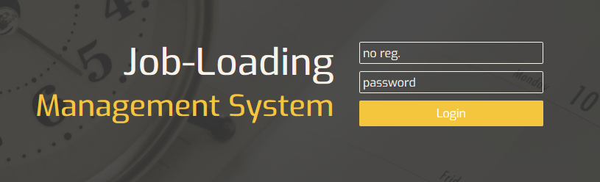

**3.2 View Monthly Job Summary**

1. After logged in, you will arrive on the **Homepage** of the system where you can see your monthly job summary.

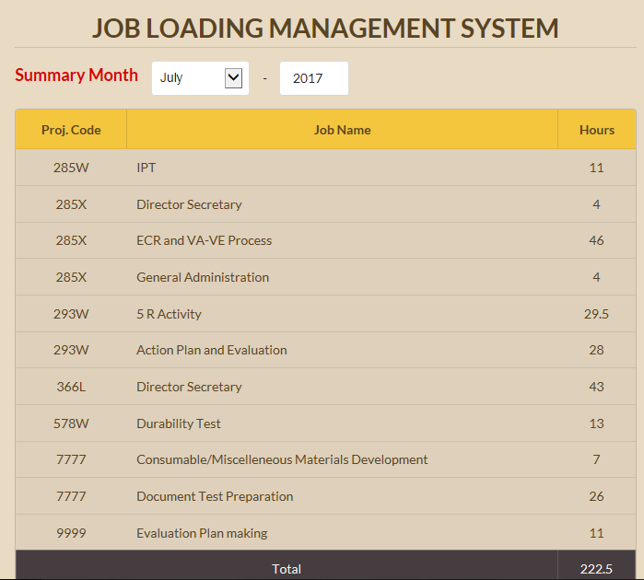

1. 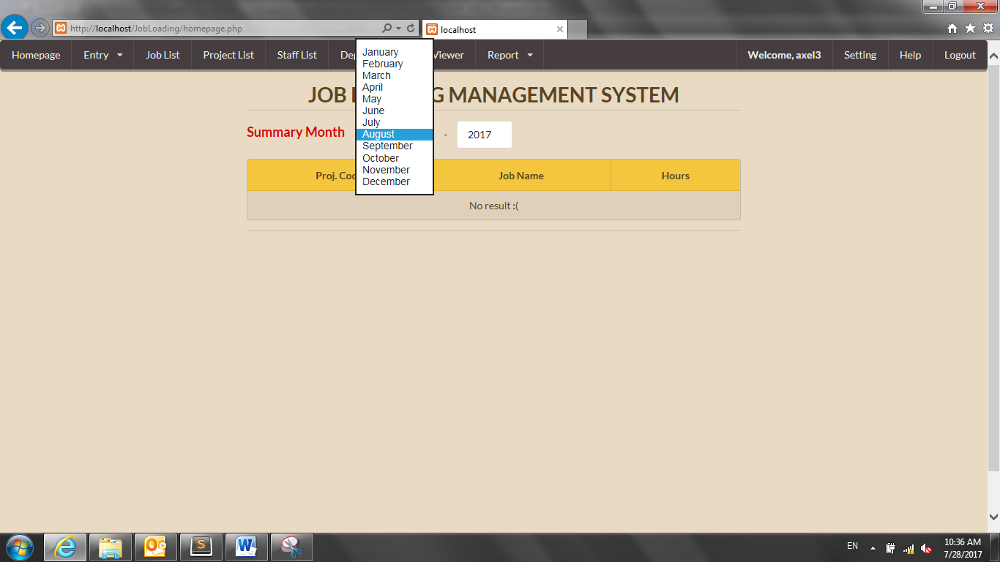Click and choose the month you want to see by clicking the **Month** dropdown box.

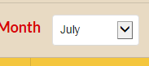

1. Click and type the year you want to see by clicking the **Year** textbox.

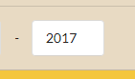

**3.3 Input**

**3.3.1 Job Hours**

1. a. For **staffs**, click the “**Job Hours**” on navigation bar on the top.

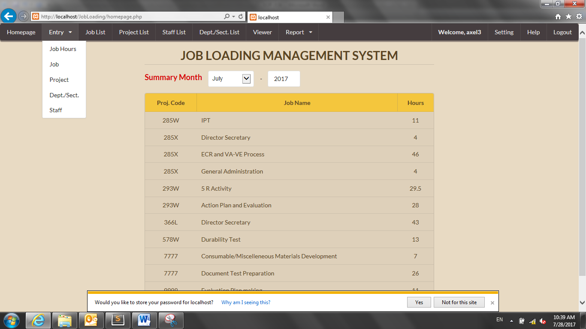

b. For **managers**, hover the mouse over the “**Entry**” dropdown

on navigation bar on the top and click “**Job Hours**”.



1. 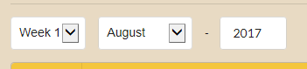Click and change the **date** to your desire. The default is the current week, month, and year.
2. 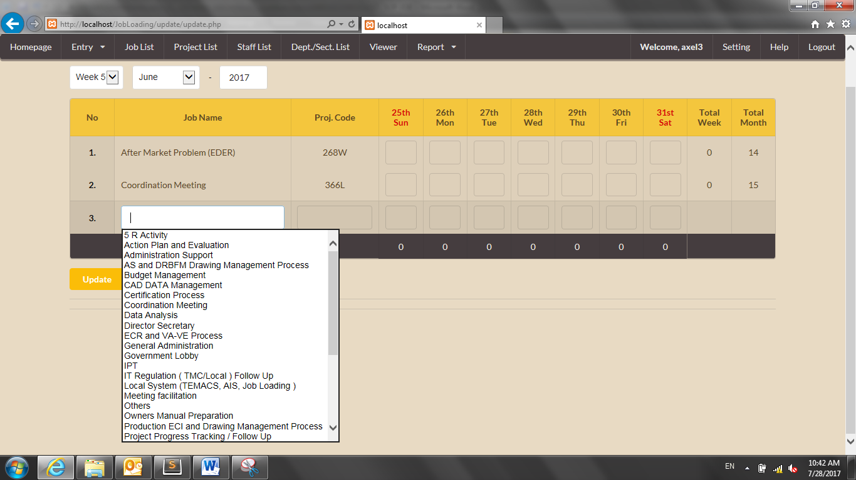To input a **job name**, click the empty textbox on the job name column. Then, choose your desired job name.

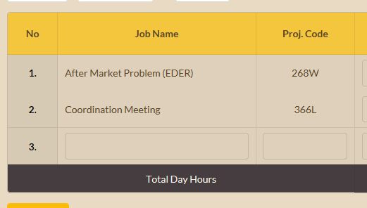

1. 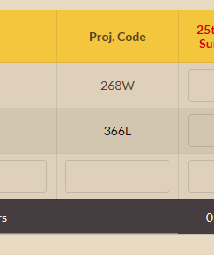To input a **project code**, click the empty textbox on the project code column. Then, choose your desired project code.

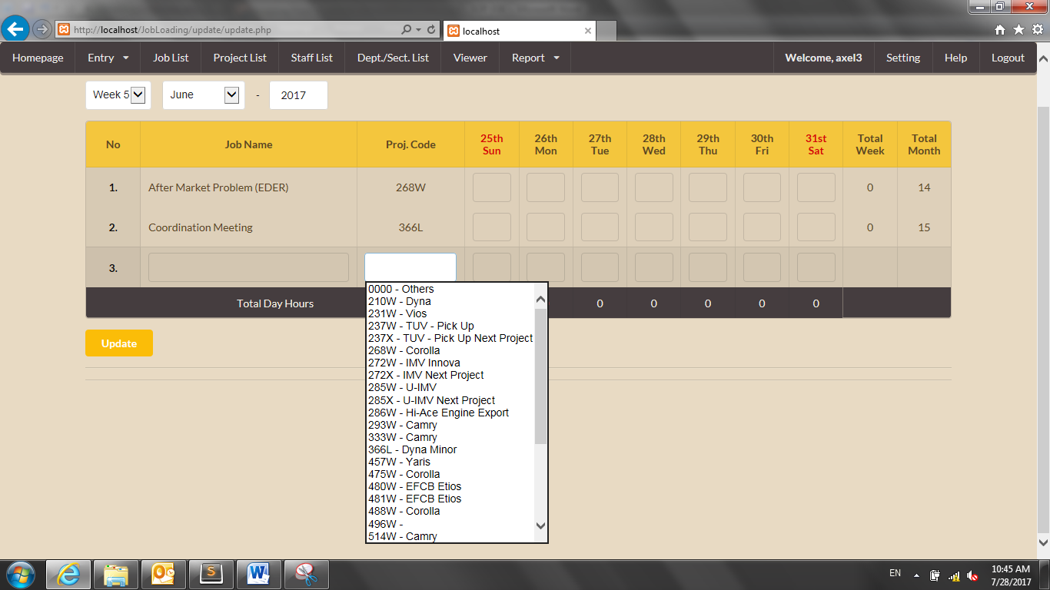

1. 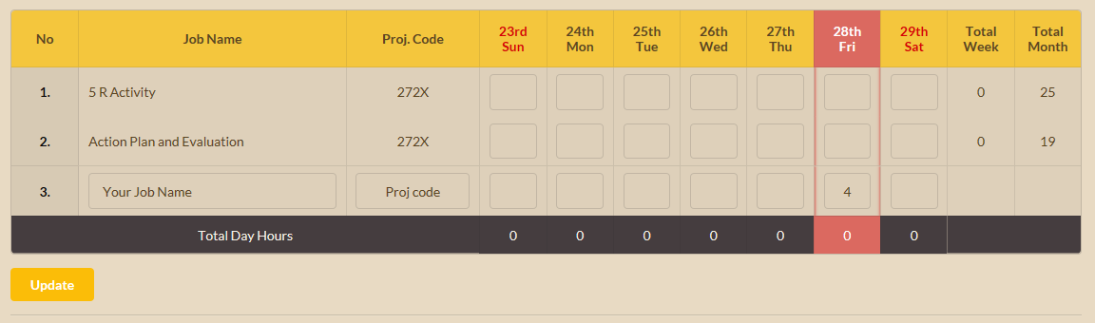To input your **chosen job hour**, type the hours on your chosen job row and today column.
2. Click **Update** button after finish typing the hours.

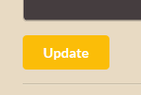

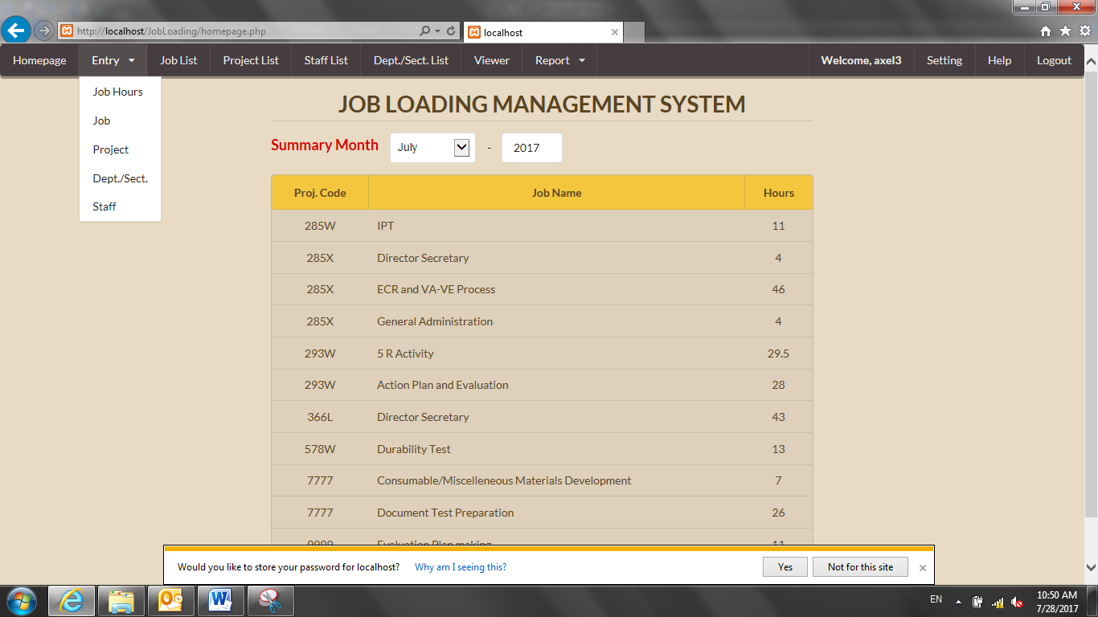**3.3.2 New Job (For Managers and EA members only)**

1. Hover the mouse over the “**Entry**” dropdown on navigation

bar on the top and click “**Job**”.

1. Fill the form with the appropriate information for the new job.

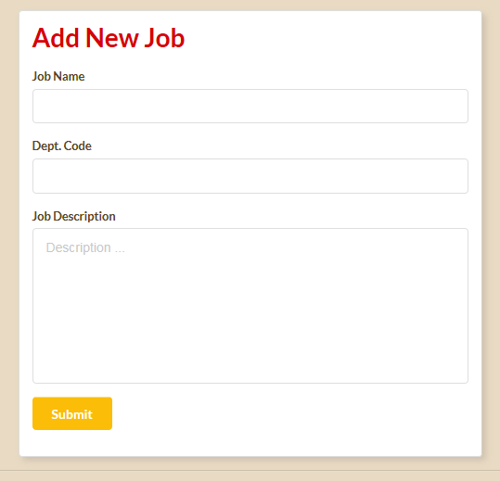

1. Click **Submit** button after finish filling the form.

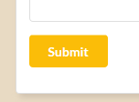

**3.3.3 New Staff Data (For EA members only)**

1. Hover the mouse over the “**Entry**” dropdown on navigation

bar on the top and click “**Staff**”.

1. Fill the staff data to their respective text box. (Suggestions are available for Department Name, Dept. Code, Section Name, Job Title, and Detail Title box and can be accessed by clicking the text box.)

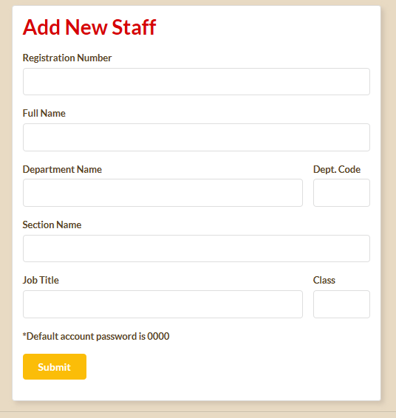

1. Click **Submit** button after filling all the staff data.



**3.3.4 New Department (For EA members only)**

1. Hover the mouse over the “**Entry**” dropdown on navigation

bar on the top and click “**Dept./Sect.**”.

1. Type the new department name, code and section name to the **Department Name, Department Code** and **Section Name** text box respectively.

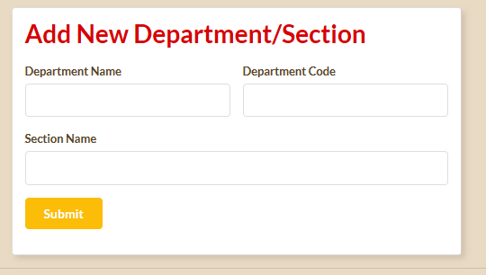

1. Click **Submit** button after finish filling the form.



**3.3.5 New Project (For EA members only)**

1. Hover the mouse over the “**Entry**” dropdown on navigation

bar on the top and click “**Project**”.

1. Type the new project code and name to the **Project Code** and **Project Name** text box respectively.

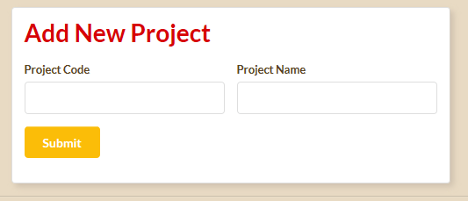

The inputted project code will be checked if it is already in database.

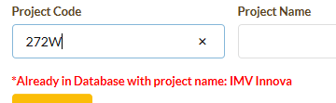

1. Click **Submit** button after finish filling the form.



**3.4 View and Search**

**3.4.1 Job List**

1. Click the “**Job List**” on navigation bar on the top.



1. You will be directed to **job list** page which contains the complete list of the job.

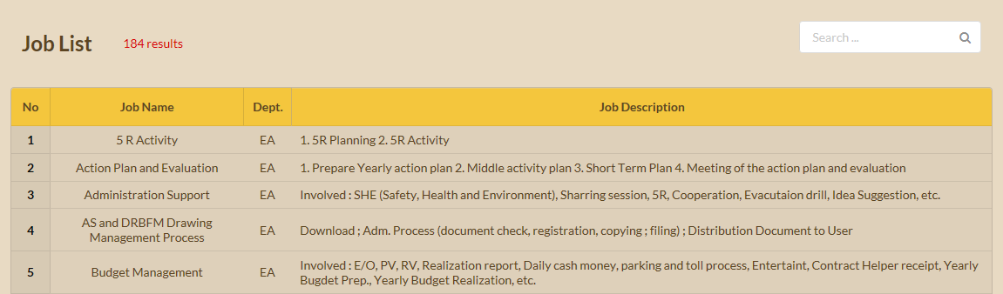

1. To search data, type the keyword in the **search** text box on the top right of the page.

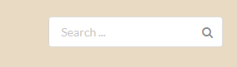

1. Press **enter** or click the **search icon** after finish typing the keyword.



**3.4.2Project List**

1. Click the “**Project List**” on navigation bar on the top.



1. You will be directed to **project list** page which contains the complete list of the project.

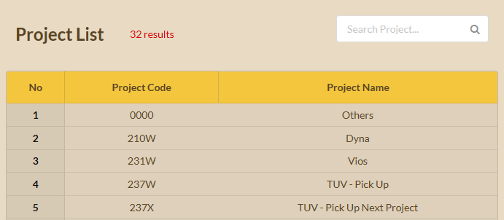

1. To search data, type the keyword in the **search** text box on the top right of the page.



1. Press **enter** or click the **search icon** after finish typing the keyword.



**3.4.3Staff List**

1. Click the “**Staff List**” on navigation bar on the top.



1. You will be directed to **staff list** page which contains the complete list of the staff.

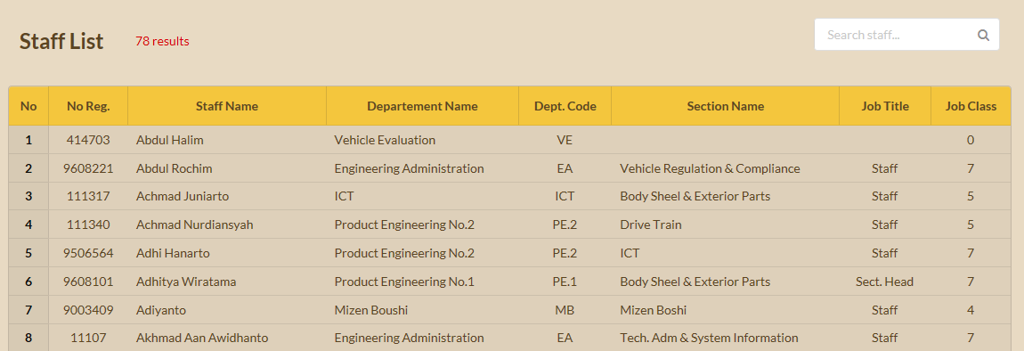

1. To search data, type the keyword in the **search** text box on the top right of the page.



1. Press enter or click the **search icon** after finish typing the keyword.



**3.4.4Department List**

1. Click the “**Dept./Sect. List**” on navigation bar on the top.



1. You will be directed to **department list** page which contains the complete list of the department and section.

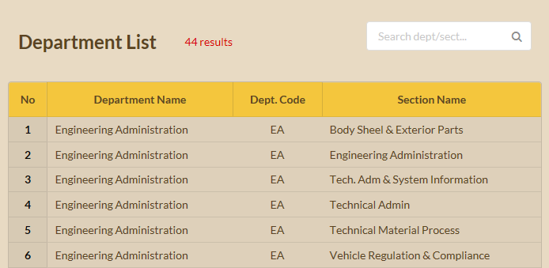

1. To search data, type the keyword in the **search** text box on the top right of the page.



1. Press enter or click the **search icon** after finish typing the keyword.



**3.5 Work Hours Viewer**

1. Click the “**Viewer**” on navigation bar on the top.



1. You will be directed to **viewer** page which contains weekly work hour list of the staffs who are in the same department and the same position or lower.

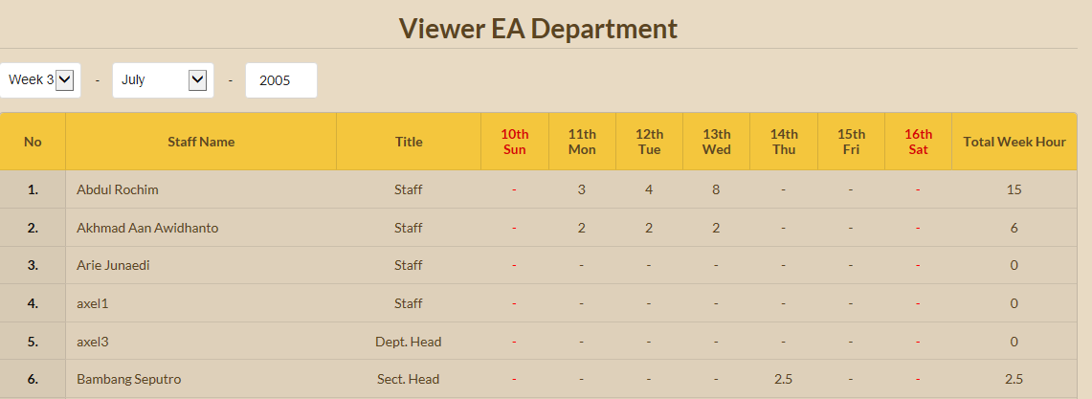

1. Change the week, month, and year according to your desire.

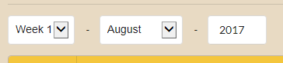

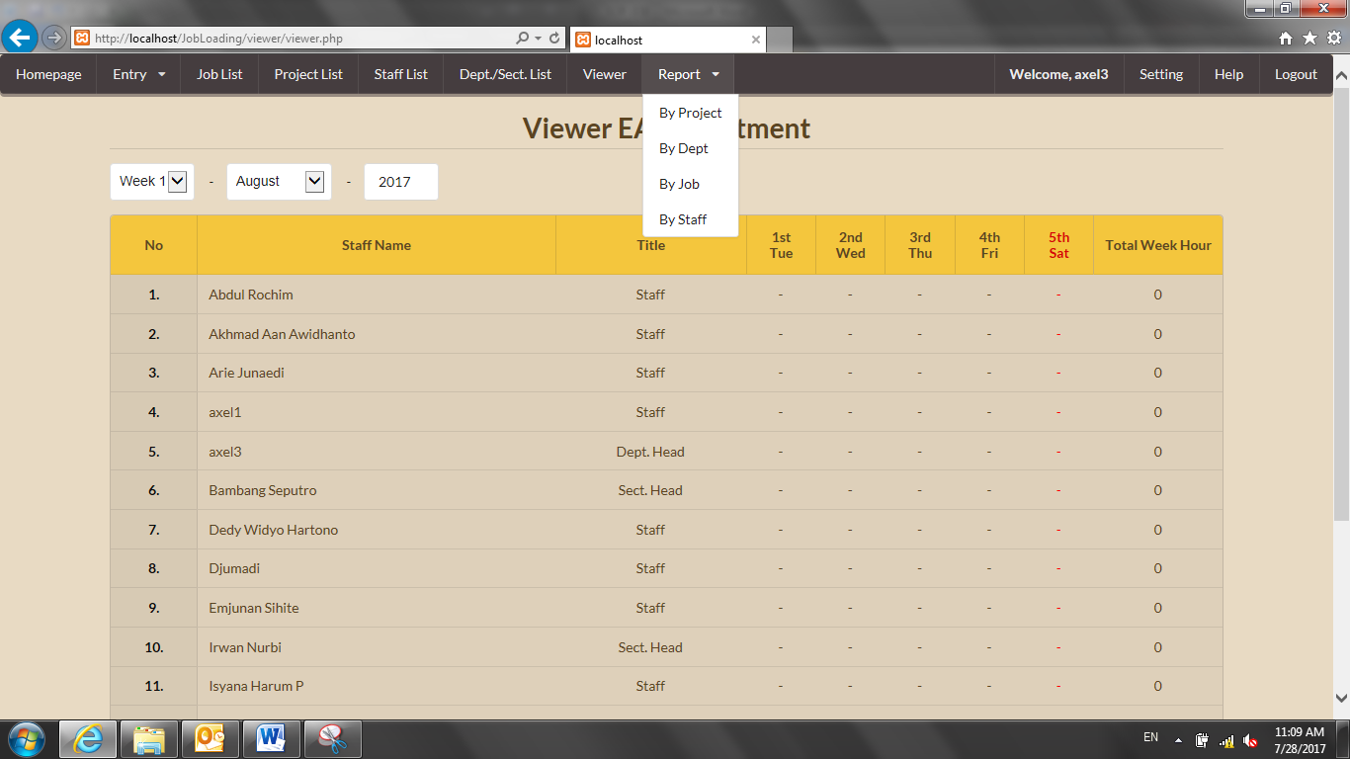**3.6 View Monthly Report**

**3.6.1 By Project**

1. Hover the mouse over the “**Report**” dropdown on navigation

bar on the top and click “**By Project**”.

1. You will be directed to report by **project** page which contains all projects, total project hours and graph.

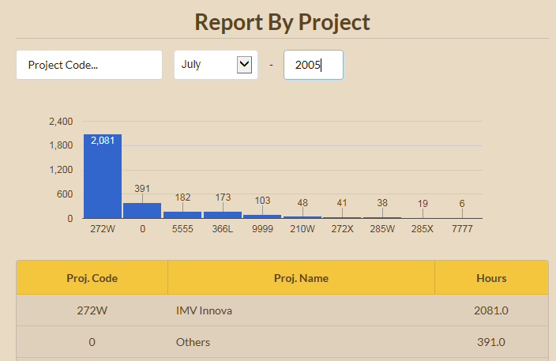

1. 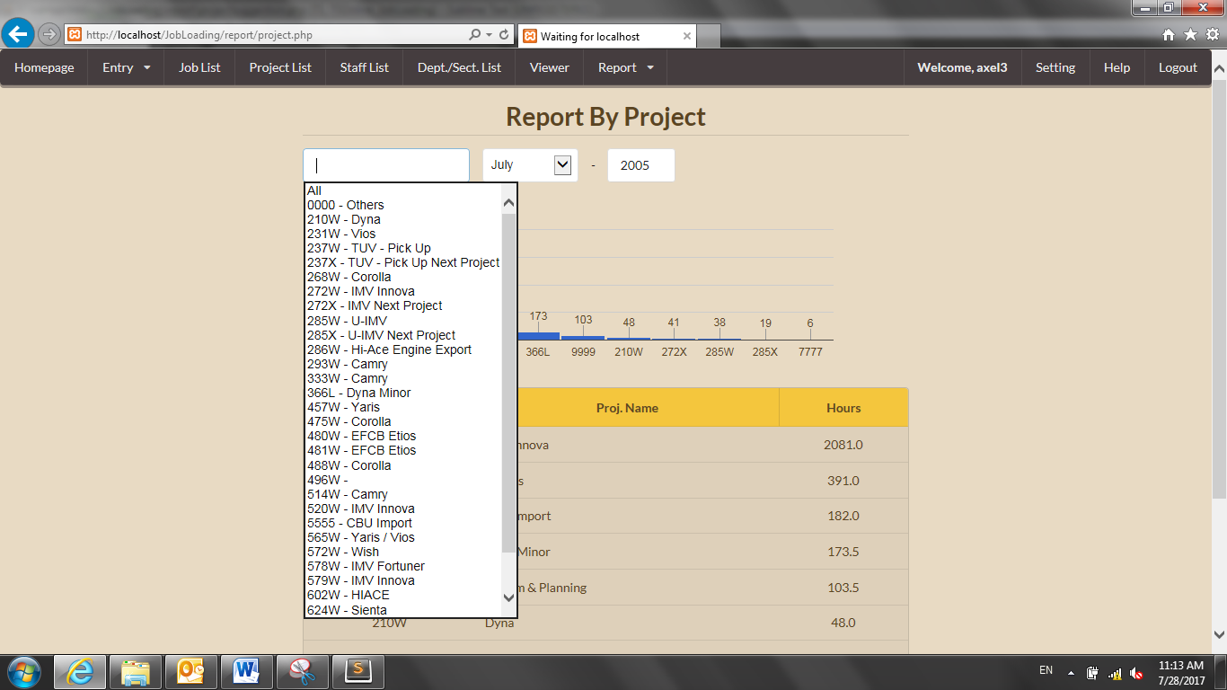To see the detail job of your desired project, you can click the **Project Code** search box and choose from the suggestion list.

**3.6.2 By Department**

1. Hover the mouse over the “**Report**” dropdown on navigation

bar on the top and click “**By Dept**”.

1. You will be directed to report by **department** page which contains all department code, name, total hours, and graph.

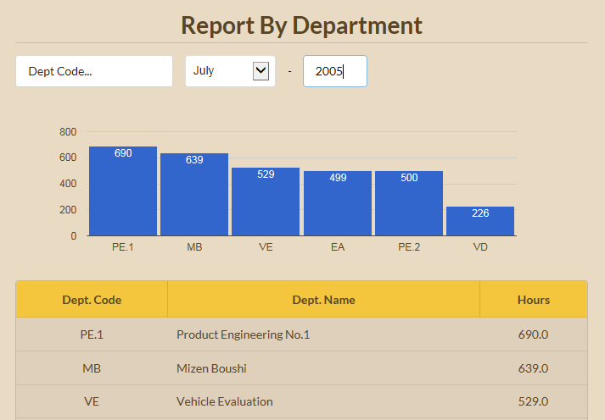

1. 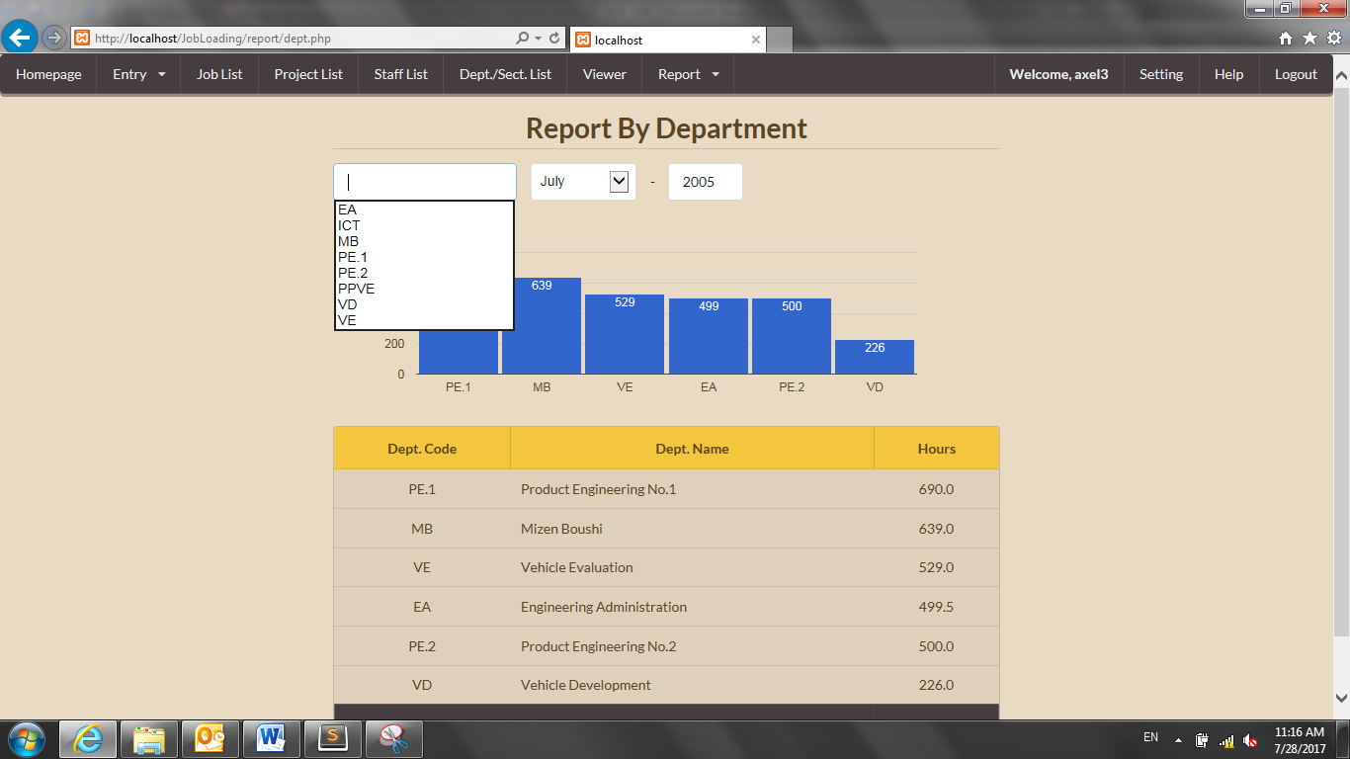To see the detail job of your desired department, you can click the **Dept Code** search box and choose from the suggestion list.

**3.6.3 By Job**

1. Hover the mouse over the “**Report**” dropdown on navigation

bar on the top and click “**By Job**”.

1. You will be directed to report by **job** page which contains all job name, total hours, and graph.

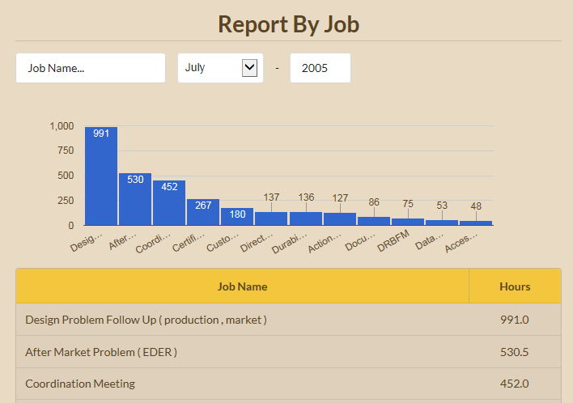

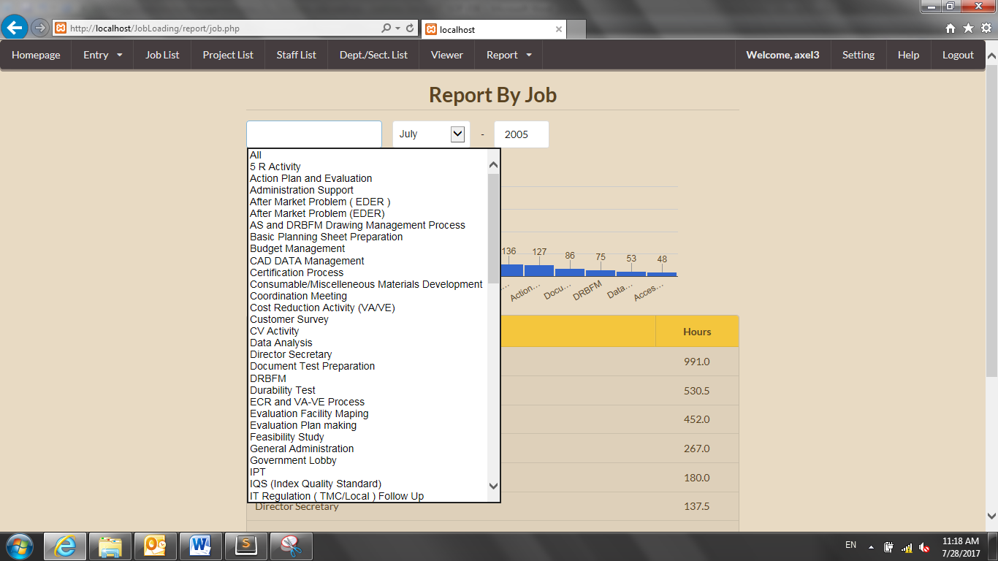

1. To see the detail staff of your desired job, you can click the **Job Name** search box and choose from the suggestion list.

**3.6.4 By Staff**

1. Hover the mouse over the “**Report**” dropdown on navigation

bar on the top and click “**By Staff**”.

1. You will be directed to report by **staff** page which contains all department code, total staffs, total hours, and graph.

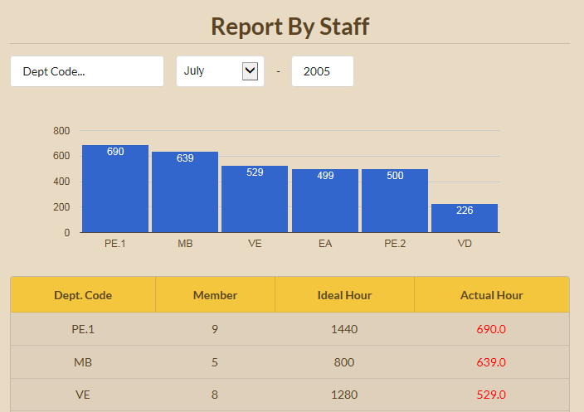

1. 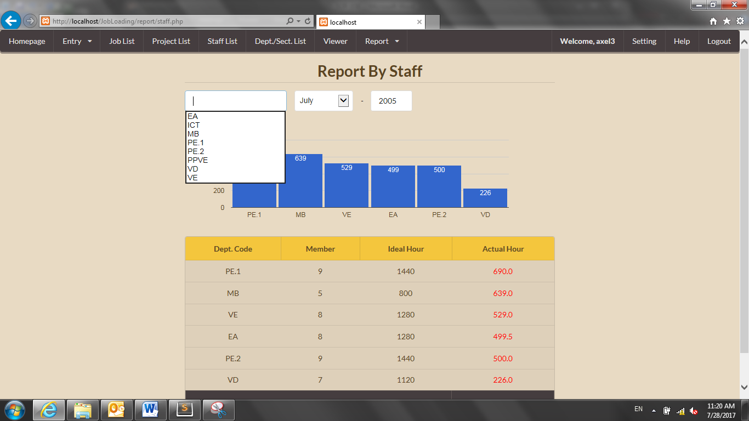To see the detail staff of your desired department, you can click the **Dept Code** search box and choose from the suggestion list.

**3.7 Change Account Setting**

1. Click the “**Setting**” on navigation bar on the top right.



1. You will be directed to “**Setting**” page which contain your account data.

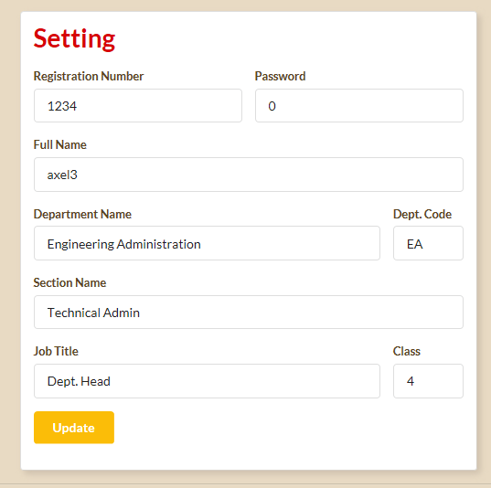

1. Change your account data in the appropriate textbox.
2. Click “**Update”** button after finish updating your account setting.



**3.8 Help**

1. Click the “Help” on navigation bar on the top right.



1. You will be directed to “Help” page which contain Frequency Answer and Question (FAQ).

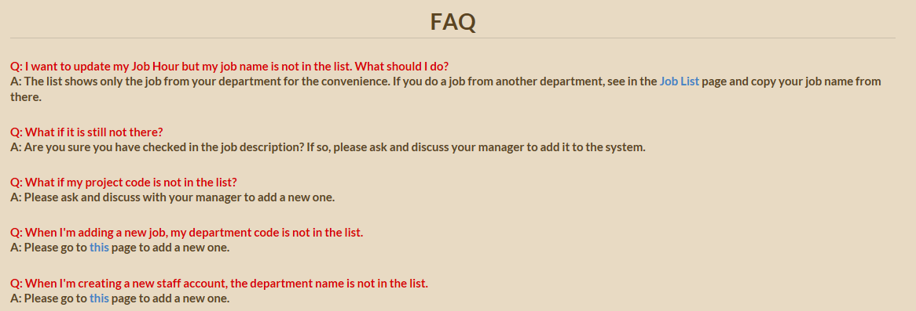

**3.9 Logout**

1. Click the “**Logout**” on navigation bar on the top right and you will be directed to **Login** page.

