Research Team File Permissions

Using Linux Bash

Project description
Check the permissions for all files in the directory, including any hidden files, to make sure that permissions align with the authorization that should be given to the research team.

Check file and directory details
Moved to the file directory to be worked in using cd projects and then checked directory contents and permissions including hidden files using ls -la.
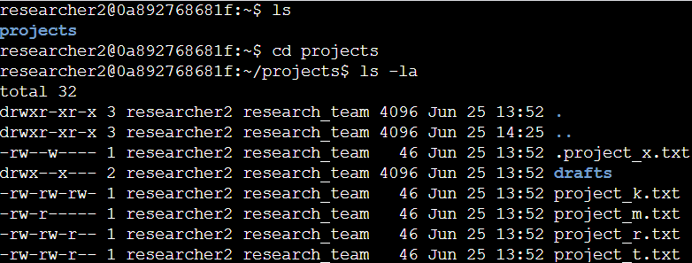

Description of the permissions string
The first column of the directory contents output describes the permissions assigned for each file. The permissions are described in 10 characters, the first of which determining whether it’s permissions for a directory (folder) or a file. If it’s a directory, it begins with a d; if a file a hyphen. Full permissions for a directory would be written as drwxrwxrwx, where each iteration of ‘rwx’ refers to ‘read’, ‘write’, and ‘execute’ permissions for user, group, and other, respectively. When a type of permission is not authorized, a hyphen is used.

Change permissions
Changed permissions on regular files, a hidden file, and a directory using chmod command.
The chmod command works by implementing or removing read, write, and execute (r, w, x) privileges assigned to user, group, or other (u, g, o) using +, -, or = implying an addition, subtraction, or setting of privileges, respectively.
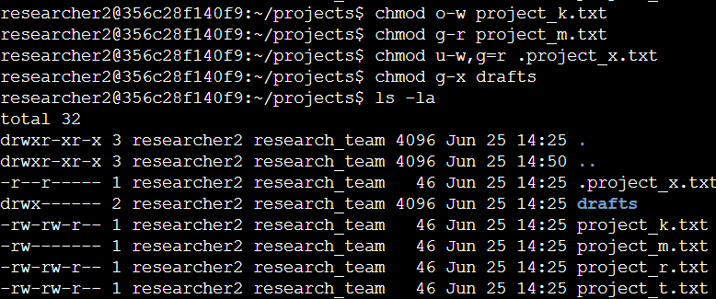

- project_k.txt – removed write privileges from other
- project_m.txt – removed read privileges from group
- .project_x.txt (hidden file) – removed write privileges from user, removed write privileges from group and added read privileges
- drafts – removed execute privileges for group on the directory

Summary
Tasks completed
- Move between directories
- Change permissions for files and directories
- View directory contents, including hidden files

