My First R Markdown

Christina Bergmann

January 17, 2017

The data we show is based on a 538 article entitled: "Comic Books Are Still Made By Men, For Men And About Men." You can read it at: <https://fivethirtyeight.com/features/women-in-comic-books/>

Let's check what the data look like

|  |  |  |  |  |  |  |  |  |  |  |  |  |
| --- | --- | --- | --- | --- | --- | --- | --- | --- | --- | --- | --- | --- |
| page_id | name | urlslug | ID | ALIGN | EYE | HAIR | SEX | GSM | ALIVE | APPEARANCES | FIRST.APPEARANCE | YEAR |
| 1422 | Batman (Bruce Wayne) | /wiki/Batman_(Bruce_Wayne) | Secret Identity | Good Characters | Blue Eyes | Black Hair | Male Characters |  | Living Characters | 3093 | 1939, May | 1939 |
| 23387 | Superman (Clark Kent) | /wiki/Superman_(Clark_Kent) | Secret Identity | Good Characters | Blue Eyes | Black Hair | Male Characters |  | Living Characters | 2496 | 1986, October | 1986 |
| 1458 | Green Lantern (Hal Jordan) | /wiki/Green_Lantern_(Hal_Jordan) | Secret Identity | Good Characters | Brown Eyes | Brown Hair | Male Characters |  | Living Characters | 1565 | 1959, October | 1959 |
| 1659 | James Gordon (New Earth) | /wiki/James_Gordon_(New_Earth) | Public Identity | Good Characters | Brown Eyes | White Hair | Male Characters |  | Living Characters | 1316 | 1987, February | 1987 |
| 1576 | Richard Grayson (New Earth) | /wiki/Richard_Grayson_(New_Earth) | Secret Identity | Good Characters | Blue Eyes | Black Hair | Male Characters |  | Living Characters | 1237 | 1940, April | 1940 |
| 1448 | Wonder Woman (Diana Prince) | /wiki/Wonder_Woman_(Diana_Prince) | Public Identity | Good Characters | Blue Eyes | Black Hair | Female Characters |  | Living Characters | 1231 | 1941, December | 1941 |

Now some plots!

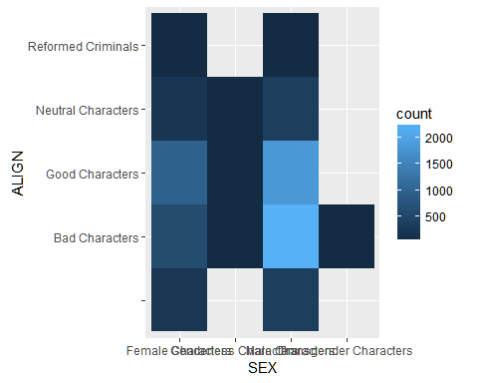

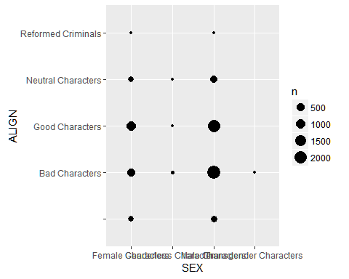

## [1] 2