PAWS Animal Return Analytics

Philadelphia Animal Welfare Society (PAWS) is a non-profit organization dedicated to saving Philadelphia’s homeless and at-risk animals. It is the city’s largest rescue partner and provider of low-cost, basic veterinary care for pet owners and rescue organizations that cannot otherwise access or afford it. Through its 3 no-kill shelters, foster care network, and special events, PAWS finds loving homes for thousands of animals each year.

R-Ladies Philly has partnered with PAWS to examine trends and patterns in animal returns after initial adoptions and recommend possible solutions to improve the adoption process. Many factors, like the time of year, animal type, age, adopter life decision, etc., can contribute to an animal being returned.

## Contributors

**Karla Fettich, PhD** is Head of Algorithm Development at Orchestrall, Inc., where she leads data-driven app development focused on senior care. She is a co-organizer of R-Ladies Philly and a long-time PAWS volunteer.

**Mitchell Maltenfort PhD** lurched into academic life as a computational neurobiologist before drifting into the less recherché field of biostatistics. He knows just enough to make a complete hash out of things and is creative enough to salvage them afterwards. In his brutish culture, this tradition is known as “larnin'’” For tax purposes, he is employed as a biostatistician at CHOP, where he has generated risk scores for hospitalization, analyzed diagnostic variations among clinics, compared international trends in childhood mortality, and evaluated patient-reported outcome scores.

**Julia Schuchard**, **PhD** is a research scientist at Children’s Hospital of Philadelphia. She plans to foster as many cats as her apartment will allow.

**Chun Su, PhD** is a Bioinformatics Scientisit at Children’s Hospital of Philadelphia (CHOP) and R-ladies Philly co-organizer. Her research focuses on the effect of 3-dimensional genome change on gene expression network regulation and its influence on the genetic susceptibility for childhood diseases.

**Jesse Wind**

## Datasets

We used a dataset extracted from PetPoint, the system used by PAWS to record animal intake and outcome processes from the perspectives of both animal and adopter. *PetPoint_byAnimal.csv* records the animal information, including animal type, breed, health status, intake date, release date, etc. *PetPoint_byPerson.csv* stored de-identified adopter data, including adopter gender, postal code, adoption location, etc.

## Executive Summary

This analysis investigated factors relating to an animal’s adoption process in the PAWS system using PetPoint data from 1/15/2018 to 1/15/2020. The group combined the byAnimal and byPerson datasets and traced each animal’s trajectory from intake to outcome. We formulated the data by adoption event per animal and defined adoption outcome as “return” or “no return” and return time as days from adoption to return. Our primary factors of interest included return reasons, animal characteristics (age, size, breed, health), length of stay in shelter, adopter geographic patterns and adoption staff experience.

We found:

* PAWS’ return rate in the last 2 years is 6.7% for cats and 10.8% for dogs; while more cats are returned in total, dogs are returned in a higher proportion.
* The majority of returns have to do with a mismatch in expectations regarding owning an animal (“Unrealistic expectation”) or a major change in the adopter’s life (e.g., “moving”, “change in lifestyle” and “health of owner/family”). Additionally, the first 2 months post-adoption have the highest risk of returns, so targeted education or support services for new adopters could focus on this time period.
* Animals that are at greater risk to be returned and whose adopters may benefit from a more individualized adoption process are older cats, younger dogs,
* Pit bulls, chihuahuas, and mixed breed dogs, as well as those animals that only spent a short time with PAWS.
* Adopters living outside Philly are less likely to return animals to PAWS (but we cannot rule out that they may be dropped off at another shelter). If adopters in the city do indeed return dogs more frequently, this may suggest that the factors that make an animal a successful city vs. suburban pet are different, and should be taken into account when a match with an adopter is assessed.
* The experience of the staff member handling the adoption contributes to the successful adoption of an animal (but only when the animal was not sick at intake). PAWS may consider additional strategies for assigning experienced staff members to process at-risk animals’ adoptions, as well as more ways to transfer knowledge from experienced adopters.
* Overall, return rates at PAWS are relatively low. The PAWS foster program for cats is particularly successful, with only 2% of cats returned.

## Results

### Overall Animal Return Outcomes

The total sample consisted of 6687 records of animals that had both intake and outcome information between 1/15/2018 and 1/15/2020. It involved 6330 animals, including 5599 cats and 731 dogs. Out of 6330 animals, 6329 animals were adopted within the last two years. Returned animals included 6.7% (378) of cats and 10.8% (79) of dogs, with 39 animals having been returned more than once.

The table below shows the number of animals returned, by animal type and age at adoption, location of adoption, intake health, and primary breed (for dogs only). We note the following highest risk factors for an animal being returned: dogs adopted at less than a year old, animals adopted from Grant Avenue, and animals who were unhealthy at intake. Additionally, dogs that are Pit Bulls, Chihuahuas or Mixed breed experience a higher number of returns than other breeds.

|  |  |  |  |  |  |  |
| --- | --- | --- | --- | --- | --- | --- |
|  | **All dog intakes** | **Returned dogs** | **Percentage dogs returned** | **All cat intakes** | **Returned cats** | **Percentage cats returned** |
| **Age at adoption** |  |  |  |  |  |  |
| Less than 1 year | 120 | 14 | 12% | 3072 | 97 | 3% |
| 1-3 years | 265 | 21 | 8% | 1619 | 87 | 5% |
| 3-10 years | 356 | 27 | 8% | 1085 | 67 | 6% |
| More than 10 years | 62 | 3 | 5% | 50 | 0 | 0% |
| **Location of adoption** |  |  |  |  |  |  |
| Grant Avenue | 201 | 22 | 11% | 1277 | 92 | 7% |
| PAC | 175 | 9 | 5% | 1491 | 72 | 5% |
| PAWS Foster | 238 | 19 | 8% | 1956 | 31 | 2% |
| Other | 189 | 15 | 8% | 1160 | 57 | 5% |
| **Intake health** |  |  |  |  |  |  |
| Healthy | 698 | 55 | 8% | 3793 | 156 | 4% |
| Not healthy | 101 | 10 | 10% | 1501 | 83 | 6% |
| Less than 7 weeks | 4 | 0 | 0% | 590 | 13 | 2% |
| **Primary Breed** |  |  |  |  |  |  |
| Pit Bull | 162 | 21 | 13% |  |  |  |
| Chihuahua | 120 | 16 | 13% |  |  |  |
| Mixed | 28 | 4 | 14% |  |  |  |
| Terrier (not pit bull) | 167 | 16 | 10% |  |  |  |
| Other | 326 | 34 | 10% |  |  |  |

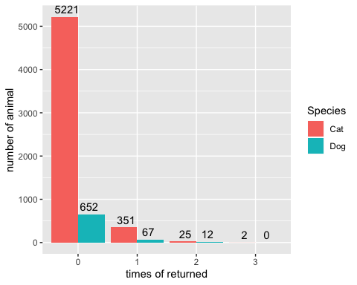

The dataset contained 347 return events for which the corresponding adoption date could be traced over the 2-year recording range. They involved 289 animals (232 cats and 57 dogs). Of these 347 return events, we noticed 17 unrealistic return events which happened within 1 hour, with 12 events happening within 5 minutes. We assumed that these events were the result of data entry errors, and chose to remove them from analyses.

Days from adoption to return

|  |  |  |
| --- | --- | --- |
| Days from adoption to return | Number of returns | Cumulative number of returns |
| 0 – 1 days | 15 | 15 |
| 1 – 7 days | 77 | 92 |
| 7 -14 days | 36 | 128 |
| 14 – 30 days | 44 | 172 |
| 30 – 90 days | 59 | 231 |
| 90 – 180 days | 42 | 273 |
| 180 – 365 days | 41 | 314 |
| Over 365 days | 16 | 330 |

After removing these entries, 70% (231) of returns happened within 90 days. The return time peaked differently between species, with 8 days for dogs, and 14 days for cats.

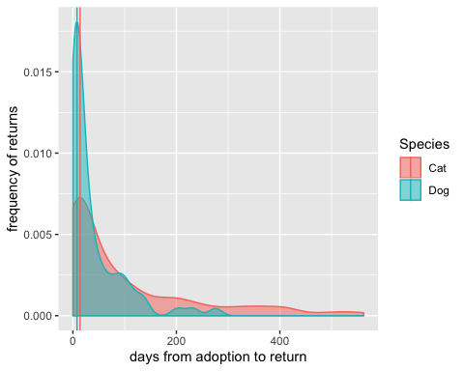

### Return Reasons

We explored the 34 recorded reasons that an animal got returned back to PAWS, and found that “moving” is the top reason contributing to cat return while “Behavior Issues” is the top reason for dog return. We further carefully classified those reasons as mainly from “adopter-side” or from “animal-side”, e.g., we would consider “moving”, “too many animals” and “Divorce / Separation” as “owner-side” reasons, while “aggression to animal”, “too active” and “behavior issue” as “animal-side” reason. Based on 34 recorded reasons, we found 16 can be devoted as “animal-side” reasons while 18 as “owner-side” reasons.

Among the top 10 return reasons for both cat and dog, more than half of cases are from adopter side, like “moving”, “unrealistic expectation”, " allergic to animal" and “health of owner or family”, “landlord issue” and “change of lifestyle”. “Unrealistic expectations” are equally important reasons for both cats and dogs.

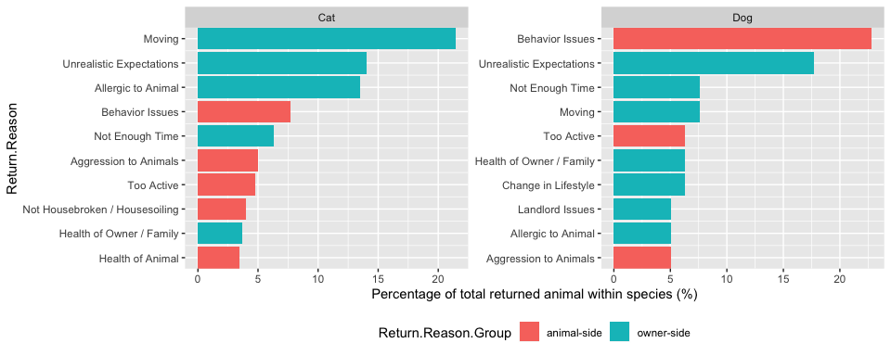

Focusing on the animal returned to PAWS multiple times, we hypothesized that those animals were always returned with animal-side reasons. Out of 39 multiple-times-returned animals, only 3 (cat A15451188, A38026544 and A42298667) were returned with always animal-side reasons. Only cat A38026544 was returned for the exactly same reason (Not Housebroken / Housesoiling).

All together, these findings suggest that the reasons for returning animals are not largely dependent on animals. “Unrealistic expectation” and adopter life-change (e.g., “moving”, “change in lifestyle” and “health of owner/family”) are important reasons for animal returning from owner-side.

### Animal characteristics

#### Species and Age

From the previous “Overall Animal Return Outcomes”, we observed a significant difference between cats and dogs in terms of return ratio. Generally, dogs experience a higher return ratio compared to cats (10.8% vs. 6.7%).

When combining with animal age to build a logistic regression model, we observed a significant interaction between animal age and species (p-value =0.0016, suggesting that this effect is highly unlikely to be due to chance). Specifically, this finding suggests that the effect of animal age on getting returned is different between cats and dogs, with older cats and younger dogs being more likely to be returned.

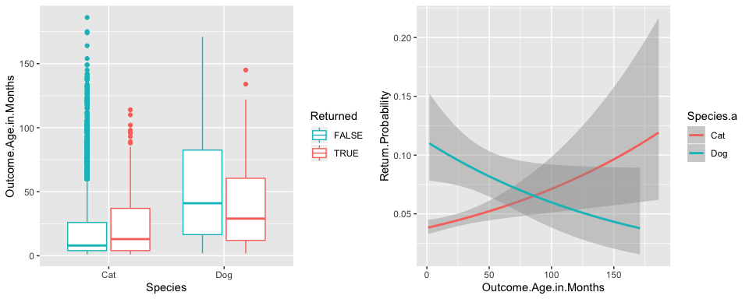

#### Length of Stay (LOS)

On average, animals stayed at PAWS for 70 days before getting adopted. Dogs stayed about half as long as cats (Dog: 38.8 days on average, Cat: 74.2 days on average). In both species, we observed a lower length of stay among the returned animals. Logistic regression revealed a significant negative correlation between LOS and return probability (P-value < 0.0001, indicating that the result is highly unlikely to be due to chance). This finding suggests that the *longer* an animal stays at PAWS, the *less* likely it is to be returned.

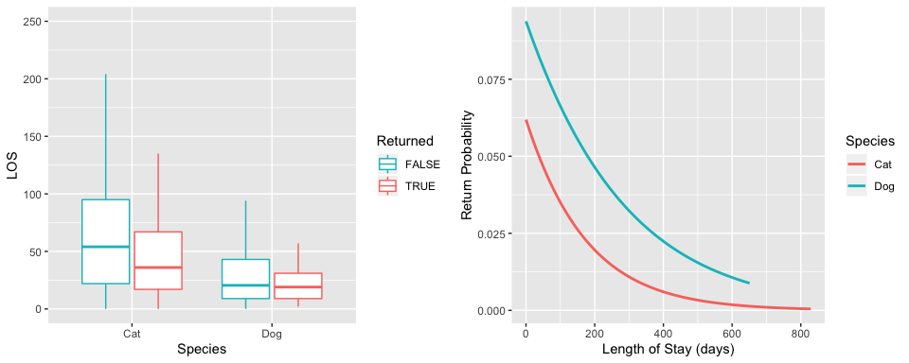

#### Sickness

Animal sickness was assessed at intake. Usually sick animals are treated before being placed in adoptive homes. By default, we were expecting that sick animals will have same outcome as healthy animals in terms of return likelihood. However, we observed statistically elevated return odds for the animals that were labeled “sick” at intake, compared to healthy animals (P-value=1.4, Odd ratio = 1.41).

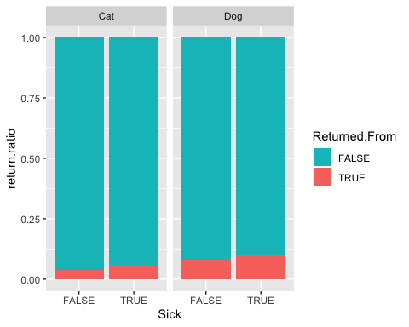

#### Breed and hair length

The PetPoint breed column contains heterogenous information for cat and dog. It mainly records hair length of cat but breed of dog. Among 731 dogs, 143 are Pitbull and 108 are Chihuahua. We observed elevated return ratios in chihuahuas and pitbulls, but neither comparison is statistically significant.

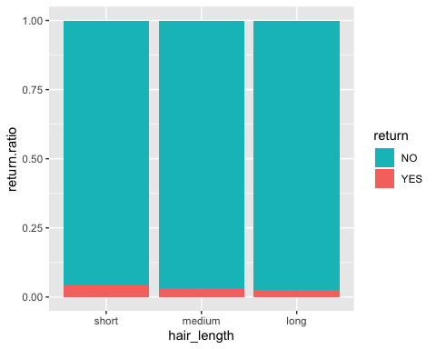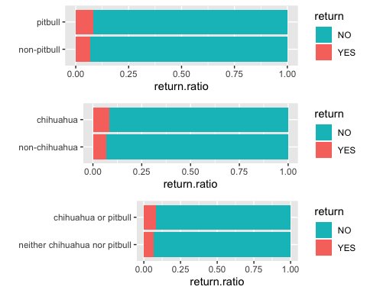

### Adopter characteristics

#### Adopter geographic impact

We found that 19.5% of adopters lived outside of Philadelphia. By comparing people living within and outside Philadelphia, we observed people living outside of Philadelphia to be less likely to return animals, particularly cats (p-value = 0.04, odds ratio = 0.7). Conversely, people living within Philly are less likely to return dogs.

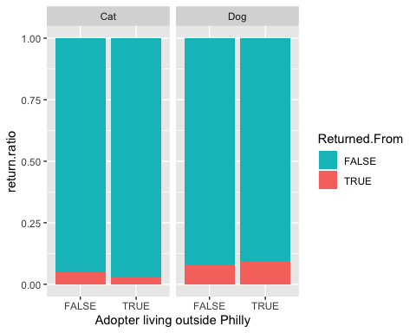

#### Adopter income impact

An important geographic characteristic is income. We incorporated median income based on postal zipcode into our byPerson dataset. Like neighbourhood difference (within-philly vs outside-philly), we found opposite return probability association between dog and cat. Higher income results in lower return for cats but higher return for dogs.

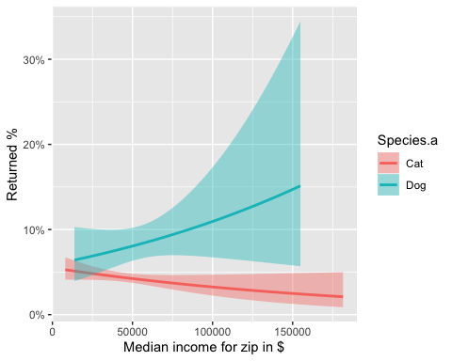

### Agents

Agent (adoption staff) experience contributes greatly to the outcome of adoptions. We created a variable “Volume by Agent” which measures the case number an Agent has handled by adoption time. We noticed a significantly negative association between Volume by Agent and return probability. More experienced agents have a better adoption outcome in terms of animal returns.

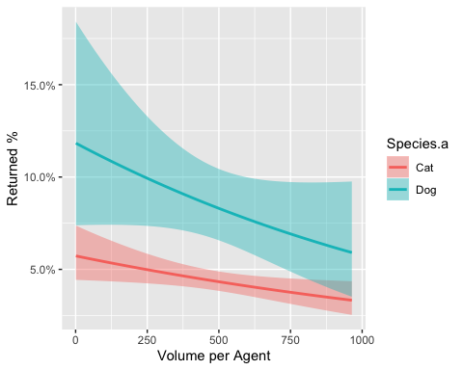

However, this association does not hold when it comes to animals that were sick at intake. If the animal was sick, the experience of the agent does not result in more successful adoptions. Although the upward slope suggests agent experience works against adoption of sick animals, note that the effect itself is not statistically significant (the confidence interval includes a perfectly horizontal line). If this upward trend is real, one possibility might be that a more experienced agent is more willing to present adopters with the possibility of returning a sick animal.

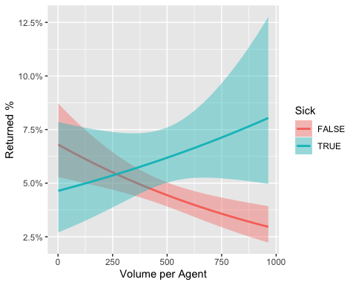

### Factor importance

In the above analysis, we found that factors “Species”, “LOS”, “animal age”, “Sickness”, “adopter neighbourhood”, “adopter median income” and “agent experience” contribute to the animal return likelihood. To understand which factor plays the most important role in animal returns, we performed a logistic regression model on the above seven factors and ranked the contribution of each factor. “Length of stay” is the most important contributor to return chance, followed by “species” and “animal age”.

