My research project

Alex Knitter

Table of Contents

Project description 1

Measurement 1

Results 2

Characteristics of the sample by country 4

Visualizing the relationships between country and quality of life 5

Discussion 8

References 8

## Project description

Using the 2019 Global Attitudes & Trends data set from the Pew Internet & American Life website, I will answer the research question, Do perceptions about the quality of life vary by country?

The data and codebook are available on the [Pew website](https://www.pewresearch.org/global/dataset/spring-2019-survey-data/) (need free account).

The data and codebook, along with this code file, **can also be downloaded at the link below**:

### Measurement

To answer my research question, I used a subset of the data that included survey participants responses to the following questions: Gender (RECORD BY OBSERVATION); How old were you at your last birthday? (RECORD AGE IN YEARS); All things considered, who has a better life in this country - men or women?; Overall, are you satisfied or dissatisfied with the way things are going in our country today?; Now thinking about our economic situation, how would you describe the current economic situation in (survey country) – is it very good, somewhat good, somewhat bad, or very bad?; and Here is a ladder representing the ladder of life. Let’s suppose the top of the ladder represents the best possible life for you; and the bottom, the worst possible life for you. On which step of the ladder do you feel you personally stand at the present time?

Questions of Interest with Response Options

| Question | Response Options |
| --- | --- |
| Gender | (RECORD BY OBSERVATION) Male, Female |
| How old were you at your last birthday? | (RECORD AGE IN YEARS) Numeric, range: 18-97 |
| All things considered, who has a better life in this country - men or women? | Men, Women, Same/both equally |
| Overall, are you satisfied or dissatisfied with the way things are going in our country today? | Satisfied, Dissatisfied |
| Now thinking about our economic situation, how would you describe the current economic situation in (survey country) – is it very good, somewhat good, somewhat bad, or very bad? | Very good, Somewhat good, Somewhat bad, Very bad |
| Here is a ladder representing the ladder of life. Let’s suppose the top of the ladder represents the best possible life for you; and the bottom, the worst possible life for you. On which step of the ladder do you feel you personally stand at the present time? | Numeric, range: 0-10 |

This paragraph might talk about the process and statistical methods used. What happened during data management (recoding, missing value handling), which descriptive statistics and statistical tests were used, what assumptions were checked.

## Results

Here is a table showing the basic descriptive statistics.

#### Table. Characteristics of 4,543 survey participants in Kenya, Nigeria, South Africa, and Tunisia (Data source: Pew Research Center Global Attitudes Survey (2019)).

| Characteristic | Category | n (%) |
| --- | --- | --- |
| Sex | Male | 2226 (49.0) |
|  | Female | 2317 (51.0) |
| Who has a better life in this country | Men | 1745 (39.5) |
|  | Women | 1478 (33.4) |
|  | Same/both equally | 1198 (27.1) |
| Satisfied/dissatisfied with country | Satisfied | 965 (21.5) |
|  | Dissatisfied | 3526 (78.5) |
| Describe economic situation country | Very good | 303 (6.7) |
|  | Somewhat good | 1076 (23.9) |
|  | Somewhat bad | 1243 (27.6) |
|  | Very bad | 1875 (41.7) |
| Age | Median (IQR) | 32.0 (24.0 to 45.0) |
| Worst (0) to best (10) life | Median (IQR) | 5.0 (4.0 to 8.0) |

Maybe add some text here pointing out anything interesting or unexpected in the table that the readers might want to view more closely. Also explain anything in the table that suggests how the research question might eventually be answered.

#### Figure. The distribution of survey participant age by country.

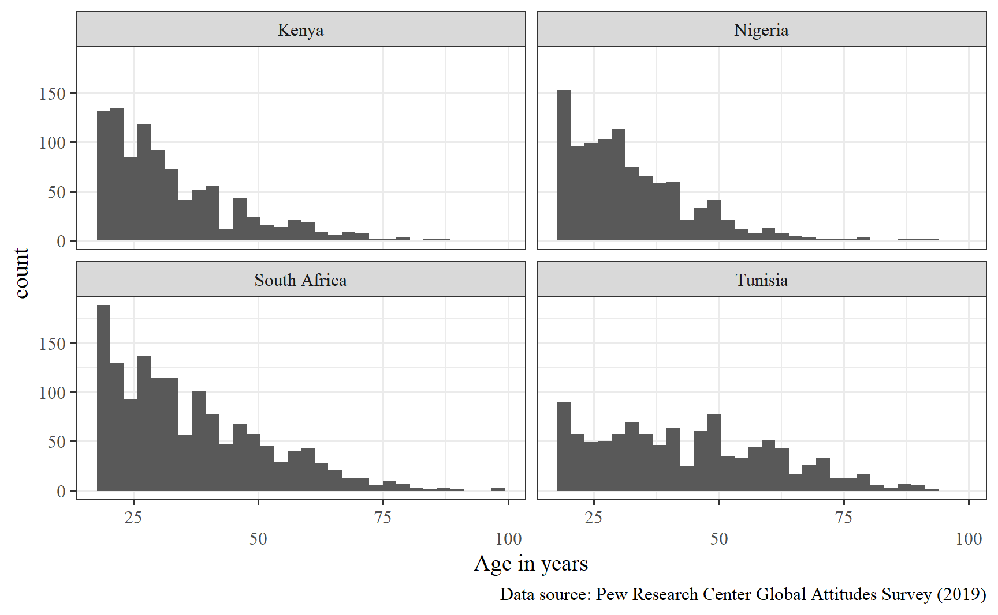

#### Figure. The distribution of survey participant responses about their place on the life ladder by country.

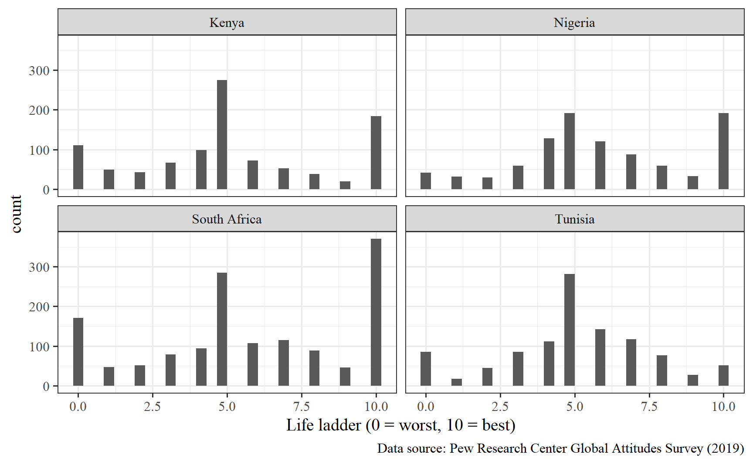

### Characteristics of the sample by country

There would be a paragraph here pointing out any descriptives that might be of interest or useful in helping to answer the research question. You could do this in a paragraph or, if there are several things to point out, maybe a bulleted list would be useful.

* This is a first-level bullet point about something you found
  + Here is a second level bullet point related to the point above
  + Here is another second level bullet point related to the point above
* This is another first-level bullet point about something you found
  + Here is a second level bullet point related to the point above

### Visualizing the relationships between country and quality of life

#### Figure. Satisfaction with how things are going by country according to 4543 participants in a 2019 survey of people from Kenya, Nigeria, South Africa, and Tunisia.

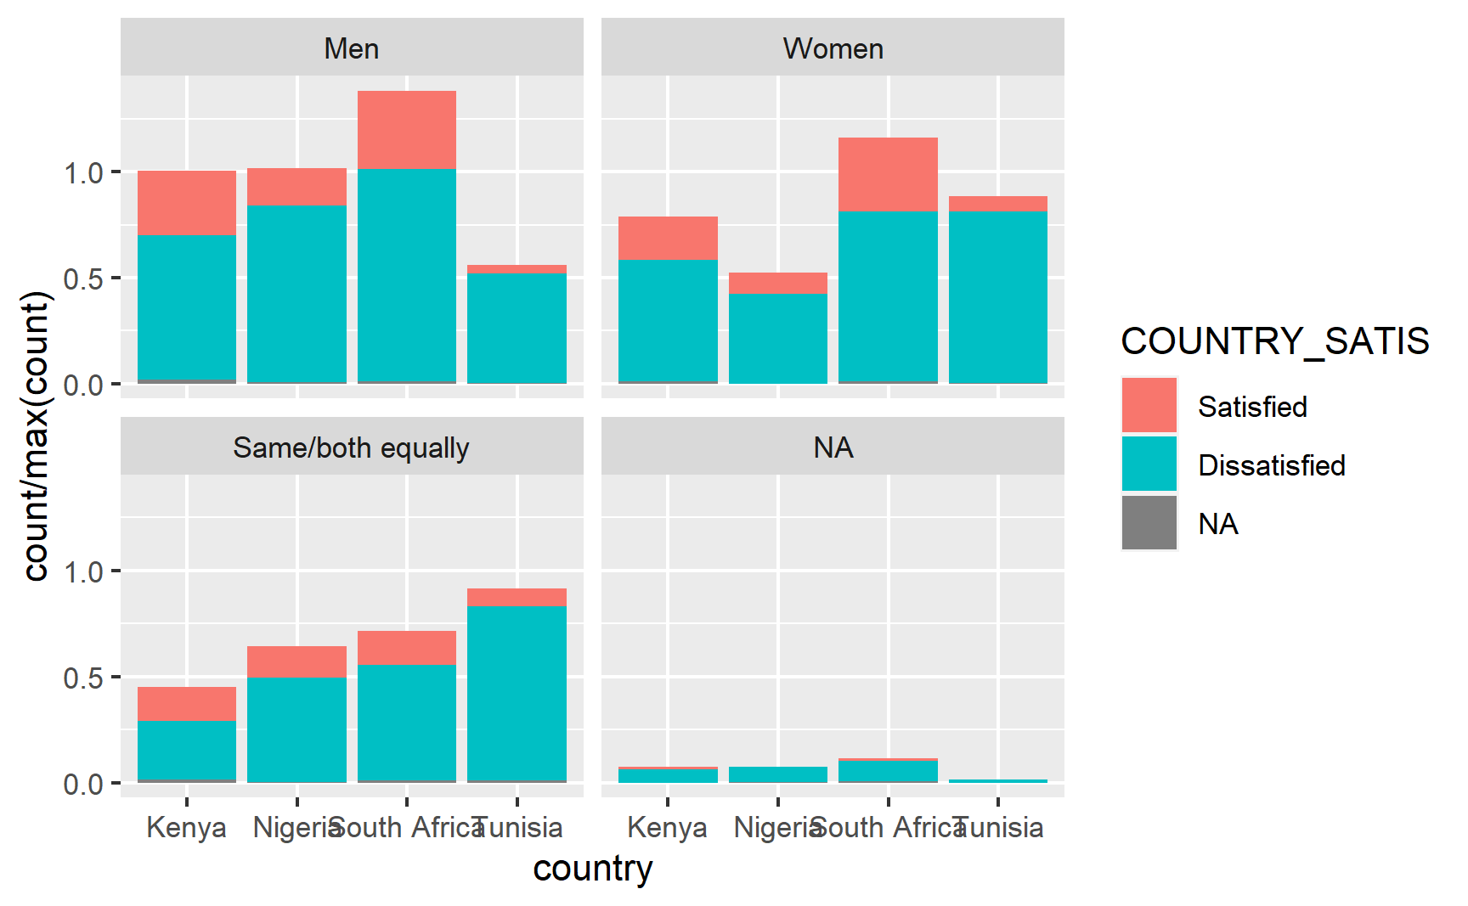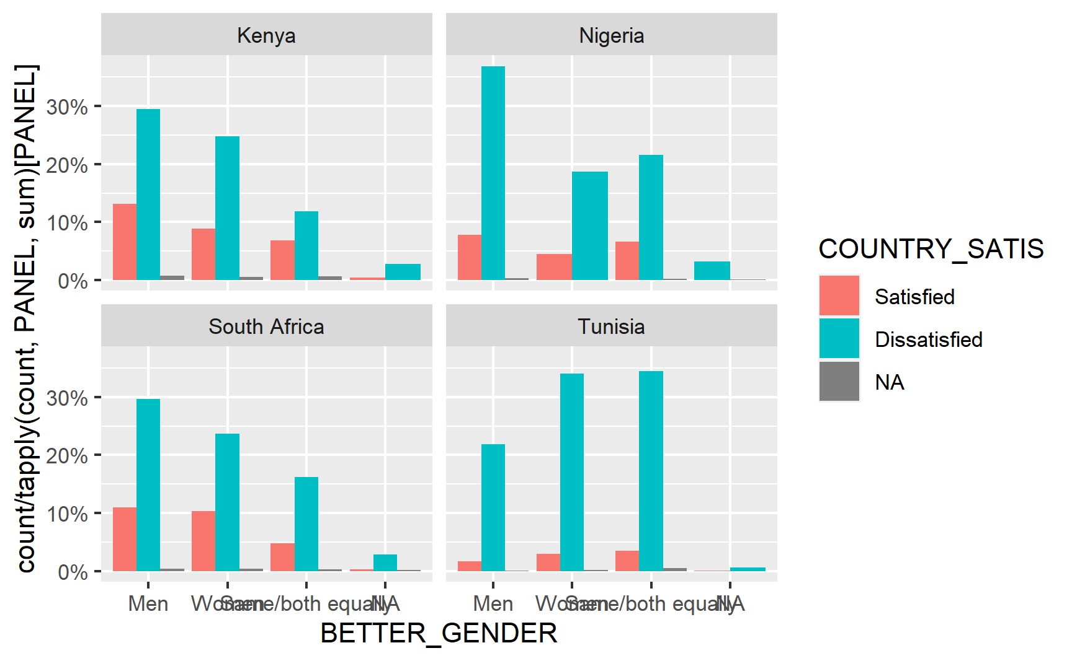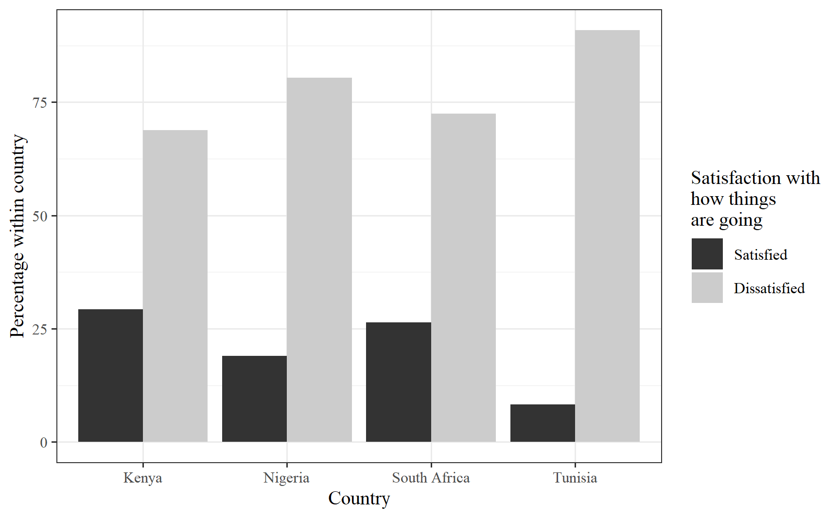

#### Figure. Life ladder by country for 4543 participants in a 2019 survey of people from Kenya, Nigeria, South Africa, and Tunisia.

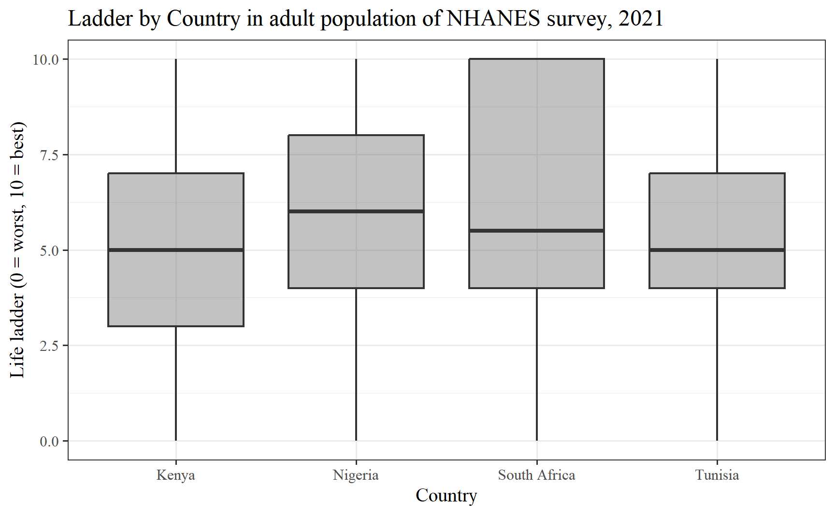

#### Figure. Who has a better life by country according to 4543 participants in a 2019 survey of people from Kenya, Nigeria, South Africa, and Tunisia.

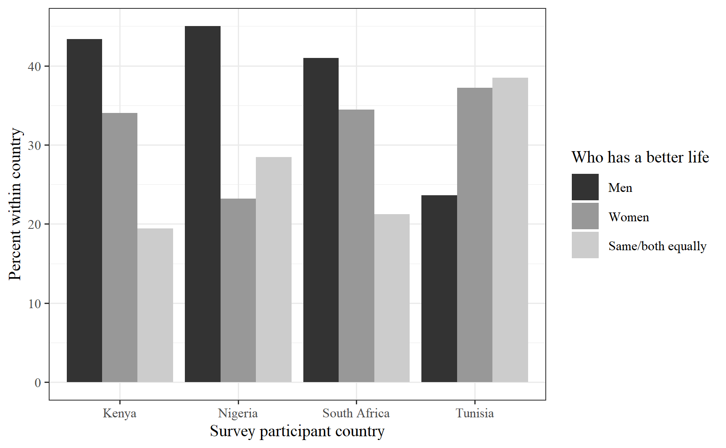

Add some text about each of the figures, pointing out interesting patterns or information that is relevant to the project research question.

## Discussion

After all the methods and results, you would usually summarize the key points from your analyses and add some context by connecting your results to published evidence relevant to your work. Here is where you might add citations. More discussion of the findings that cite some of the literature in this area (Campos et al. 2014). Another statement about the literature and citing it goes here (Wickham et al. 2019).

## References

Campos, Ana Cristina Viana, Efigênia Ferreira e Ferreira, Andréa Maria Duarte Vargas, and Cecilia Albala. 2014. “Aging, Gender and Quality of Life (AGEQOL) Study: Factors Associated with Good Quality of Life in Older Brazilian Community-Dwelling Adults.” *Health and Quality of Life Outcomes* 12 (1). <https://doi.org/10.1186/s12955-014-0166-4>.

Wickham, Hadley, Mara Averick, Jennifer Bryan, Winston Chang, Lucy McGowan, Romain François, Garrett Grolemund, et al. 2019. “Welcome to the Tidyverse.” *Journal of Open Source Software* 4 (43): 1686. <https://doi.org/10.21105/joss.01686>.