import

from cmd line and folder where mongoimport is located:

mongoimport -d database -c collection --type csv --file C:/location/file --headerline

show dbs

show collections

db.collection.find()

db.collection.findOne()

db.collection.find().count()

db.collection.find().limit(1)

db.collection.find().pretty()

db.collection.distinct().pretty()

db.collection.find().limit(5).sort({key:-1}) -1 for desc or 1 for asc

db.collection.find().limit(5).sort({$natural:1}) for natural order

db.collection.distinct(‘key’) find distinct specified key

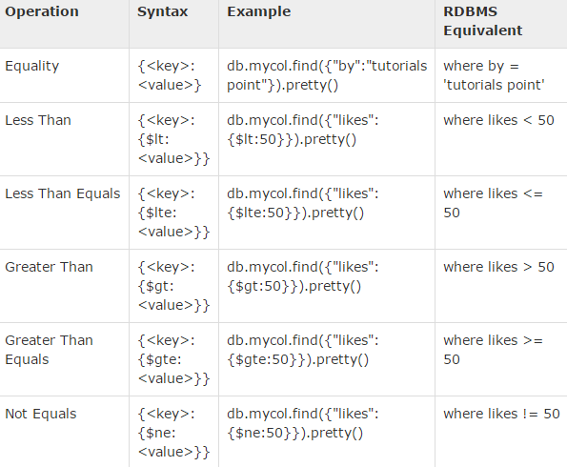

For AND separate keys by comma:



For OR:

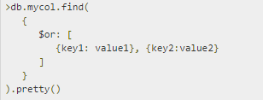

Combine AND/OR:

Likes > 10 and by … or title …



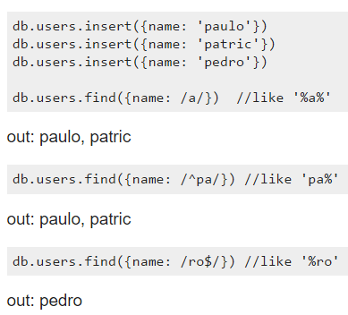

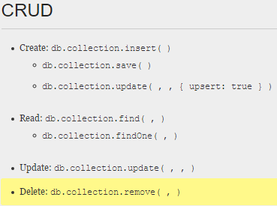

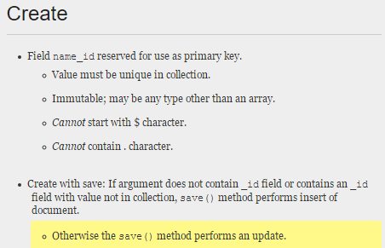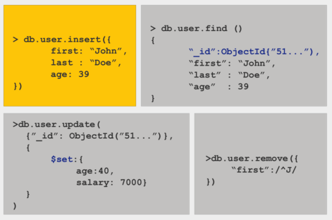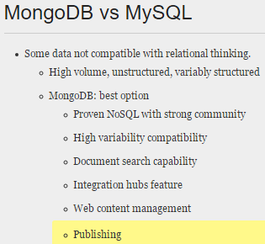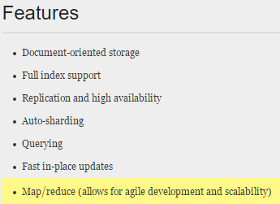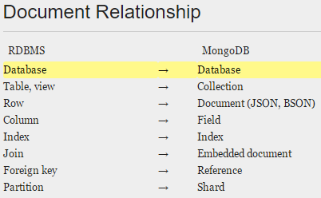

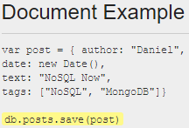

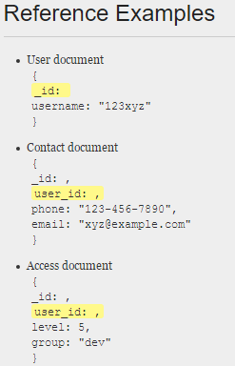

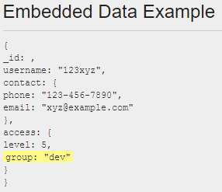

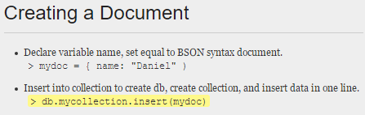



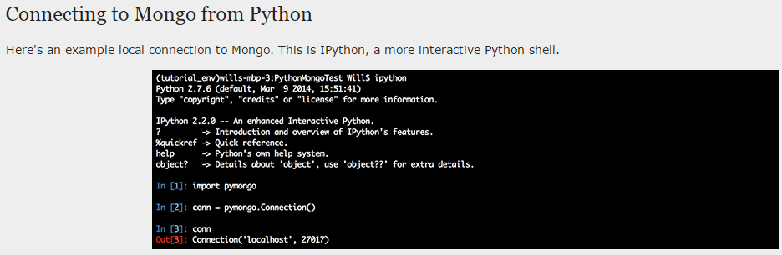

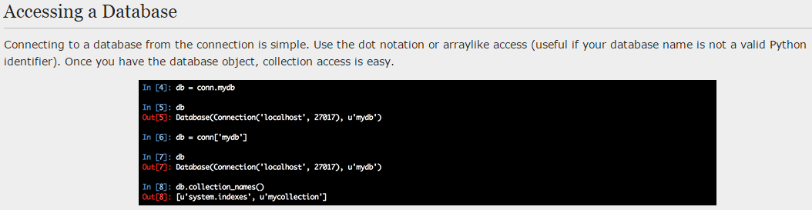

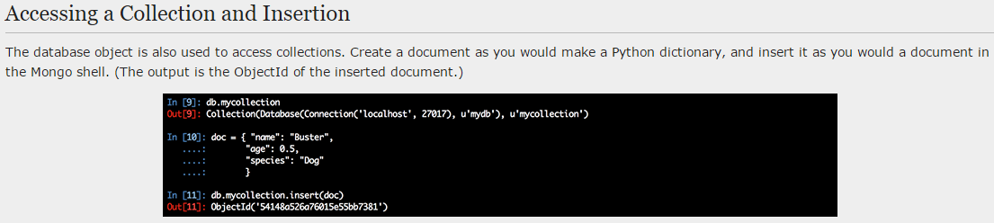

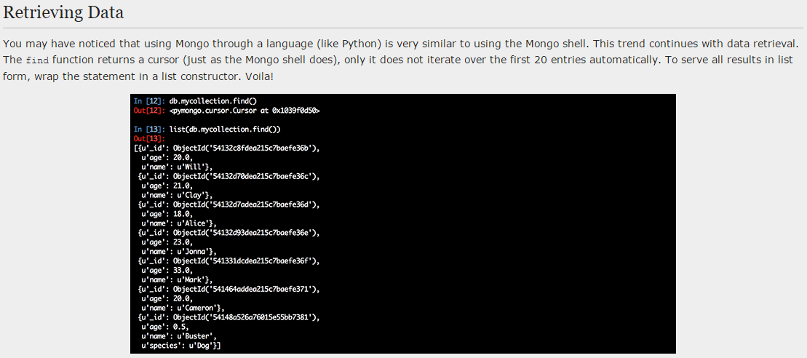

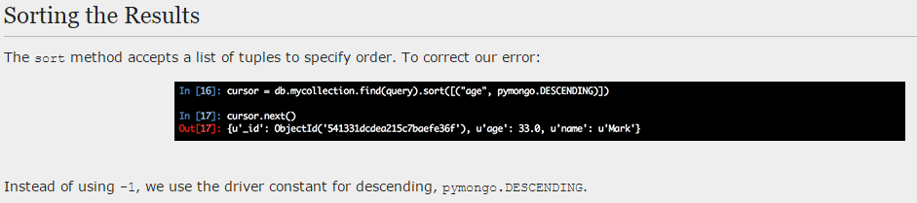

Rename a key:

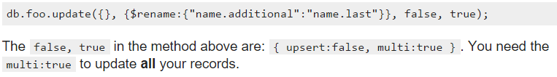

Simple count: 

Simple aggregation:

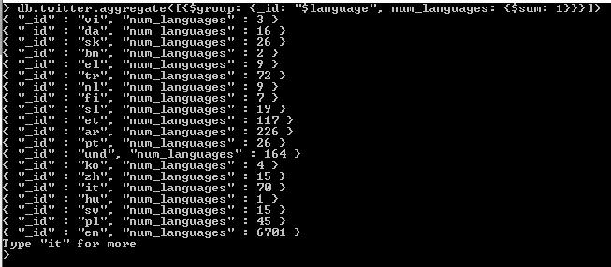

Aggregate and sort:

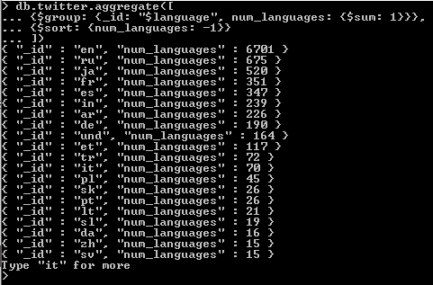

Substring aggregation:

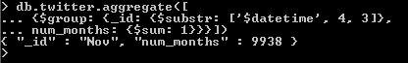

Function to convert to ISO date:



Count the occurrences per day:

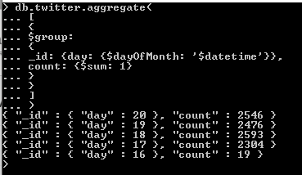

Group and sort:

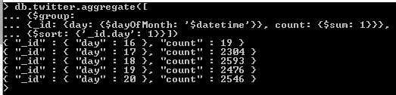

Multi-group and sort:

