ECE 375 Prelab 6

**Lab Time: Friday 16:00~17:50**

Hyunjae Kim

# Questions

1. In computing, there are traditionally two ways for a microprocessor to listen to other devices and communicate: polling and interrupts. Give a concise overview/description of each method, and give a few examples of situations where you would want to choose one method over the other.

Polling is jumping through a subroutine by keep checking the branch condition in the main routine. (busy-waiting)

Interrupt is going to subroutine from main routine when unexpected event is triggered.

<Examples>

Choose Polling:

In 24-bit adder by using Assembly, the adder has to check the carry is cleared or not in the process of adding. Thus, I would choose polling over interrupt.

Choose Interrupt over Polling:

In designing fire alarm, the alarm has to be alert as soon as possible when the smoke is detected. Thus, I would choose interrupt over polling.

2. Describe the function of each bit in the following ATmega128 I/O registers: EICRA, EICRB, and EIMSK. Do not just give a brief summary of these registers; give specific details for each bit of each register, such as its possible values and what function or setting results from each of those values. Also, do not just directly paste your answer from the datasheet, but instead try to describe these details in your own words.

EICRA: Set the external interruption detection,INT0~3(Port D 3:0), when to interrupt – 00(low level), 01(high level), 10(falling edge), 11(rising edge)

EICRB: Set the external interruption detection, INT4~7(Port E 7:4),when to interrupt – 00(low level), 01(high level), 10(falling edge), 11(rising edge)

EIMSK: Masks out the external interrupt vectors not going to be used by writing zero, and going to be used by writing one on the bits. For instance, if the INT0 is going to be used, and the INT7 is not going to be used, then bit 0 of EIMSK is written 1, and bit 7 of EIMSK is written 0.

3. The ATmega128 microcontroller uses interrupt vectors to execute particular instructions when an interrupt occurs. What is an interrupt vector? List the interrupt vector (address) for each of the following ATmega128 interrupts: Timer/Counter0 Overflow, External Interrupt 5, and Analog Comparator.

Interrupt vector is the address where interrupt source is stored in program memory.

Timer/Counter0 Overflow : $0020

External Interrupt 5: $000C

Analog Comparator: $002E

4. Microcontrollers often provide several different ways of configuring interrupt triggering, such as level detection and edge detection. Suppose the signal shown in Figure 1 was connected to a microcontroller pin that was configured as an input and had the ability to trigger an interrupt based on certain signal conditions. List the cycles (or range of cycles) for which an external interrupt would be triggered if that pin’s sense control was configured for: (a) rising edge detection, (b) falling edge detection, (c) low level detection, and (d) high level detection. Note: There should be no overlap in your answers, i.e., only one type of interrupt condition can be detected during a given cycle.

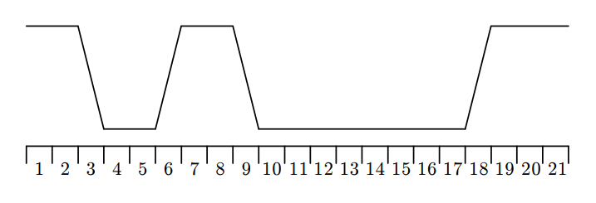

(a) [5.5,6.5] (Detect in rising edge)

(b) [8.5, 9.5] (Detect in falling edge)

(c )[9.5, 17.5] (Detect in low level)

(d)[18.5, 21.5] (Detect in high level)

# Reference

[AVR Data Sheet](http://ww1.microchip.com/downloads/en/devicedoc/doc2467.pdf)

Computer Organization and Assembly Programming: Embedded System Perspective, Ben Lee