**Understanding the problem:**

1.Problem:

The problem is that there is possibility that the player can input invalid choices. Moreover, the players can feel the game simple.

2.Goal:

The game will progress by choosing numbers like 1,2,3.

The primary goal of this game is drinking coffee in a café. And the secondary goal of this game is getting autograph(s) of famous athlete or taking a picture with famous athlete. (ex. Michael Jordan, Lebron James) [The secondary goal is for players who failed the primary goal.]

My program is leading players to the goals by suggesting choices.

3.Setting:

My game will take place in a city.

4.Scoring:

Players will earn 7 points if their choice is helpful to accomplish the goal. However, players will lose 4 points if their choice is not helpful to accomplish the goal.

5. Assumptions:

I assume negative number input don’t count as a choice.

I assume decimal number input don’t count as a choice.

I assume choices will be at least 2.

**Devise a plan**



(flow chart)

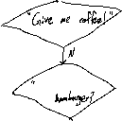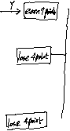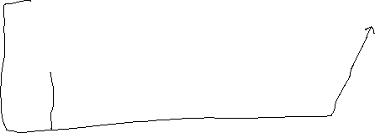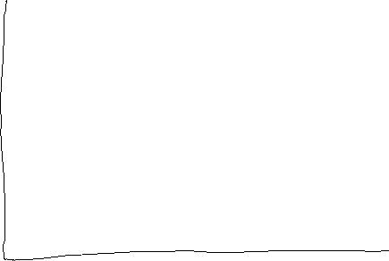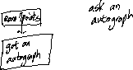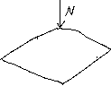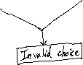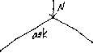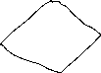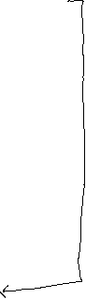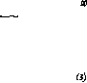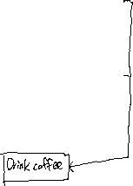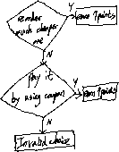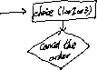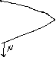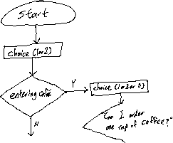

**Strategy:**

I predict that it will take about three hours to me to implement this code. First of all, I will start by making cases in order to decide entering a café or not, and quit the game if the input is invalid. In case of entering café, I will make cases in ordering coffee, and the type of coffee that player will get randomly. Then, make the situation that the player has less money to pay for player’s order. I will make cases to pay for it. Depending on the choices that player had chosen, I will print out the scores and the ending different. In case of meeting a famous athlete, I will print out three choices. And then, depending on the choices that player had chosen, I will print out the scores and the ending different. Moreover, the number of autograph and photos will be printed out randomly.

**Identify test cases:**

|  |  |  |
| --- | --- | --- |
| **Test case setting** | **Player input** | **Expected result** |
| You are in a café. You will say  1.Can I order one cup of coffee?  2.Give me coffee!  3.Can I order hamburger? | 1 | Increase score by 7 points. |
| You are in a café. You will say  1.Can I order one cup of coffee?  2.Give me coffee!  3.Can I order hamburger? | 2 | Decrease score by 4 points. |
| You are in a café. You will say  1.Can I order one cup of coffee?  2.Give me coffee!  3.Can I order hamburger? | 3 | Decrease score by 4 points. |
| You are in a café. You will say  1.Can I order one cup of coffee?  2.Give me coffee!  3.Can I order hamburger? | -1 | Output “Invalid choice! Game Over! Try again?(y/n)”  y-start the game again  n-quit the game(return 1) |
| You are in a café. You will say  1.Can I order one cup of coffee?  2.Give me coffee!  3.Can I order hamburger? | 0.000867 | Output “Invalid choice! Game Over! Try again?(y/n)”  y-start the game again  n-quit the game(return 1) |
| You are in a café. You will say  1.Can I order one cup of coffee?  2.Give me coffee!  3.Can I order hamburger? | 150 | Output “Invalid choice! Game Over! Try again?(y/n)”  y-start the game again  n-quit the game(return 1) |
| You are in a café. You will say  1.Can I order one cup of coffee?  2.Give me coffee!  3.Can I order hamburger? | -0.123456 | Output “Invalid choice! Game Over! Try again?(y/n)”  y-start the game again  n-quit the game(return 1) |
| You saw a café. You will   1. enter a café. 2. Pass a café. | 2 | Output  “You saw a famous athlete on the street. You will  1.Ignore and go home.  2.Ask autograph(s) to the athlete.  3.Ask taking photos to the athlete.” |