clear
clear all
close all
home
global H;
global C;
global G;
global u;
global temp1;
global temp2;
global m1;
global m2;
global l1;
global l2;
global g;
global tf;
global t0;
% Robot Parameters
m1 = 0.5;
m2 = 0.5;
l1 = 0.15;
l2 = 0.15;
g = 9.806;
% Control frequency is defined as follows %
s_time = 0.005;
% Terminal time %
t0=0; tf=4;
% Variable for converting RADIAN -> DEGREE or DEGREE -> RADIAN
R2D = 180/pi;
D2R = pi/180;
% Initial Configurations defined in RADIAN %
q = [-pi/2; 0];
qdot=[0; 0];
qddot=[0; 0];
% Robot trajectories %
q_0 = q; q_f = [pi/3, pi/6];
qdot_0 = qdot; qdot_f = [0;0];
qddot_0 = qddot; qddot_f = [0;0];
[a10,a11,a12,a13,a14,a15]=QuinticPolynomialPath(q_0(1), qdot_0(1), qddot_0(1), q_f(1), qdot_f(1), qddot_f(1));
[a20,a21,a22,a23,a24,a25]=QuinticPolynomialPath(q_0(2), qdot_0(2), qddot_0(2), q_f(2), qdot_f(2), qddot_f(2));
% Iteration numbers
n=1; %Iterator for main loop
n_trj=1; %Iterator for trajectories of joint points
% Plot Setting %
figure(1)
title('Animation')
grid
hold on
axis([-0.4 0.4 -0.4 0.4]);
Ax1 = [0, l1];
Ay1 = [0, 0];
Ax2 = [l1, l1+l2];
Ay2 = [0, 0];
p1 = line(Ax1,Ay1,'EraseMode','xor','LineWidth',[5],'Color','b');
p2 = line(Ax2,Ay2,'EraseMode','xor','LineWidth',[5],'Color','c');
% Robot Implementation
for i = t0 : s_time : tf
% Desired Trajectory
t=i+s_time;
q_d(1)=a10+a11*t+a12*t^2+a13*t^3+a14*t^4+a15*t^5;
q_d(2)=a20+a21*t+a22*t^2+a23*t^3+a24*t^4+a25*t^5;
qdot_d(1)=a11+2*a12*t+3*a13*t^2+4*a14*t^3+5*a15*t^4;
qdot_d(2)=a21+2*a22*t+3*a23*t^2+4*a24*t^3+5*a25*t^4;
qddot_d(1)=2*a12+6*a13*t+12*a14*t^2+20*a15*t^3;
qddot_d(2)=2*a22+6*a23*t+12*a24*t^2+20*a25*t^3;
% Forward Kinematics Part %
x1 = l1*cos(q_d(1));
y1 = l1*sin(q_d(1));
x2 = x1 + l2*cos(q_d(1)+q_d(2));
y2 = y1 + l2*sin(q_d(1)+q_d(2));
% Calculate the coordinates of robot geometry for animation
Ax1 = [0, x1];
Ay1 = [0, y1];
Ax2 = [x1, x2];
Ay2 = [y1, y2];
% Save the results of joint angles, angular velocities, angular acceleration
q1_save(n) = q_d(1)*R2D; % Save the joint angle in degree
q2_save(n) = q_d(2)*R2D;
qdot1_save(n) = qdot_d(1)*R2D; % Save the angular velocity in degree
qdot2_save(n) = qdot_d(2)*R2D;
qddot1_save(n) = qddot_d(1)*R2D; % Save the angular acceleration in degree
qddot2_save(n) = qddot_d(2)*R2D;
% Update the animation
if rem(n,50) == 0
set(p1,'X', Ax1, 'Y',Ay1);
set(p2,'X', Ax2, 'Y',Ay2);
drawnow
end
% Increase the iteration number
n=n+1;
end
T=t0:s_time:tf;
% Plot the graph of joint angles
figure(2)
subplot(3,1,1)
plot(T, q1_save, T, q2_save, 'r')
title('< Joint angle >')
legend('q_1 (deg)', 'q_2 (deg)')
xlabel('Time (sec)')
ylabel('q (deg)')
subplot(3,1,2)
plot(T, qdot1_save, T, qdot2_save, 'r')
title('< Anglular velotity >')
legend('qdot_1 (deg/sec)', 'qdot_2 (deg/sec)')
xlabel('Time (sec)')
ylabel('qdot (deg/sec)')
subplot(3,1,3)
plot(T, qddot1_save, T, qddot2_save, 'r')
title('< Angular acceleration >')
legend('qddot_1 (deg/sec^2)', 'qddot_2 (deg/sec^2)')
xlabel('Time (sec)')
ylabel('qddot (deg/sec^2)')
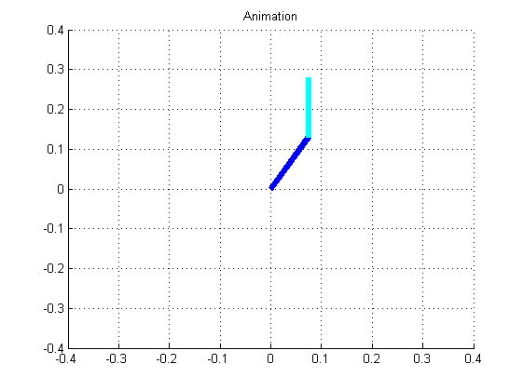
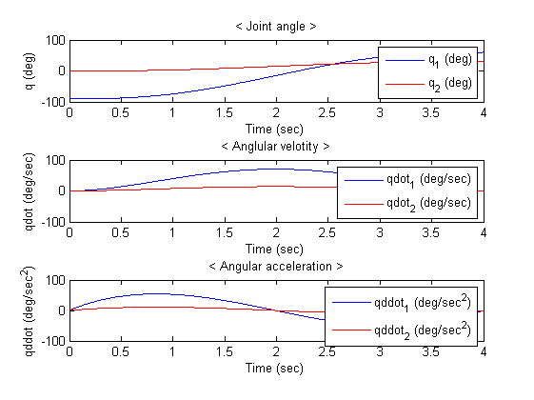
Published with MATLAB® R2013a

