clear
clear all
close all
home
global H;
global C;
global G;
global u;
global temp1;
global temp2;
global m1;
global m2;
global l1;
global l2;
global g;
% Robot Parameters
m1 = 0.5;
m2 = 0.5;
l1 = 0.15;
l2 = 0.15;
g = 9.806;
% Control frequency is defined as follows %
s_time = 0.002;
% Terminal time %
tf = 3;
% Initial Configurations should be defined in RADIAN %
q(1) = -pi/2;
q(2) = 0;
qdot(1) = 0;
qdot(2) = 0;
qddot(1) = 0;
qddot(2) = 0;
%Joint position save
q_save=zeros(2,tf/s_time+1);
%Joint velocity save
q_dot_save=zeros(2,tf/s_time+1);
% Iteration number %
n=1;
% Plot Setting %
figure(1)
title('Animation')
hold on
axis([-0.4 0.4 -0.4 0.4]);
grid
Ax1 = [0, l1];
Ay1 = [0, 0];
Ax2 = [l1, l1+l2];
Ay2 = [0, 0];
p1 = line(Ax1,Ay1,'EraseMode','xor','LineWidth',[5],'Color','b');
p2 = line(Ax2,Ay2,'EraseMode','xor','LineWidth',[5],'Color','c');
% Robot Implementation
for i = 0 : s_time : tf
% Control part to be designed %
u(1) = 0;
u(2) = 0;
u=[ u(1) ; u(2) ];
% Forward Dynamics Part for Motion Generation %
[t,y] = ode45('two_link_PDG',[0, s_time] , [q(1); q(2); qdot(1); qdot(2)] );
index = size(y);
q(1) = y(index(1), 1);
q(2) = y(index(1), 2);
qdot(1) = y(index(1), 3);
qdot(2) = y(index(1), 4);
%Save the results
q_save(1,n)=q(1);
q_dot_save(1,n)=qdot(1);
q_save(2,n)=q(2);
q_dot_save(2,n)=qdot(2);
torque_save(1,n) = u(1);
torque_save(2,n) = u(2);
% Forward Kinematics Part %
x1 = l1*cos(q(1));
Ax1 = [0, x1];
y1 = l1*sin(q(1));
Ay1 = [0, y1];
x2 = x1 + l2*cos(q(1)+q(2));
Ax2 = [x1, x2];
y2 = y1 + l2*sin(q(1)+q(2));
Ay2 = [y1, y2];
% Increase the Iteration Number
n=n+1;
% Draw now %
if rem(n,10) == 0
set(p1,'X', Ax1, 'Y',Ay1)
set(p2,'X', Ax2, 'Y',Ay2)
drawnow
end
end
t= 0 : s_time : tf;
figure(2)
title('Joint position Graph')
plot(t,q_save)
xlabel('Time(sec)')
ylabel('Joint angle(rad)')
legend('q1(rad)','q2(rad)')
figure(3)
title('Joint velocity Graph')
plot(t,q_dot_save)
xlabel('Time(sec)')
ylabel('Joint angular velocity(rad/sec)')
legend('q1 dot(rad/sec)','q2 dot(rad/sec)')
figure(4)
title('Torque Graph')
xlabel('Time(sec)')
ylabel('Joint Torques (Nm)')
plot(t,torque_save)
legend('tau 1(Nm)','tau 2(Nm)')
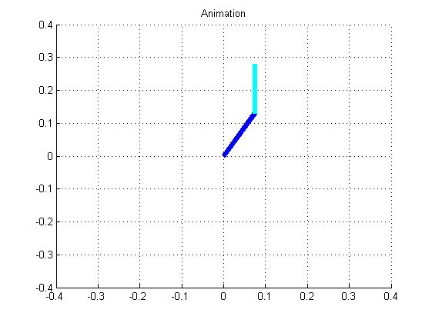
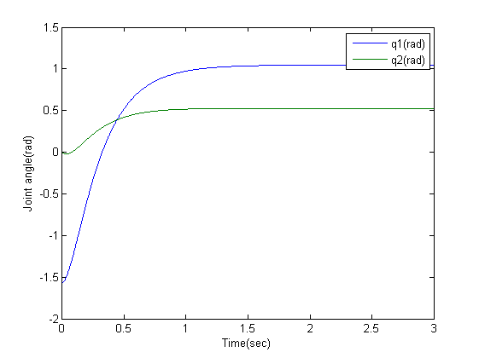
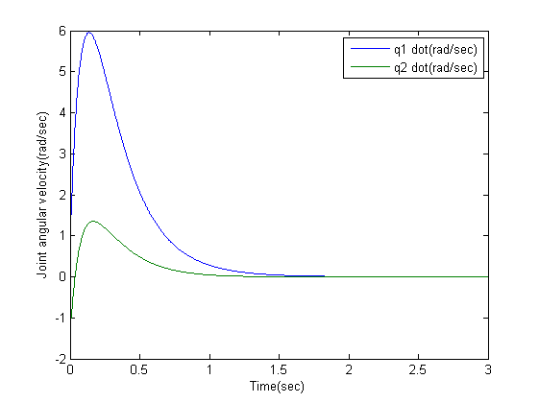
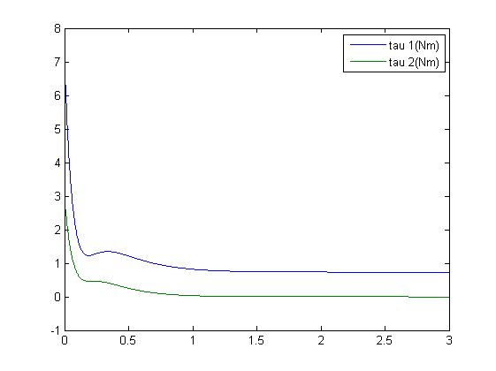
Published with MATLAB® R2013a

