1. **CPU Benchmark by Arithmetic operations:**
2. Airthe 1threads

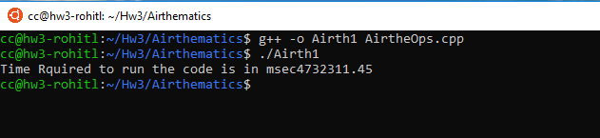

1. Airthe 2 threads

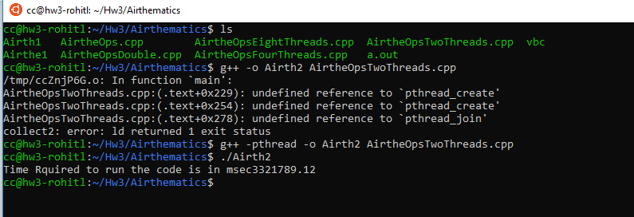

1. Airth2 4 Threads

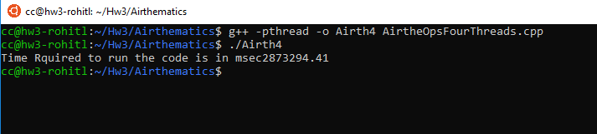

1. Airthe 8 Threads

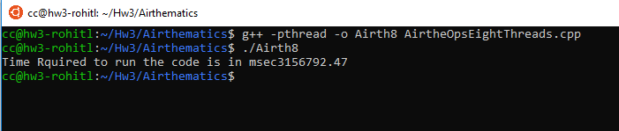

1. AirtheDouble

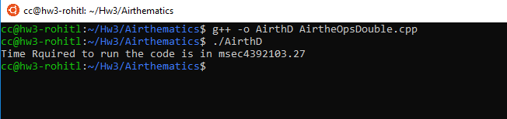

2.AirtheDouble2Threads

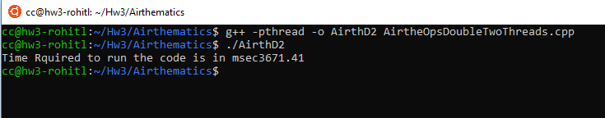

1. AirtheDouble4Threads

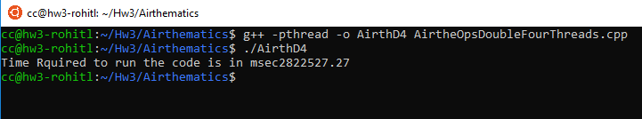

1. AirtheDouble8Threads
2. **Matrix-Bench Benchmark:**

Conditions for creating square matrix are:

* + 1. Its size should be <= 0.75 of RAM (RAM Provided is 8GB)
    2. Memory = 6 GB = 6 * 1024 = 6144MB = 6144000000 bytes
* **Single precision matrix size:**  
  N * N * size of float = Memory size/ no of matrices

N^2 * 4 = 6144000000/3

N^2 * 4 = 2048000000

N^2 = 512000000

N = 22627.41 = Aprox 22627

* **Double precision matrix size:**

N * N * size of double = Memory size/ no of matrices

N^2 * 8 = 6144000000/3

N^2 * 8 = 2048000000

N^2 = 2550000000

N = 15968.71 = Aprox 15968

**Screenshot showing code supports any N*N matrix:**

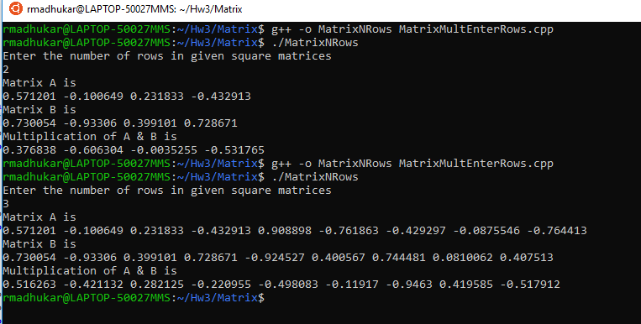

**Note:** Above example is implemented on local machine while all other codes are implemented on chameleon cloud.

**Theoretical Performance of CPU:**

CPU Performance = Speed in Ghz * No of CPU cores * Threads per core * Instructions per cycle

Single Thread = 2.4 * 4 * 1 * 2.4 * 1000000000 = 2.304 GigaOps

Two Thread = 2.4 * 4 * 2 * 2.4 * 1000000000 = 4.608 GigaOps

Four Thread = 2.4 * 4 * 4 * 2.4 * 1000000000 = 9.216 GigaOps

Eight Thread = 2.4 * 4 * 4 * 2.4 * 1000000000 = 9.216 GigaOps

**No Thread SP:**

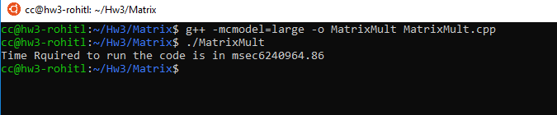

Time is 6240.9648 sec

Number of operations 22627*22627*22627 = 11584.59 * 10^9

Speed = (11584.59 * 10^9)/6240.964 = 1.8 GigaOps/sec

**Two Threads SP:**

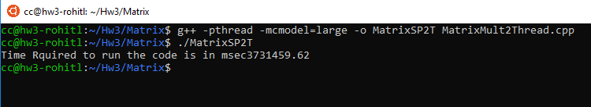

Time is 3731.4596 sec

Number of operations 22627*22627*22627 = 11584.59 * 10^9

Speed = (11584.59 * 10^9)/ 3731.4596 = 3.1 GigaOps/sec

**Four Threads SP:**

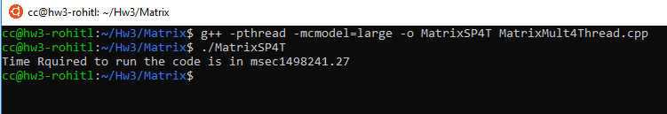

Time is 1498.24 sec

Number of operations 22627*22627*22627 = 11584.59 * 10^9

Speed = (11584.59 * 10^9)/ 1498.24 = 7.7 GigaOps/sec

**Eight Threads SP:**

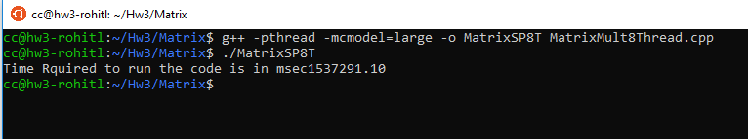

Time is 1537.29 sec

Number of operations 22627*22627*22627 = 11584.59 * 10^9

Speed = (11584.59 * 10^9)/ 1537.29 = 7.53 GigaOps/sec

**Similarly double calculations can be done**

1. **HPL BenchMark:**

Below are the screenshots for HPL benchmarking: