1. **RWS No Thread BlockSize 1KB,1MB,10MB**

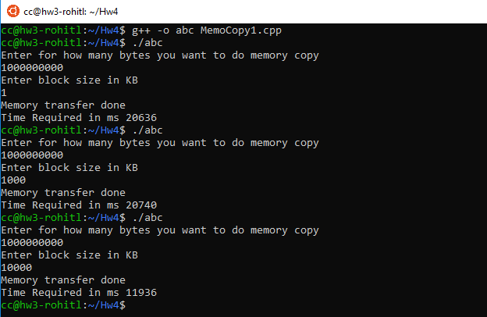

1. RWS 2 Thread BlockSize 1KB,1MB,10MB

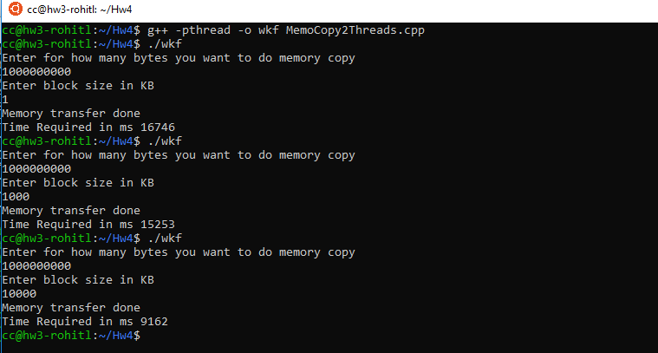

1. RWS 4 Thread BlockSize 1KB,1MB,10MB

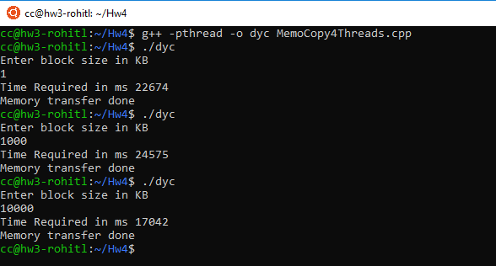

1. RWS 8 Thread BlockSize 1KB,1MB,10MB

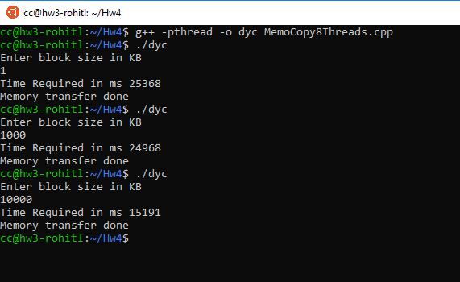

1. RWR No Thread BlockSize 1KB,1MB,10MB

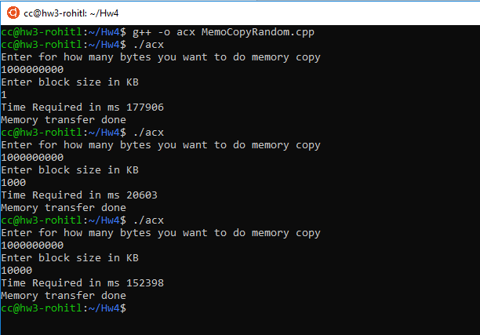

1. RWR 2 Thread BlockSize 1KB,1MB,10MB

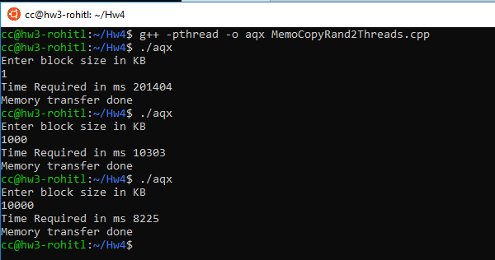

1. RWR 4 Thread BlockSize 1KB,1MB,10MB

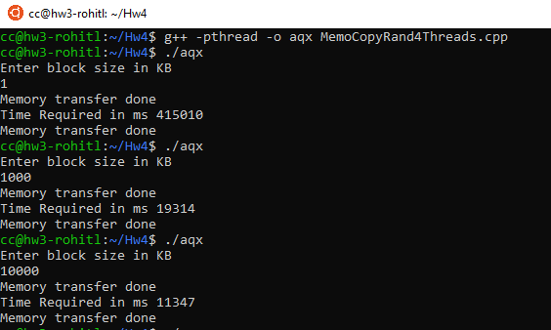

1. RWR 8 Thread BlockSize 1KB,1MB,10MB

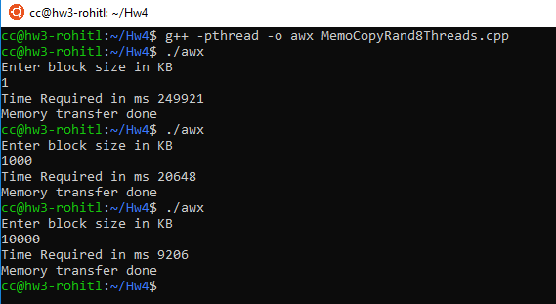

1. Latency RWS No Thread BlockSize 1Bytes

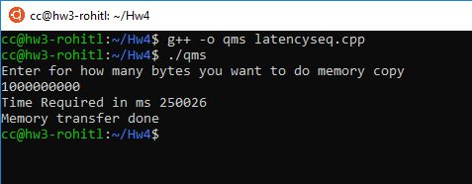

1. Latency RWS 2 Threads BlockSize 1Bytes

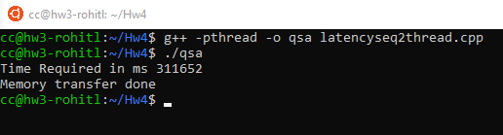

1. Latency RWS 4 Threads BlockSize 1Bytes

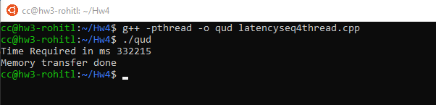

1. Latency RWS 8 Threads BlockSize 1Bytes

