Uncharted

### 

# Team Members

Raissa Largman: Development, Design

Kate Wendell: Manager, Design

Moustafa Asfour: Development, User Testing

Matt Taylor: Development, Documentation

# Value Proposition

Discover the travel destinations you never imagined.

# Problem and Solution Overview

Travelers and travel planners are inundated with information about locations and itineraries that is often irrelevant to their needs. We seek to simplify and improve travel planning by making new places that suit your needs easily discoverable. We will only share the important details, preventing information overload and keeping the location and activities relevant to your stated desires.

Contextual Inquiry Customers

Travel planning is an extremely large and diverse space, covering everything from family vacations to frequent business trips and long term backpacking. We decided to focus on student travel because we thought this demographic had some unique challenges and needs, namely making group decisions and operating under a budget. We recruited students who have traveled for extended periods of time and/or have organized a trip for a large group.

Our first interview was with John Spratley, a friend of a group members who was the initiator and planner for a Grand Canyon trip the friends made. We asked him to talk us through the experience of planning this trip for the group, and to show us the tools he used during the process. We asked him to reflect on his role and the group dynamic during planning, as well as the pain points they experienced along the way.

Next we met with Aileen Lerch who spent 5 months abroad last year and learned about her experience. After studying abroad in Madrid, Aileen decided to continue her exploration and spend the summer traveling as well. She showed us her google folder of travel plans and explained what tools she used to gather information, make and execute plans. We probed at this experience and asked why she choose the places she did, how satisfied she was with her choices, and how the planning experience could be better for her.

Finally we met with Shelly Xu who spent several weeks of the summer traveling in Southeast Asia. Shelly was mostly traveling by herself, but meeting friends at certain points along the way. She faced interesting challenges in arranging these logistics and figuring out how to cover a wide geographic area efficiently.

Contextual Inquiry Results

We learned a lot about the planning process involved before and during travel while talking to our users. We found that all three users followed a similar overall planning process which starts with choosing a destination, and then moves into a logistics phase, all the while discussing options with friends. There is room for significant improvement in many areas of the process.

The process starts with an initiator, who usually becomes the defacto trip leader, proposing a destination. Our interviewees had all served as the initiator in their respective groups. These destinations are usually chosen from friends’ recommendations and very limited online research. It is interesting to note that none of the users were very thrilled with the online tools available to discover destinations, reporting that they felt “touristy,” “not very relevant [to them],” and “wading through all the information is overwhelming”. Once a destination is chosen, it is proposed to the group. This might be one other travel companion as in Aileen’s case, or an email sent to an entire friend group looking to gauge interest, as in John’s case.

After they confirm interest with friends, the leader moves into a logistics phase that is focused on figuring out the most economical transportation to the destination and finding a good place to stay. Users use a variety of tools at this stage, including kayak and theflightdeal.com to find good airfare, and hostel world and trip advisor to find good accomodations. Shelly faced complications at this stage as the logistics are particularly complex when planning a multi-destination trip. She reflected that before the trip she didn’t “have a good idea of southeast asian geography” and “instead of traveling in a nice semi-circle I zig zagged [across the region]” which inevitably cost her money and time spent in airports (see figure 1 below). It seems there are a variety of somewhat satisfactory tools for booking these logistics, but for longer trips it gets more complicated and there could be more guidance in how to design your journey for maximum ease.

The leader narrows the logistical options at this stage, by selecting one or two options for transportation and accommodations, and proposes the results to the group. This is done through email or collaborative documents like google docs. Users expresses some dissatisfaction with this process of proposing options and getting feedback, particularly John who was planning for a large group of people. He noted that the process can be messy and the information got lost in a growing email thread in which friends debated costs and other priorities (see figure two). Aileen was using a google doc to make plans with a friend she intended to meet in England, the google doc had a list of dates and links to the hostel for that night, which she admitted was also “not ideal” (see figure 3).

Finally, users make day to day plans while traveling. It seems that users have a general idea of the activities they want to do, as these are the activities that drew them to that destination in the first place. In practice, users make specific plans after arriving at the hotel or hostel on what they want to do they next few days, using google searches and maps provided by the hostels. Aileen and Shelly separately referenced these maps as as a great resource, as they seemed relevant to their interests and simplified their options.

After reviewing our notes from these three interviews, we realized that there are three main types of tasks involved in travel planning that are highly interconnected. The first is research, including research on potential destinations and itineraries. The second is logistics, which involves identifying the best transportation and accommodations that satisfy the group needs. The last is communication which is the discussion from the group around the proposed destinations and logistics that come out of the previous two areas. Users are most effective in their planning when these three types of tasks happen in context of the other, for example the group members are more effective at communicating their preferences when the options for transportation and hotels are clear, and they are excited about the destination and believe it is worthwhile.

# Task Analysis

## Questions

Who is going to use the system?

People in the age range of 18-25 who travel mostly for fun and enjoyment. These people are looking for new experiences, have expendable income and may be traveling as individuals or groups.

What tasks do they perform?

These people use a pre-existing idea or destination, or search for one when beginning to plan travel. They communicate with their friends to gauge interest, search for accommodations and transportation, and then propose these pre-selected accommodation and transportation options. User engagement in these tasks depends on group size and trip length. Many are willing to depend on friends they trust to carry out these actions for them. They then provide feedback on proposed options.

What tasks are desired?

Desired tasks fall into three categories: communication, research, and logistics. Communication is often done through email threads, skype or facebook, but this becomes unwieldy. People want a way to communicate that is more integrated with the outcomes of the travel planning. Research is the most important category and although there is a lot of information out there, much of it was deemed inaccessible and inapplicable. People want relevant information that is easy to follow, as often found on hostel maps. Sample trips and budgets, especially from friends, are also often desired. Logistics is where most people spend the majority of time planning, but there are already many tools for this. However, people want a better way to know what the best and cheapest way to get into a region is and how to route between a region and city to optimize cost. Additionally, logistics information often ends up scattered and disorganized, so centralizing this information is desired.

How are the tasks learned?

The tasks are learned through repeated action or adaptation of pre-existing skills, such as using Google search. Another way tasks are learned is through seeing other people do them or tell you about them, such as showing somebody where to search for flights.

Where are the tasks performed

Most choosing of destination and logistics planning is at home. Often the planning of day logistics and activities can be in a hostel or hotel room. These tasks are mostly done on a computer.

What is the relationship between customer & data?

There is already a lot of data out there, but it is not tailored, and people often are too inundated with the data, not knowing where to start. The customer wants less data, but more specific to them. Many people have planned similar trips before, but that information is always discarded when the trip is done rather than shared.

What other tools does the customer have?

Communication: Google docs, Facebook, email, Skype

Research: Friends’ recommendations, TripAdvisor, Google search

Logistics: HostelWorld, Kayak, FlightDeal, Car Rental companies, Sticky Notes

How do users communicate with each other?

There is often a trip leader that pre-selects options and proposes them to the group via email, Facebook, or Google drive for feedback. Between friends there is often word of mouth communication for suggestions and information. Communication through Skype is also common to decide on when to meet up and what to plan when abroad.

How often are the tasks performed?

Logistics planning is cyclic and people will go through many rounds of trying to find the best options and looking up reviews and then checking again. These tasks are performed often during travel planning. However, the list of tasks for travel planning is only performed once or twice a year as a whole.

What are the time constraints on the tasks?

Activity planning can often be done during the night before for a few hours. This type of planning is more flexible, except high demand activities. Logistics planning generally has a long time frame, perhaps of several months, but people feel pressured to find the best deals as soon as possible, fearing price increases over time.

What happens when things go wrong?

When things go wrong you might be stuck in a foreign country without a way to go home. Perhaps the results are not that dire, and you’re just engaging in an activity that is not as fun and exciting as you hoped. However, with travel there is often an expectation that things will go wrong, so a traveler needs to be flexible and adaptable to change. Furthermore, you need to be able to find other options on short notice.

## Tasks to be Performed

Our application with perform the following tasks:

1. Discover new places - Make it easy to find places that were previously unknown to the user as travel destinations and fit the user’s needs.
   1. Complex task
   2. Status Quo: word of mouth from friends, searching top travel lists on Google or StumbleUpon
   3. Rationale: There is too much information about where one should travel and it is not fitting to the user’s needs. This information can often be “touristy” and cliche, or just overwhelming.
2. Create a wishlist of travel destinations - Allowing the user to gather found travel destinations into one central location
   1. Complex task
   2. Status Quo: sticky notes, notes on a phone
   3. Rationale: Users can often forget about places they had previously discovered and are then forced to choose from among the most common destinations. Furthermore, when proposing trips to friends this would centralize the options to be proposed, simplifying feedback.
3. Filtering destinations based on preferences - A user can pick and choose destinations and sets of destinations based on various preferences, such as type of location, climate, types of activities, etc.
   1. Moderate task
   2. Status Quo: Tripadvisor or Google
   3. Rationale: This would allow information about locations and activities to be more targeted toward user preferences, avoiding the deluge of irrelevant information that is currently present.
4. Viewing trip details - This would give a user a bit more information on a location to allow them to decide if the destination is truly relevant to their needs.
   1. Moderate task
   2. Status Quo: Tripadvisor or Google
   3. Rationale: Once a user has expressed initial interest in a location they want more information on the types of activities they might find, or the price for a trip. However, the information would still be minimal as to avoid overcomplicating the destination selection process.
5. Giving feedback about locations - Deciding whether or not you are interested in a location and indicating this with a yes/no or rating of the location
   1. Simple task
   2. Status Quo: Positive feedback results in being added to the list in whatever way you keep it. Negative feedback does not. Tripadvisor ratings.
   3. Rationale: This makes it easier to synthesize the wishlist and keep track of the locations you want to visit as well as provide feedback on things that are irrelevant to you or you do not like, which is limited in the status quo.

Application Ideas

**Customizable Itineraries**: Our first idea was based on the ability to share and distribute itineraries. It allowed for people to use pre-made itineraries and customize them to their liking. We imagined that initially these itineraries would be “stock” itineraries from travel companies, but users could customize these and the share their own as well, so future users can see what their friends did. For example, we imagine that students who study abroad in Madrid go on several short weekend trips, and students the following quarter probably have similar interests and would love to have access to their previous students’ plans so they may recreate the trips and/or tweak them to their preferences.

**Group Planning:** Our second idea centered around facilitating effective communication between friends planning travel together. Using what we know about group dynamics, and the common structure of having one or two group initiators and planners, we imagined building a dashboard where they can propose options for destinations and logistics and get feedback in context from their group. The planner could receive positive or negative feedback from everyone involved in the trip through the use of up votes or down votes. It would also give the option for the organizer to delegate individual aspects of the planning stage to other members of the group making the entire process less stressful.

**Uncharted:** Our last idea focused on the initial planning stage, or the “discovery” stage where users select a destination. It allows for our users to find new destinations, and save them in wishlists. It is a fun, easy way to browse ideas for a spring break trip or destinations in a summer of travel. We imagined that these ideas would be presented with beautiful photos and have a barebones itinerary associated with them. For example a picture of yosemite might propose “spend a weekend camping in Yosemite valley in the Curry village campground. Hike Half Dome and float down the Merced River”.

|  |  |  |  |
| --- | --- | --- | --- |
|  | Significance | Feasibility | Interest |
| Customizable Itineraries | High | Medium | High |
| Group Planning | High | Low | High |
| Unchartered | Medium | High | High |

**Our choice:** We choose to focus on our uncharted idea. We believe its high feasibility means that we can develop a beta app quickly in order to get user reviews and input. Based on the feedback we can then add more features or change features that did not test well. We think this application idea has an easy minimum viable product that has the potential to grow into a great travel planning tool. Additionally, we thought it was a very significant product as users currently do not use any tools in the ideation phase of their travel planning. From an interest point of view, we also feel that the ability to flip through beautiful pictures ranging from artwork to scenic backdrops is highly appealing to our target audience.

Sketches of Uncharted Design Ideas

Design Idea: Focus on Filters

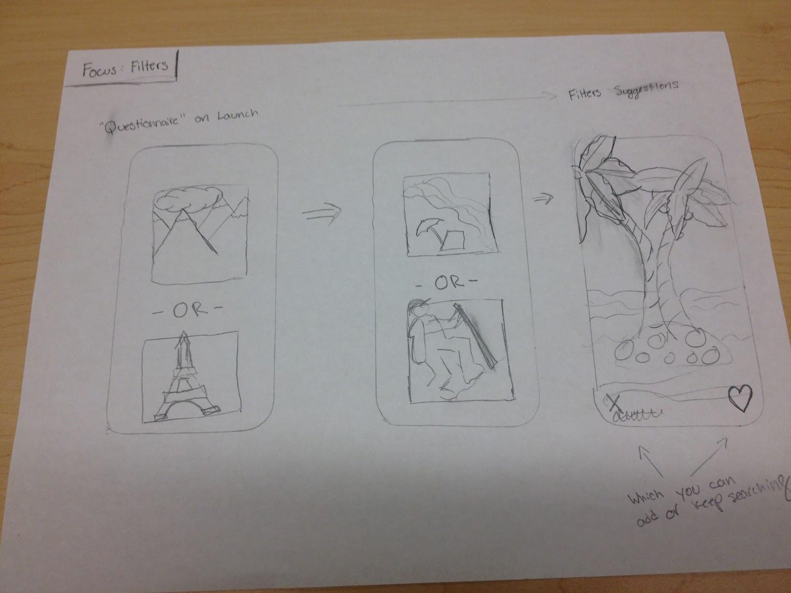

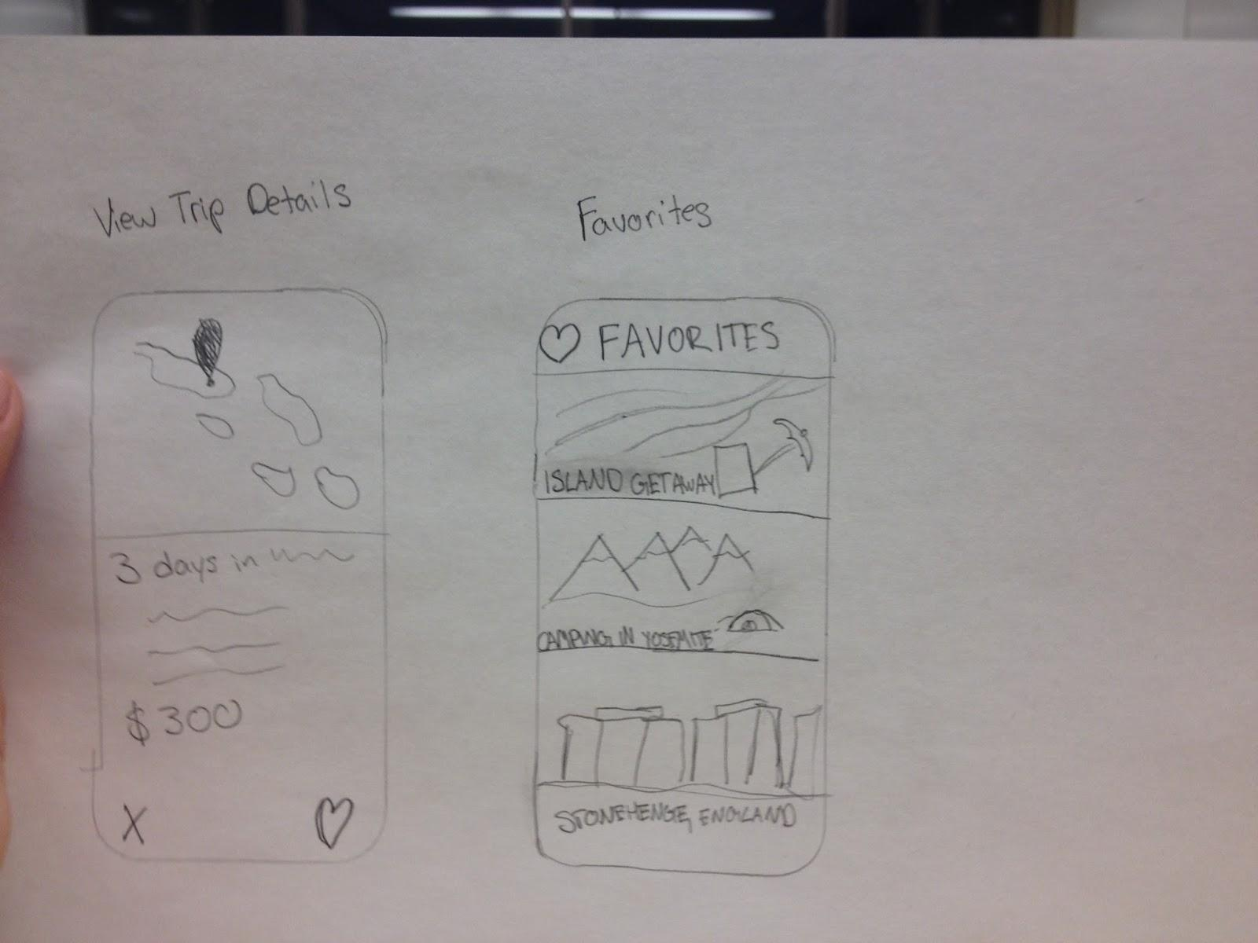

Design Idea: Focus Itineraries

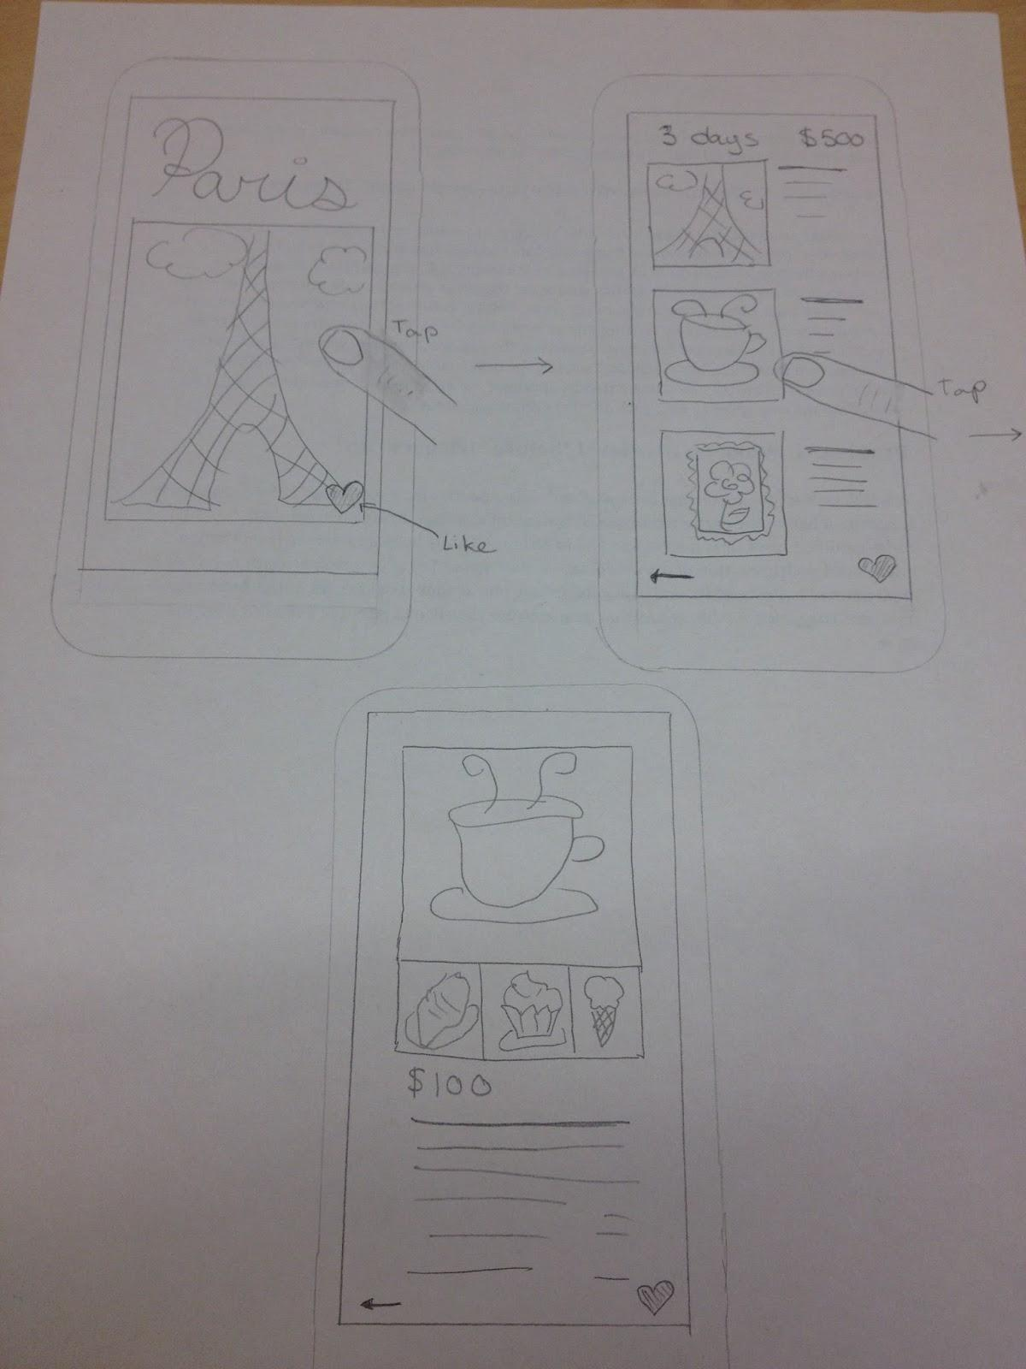

Design Idea: build wishlists

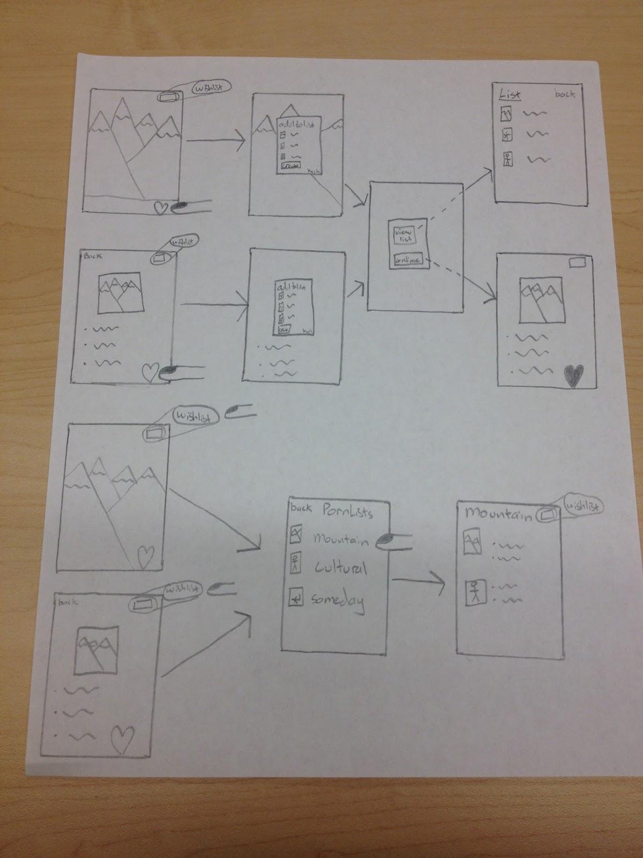

Design Idea: search the globe

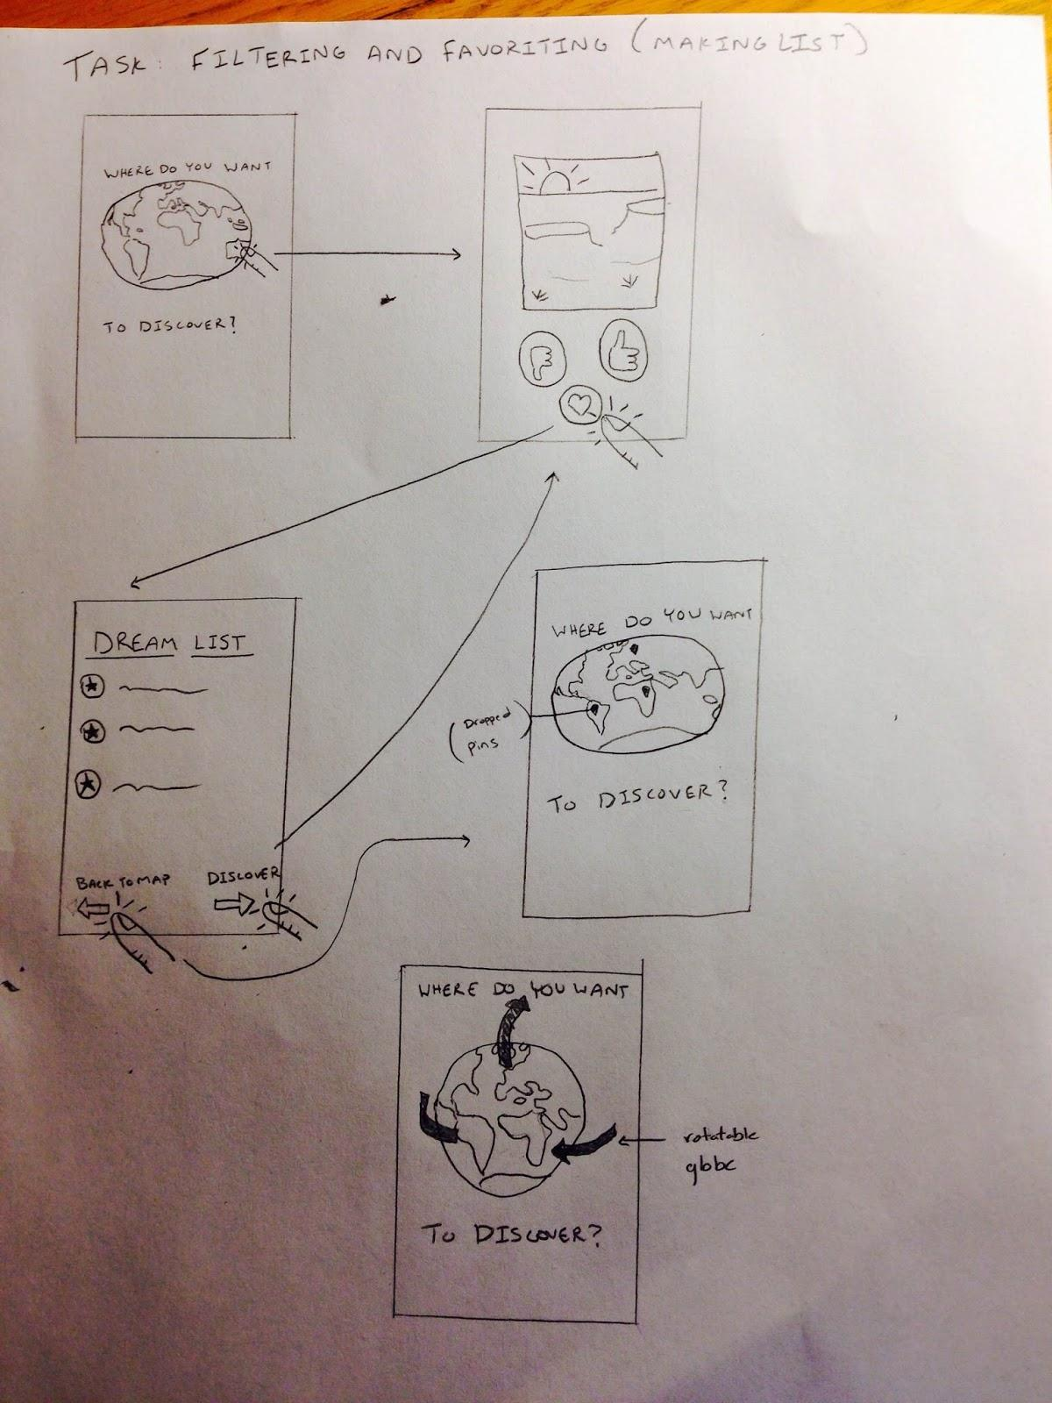

Contextual Inquiry Photos

**Figure One: Shelly searches for flights on “Theflgihtdeal.com”**

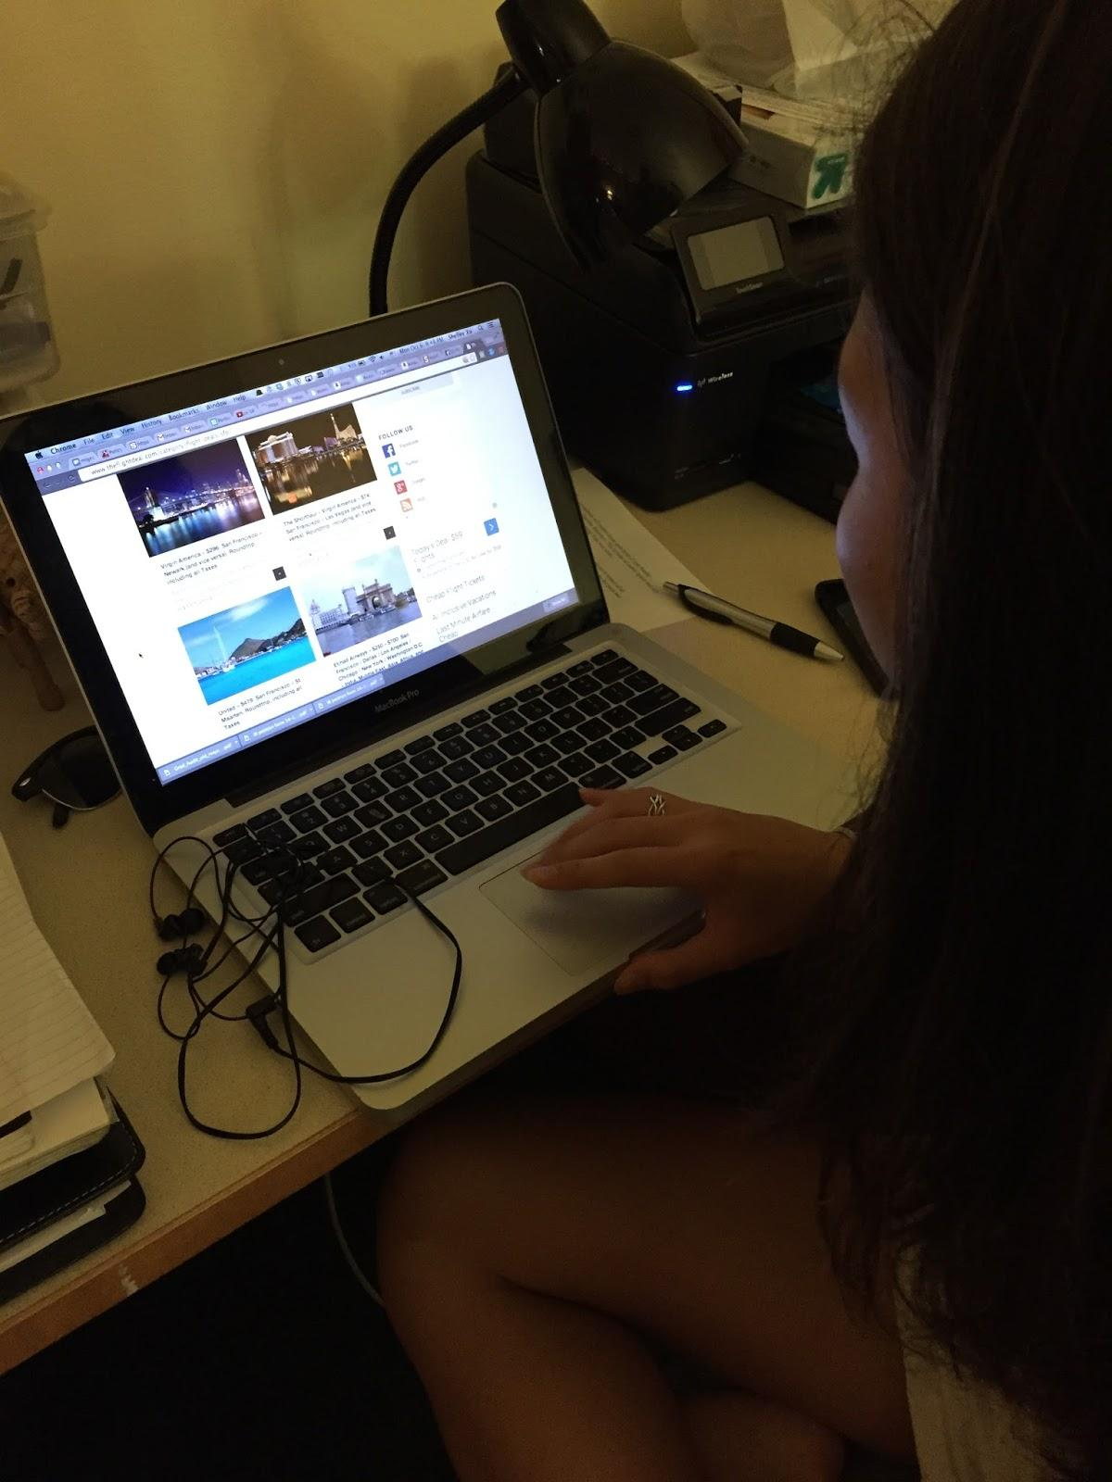

**Figure Two: John proposed logistics to the group**

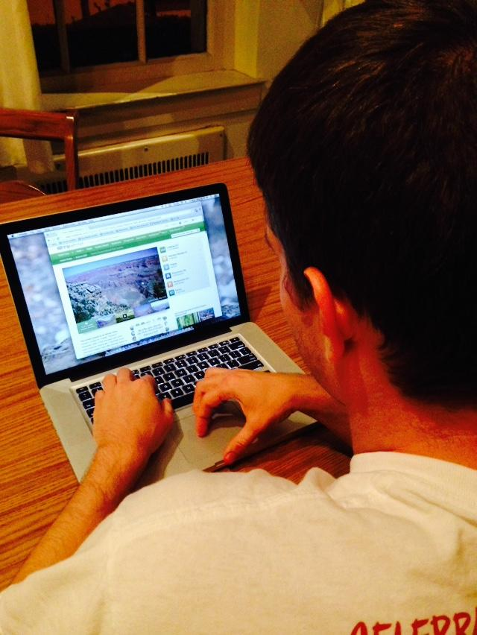

**Figure Three: An Excerpt from Aileen’s Google Doc**

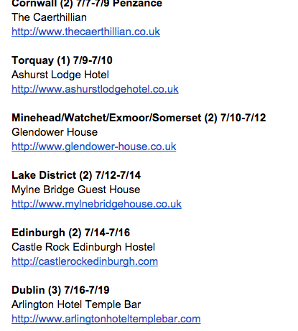

**Figure Four: Aileens show us her doc**

