CS 147 Autumn 2014: Assignment 13 Instructor: James Landay

1. Problem

The Uncharted application aims to solve the problem of travel planning for “20­something travelers” by aiming to make travel planning more simple, fun, and inspiring on a mobile device ­ Uncharted caters to 20­somethings who want to discover awesome budget friendly destinations.

***2. Violations Found***

**Browsing Destinations Task**

**1. [ H2­3. User control and freedom ] [ H2­4. Consistency and standards ][Severity**

4] ­ No Swipe Right [A,C] According to the writeup and prototype interface, on the main interface, users can swipe left to move on to the next destination. However, there is no ability to swipe right to go back to the last destination. It would be easy to swipe past a location that you might want to explore further or save, but in the current implementation, you would not be able to “go back” as you might expect the swiping to work on many platforms.

It would be simple to implement at swipe right to go back functionality that would be consistent with platform standards and also give more user control and freedom to go back to a previous place instead of just moving forward through locations

**2. [ H2­1. Visibility of system status ] [ H2­4. Consistency and standards ] [Severity**

3] ­ Back Button When Viewing Individual Destinations [A] When viewing individual destination details, the indented design according to the report is to:

*“Tap anywhere on the details page to go back to destinations [swiping interface].“*

This can be confusing to the user for a few reasons. First, because the screen has multiple “card” like details and is scroll­able, it is not consistent with standards for a page of that type to be clickable as a whole to provide an action. Some components like the heart on the details page actually perform other actions. This makes it unclear, especially for a new user, as to why they return to the swiping interface when another area of the screen is clicked. Furthermore, this confusion from divergence from

1

CS 147 Autumn 2014: Assignment 13 Instructor: James Landay

platform standards can make it confusing for the user to understand where they are in the system and become disoriented about the system status.

A simple solution would be following platform standards of having a “back” button in the top left corner of the detail screen to go back to the swipe interface instead of tapping anywhere that does not already have an action on the detail interface.

A back button, would also have the added benefit of providing a better idea of the current system’s navigation status to the user.

**3. [ H2­4. Consistency and standards ][Severity 2] ­ Map Details [A]**

The map on the current details page can be navigated by holding down the map and moving one’s finger, but it does not open into a more detailed map or map application when clicked and neither does clicking on the pin reveal additional information.

Both of these aforementioned features are usually common place when an map with a pin is included in a mobile application. Initially, lacking those features felt like the application violated those standards.

Adding the ability to tap the map to open it in detail (or an application like Google Maps) and either choosing a pin other than the standard Google “information pin” or adding details upon clicking could remedy these problems.

**4. [ H2­7. Flexibility and efficiency of use ] [ H2­4. Consistency and standards]**

[Severity 2] ­ Destination Detail Cards [A] The location details (activities, places to eat, etc.) have badges and clear delineations between them using white space that suggest a “card­like” appearance common in many platforms such as Google’s Android system. Normally on these platforms those “cards” are clickable and interactive.

However, in Uncharted, the “card­like” details are static and non interactive. It might be easy for a user to think that clicking them should bring up more details in the application or lead to information linked to the relevant detail and frustrated when they cannot. The details, such as how to book an activity or restaurant, would also be an important feature of flexibility for power users who want to dive into the app.

Making this addition of being able to dive into details for the “card­like” information in the location details would be both a more straightforward and convention following means of the application design and also provide a crucial feature for power users.

**5. [ H2­8. Aesthetic and minimalist design ][Severity 1] ­ Where to Stay and What to**

**Budget Inconsistency [A]**

2

CS 147 Autumn 2014: Assignment 13 Instructor: James Landay

On the location details page, the “Where to Stay” and “What to Budget” sections stand out as being different than all the other sections (e.g. activities, restaurants, etc.) that all have a “card­like” and picture focused appearance. These two former sections are providing the same “type” of information as the latter sections so it would make more sense and be more aesthetically pleasing to have them in the same card­like format.

A solution to this could be adding a picture of the recommended hostel and using a graphic related to money for the images of proposed cards for the “Where to Stay” and “What to Budget” details respectively.

**6. [H2­1 Visibility of System Status][Severity 2] ­ Home Screen Confusion [B]**

On the home screen I honestly don’t know what I’m supposed to do. It’s beautifully minimalistic, but I’m not sure what actions I can take and what those actions would do. Some small helper text at the bottom of the screen could help first time users understand the function and purpose of the screen better.

**Organizing Favorite Locations Task**

**7. [ H2­5. Error prevention ] [ H2­4. Consistency and standards ][Severity 1] ­ “Make**

Default” in WishLists [A] In the WishLists section, the ability to “Make Default” a list appears to be in a small link in the bottom right corner. Having a link so small and in white text that appears to be a static label by platform standards could make it easy for a user to make an error and choose a list as default accidentally.

To fix this, I would suggest delineating the “Make Default” more obviously visually in the style of a button so it is visually clear and not accidentally tapped or inadvertently looked over. Doing this could also visually separate it from the “Default List” label which it currently, confusingly looks the same as.

**8. [ H2­1. Visibility of system status ] [ H2­6. Recognition rather than recall]**

[Severity 2] ­ Distinguishing Lists and places [A] It is hard to distinguish lists from individual places in a list since both use a single image as a background for white text. This makes it confusing when navigating through lists. For instance, I could name a list “Thailand,” and then would need to remember if I was looking at “Thailand” the list or a single item list called “Thailand.” This could add extra mental overhead and make the system status ambiguous for the user.

A solution could be visually distinguishing lists from places by using a signal background picture for the place and a collage of multiple background pictures of the places in a list for the list picture. This is similar to how SoundCloud currently

3

CS 147 Autumn 2014: Assignment 13 Instructor: James Landay

distinguishes between song collections and individual songs on their site even when both have the same image background with text display format.

**9. [ H2­8. Aesthetic and minimalist design ][Severity 1] ­ Adding a New List [A]**

A pop up dialogue is currently used to add a new list. This disambiguates the user from the existing lists to some extent which causes them to lose the context of the other lists they already have when creating a list. Dialogues are also a bit clunky on mobile. It is also not immediately clear exactly what the “+” button does ­ though it may be inferred by platform conventions.

A simpler way to allow list creation could be to have a place holder “list” that has a place holder grey background instead of an image and has the words “create a new list” that always exists at either the top or bottom to the list of lists. Clicking it could allow you to edit the name inline.

This would allow the space to make a larger, more clear, list creation button, while still keeping the minimalist design aesthetic.

**10. [ H2­1. Visibility of system status ][Severity 1] ­ Visibility of Navigation Headers**

[A] This is a very minor UI violation. The text of the headers such as “Wishlists” and “Destinations” on the top navigation bar are small and sometimes do not standout as much as would be helpful to convey the current application location/state to the user.

It would be helpful to bold them and slightly increase their size to make sure that the application status is more visible.

**11. [ H2­4. Consistency and standards ][Severity 1] ­ Capitalization of Sections [A]**

In the left hand menu drawer ‘WISHLISTS” are all uppercase whereas when in the wishlists section, the title is “Wishlists”.

This titles should be consistent across the platform (changed to all lower, all uppercase, or all proper case) in order to provide the best consistency for the user.

**12. [ H2­3. User control and freedom ][Severity 2] ­ Post­Creation List Manipulation**

[A] There does not yet seem to be a design to allow for list deletion, removal of list items, or renaming of lists. This in addition to being able to share or export lists (so that trips can be planned in detail by “power users”) would be important features for more rigorous users. While this is a suggestion on feature set. I think at least the first three pieces are quite crucial for any moderate user.

4

CS 147 Autumn 2014: Assignment 13 Instructor: James Landay

**13. [H2­6. Recognition rather than recall ] [ H2­3. User control and freedom**

][Severity 2] ­ Long Hold to Add to Non­Default List [A] The tap on the heart to save the destination to the default list requires the user to remember the default list ­ therefore requiring recall. Furthermore, the long hold to add to a custom list ­ while a great power user feature ­ could be quite hard to discover and therefore make it hard for users to add to different lists.

A possible solution would be having text representing the default list included on the swipe screen (perhaps vertically to keep the aesthetic appeal and avoid clutter).

Another solution might be to have only a hold down option (no clicking). When holding down on the heart, an options menu for the lists available could pop up and the default would be under your finger. This would keep a simple interface and allow for more a more transparent way to add to lists other than the default.

**14. [H2­4 Consistency & Standards][Severity 2] ­ What does heart do? ­ Clicking the**

Heart is Inconsistent [B] I’m not immediately sure what clicking the heart does. I understand that it adds the location to the favorites list, but a user new to the interface might wonder at the exact function of the heart icon due to the wide variety of uses of heart icons across different web sites. For example, on Tumblr a heart functions more similar to a Facebook “like” than as a way of creating a structured favorites list. I think a quick notification text saying “added to favorites” would help clarify this.

**15. [H2­4 Consistency & Standards][Severity 2] ­ Clicking on Favorites list**

destination. [B] Tapping on one of the destination icons from the “favorites list” screen takes you to the destinations screen of that destination rather than to the details page of that destination. I think that’s an unnecessary extra step because that view doesn’t really provide any additional info aside from a bigger picture. Also, the user is trained to tap on a destination to get to the details page, so having a different result for tapping on a destination on the favorite’s list feels inconsistent and confusing. I recommend having a tap on the favorites screen go directly to the details screen rather than to the destinations screen.

**16. [H2­3. User control and freedom][Severity 2] ­ Ability to Undo the Heart List [C]**

I long­tapped the heart to add it to a wishlist, but then changed my mind ­ I couldn’t cancel this action and return back easily. Fix would be adding a little ‘x’ that just returns me to the previous screen.

5

CS 147 Autumn 2014: Assignment 13 Instructor: James Landay

**Filtering Destinations Task**

**17. [ H2­6. Recognition rather than recall ] [ H2­4. Consistency and standards ] [**

H2­5. Error prevention ][Severity 1] ­ Go Button Shape on Filters [A] Once a user is in the filters section, the Go! button is self explanatory. However, a small adjustment that could make it more clear that this button moves the user forward in the exploration process is to use the platform convention of an asymmetrical arrow button to the right ( | ___|>) that could make it clearer for the user to recognize that the button is the next step after.

Furthermore, the Go! button can still be clicked even if there is no continent selected. It would make sense to hide the go button first, then only reveal it when at least on continent has been selected. This would help with error prevention, it would also bring attention to the go button. When the button appears, it will attract the user’s attention and help draw them to the next action in the application.

**18. [H2­2 Match Between System & Real World][Severity 1] ­ Globe icon/”filter”**

mismatch ­ Globe Icon Inconsistency [B] I don’t feel the “globe” icon (when clicking on the menu from the home screen) matches up with the word “filter.” This mismatch in text/image could confuse users. Perhaps changing the icon to a magnifying glass and the text to “search” would make that function more clear.

**19. [H2­2 Match Between System & Real World] [Severity 1] ­ What Does “Go” Do? ­**

Ambiguity of the Go! Button [B] The “Go!” button on the filters screen is a bit ambiguous to me. A user might wonder the exact function of that button. For example, will it actually take me down an action funnel that results in me going to the location? Or does it simply allow me to browse locations in that continent region?

**20. [H2­7 Flexibility & Efficiency of Use][Severity 3] ­ Lack of More Specific Filtering**

­ Advanced Users Search [B] The filters screen allows you to see destinations from a particular continent, but an advanced user looking to see a more specific region’s destination or even to look up a particular destination might be frustrated with the filter interface. I recommend adding a “search” option or the ability to look at sub­regions to this screen. Perhaps a long tap will allow the user to “zoom” in on a continent.

**21. [H2­1. Visibility of system status][Severity 3] ­ Context of the Filter View [C]**

After enabling a filter, it wasn’t clear to me that I was using a filtered view. It might help to have some ‘Filter: Australia’ type indicator so that I don’t get confused by seeing less places and then having to remember that I put a filter on.

6

CS 147 Autumn 2014: Assignment 13 Instructor: James Landay

**General and Miscellaneous Tasks**

**21. [ H2­10. Help and documentation ] [Severity 2] ­ Application Audience and**

Context [A] The report and readme explains how the application is tailored to “20­somethings” on a budget. However, it is not clear anywhere in the application what kind of audience the interface is tailored for. While this might not strictly be a usability issue, it could easily lead to non­target users downloading the application and being confused or frustrated by the very narrow content.

A simple solution might be a loading screen or splash page when the application starts up with a logo and tagline such as “The 20­Something Digital Travel Book” that alludes to the target audience.

Alternatively, an “about” section even hidden in the left drawer with information about the application and purpose could be helpful. This About section could also provide suggested use cases for the application to give users context.

**23. [ H2­8. Aesthetic and minimalist design ] [Severity 1] ­ Size of Menu Drawer**

Icons [A] The menu drawer icons are overwhelmingly large compared to other components in the application. Does this make sense hierarchically according to their importance in the application? Traditionally, the menu drawer has a feature set secondary to the main application so it would make more sense to have smaller icons to reflect this message to the user.

**24. [H2­4. Consistency and standards] [Severity 2] ­ Visual Consistency of Buttons**

[A,C] When I had first clicked on filters and then wanted to get back to the main destinations, I wasn’t sure how to do it, because the options in the side menu have one option without an icon, and two options with large icons ­ thus I didn’t realize that ‘destinations’ was clickable initially. To fix this, make the buttons for destinations, wishlists, and filters the same visual style (i.e. 1/3 of the height and with a large icon).

**25. [H2­8 Aesthetic & Minimalist Design] [Severity 2] ­ Duplicate Menu Icon ­ Extra**

Menu Icons [B] Upon clicking the menu button on the home screen, there are two menu icons present because a duplicate menu icon appears with the menu frame. Having two menu icons wastes screen space and could confuse the user in terms of knowing where to click. I recommend removing one of the two menu icons during the time when the menu frame is open.

7

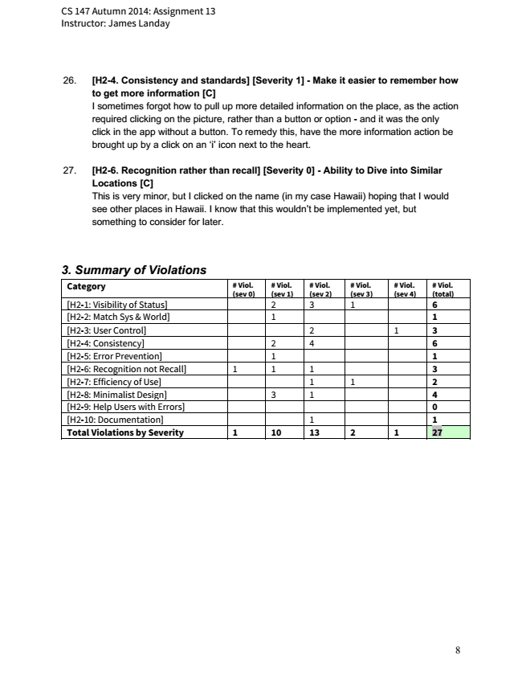

CS 147 Autumn 2014: Assignment 13 Instructor: James Landay

**26. [H2­4. Consistency and standards] [Severity 1] ­ Make it easier to remember how**

to get more information [C] I sometimes forgot how to pull up more detailed information on the place, as the action required clicking on the picture, rather than a button or option ­ and it was the only click in the app without a button. To remedy this, have the more information action be brought up by a click on an ‘i’ icon next to the heart.

**27. [H2­6. Recognition rather than recall] [Severity 0] ­ Ability to Dive into Similar**

Locations [C] This is very minor, but I clicked on the name (in my case Hawaii) hoping that I would see other places in Hawaii. I know that this wouldn’t be implemented yet, but something to consider for later.

***3. Summary of Violations***

**Category # Viol. (sev 0)**

**# Viol. (sev 1)**

**# Viol. (sev 2)**

**# Viol. (sev 3)**

**# Viol. (sev 4)**

# Viol. (total) [H2-1: Visibility of Status] 2 3 1 6 [H2-2: Match Sys & World] 1 1 [H2-3: User Control] 2 1 3 [H2-4: Consistency] 2 4 6 [H2-5: Error Prevention] 1 1 [H2-6: Recognition not Recall] 1 1 1 3 [H2-7: Efficiency of Use] 1 1 2 [H2-8: Minimalist Design] 3 1 4 [H2-9: Help Users with Errors] 0 [H2-10: Documentation] 1 1 Total Violations by Severity 1 10 13 2 1 27

8

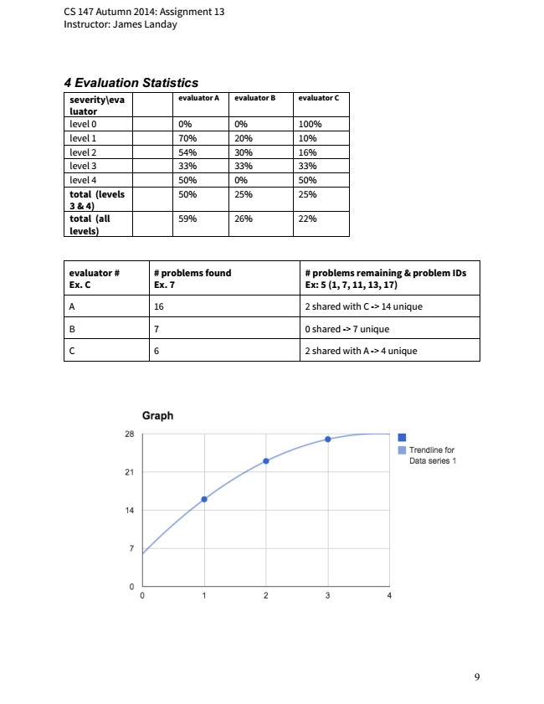

CS 147 Autumn 2014: Assignment 13 Instructor: James Landay

***4 Evaluation Statistics***

**severity\eva luator**

**evaluator A evaluator B evaluator C**

level 0 0% 0% 100% level 1 70% 20% 10% level 2 54% 30% 16% level 3 33% 33% 33% level 4 50% 0% 50% total (levels 3 & 4)

50% 25% 25%

**total (all levels)**

59% 26% 22%

**evaluator # Ex. C**

**# problems found Ex. 7**

**# problems remaining & problem IDs Ex: 5 (1, 7, 11, 13, 17)**

A 16 2 shared with C -> 14 unique

B 7 0 shared -> 7 unique

C 6 2 shared with A -> 4 unique

9

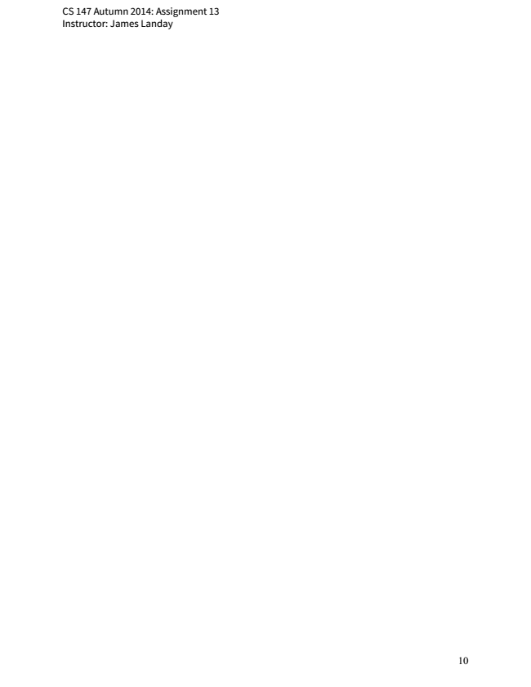

CS 147 Autumn 2014: Assignment 13 Instructor: James Landay

10