Uncharted: Medium-Fidelity Prototype

Full filepath to prototype on Moustafa’s AFS space:

/afs/[ir](https://afs.stanford.edu/?path=%2Fafs%2Fir)/[users](https://afs.stanford.edu/?path=%2Fafs%2Fir%2Fusers)/[m](https://afs.stanford.edu/?path=%2Fafs%2Fir%2Fusers%2Fm)/[a](https://afs.stanford.edu/?path=%2Fafs%2Fir%2Fusers%2Fm%2Fa)/[masfour](https://afs.stanford.edu/?path=%2Fafs%2Fir%2Fusers%2Fm%2Fa%2Fmasfour)/[CS_147](https://afs.stanford.edu/?path=%2Fafs%2Fir%2Fusers%2Fm%2Fa%2Fmasfour%2FCS_147)/med_fi_prototype/uncharted_med_fi_prototype.zip

Public Link to Prototype: <https://raissa.proto.io/share/?id=9c3526da-fd16-44d5-a338-307dde09a806&v=2>

# Team

Raissa Largman: Development, Design

Kate Wendell: Manager, Design

Moustafa Asfour: Development, User Testing

Matt Taylor: Development, Documentation

# Problem and Solution Overview

Through our contextual inquiry, we found that student travelers are frustrated with current travel planning tools. They reported TripAdvisor and other guides feel irrelevant to their interests and too touristy. Additionally, wading through all of the information is exhausting and making decisions about destinations, where to stay, and what to do is still difficult. We’re building a tool to make initial travel planning inspiring, fun and easy. Our application uses sublime imagery of travel destinations to inspire students to explore new places. Each destination includes trip details with activities for 20-something travelers, the top hostel to stay at in the area, and an estimated daily budget. We’re designing our app to provide relevant and targeted suggestions to jumpstart full logistics planning, but not overwhelming users with options and decisions to make. In order to help users find even more relevant destinations, we’re creating filters to narrow results. Finally, our wishlist feature helps users save and organize the destinations they love.

# Tasks

The first, simple task, is to browse destinations. We hope that a user thoroughly enjoys this this task, is awed by the possibilities and can quickly find the basic information that helps him or her imagine a trip there. We imagine a user discovers a new destination, views images of the major attractions and things to do, and is presented with a map pinned with the location to get a sense of the geographical context. Additionally, the user can find a daily budget and a hostel recommendation.

Secondly, a medium complexity task, users can save and organize their favorite destinations. Users can quickly favorite destinations to make them easily retrievable later. Users may also create customized lists for organizing their saved destinations, whether it is collecting a couple possible options for spring break, or stringing together destinations for a longer journey.

Experienced users may use our destination filter, a complex task. Users can narrow the destinations suggested by geographical location. This helps users looking for more specific and feasible recommendations if they are constrained by time and/or cost. For example, users with only a week to travel might not want to leave the region they live in, or be looking for destinations they don’t have to fly to. This task has been simplified from previous iterations that allowed users to filter destinations by other categories as well.

# Revised Interface Design

Our biggest change in response to our low-fi user tests is simplifying the filters. Our testers all wanted to filter destinations geographically, but were open to seeing a variety of adventures and destinations within those areas. Some users wanted to filter by budget to find more feasible destinations. In response, we agreed that the entire application would focus on budget travel for 20-somethings. This means that all activities and accommodation recommendations will be low cost and of interest to younger travelers. The only explicit filtering our users need then, is geographical location. So we changed our design from 3 separate pages of possible filters (geographical, setting and activity) to a single page of geographical filtering. Additionally, we originally imagined that users would select regions on a world map, but we found this to be more ambiguous to users about how specific an area they could select--entire continents v. country or region. Our revised geo-filter screen uses silhouettes of each continent instead.

***Browse Destinations:*** *Starting from the initial screen, swipe left to view the next destination, or tap the picture to view the trip details. Scroll through trip details to view suggested activities, accommodations and budget. Tap anywhere on the details page to go back to destinations.*

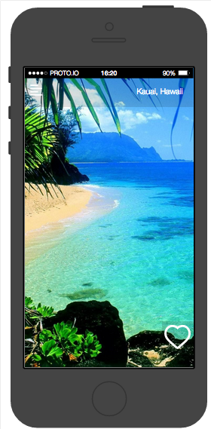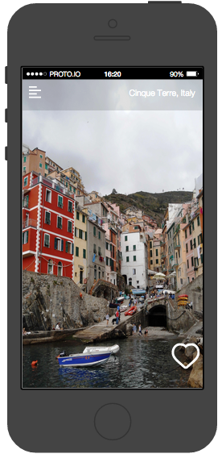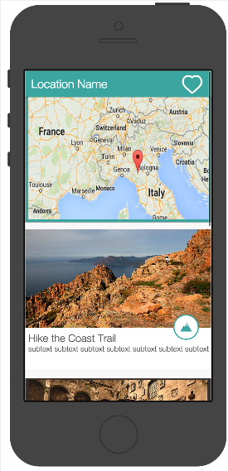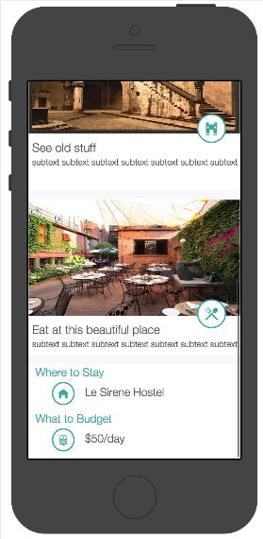

***Save and organize your favorite destinations****: Tap the heart to add a destination to the default Wishlist “Favorites”. Long tap the heart to select a custom list. See your wishlists by going to menu and tapping the wishlist icon. Tap the plus icon to create a new list. View the destinations in your lists by clicking it on the wishlists page.*

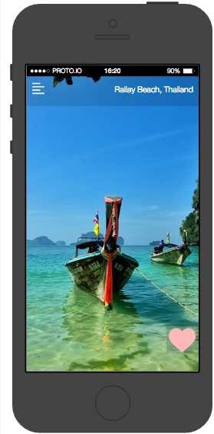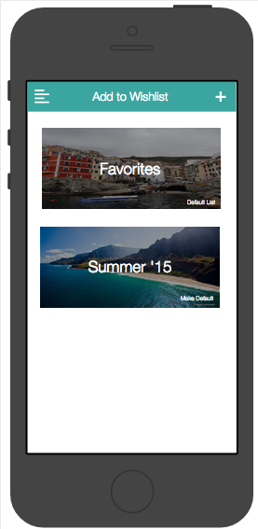

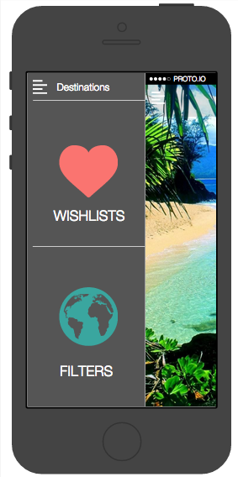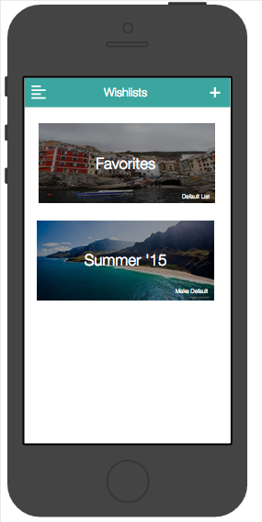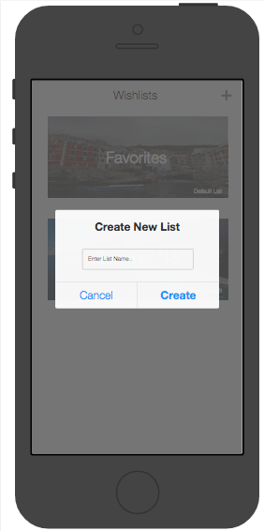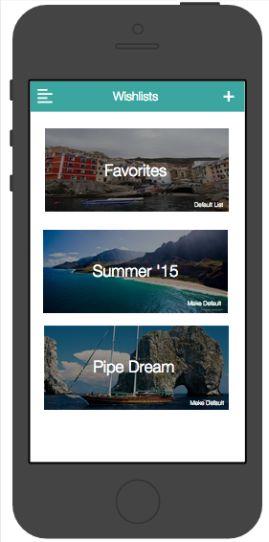

***Filter Destinations****: Go to menu, click the filters icon. Select one or multiple continents, then tap the go button to see destinations in those locations.*

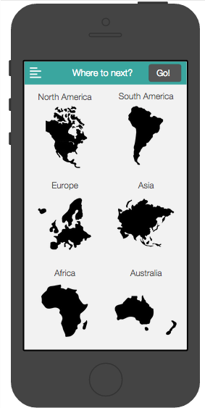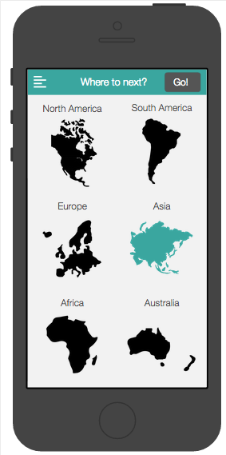

# Prototype Overview

We used Proto.io to create our medium fidelity prototype. We choose this program because it allowed us to create and link our screens in the same place, as opposed to designing the screens in a separate application and then loading them into another program to be linked. This made revising and tweaking the designs much faster and easier. Proto.io has helped us get a better sense of the overall flow of our product and how a user may engage in any of the three tasks from any screen. Designing for real mobile screen dimensions has also helped us focus on the most important items on each screen, and narrow our features based on this.

The biggest drawback to this program is that it can’t react to a user the way we were able to fake with our low-fi paper prototype. For example, there is no way to tag our screens with filter locations so that the relevant places will display if a geo-filter is selected. Instead we are forced to hard-code a sequence of destinations that your will see in every search. Similarly, it was too complicated to save a destination the user liked and add it to a wishlist, instead we pre-populates the lists with sample destinations. While the major interactions and features are represented in this prototype, it is frustrating that the real functionality isn’t there.

# Prototype Screenshots

All screens are included in the Revised UI Section above.

# Read Me

Heres a copy of our read me included with the prototype:

Uncharted Medium-Fidelity Prototype Readme  
Full path to prototype on Moustafa’s AFS: /afs/ir/users/m/a/masfour/CS_147/med_fi_prototype  
  
The tool the prototype runs with:  
The medium-fidelity prototype is built in proto.io, a web-based prototyping tool.  
  
**Operating instructions:**To operate the prototype, you can click to simulate a tap in a touch interface, long click to simulate a long tap and drag left to simulate swiping left. The following is how you would accomplish our three tasks in our complete prototype without current limitations:  
  
Browse destinations: Swipe left to view additional destinations, tap the destination view to view trip details.  
  
Filtering by location: Tap on the menu button on the top left and select the "filters" icon. From here, tap the continents you want to filter by and tap "go" to show filtered destinations.  
  
Save and organize destinations: Tap on the heart icon to add the destination to the default wish list. To create custom wish lists, navigate to the wish lists view from the menu button in the top left by tapping on the "wish lists" icon. Tap the "plus" icon and enter the name of the new wish list. To add the destination to a custom wish list, long tap the heart icon on the destination page, and add the destination to a custom wish list.  
  
**Any limitations in the current implementation:**-There are only 6 destinations included in the prototype

-Each destination has the same trip details page

-Filters do not currently do anything, selecting continents and clicking go will always take you to the same destination in the loop of 6.  
-Currently, a tap on the wish list heart simply fills in the heart, rather than adding the destination to the default wish list.

-A long tap on the heart opens the favorites page and only allows you to tap a list to simulate adding the destination to that list, although the destination is not in fact added to that chosen list. This action, however, does correctly return you to the original destination that you just added to your wish lists.  
-Navigating to the wish lists page allows you to view a wish list, but the only currently viewable list is the “Summer ’15” list, which is prepopulated with hard coded destinations.  
-From the wish lists page (when accessed via the menu), we simulate creating a new list by allowing the user to tap the "plus" icon in the top right. Clicking on the plus icon opens a window that allows the user to input the name of the new list, but regardless of what the user enters, the list that is ultimately added is called "Pipe Dream."