|  |  |
| --- | --- |
|  |  |
|  |  |

Anti-Lock Braking System

## Name: Lakshmi Ramesh.

## Unique ID: 2005439

## Abhinav Monda, 2005576



## Name and Unique ID:

## Abhinav Mondal, 2005576



## Name and Unique ID:

## Abhinav Mondal, 2005576



## Name and Unique ID:

## Abhinav Mondal, 2005576



## Name: Lakshmi Ramesh.

## Unique ID: 2005439

## Abhinav Monda, 2005576



## Name and Unique ID:

## Abhinav Mondal, 2005576



## Name and Unique ID:

## Abhinav Mondal, 2005576



## Name and Unique ID:

## Abhinav Mondal, 2005576



## Name: Lakshmi Ramesh.

## Unique ID: 2005439

## Abhinav Monda, 2005576



## Name and Unique ID:

## Abhinav Mondal, 2005576



## Name and Unique ID:

## Abhinav Mondal, 2005576



## Name and Unique ID:

## Abhinav Mondal, 2005576



## Name: Lakshmi Ramesh.

## Unique ID: 2005439

## Abhinav Monda, 2005576



## Name and Unique ID:

## Abhinav Mondal, 2005576



## Name and Unique ID:

## Abhinav Mondal, 2005576



## Name and Unique ID:

## Abhinav Mondal, 2005576



## Name: Lakshmi Ramesh.

## Unique ID: 2005439

## Abhinav Monda, 2005576



## Name and Unique ID:

## Abhinav Mondal, 2005576



## Name and Unique ID:

## Abhinav Mondal, 2005576



## Name and Unique ID:

## Abhinav Mondal, 2005576



## Name: Lakshmi Ramesh.

## Unique ID: 2005439

## Abhinav Monda, 2005576



## Name and Unique ID:

## Abhinav Mondal, 2005576



## Name and Unique ID:

## Abhinav Mondal, 2005576



## Name and Unique ID:

## Abhinav Mondal, 2005576



## Name: Lakshmi Ramesh.

## Unique ID: 2005439

## Abhinav Monda, 2005576



## Name and Unique ID:

## Abhinav Mondal, 2005576



## Name and Unique ID:

## Abhinav Mondal, 2005576



## Name and Unique ID:

## Abhinav Mondal, 2005576



## Name: Lakshmi Ramesh.

## Unique ID: 2005439

## Abhinav Monda, 2005576



## Name and Unique ID:

## Abhinav Mondal, 2005576



## Name and Unique ID:

## Abhinav Mondal, 2005576



## Name and Unique ID:

## Abhinav Mondal, 2005576



Contents

[Name: Lakshmi Ramesh. 1](file:///C:\Users\Lakshmi\Desktop\prob3_Report.docx#_Toc59207304)

[Unique ID: 2005439 1](file:///C:\Users\Lakshmi\Desktop\prob3_Report.docx#_Toc59207305)

[Introduction 3](#_Toc59207340)

[Working 3](#_Toc59207341)

[System design 3](#_Toc59207342)

[Modelling 4](#_Toc59207343)

[Simulink Model 5](#_Toc59207344)

[Results: 6](#_Toc59207345)

[• Data inspector: 6](#_Toc59207346)

[• MATLAB function: 6](#_Toc59207347)

[• Solver settings: 7](#_Toc59207348)

[• Call Back Functions: 8](#_Toc59207349)

[References 8](#_Toc59207350)

## Introduction

An anti-lock braking system (ABS) is a safety anti-skid braking system used on aircraft and on land vehicles, such as cars, motorcycles, trucks, and buses. ABS operate by preventing the wheels from locking up during braking, thereby maintaining tractive contact with the road surface and allowing the driver to maintain more control over the vehicle. ABS operate at a much faster rate and more effectively than most drivers could manage.

Although ABS generally offer improved vehicle control and decreases stopping distances on dry and some slippery surfaces, on loose gravel or snow-covered surfaces ABS may significantly increase braking distance, while still improving steering control. Since ABS was introduced in production vehicles, such systems have become increasingly sophisticated and effective.

## Working

ABS is part of an overall stability system, commonly known as electronic stability control, which monitors wheels under heavy braking. Each wheel has a sensor attached to it. If the intelligent sensors detect that a wheel is about to lock up and stop moving, the system will release the brake. The release is only for a moment.

ABS then continuously and repeatedly apply optimum braking pressure to each wheel, meaning the system will brake just enough to not lock the wheels. When ABS is active you may feel pulsation through the brake pedal as you’re pressing it. The anti-lock system helps the driver remain in control of the vehicle rather than bringing the car to a stop. It reduces the risk of skidding even when undertaking excessive evasive manoeuvres. Therefore, it’s important to remember that the car’s braking distance may increase.

## System design

The wheel rotates with an initial angular speed that corresponds to the vehicle speed before the brakes are applied. Separate integrators are used to compute wheel angular speed and vehicle speed. Two speeds are used to calculate slip, which is determined by Equation 1. Vehicle speed is introduced and expressed as angular velocity.

$$\omega_v = \frac{V}{R} \mbox{ (equals the wheel angular speed if there is no slip)}$$

**Equation 1**

$$ \omega_v = \frac{V_v}{R_r}$$

$$slip=1-\frac{\omega_w}{\omega_v}$$

$$\omega_v = \mbox{ vehicle speed divided by wheel radius}$$

$$ V_v = \mbox{ vehicle linear velocity}$$

$$ R_r = \mbox{ wheel radius}$$

$$ \omega_w = \mbox{ wheel angular velocity}$$

From these expressions, it can be observed that slip is zero when wheel speed and vehicle speed are equal, and slip equals one when the wheel is locked. A desirable slip value is 0.2, which means that the number of wheel revolutions equals 0.8 times the number of revolutions under non-braking conditions with the same vehicle velocity. This maximizes the adhesion between the tire and road and minimizes the stopping distance with the available friction.

## Modelling

The friction coefficient between the tire and the road surface, mu, is an empirical function of slip, known as the mu-slip curve. We created mu-slip curves by passing MATLAB variables into the block diagram using a Simulink lookup table. The model multiplies the friction coefficient, mu, by the weight on the wheel, W, to yield the frictional force, Ff, acting on the circumference of the tire. Ff is divided by the vehicle mass to produce the vehicle deceleration, which the model integrates to obtain vehicle velocity.

In this model, we used an ideal anti-lock braking controller, that uses 'bang-bang' control based upon the error between actual slip and desired slip. We set the desired slip to the value of slip at which the mu-slip curve reaches a peak value, this being the optimum value for minimum braking distance (see note below.).

## Simulink Model

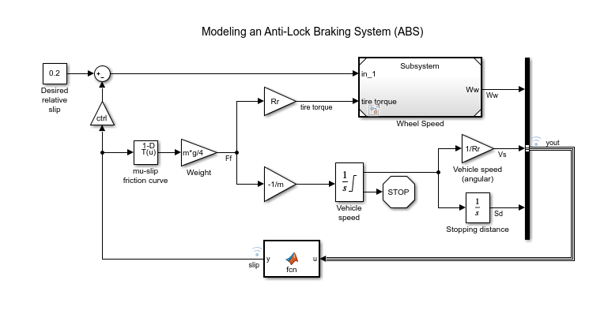

Fig1: ABS Model

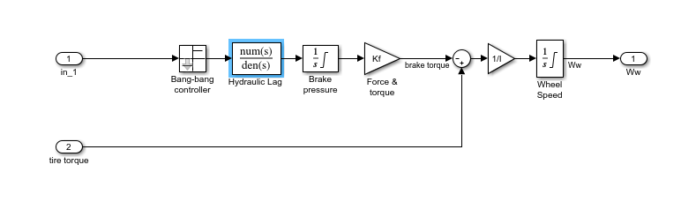

Fig2: Wheel\_Speed (Subsystem Model)

## Results:

### Data inspector:

Figure 3: Data inspector used to observe the signals.

The various logged signals were observed on the data inspector to get a deeper insight abot the behavior of various signals

### MATLAB function:

A MATLAB function was implemented which takes u as the input signal and produces y as the output.

Its main function is to calculate the relative slip of the vehicle with respect to the application of brake.

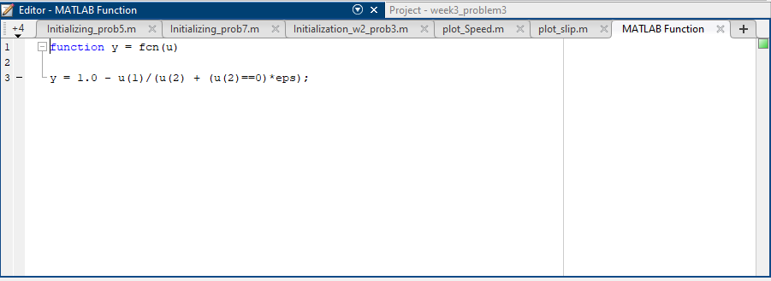

Figure 4: MATLAB Function.

### Solver settings:

The solver used for this model is ode45 and the step size is variable.

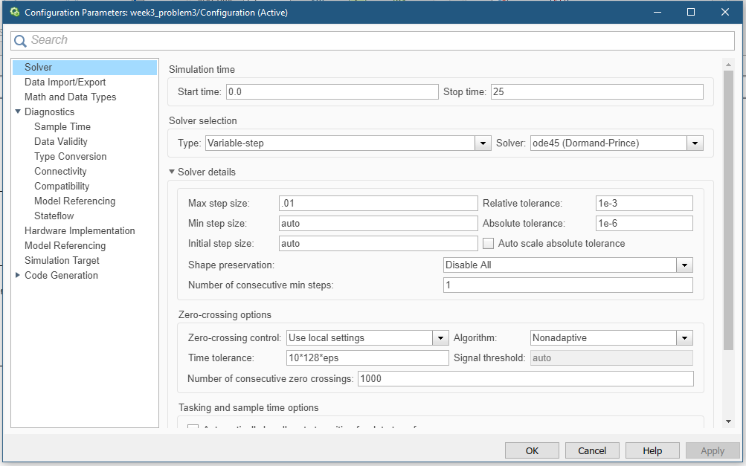The main reason of using variable step size is it varies the step during the simulation to adapt to the changing environment in order to avoid unnecessary steps and thereby increase the accuracy. Computing the step size for each state adds to the computational overhead but can also reduce the total number of steps which in-turn helps in maintaining the simulation accuracy within a specified range for models with rapidly changing or piecewise continuous states.

Figure 5: Solver Settings.

### Call Back Functions:

Figure 6: CallBack Functions

Callbacks are commands you can define that execute in response to a specific modelling action, such as opening a model or stopping a simulation. Callbacks define MATLAB expressions that execute when the block diagram or a block is acted upon in a way.

The various callbacks implemented in this model include:

1. PreLoadFcn (Pre-load Function)
2. StopFcn (Stop Function)
3. CloseFcn (Close Function).

## 

## References

[1] <https://en.wikipedia.org/wiki/Anti-lock_braking_system>

[2] <https://www.confused.com/on-the-road/gadgets-tech/what-is-abs>

[3] <https://in.mathworks.com/help/simulink/automotive-applications.html>