# **JConsole – Team 5CHAR**

# Overview

JConsole is a graphical monitoring tool that tracks Java processes on remote and local machines. It provides information such as performance, memory, threads, classes, VM summary and Mbeans.

JConsle is part of the Java Development Kit so it’s already installed and can be started in 2 ways.

1. By going to This PC - C drive - Program Files - Java - JDK- Bin - jconsole and double click on it or simply by going to command line and running jconsole as shown in Fig 1.

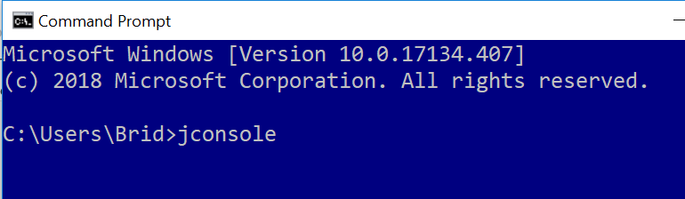

Figure 1 Jconsole command line start

1. Jconsole will open as shown in Fig 2.

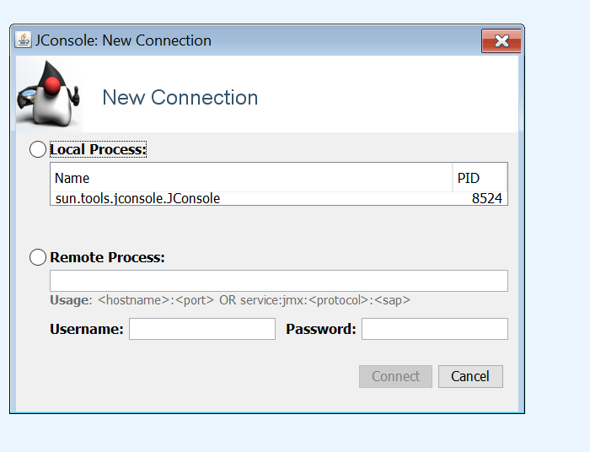

Figure 2 Jconsole interface

1. The Local and Remote processes will be shown. For the purposes of this example only Local will be shown. Click on the Java process (here there is only one) and click **Connect.**

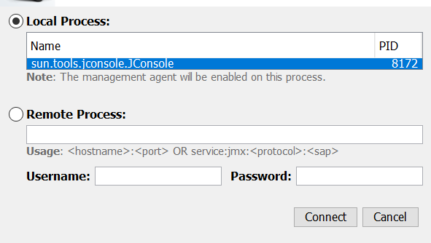

Figure 3 Local & Remote Processes

1. An Insecure connection warning will be shown. Because this is a Local process, insecure connection can be accepted as shown in Fig 4.

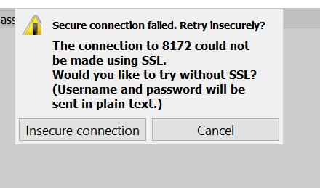

Figure 4 Insecure connection warning

1. The JConsole overview will now been shown for the selected Java Local process. Please note the tabs shown in Fig 5. These will be explored individually for 5CHAR’s documentation.

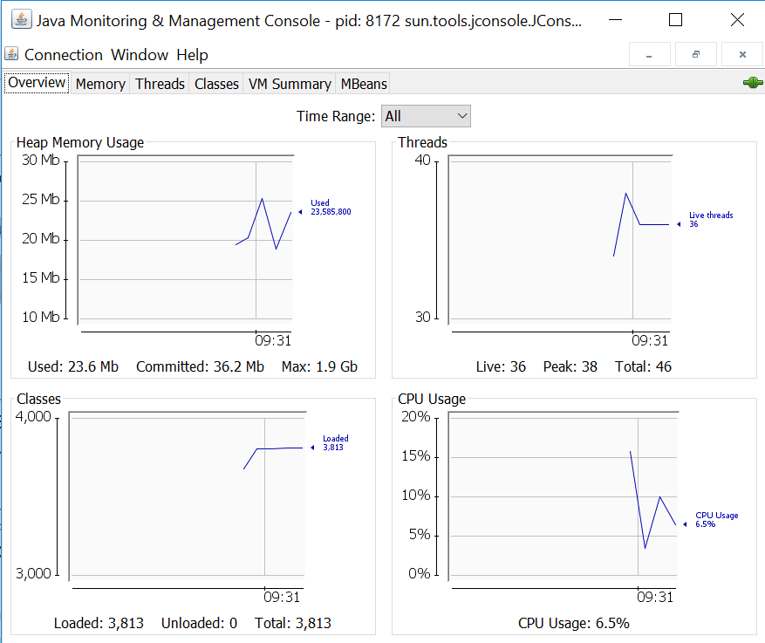

Figure 5 Overview of JConsole in action