Build Server configuration

@ Mary Walsh McGinty

# Op System: Ubuntu 16.04

# Build_Jenkins_server IP address : (Gold) 172.28.25.136 , (Sandbox) 172.28.25.123 Java

### Download Site:

<http://www.oracle.com/technetwork/java/javase/downloads/index.html>

Version to download: jdk-11.02_linux-x64_bin.tar.gz

x64 for 64 bit systems and tar.gz for Ubuntu Op Systems

### Steps:

Cd Downloads directory

/Downloads$ sudo tar -xzvf jdk-11.02_linux-x64_bin.tar.gz -C /usr/lib/jvm

X = extract, v= verbose, z= gunzip/unzipping f= extract in filesystem tar= to create and extract tape archives

-C specifies a different directory other than the current working directory

1. Add the file path for java to the /etc/environment file as JAVA_HOME

cd /etc

sudo nano environment

#Edit the file with this line.

JAVA_HOME=”usr/lib/jvm/java-8-oracle”

1. Next show Ubuntu a link to java

sudo update-alternatives --install "/usr/lib/jvm" "java" "/usr/lib/jvm/java-8-oracle/bin/java" 1

Set this version of java as the default

sudo update-alternatives --set java /usr/lib/jvm/java-8-oracle/bin/java

1. To check that java is install

java -version This should return:

java version "1.8.0_201"

Java(TM) SE Runtime Environment (build 1.8.0_201-b09)

Java HotSpot(TM) 64-Bit Server VM (build 25.201-b09, mixed mode)

@Liam Whorriskey

# Jenkins

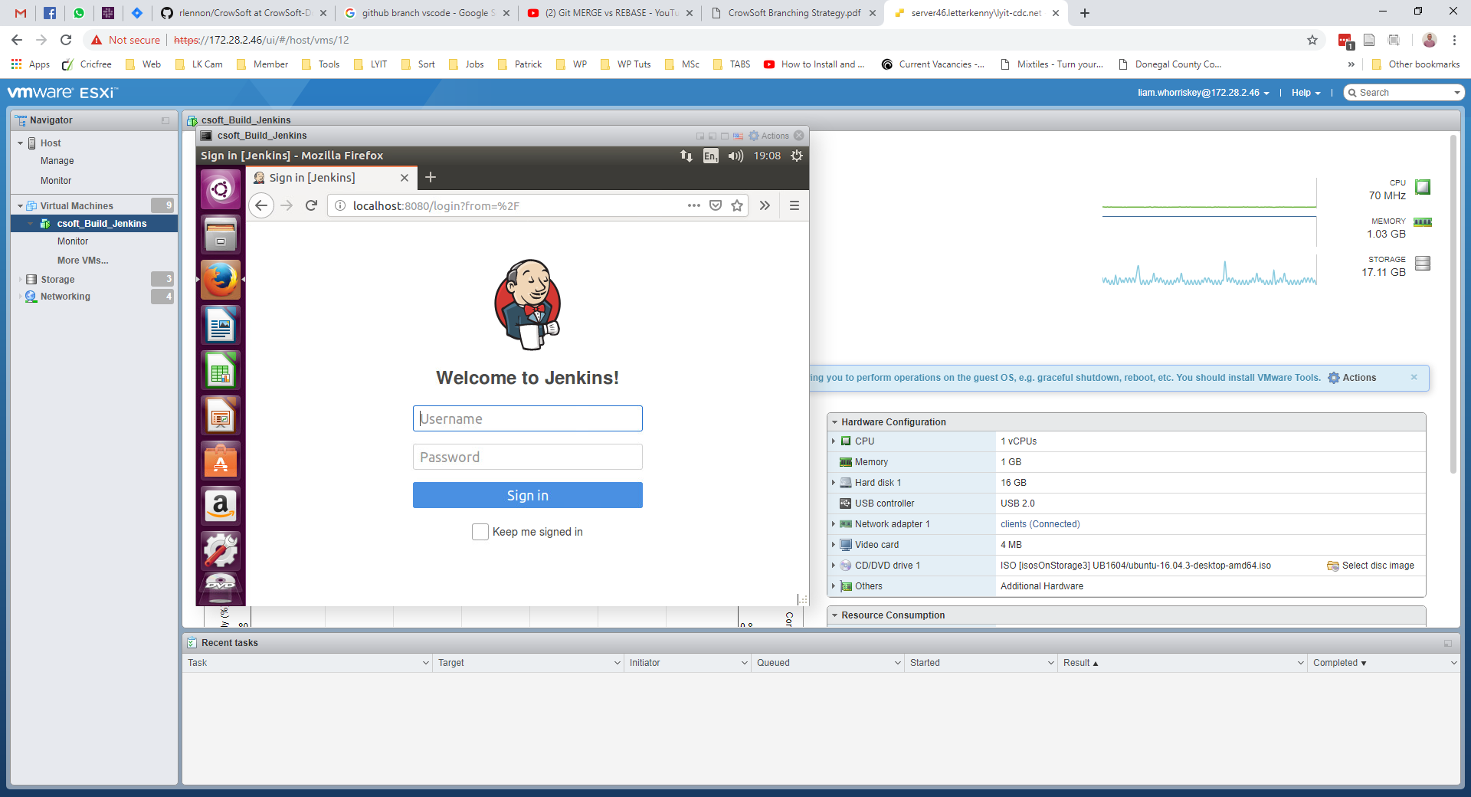

**Jenkins Setup Complete with suggested plugins.**

* Name: Dev Ops
* User: admin
* Pass: ********
* email: [l00113360@student.lyit.ie](mailto:l00113360@student.lyit.ie)
* Jenkins Url: <http://localhost:8080/>

**Plugins Installed**

* Ant Plugin
* Build Timeout
* Email Extension Plugin
* GitHub Branch Source Plugin
* Gradle Plugin
* LDAP Plugin
* Matrix Authorisation Strategy Plugin
* SWASP Markup Formatter Plugin
* PAM Authentication Plugin
* Pipeline
* Pipeline: GitHub Groovy Libraries
* SSH Slaves Plugin
* Subversion plugin
* Timestamper
* Workspace Cleanup Plugin

@Mary Walsh McGinty

* Artifactory plugin
* Ansible
* Audit Trail
* Backup plugin

Figure 1 Thin Backup

* CodeSonar
* OWASP Dependency-Check
* Release
* Selenium Builder
* Selenium
* SonarQube Scanner for Jenkins
* Visual Studio Code Metrics

@Mary Walsh McGinty

Jenkins must be running before it can be accessed through LOCALHOST

To start Jenkins: sudo systemctl start jenkins

To check if Jenkins is running: sudo systemctl status jenkins

To stop Jenkins: sudo systemctl stop jenkins

### Jenkins Security

* Added Users with permissions
* Disabled “Remember Me” option
* Set up Matrix-based security

# Artifactory

### Prerequisites : Java JDK

Install: JFrog Artifactory-OSS Version 5.8.3. An open source version of JFrog Artifactory

Version to download : jfrog-artifactory-oss-5.8.3.deb

### Steps

1. You must be running as root to download

wget <https://bintray.com/artifact/download/jfrog/artifactory-debs/pool/main/j/jfrog-artifactory-oss-deb/jfrog-artifactory-oss-5.8.3.deb>

1. Install artifactory

$ gpg -keyserver pgpkeys.mit.edu -recv-key6B219DCCD7639232

$ gpg -a -export 6B219DCCD7639232 | sudo apt-key add –

$ apt-get update

$ dpkg -i jfrog-artifactory-oss-5.8.3.deb

1. Start the service

sudo systemctl start artifactory.service

Artifactory must be running before it can be accessed through LOCALHOST

To start Artifactory: sudo systemctl start artifactory.service

To stop Artifactory: sudo systemctl stop artifactory.service

## Configure Artifactory

Artifactory can be accessed through the default Artifactory URL: localhost:8081/artifactory

### Steps

1. Initial setup activates a setup wizard where basic configuration is completed.
2. Setup administration username and password. Artifactory comes with a default set.
3. Create repositories. Created: Maven, Gradle and Generic Repositories.
4. Create a group; Admin section -> Security -> Groups

Click Save to save the group.

Double click on

1. Set up: Users with username, password.
2. Set permissions for each User.
3. Configured general security

### Configuring Artifactory on the Jenkins Server

#### Steps

1. Log into Jenkins and click on Manage Jenkins
2. Click on Configure System
3. Scroll down the page to the Artifactoy section
4. Add the server details, Url: localhost:8081/artifactory,

@ Matthew McColgan

1. Add the Artifactory log in details, username and password, then test the connection

@Mary Walsh McGinty

### Configuring Jenkins Build

1. Log into Artifactory

1. Click on repository in Set me up and add your password

1. A curl command will be returned with a path to the repository you choose

1. Log into Jenkins and in the configuration file for the build go to the build section

Copy the curl command into the Build section as shown, inserting the details relevant to you.

1. Run the Build Now in Jenkins

# Gradle

### Prerequisites : Java JDK

After Java JDK has been installed install Gradle.

### Steps

1. Download the zip Gradle file

cd /tmp

wget <https://services.gradle.org/distributions/gradle-4.10.2-bin.zip>

This will download the file into the tmp directory

sudo unzip -d /opt/gradle /tmp/gradle-*.zip

This extracts the file into the /opt/gradle/gradle-4.10.2 directory

2. Configure Ubuntu Environment Variables

sudo nano /etc/profile.d/gradle.sh

This creates a new file called gradle.sh in the /etc/profile.d directory. Inside this file the following is added.

export GRADLE_HOME=/opt/gradle/gradle-4.10.2

export PATH=${GRADLE_HOME}/bin:${PATH}

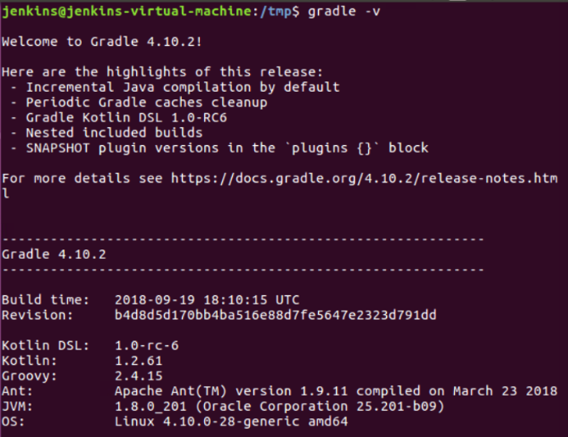 Exit and save the file ‘ctrl + x’ then y.

When done run the following commands to make the file executable.

sudo chmod +x /etc/profile.d/gradle.sh

source /etc/profile.d/gradle.sh

3. To check if Gradle installed correctly

gradle -v

It should return this →

## Gradle Freestyle Example

This pulls from Github and builds using Gradle then publishes to Artifactory

### Artifactory Configuration

In the artifactory configuration of the Freestyle project. These details were used.

In the More Details check the box to publish the artifacts.

### Build the project

In the Build section add the **Invoke Gradle Script**

Here the name of the gradle to use is added.

##### Example of Gradle script

**NOTE:** The plugin to msBuild through Gradle

This allows for .NET projects to be built in Gradle

# Build Scan

This tool allows for a graph representation of the build