Team CrowSoft

LYIT - MSc

5/1/2019

Team CrowSoft - Documentation

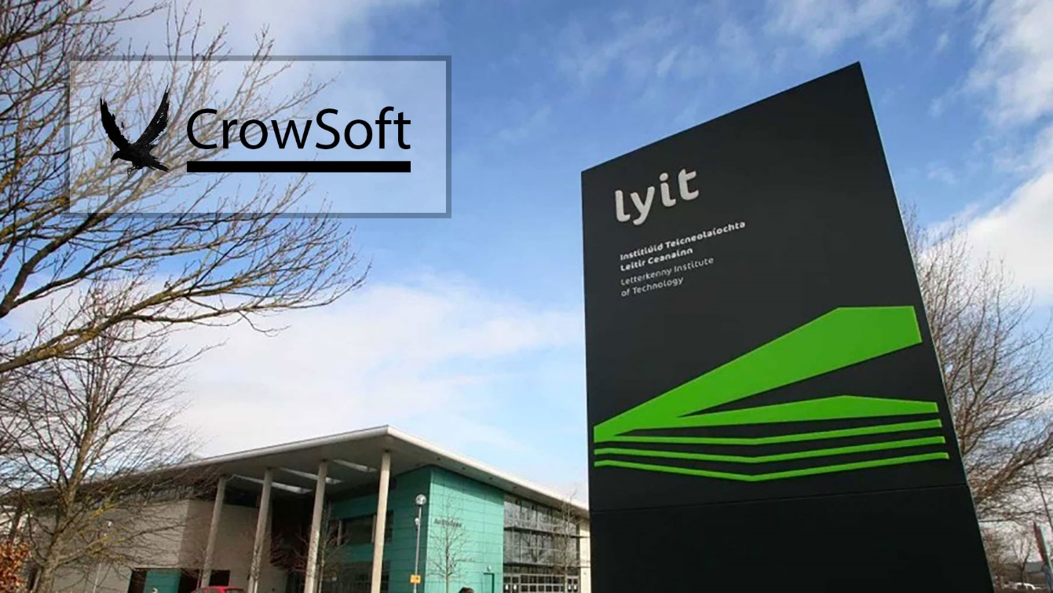

Team Members

|  |  |
| --- | --- |
| nAME | L Number |
| Bharathi Gadhiraju | L00144819 |
| Mary Walsh McGinty | L00113835 |
| Charles Aylward | L00131535 |
| Colin Kenny | L00086074 |
| Matthew Mc Colgan | L00083863 |
| Michael McFadden | L00105787 |
| Joji Thokla | L00144702 |
| Liam Whorriskey | L00113360 |