**Documentation**

Use Case Diagram:

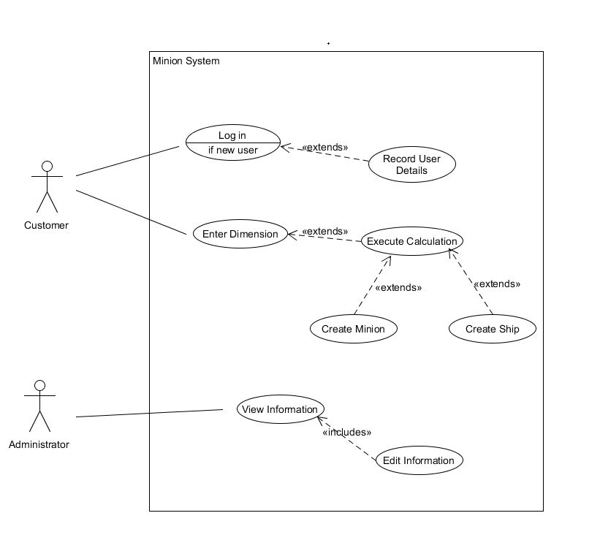

Use Case Descriptions:

|  |  |
| --- | --- |
| Use Case | Create Minion. |
| Objective | Create a minion based on customer requirements. |
| Precondition | Customer is creating a minion for use. |
| Main Flow | 1. Customer logs in.  2. Customer enters dimensions required.  3. Calculation is executed.  4. Minion is created. |
| Alternative Flow | 1. Customer is new and must have his/her details recorded.  2. Customer enters dimensions which are not acceptable, display error message and make customer re-enter appropriate dimensions. |
| Post Condition | Customer has logged in, entered dimensions and a minion has been created. |

|  |  |
| --- | --- |
| Use Case | Create Ship. |
| Objective | Create a ship based on customer requirements. |
| Precondition | Customer is creating a ship for use. |
| Main Flow | 1. Customer logs in.  2. Customer enters dimensions required.  3. Calculation is executed.  4. Ship is created. |
| Alternative Flow | 1. Customer is new and must have his/her details recorded.  2. Customer enters dimensions which are not acceptable, display error message and make customer re-enter appropriate dimensions. |
| Post Condition | Customer has logged in, entered dimensions and a ship has been created. |

|  |  |
| --- | --- |
| Use Case | View Information. |
| Objective | Allow the administrator to view and edit information on requirements. |
| Precondition | Administrator is viewing information. |
| Main Flow | 1. Administrator clicks on option to view information.  2. Requirement information is available to view such as minion, ship and laser details.  3. Administrator can edit information. |
| Alternative Flow | 3. Administrator tries to edit information which is not possible. Display error message, set information back to default and allow administrator to try again. |
| Post Condition | Administrator has been able to view and edit the information that is available. |

|  |
| --- |
| **Use Case: Enter Dimensions Use Case** |
| **Objective: This use case describes the steps involved in a user entering their preferred dimensions into the system** |
| **Pre-condition: The user has logged into the system** |
| **Main Flow:**   1. The user enters their preferred dimensions and complete all fields 2. The user submits their preferred dimensions 3. The user’s entered data is sent for calculation |
| **Alternative Flow:**  2a. The user does not complete all fields before submission  2b. The user is prompted to complete the remaining empty fields  2c. Use case ends. |
| **Post-condition: The Users dimensions will have been sent for calculation** |

|  |
| --- |
| **Use Case: Execute Calculations Use Case** |
| **Objective: This use case describes the steps involved in calculating the data submitted by the user** |
| **Pre-condition: The user has successfully submitted data to be calculated** |
| **Main Flow:**   1. The user data is calculated 2. The user is informed of the result/conclusion |
| **Alternative Flow:** |
| **Post-condition: The Users data is successfully calculated and user informed of result/conclusion** |

|  |
| --- |
| **Use Case: Log In Use Case** |
| **Objective: This use case describes the steps involved in a member logging into the system** |
| **Pre-condition: A user makes an attempt to log in** |
| **Main Flow:**   1. The user enters their log in details 2. The user’s log in details are compared within the database records for a match 3. The user is logged into the system |
| **Alternative Flow:**  2a. The user’s details do not match any record in the database  2b. The user is informed that they are not registered  2c. Use case ends. |
| **Post-condition: A user will have been logged into the system** |

Class Diagram:

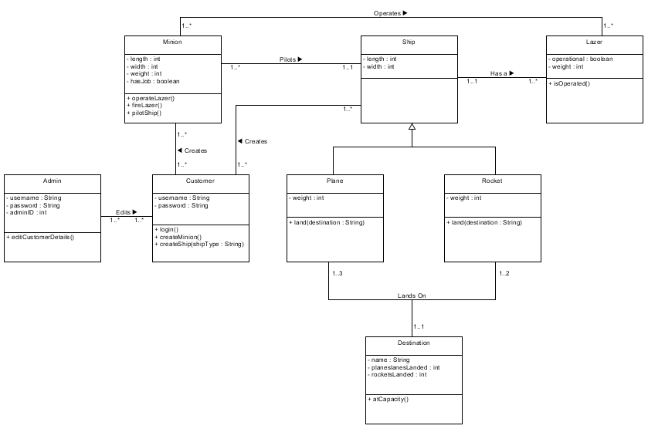

Sequence Diagram:

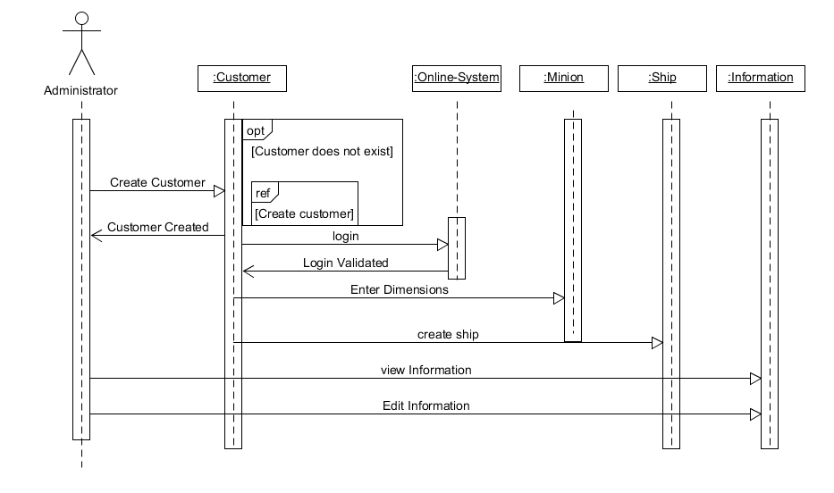

Requirement Analysis:

