NAME  Fabillorin, Ramona L. |  | DATE  2/4/2017 | SCORE
SCHEDULE  SAT – 10:00AM-12:50PM | SCORE |  | SCORE

LABORATORY EXERCISES
RECURSION

OBJECTIVES:
- Understand recursion and its parts
- Use recursion to solve programming problems

PROCEDURE:
- Encode the C++ program below.
- Save as rec1.cpp,and rec2.cpp, respectively.
- Compile and run the program by pressing Ctrl + F9.
- For each syntax or logical error encountered in the given program, do the following:
- Correct the error
- Recompile the program
- Repeat step 4 until no errors are encountered in the program.
- Illustrate the output of the modified program.

Program No. 1

#include <iostream>
Output:
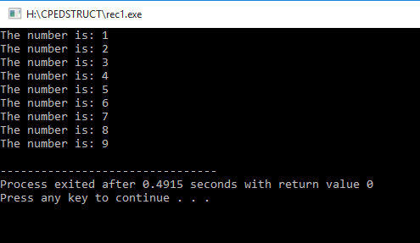

using namespace std;

void numberFunction(int i) {
cout << "The number is: " << i << endl;
i++;
if(i<10) {
numberFunction(i);
}
}

int main() {

int i = 1;
numberFunction(i);

return 0;
}

Program No. 2

#include <iostream>
using namespace std;

int factorial(int);

int main() {
int n;
cout<<"Enter a number to find factorial: ";
cin>>n;
cout<<"Factorial of "<<n<<" = "<<factorial(n);
return 0;
}
Output:
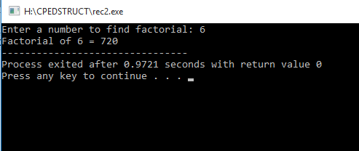

int factorial(int n) {
if (n>1) {
return n*factorial(n-1);
}
else {
return 1;
}
}

Supplementary Problem

- A recursive function that sums up the 10 integers in an array.

Program:

#include<iostream>
using namespace std;

int arrSum(int arr[], int x){
if (x<0)
return 0;
else
return arr[x]+ arrSum(arr, x-1);
}

int main (){
int array[]={1,2,3,4,5,6,7,8,9,10};
int sum;

sum=arrSum(array,9);

cout<<"Sum of the array: "<<sum;
return 0;
}

Output:

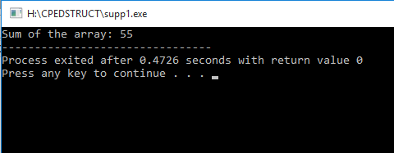

- A recursive function to produce the Fibonacci number for a given index in the series.
Use the function int fibonacci(int n)

Program:

#include<iostream>
using namespace std;

int fibonacci(int n){
if (n==0)
return 0;
else if(n==1)
return 1;
else
return fibonacci(n - 1) + fibonacci(n - 2);
}

int main (){
int num;
cout<<"Input num: ";
cin>>num;
cout<<"Fibonacci #: "<<fibonacci(num);
return 0;
}

Output:

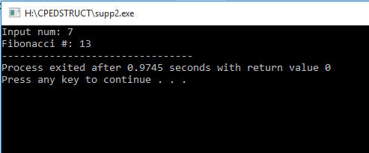

- A recursive function which raises its first parameter to the power of its second parameter.
Use the function int power(int number, int power)

Program:

#include<iostream>
using namespace std;

int power(int number, int exp){
if (exp==1)
return number;
else
return number * power (number, exp-1);
}

int main(){
int num, expo, res;

cout<<"Input num: ";
cin>>num;
cout<<"Input exp: ";
cin>>expo;

cout<<"Result: "<<power(num, expo);
}

Output:

