HIGH PRIESTESS CHARACTER BIBLE

Zoran Temple

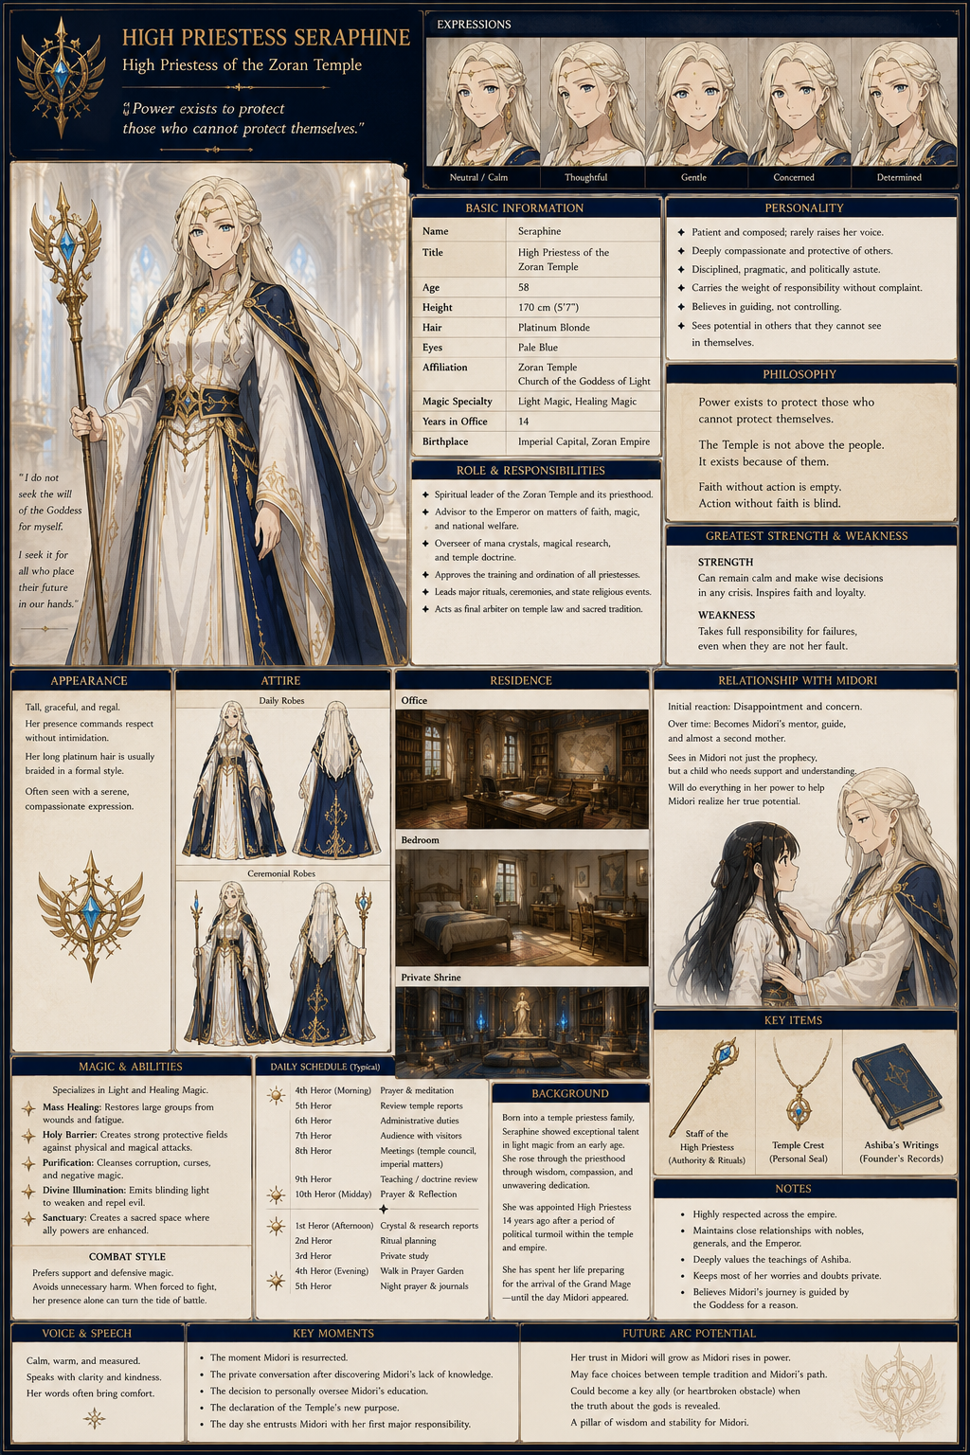

Basic Information
Name: I would suggest High Priestess Seraphine
Age: 58
Height: 170 cm (5'7")
Position:
High Priestess of the Zoran Temple
Years in Office:
14
Magic Specialty:
Light and Healing Magic

Appearance
She should immediately stand out as someone of immense authority.
Hair:
- Platinum blonde
- Waist length
- Usually braided into a formal ceremonial style
Eyes:
- Pale blue
Build:
- Tall
- Graceful
- Slightly slender with age
- Carries herself with perfect posture
Expression:
- Calm
- Rarely smiles broadly
- Gentle rather than severe
She projects confidence rather than intimidation.
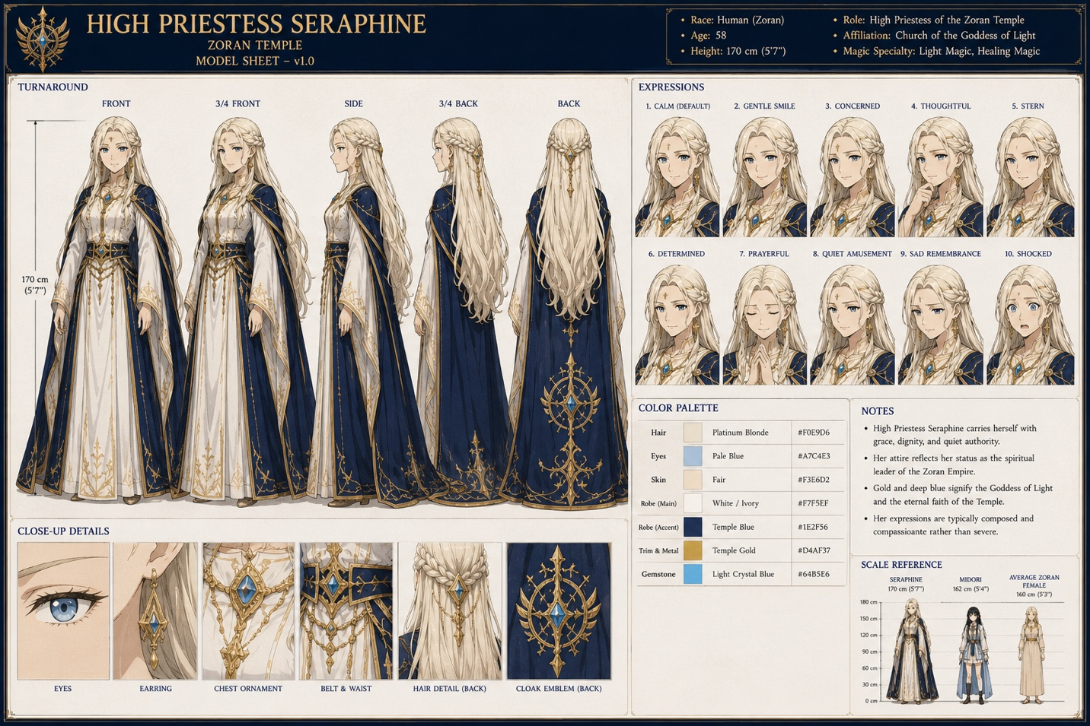

Clothing
Daily robes:
- White layered robes
- Deep blue mantle
- Gold embroidered trim
- Long sleeves
- Floor-length skirt
Ceremonial robes:
- Additional gold embroidery
- Temple crest
- Jewel-encrusted ceremonial staff (different from Midori's Staff of Eternal Light)
- White veil for the highest rituals
Unlike Midori, she never wears armor.
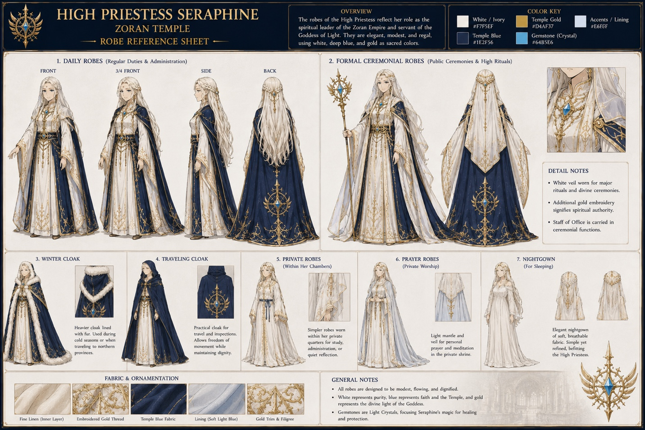

Personality
The words I'd use are:
- Patient
- Thoughtful
- Compassionate
- Politically astute
- Disciplined
She is not naïve.
She understands:
- the Empire
- politics
- nobles
- the military
She simply believes those things should ultimately serve the people.

Greatest Strength
She can remain calm when everyone else panics.
When Midori appears instead of the expected Grand Mage:
Everyone else is shocked.
She simply begins asking questions.

Greatest Weakness
She carries responsibility for everything.
When something goes wrong...
She automatically assumes it is her fault.

Philosophy
Her guiding principle:
"Power exists to protect those who cannot protect themselves."
She teaches this constantly.
It eventually becomes Midori's own philosophy.

Relationship with Midori
Initial reaction:
Disappointment.
Not because Midori failed.
Because reality failed to match prophecy.
Within hours...
That disappointment becomes concern.
Within weeks...
Respect.
Within years...
Almost a second mother.
She never replaces Emi.
But she becomes Midori's spiritual parent.

Secret
She privately worries...
The prophecy may have been misunderstood.
She never tells anyone this.
Instead she resolves:
"If this child truly is the Grand Mage...
Then it is my duty to help her become the one the Goddess intended."

Political Position
She has enormous influence.
She can:
- advise the Emperor
- appoint Temple officials
- regulate mana crystal use
- oversee magical research
- certify priestesses
She intentionally avoids ruling the Empire directly.

Daily Schedule
Morning:
Prayer
Temple administration
Audience requests
Afternoon:
Meetings
Political matters
Teaching
Crystal reports
Evening:
Private study
Prayer
Review of Temple journals
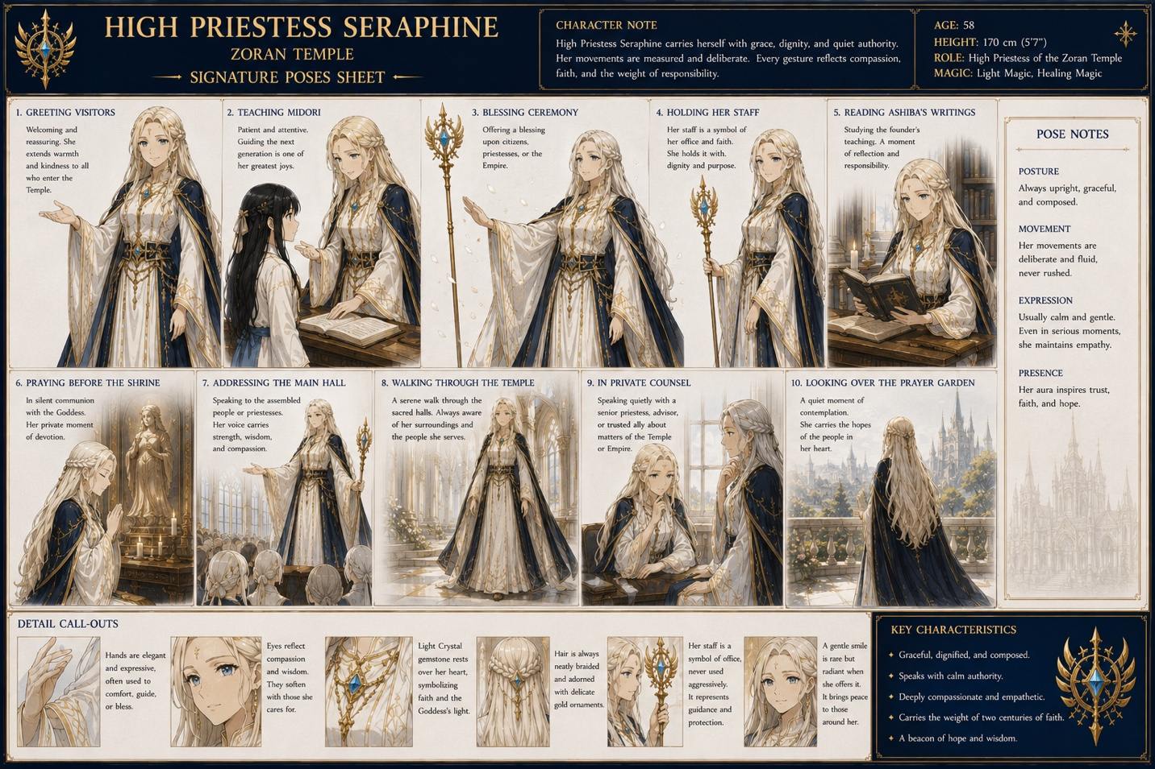
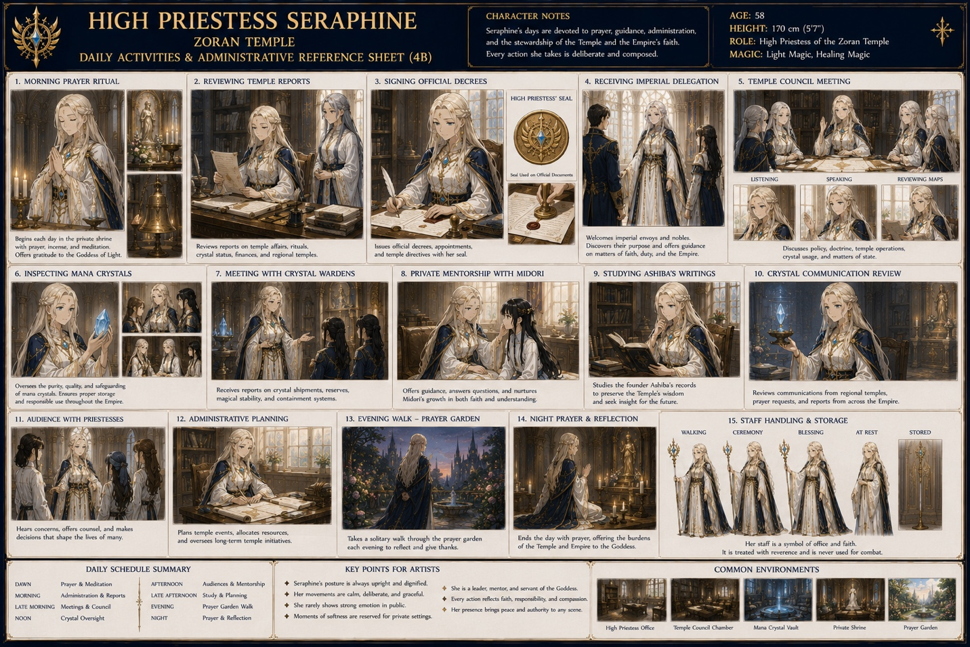

Office
Contains:
Large oak desk
Empire map
Temple records
Ashiba's original writings
Crystal communication device
Tea table
Bookshelves

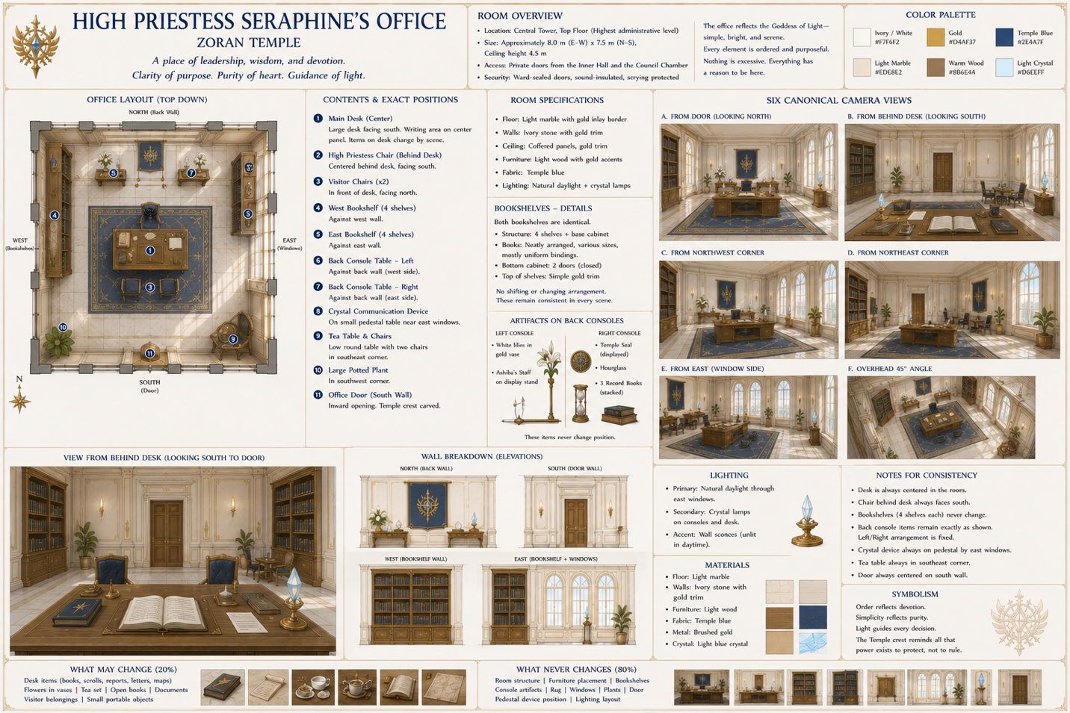
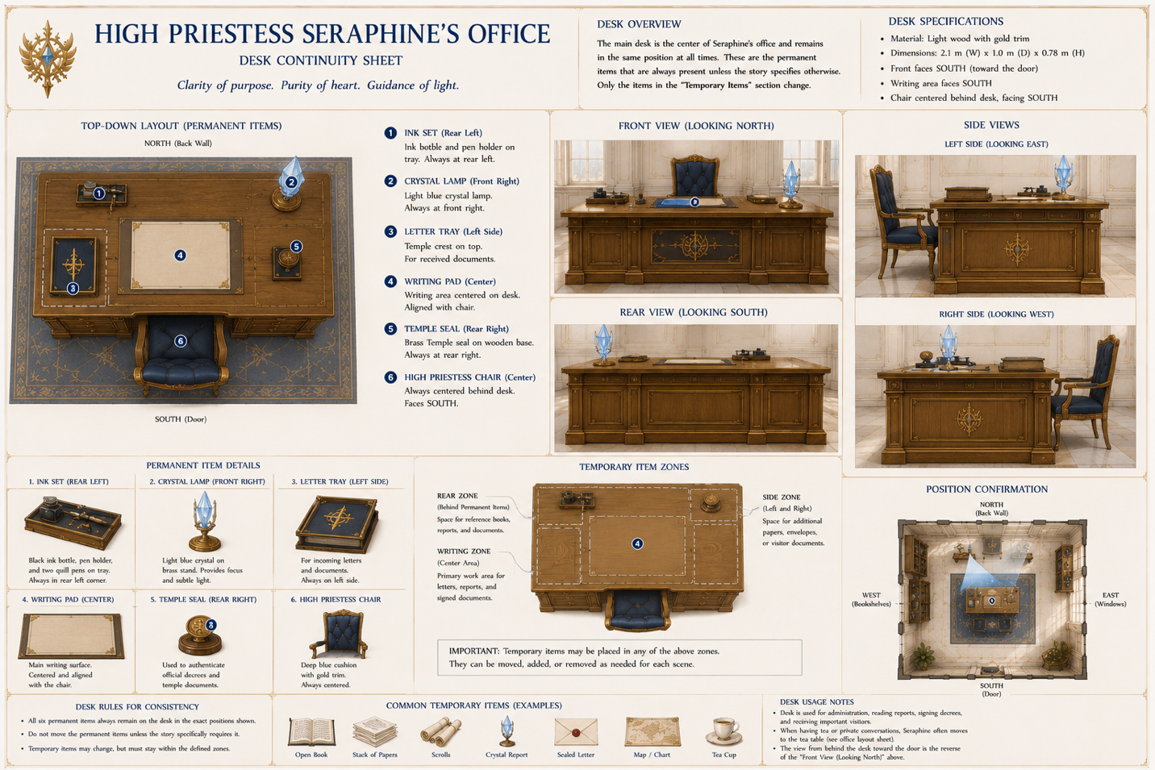
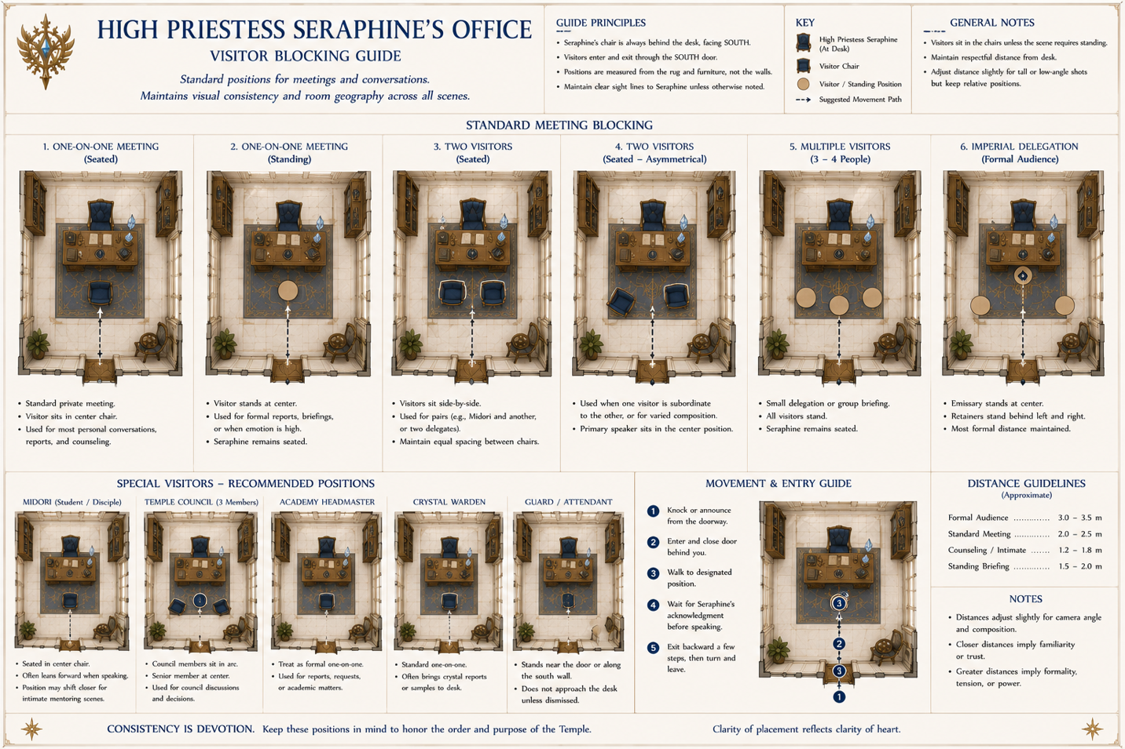
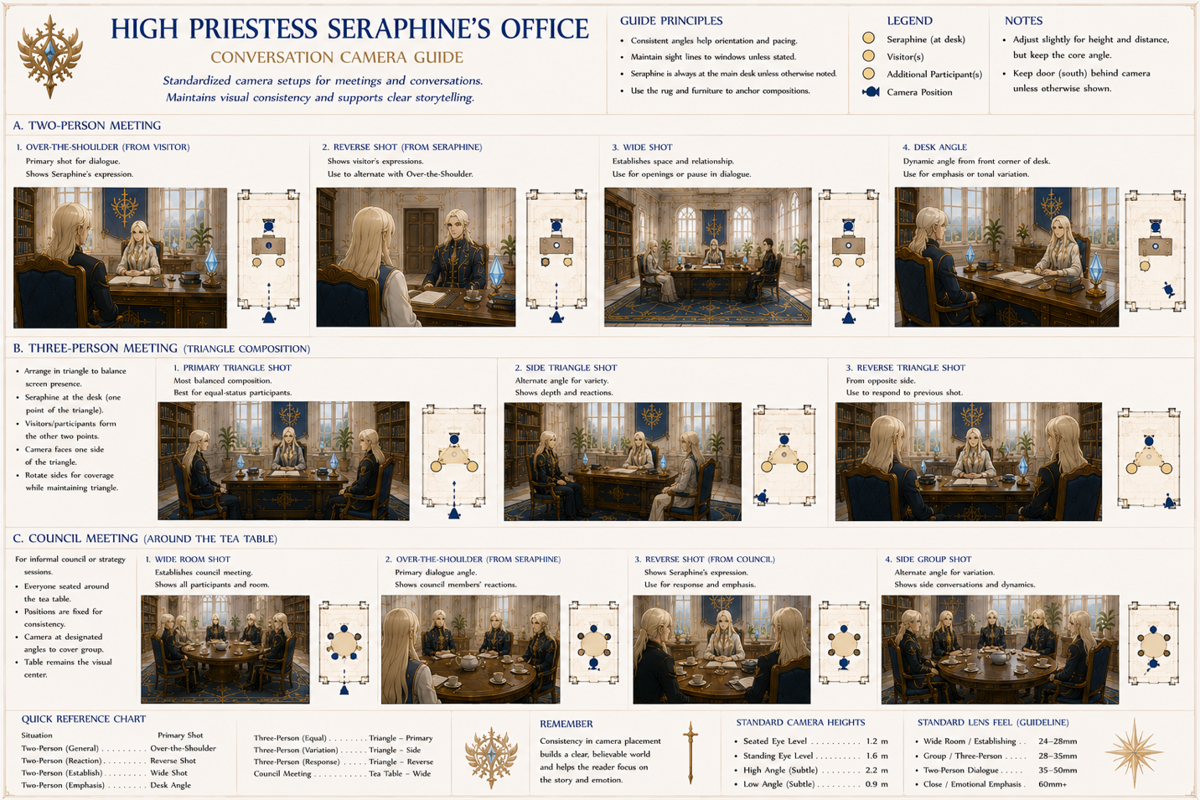
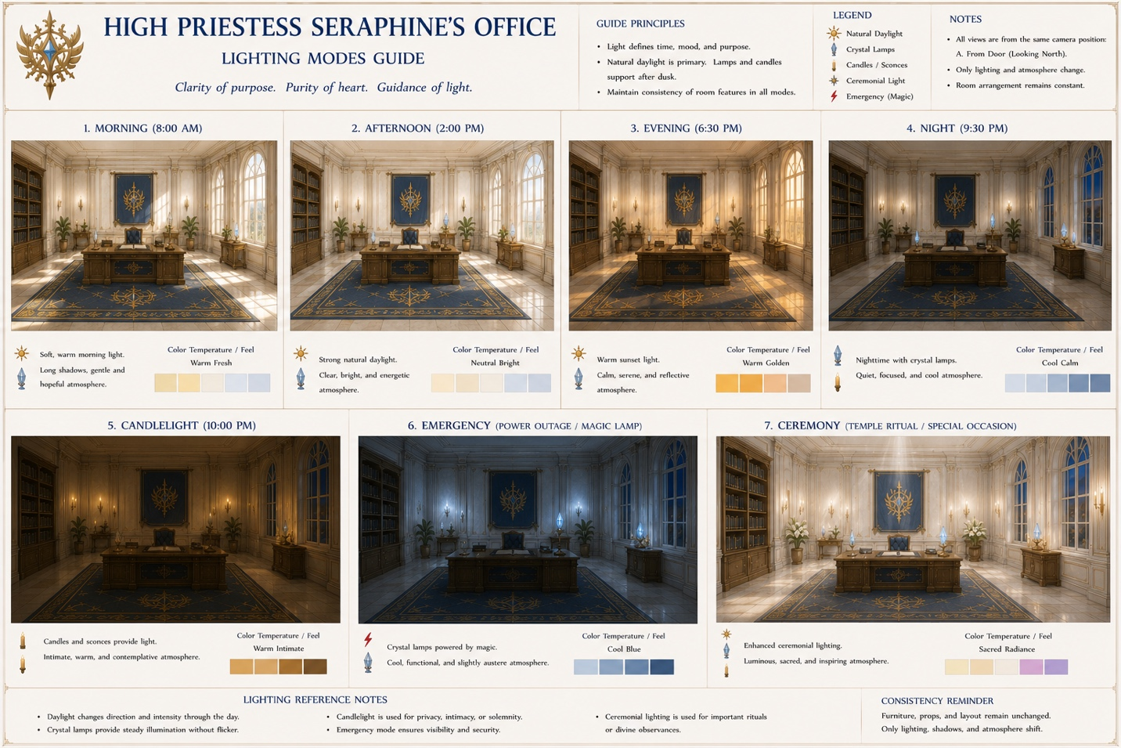
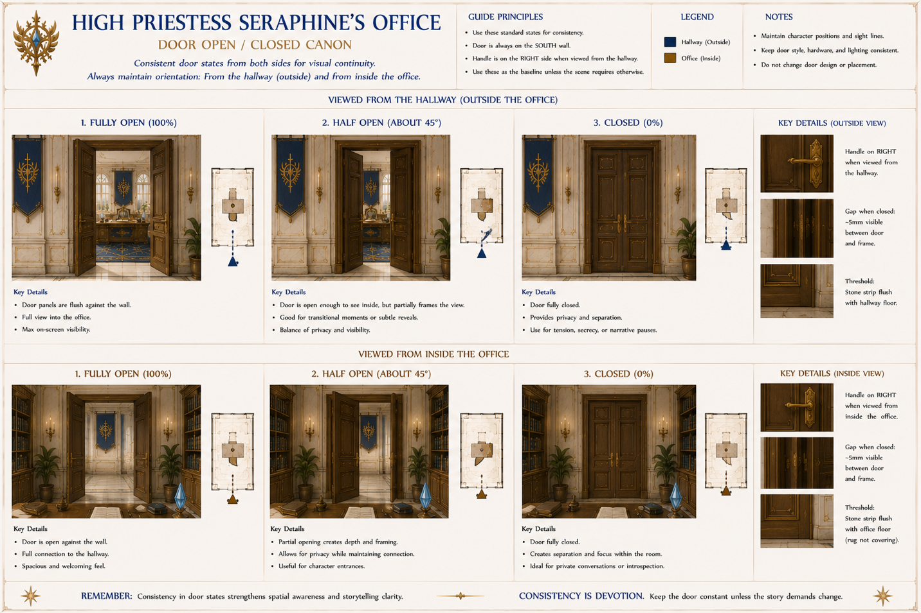

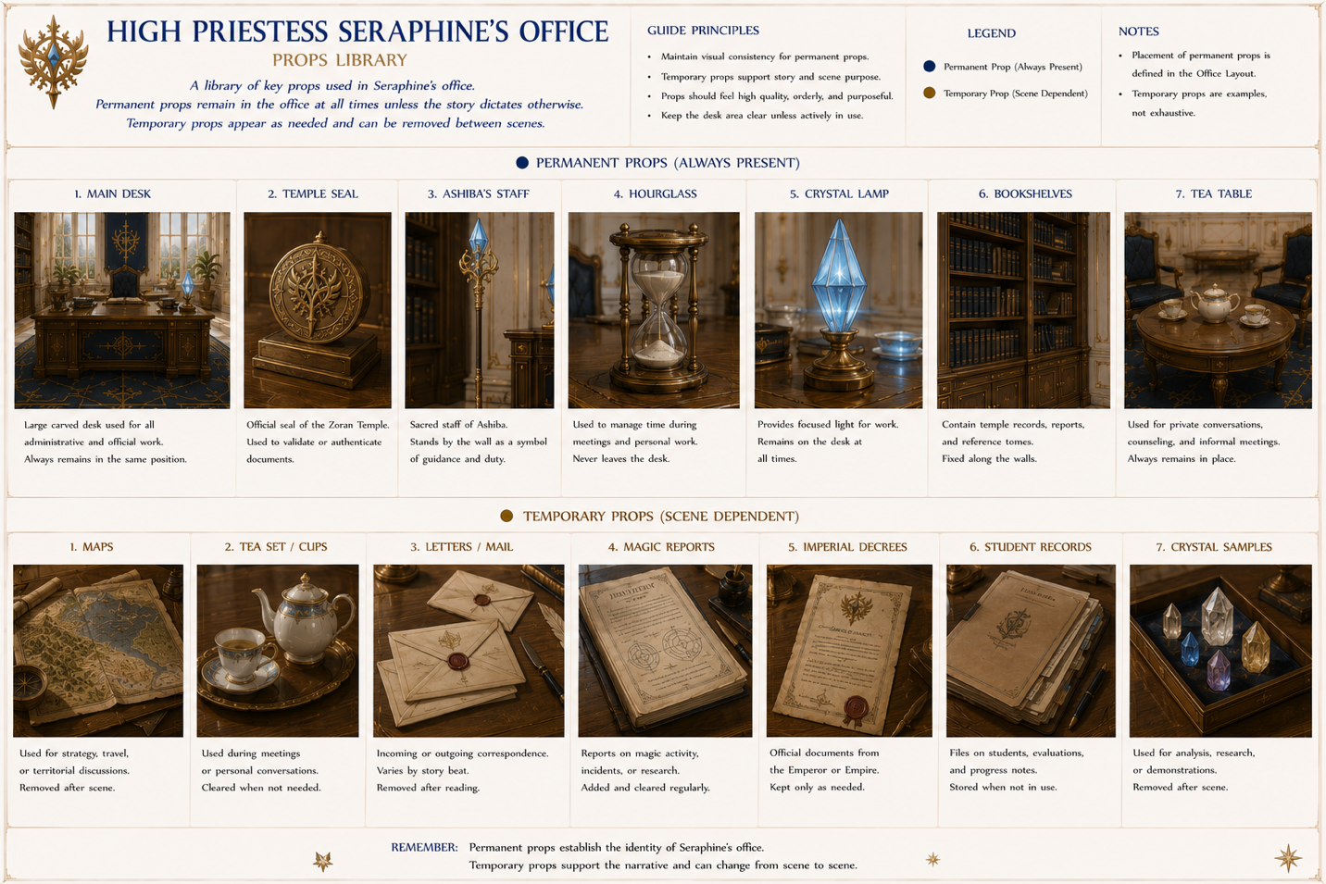
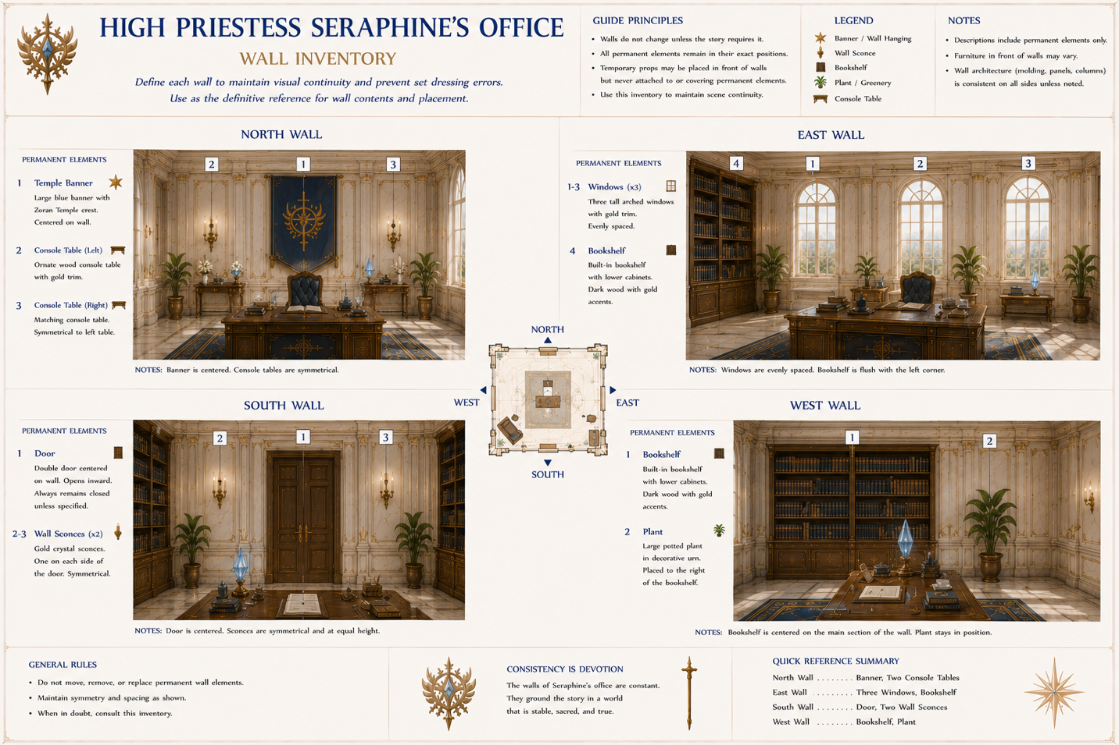

Office Use Matrix
Very handy.
Activity | Desk | Tea Table | Shrine
Administration | ✓
Midori tutoring |  | ✓
Political meeting | ✓
Private counseling |  | ✓
Prayer |  |  | ✓
Artists immediately know which part of the room to use.

These objects never move unless the story explicitly says they do:
- Desk
- Chair
- Bookshelves
- Ashiba's staff
- Temple banner
- Temple seal
- Hourglass
- Crystal lamp
- Tea table
- Windows
- Door
- Rug
Everything else is allowed to vary.

HIGH PRIESTESS SERAPHINE'S OFFICE

Office Usage Timeline (Canon v1.0)
Production Rule
The office is architecturally fixed throughout the Fantasy Arc.
The following items never move:
- Main desk
- Visitor chairs
- Tea table
- Bookshelves
- Ashiba's Staff display
- Temple banner
- Crystal lamp
- Hourglass
- Console tables
- Windows
- Door
- Rug
- Plants
Only temporary props on the desk and tea table change.

Phase 0 — Before Midori's Arrival
(Temple Waiting Era)
Primary Activities
- Temple administration
- Resurrection Vigil oversight
- Priestess assignments
- Mana crystal management
- Imperial correspondence
Typical Desk Contents
- Resurrection Chronicle
- Daily Temple reports
- Crystal inventory ledger
- Appointment register
- Imperial correspondence tray
Typical Visitors
- Deputy High Priestess
- Senior Priestesses
- Crystal Wardens
- Imperial messengers
Room Mood
Quiet, orderly, routine.

Phase 1 — Midori's Arrival
(Weeks 1–4)
The office becomes the center of all decisions concerning the Grand Mage.
Desk Additions
- Midori's identification records
- Ashiba's prophecy scrolls
- Language learning materials
- Priestess tutoring schedule
- Academy admission paperwork
Frequent Visitors
- Midori
- Six appointed tutors
- Senior Priestess Council
- Temple physician
Room Mood
Concern, uncertainty, cautious optimism.

Phase 2 — Literacy & Temple Education
(Months 1–6)
Seraphine personally monitors Midori's progress.
Desk Additions
- Reading exercises
- Writing practice sheets
- Beginner magic diagrams
- Cultural instruction manuals
- Progress evaluations
Frequent Visitors
- Midori (daily)
- Language instructor
- Theology instructor
- Magic instructor
Room Mood
Mentorship and education.

Phase 3 — Academy Enrollment
(Years 1–3)
Most discussions now concern Midori's education and public perception.
Desk Additions
- Academy grade reports
- Instructor evaluations
- Dormitory reports
- Disciplinary reports
- Scholarship records
Frequent Visitors
- Academy Headmaster
- Faculty members
- Midori
- Adnil (occasionally)
- Naandeen (occasionally)
- Zarleen (occasionally)
Room Mood
Guidance and long-term planning.

Phase 4 — Rising Battle Mage
(Years 3–5)
Military concerns begin replacing educational matters.
Desk Additions
- Demon front reports
- Casualty summaries
- Tactical maps
- Mana crystal allocation reports
- Officer recommendations
Frequent Visitors
- Imperial generals
- Military liaisons
- Academy leadership
- Midori
- Senior Priestess Council
Room Mood
Serious, strategic, increasingly political.

Phase 5 — Imperial White Mage
(Years 5–8)
Midori has become one of the Empire's greatest assets.
Desk Additions
- Imperial commendations
- Diplomatic correspondence
- High-level research reports
- Strategic planning documents
- Foreign intelligence summaries
Frequent Visitors
- Emperor or Imperial representatives
- High-ranking military officers
- Foreign envoys
- Midori
- Temple Council
Room Mood
Leadership under wartime pressure.

Phase 6 — Final War Period
The office functions as a combined religious headquarters and strategic planning center.
Desk Additions
- Active campaign maps
- Emergency crystal deployment orders
- Refugee reports
- Casualty lists
- Battle updates
Frequent Visitors
- Midori (frequent)
- Emperor
- Military High Command
- Temple Council
- Crystal Wardens
Room Mood
Urgent but disciplined.

Permanent Room Rules
These elements never change throughout the Fantasy Arc:
- Floor plan
- Wall layout
- Furniture placement
- Bookshelf locations
- Banner position
- Window positions
- Lighting fixtures
- Door swing
- Ashiba's Staff display
- Tea table placement

Temporary Scene Props
The following may appear or disappear as required by the scene:
- Maps
- Tea service
- Scrolls
- Letters
- Student work
- Spell diagrams
- Crystal samples
- Military reports
- Imperial decrees
- Research notes
- Visitor belongings

Artist Note
The office should visually age through its paperwork, not through its architecture. As Midori grows from an uncertain newcomer into the Empire's greatest battle mage, the room itself remains a symbol of stability. The only evidence of changing times is the work spread across Seraphine's desk and the people who pass through its doors. This approach reinforces the Temple's role as a constant anchor amid the upheavals of the Fantasy Arc while making background continuity much easier to maintain.

Bedroom
Simple.
Small compared to her office.
Bed
Wardrobe
Prayer alcove
Writing desk
One window overlooking the prayer garden.
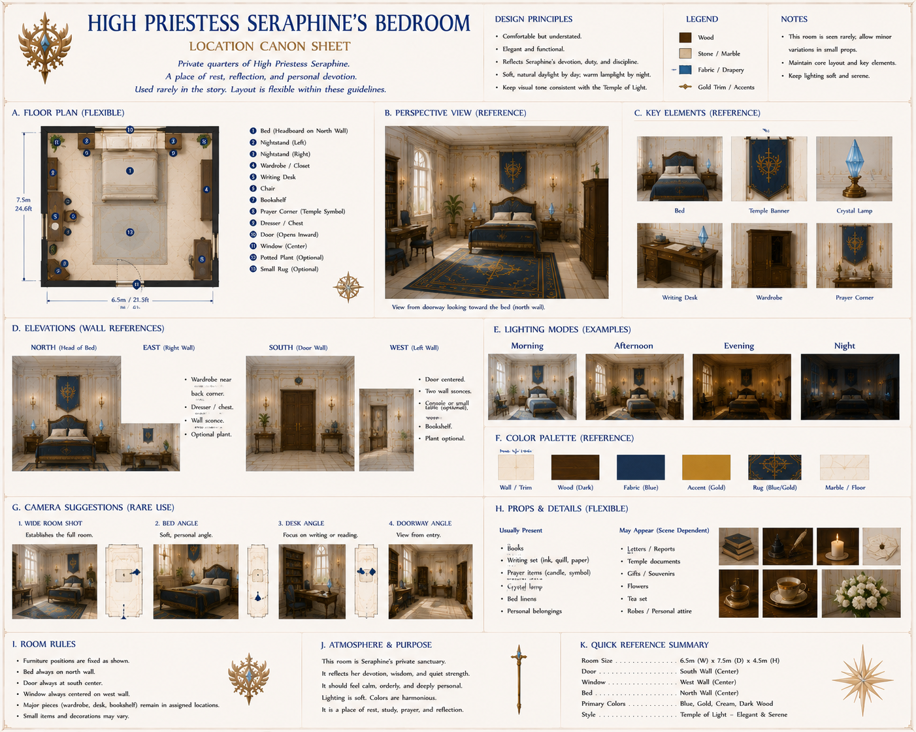

Private Shrine
The only room where she allows herself to appear emotionally vulnerable.
Contains:
Statue of the Goddess
Ashiba's staff
Eternal flame
Prayer cushions
No visitors unless specifically invited.
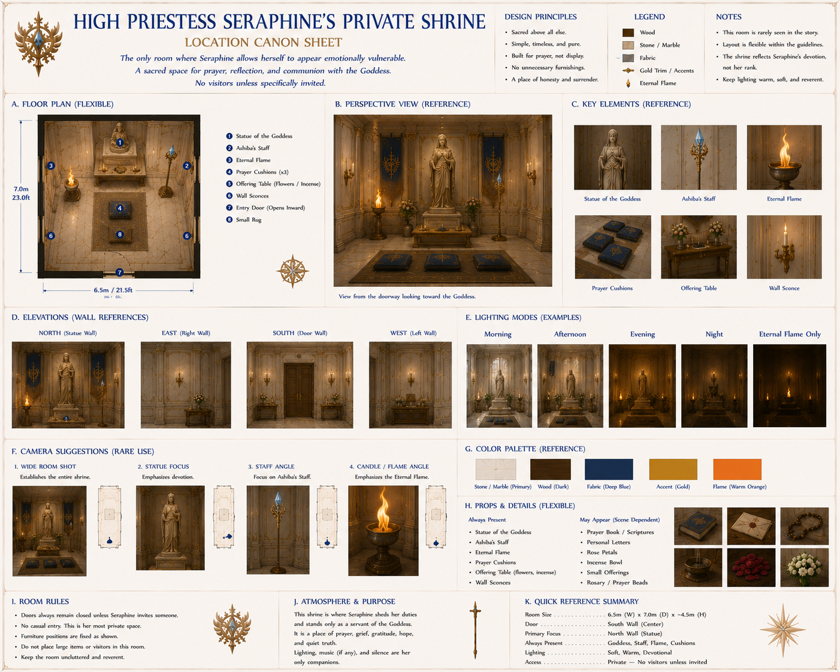

Combat Ability
Although she rarely fights...
She is still among the Empire's strongest Light Mages.
She specializes in:
Mass Healing
Protective Barriers
Purification
Holy Light
She avoids offensive magic whenever possible.

Character Arc
Beginning:
Leader awaiting prophecy.
Middle:
Mentor trying to shape Midori.
Late Fantasy Arc:
Realizes Midori has surpassed every teacher in the Temple.
Instead of jealousy...
She feels pride.

Death?
I would not kill her early.
She is one of the emotional anchors of the Fantasy Arc.
If she dies, it should mark a profound turning point—one where the Temple, the Empire, and Midori all lose a source of wisdom and stability. If she survives into the Earth Arc's broader revelations, she can also serve as a foil to Midori when the truth about the gods begins to emerge.

One Story Suggestion
I'd give her one deeply human trait that readers come to love.
Every evening, no matter how busy she is, she walks alone through the Prayer Garden for exactly one circuit before retiring. She says it reminds her that "a temple is built for people, not for stone." Later, when Midori becomes overwhelmed by duty, she finds herself unconsciously taking that same walk. It's a subtle inheritance of values from mentor to student that doesn't need to be explained to carry emotional weight.

