Student Clubs and Events Website Planning Document

Names of Team Members:
1. Rob Lindauer
2.
3.
4.
Exchange contact information and determine that best days and time(s) of the week to meet.

Discussion About Student Clubs and Events
As a group, discuss what various clubs, events, and/or activities you would like to showcase at your school to help increase awareness.
Idea 1: We can provide a listing of all student clubs, with a hyperlink to more information about each club (ithe link will take the user to the club’s own webpage, if one exists, and otherwise to a basic info page created as part of this project)
Note: We must provide a mechanism for addition of new clubs, update/correction of the information we have on existing clubs, and deletion of defunct clubs. We must look into what university organization has the authoritative list of clubs, club info, and club contacts.
Idea 2: We can provide a weekly calendar (with user ability to scroll to any past or future week) listing the student events by day and time, with a hyperlink from the calendar entry to an info page about the event.
Note: We must provide a mechanism for addition, correction/update, and deletion of events
Idea 3:

Idea 4:

Idea 5:

Website Plan

Topic | Questions | Answers
Purpose of Website | What is the purpose and goal of the website? | To increase student involvement in university clubs and events by creating a website that promotes awareness of the student clubs and activities.
Target Audience | Describe the target audience (age, gender, demographics) | CCSU undergraduate and graduate students, typically aged ~18-25. There is no requirement to limit access to current CCSU students or students only within that typical range.
Graphics | What graphics will you use on the website? | The pages will all display the CCSU logo. The main content will include club logos, where they exist (otherwise plain-text club names without logos.
Color | What colors will you use within the site to enhance the purpose and brand? | The site will be largely black and white, with blue highlights (blue and white being the CCSU colors).
Accessibility | How will the website accommodate people with disabilities? | The site will use standard accessibility attributes, such as alternative text for graphics.
Project Timeline | Identify the project timeline | The initial version of the website will be operational by the end of the Spring 2026 semester.

Wireframe
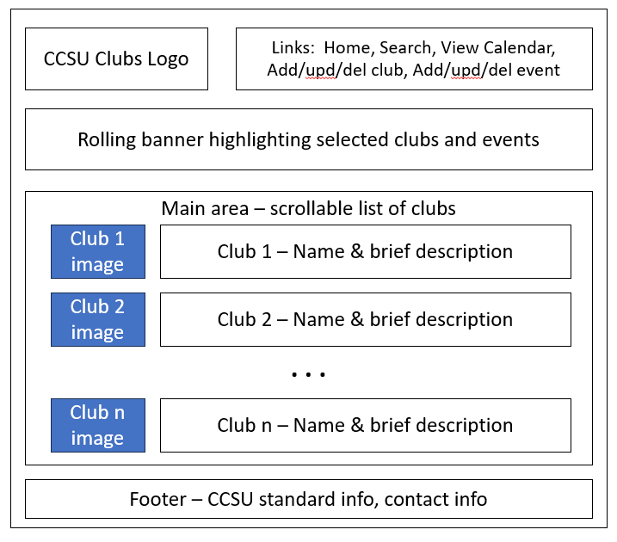

Site map
