MSDS 6372 : Principal Component Analysis

***Glass Identification : Refractive Index (RI) Analysis***

**1. Introduction**

“*Now you see it, now you don't. Glass is a bit of a riddle. It's hard enough to protect us, but it shatters with incredible ease. It's made from opaque sand, yet it's completely transparent. And, perhaps most surprisingly of all, it behaves like a solid material... but it's also a sort of weird liquid in disguise! You can find glass wherever you look: most rooms in your home will have a glass window and, if not that, perhaps a glass mirror... or a glass lightbulb. Glass is one of the world's oldest and most versatile human-created materials.”* (Woodford 2016)

Soda Lime glass is the most common type of glass used for windows and glass containers. Its primary components are Silica (Quartz sand), Sodium Oxide (Soda Ash), and Calcium Oxide (Lime). (Soda-Lime Glass n.d.) Soda Lime glass dates as far back as 2000 B.C. It is made in batch and continuous casting processes with refining temperatures as high as . (IMI-NFG course on Processing Glass 2015)When the mixture cools, it completely transforms into a different structure that is not quite solid. It becomes a material that scientists refer to as an **amorphous solid**, a cross between a solid and a liquid. Usually other minerals are added into the liquid glass to change its working temperature, hardness, chemical properties, or color based on the purpose of the glass.

Refractive index (RI) determines how much light is bent or refracted when entering or exiting a transparent material or in our case glass. The purpose of this observational study is to understand the different chemical compositions of glass and determine if refractive index can be predicted based on composition. This study looks at seven chemical compositions of Soda Lime Silica Glass using a dataset from The University of California, Irvine which contains 214 observations of 7 different glass types composed of 8 minerals by % weight. (UCI Machine Learning Repository n.d.)

**2. Exploratory Analysis**

The dataset includes compositions for Building and Vehicle windows (float and non-float processed) containers, tableware, and headlamps. (Float Glass process n.d.) SAS proc Means was used to summarize the data. Note that Silica, Soda, and Lime make up 95% of the composition by weight



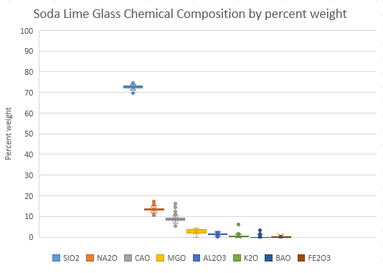The box and whisker plot shows the variability of each mineral in the UCI glass dataset as a percent of weight.



The box and Whisker plot shows a relationship between the type of glass and the refractive index (RI). Further analysis will help determine if the refractive index can be predicted based on glass composition.

Scatter plots show a strong negative relationship for Silica and a strong positive relationship for Calcium Oxide on Refractive index.

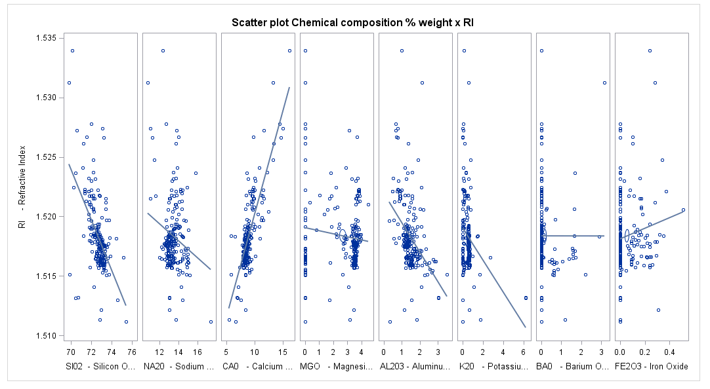

**3. Validation of assumptions**

For purposes of this study, it is assumed that the refractive index of soda lime glass can be predicted using statistical tools such as principal components and regression. Although there are only 8 minerals in the dataset, the objective of this project is to use principal components to reduce the number of independent variables.

**4. Principal Components Analysis (PCA)**

**Correlations**:

First we will take a look at the correlation matrix between the elements of sand. In our study, we are using the correlation matrix over the covariance matrix because of the variance in the variables of these data. The correlation matrix is a sums of squares and cross products from the standardized data. This correlation will tell use which elements have the highest positive and highest negative correlation.

In the correlation matrix **(Ref: Table A)**, we see a high positive correlation between variables ***Sodium Oxide***(NA20) and ***Barium Oxide***(BA0) with ***0.33***, ***Aluminum Oxide***(AL203) and ***Potassium Oxide***(K20) with **0.33** and ***Aluminum Oxide*** (AL203) and ***Barium Oxide***(BA0) with **0.48**. We also see a low negative correlation between variables ***Magnesium Oxide***(MG0) and ***Aluminum Oxide***(AL203) with ***-0.48***, ***Magnesium Oxide***(MG0) and ***Barium*** Oxide(BA0) with ***-0.49*** and ***Magnesium Oxide***(MG0) and ***Calcium Oxide***(CA0) with ***-0.44***.

|  |
| --- |
| \\.psf\Home\Desktop\Screen Shot 2016-11-10 at 9.06.25 PM.png |

**Table A – Correlation Matrix Standardized Data**

**Eigenvalues**:

Next we are going to take a look at the Eigenvalues from the Eigenvalue Matrix below and the scree plot **(Ref: Table B and C)**. Looking at the matrix the first four (4) principal components variables have Eigenvalues greater than one (1) explaining 77% of the variance. The largest difference is between component one (1) and component two (2) with 0.60.

Our Scree Plot for these data doesn’t indicate a steep curve, followed by a bend then a flat horizontal line. Instead this Scree Plot seem to descend at an angle almost linear pattern and ???. Next to the Scree Plot in Table C is the Variance Explained plot which is a graphical view of the Eigenvalue Matrix in Table B. Between the Eigenvalue Matrix and the Variance Explained graph helps us decide the number of components.

|  |
| --- |
| \\.psf\Home\Desktop\Screen Shot 2016-11-10 at 9.07.03 PM.png  **Table B – Eigenvalue Matrix** |
| \\.psf\Home\Desktop\Screen Shot 2016-11-10 at 9.08.06 PM.png |

**Components**:

From the Eigenvalues analysis, above we will focus on the first four (4) principal components more closely. In **Graph 2** shows a matrix plot of component scores between the first four components. The histogram of each component is displayed in the diagonal element of the matrix. This histogram for the first component shows that it is skewed to the right with the fourth component slightly skewed to the left. The second the third component histogram are close to normal distribution.

|  |
| --- |
| \\.psf\Home\Desktop\Screen Shot 2016-11-11 at 11.09.18 PM.png  **Graph 1 – Component Scores Matrix** |
| \\.psf\Home\Desktop\Screen Shot 2016-11-12 at 12.15.05 PM.png |
| \\.psf\Home\Desktop\Screen Shot 2016-11-12 at 12.15.27 PM.png |

**6. Conclusion**

**Statistical Conclusion** :

**APPENDIX**

**SAS CODE**

|  |
| --- |
| **data** glass;  infile 'glass.csv' dlm=',' firstobs=**2** dsd;  input ID RI NA20 MG0 AL203 SI02 K20 CA0 BA0 FE203 Type ;  **run**;  **proc** **print** data=glass ; **run**;  /* Initial princomp with standardizated data and correlation matrix */  **proc** **princomp** data=glass;  var NA20 MG0 AL203 SI02 K20 CA0 BA0 FE203 ;  **run**;  /* Trying the proc factor for principal components analysis validate our number of components*/  **proc** **factor** data=glass method=prin scree ;  var NA20 MG0 AL203 SI02 K20 CA0 BA0 FE203 ;  **run**;  /* Rerunning the princomp with only the first 4 principal components id RI;*/  **proc** **princomp** data=glass out=glassPC plots(ncomp=**3**)=all n=**4**;  var NA20 MG0 AL203 SI02 K20 CA0 BA0 FE203 ;    **run**;  /* final selection for the principal components using proc reg - all have a p-value < 0.0001  the adjusted R-square is 0.82*/  **proc** **reg** data = glassPC;  model RI = prin1 prin2 prin3 prin4;  **run**; |

**References I think these should be put in as citations and show up in the bibliography.**

<http://www.explainthatstuff.com/glass.html>

<http://hypertextbook.com/facts/2002/SaiLee.shtml>

Use References Insert citation to add new citations then right click the bibliography and select update

************

# Bibliography

n.d. *Float Glass process.* http://www.pilkington.com/pilkington-information/about+pilkington/education/float+process/step+by+step.htm.

n.d. *History of Glass.* https://en.wikipedia.org/wiki/History_of_glass.

2015. *IMI-NFG course on Processing Glass.* http://www.lehigh.edu/imi/teched/GlassProcess/Lectures/Lecture02_Hubert_Melting%20and%20fining%20processes.pdf.

n.d. "SAS princomp." *OKState.edu.* https://www.okstate.edu/sas/v8/saspdf/stat/chap52.pdf.

n.d. *Soda-Lime Glass.* https://en.wikipedia.org/wiki/Soda-lime_glass.

n.d. *UCI Machine Learning Repository.* http://archive.ics.uci.edu/ml/datasets/Glass+Identification.

Woodford, Chris. 2016. September 17. http://www.explainthatstuff.com/glass.html.