Vital Signs Rwanda - Descriptives Master Sheet

Rachel Kenny and Meghan Cook

1/14/2019

##Tables of Contents 1. Data Wrangling 2. Descriptives a. Pesticide b. Organic Fertilizer c. Inorganic Fertilizer d. Quantity of Crop Harvest e. Reason for Intercropping f. Soil Quality g. Crop Residue Use h. Food Loss

##Data Wrangling

#load libraries  
library(tidyverse)

## ── Attaching packages ──────────────────────────────── tidyverse 1.2.1 ──

## ✔ ggplot2 3.1.0 ✔ purrr 0.3.2   
## ✔ tibble 2.0.1 ✔ dplyr 0.8.0.1  
## ✔ tidyr 0.8.3 ✔ stringr 1.4.0   
## ✔ readr 1.3.1 ✔ forcats 0.2.0

## Warning: package 'ggplot2' was built under R version 3.4.4

## Warning: package 'tidyr' was built under R version 3.4.4

## Warning: package 'readr' was built under R version 3.4.4

## Warning: package 'dplyr' was built under R version 3.4.4

## Warning: package 'stringr' was built under R version 3.4.4

## ── Conflicts ─────────────────────────────────── tidyverse_conflicts() ──  
## ✖ dplyr::filter() masks stats::filter()  
## ✖ dplyr::lag() masks stats::lag()

library(dplyr)  
library(readr)  
library(ggplot2)  
library(broom)  
library(purrr)  
library(readr)  
library(RColorBrewer)  
library(coefplot)

## Warning: package 'coefplot' was built under R version 3.4.3

library(wesanderson)  
  
#load data  
fieldcrop <- read_csv(url("https://vitalsigns-website-downloads.s3.amazonaws.com/tables/household_field_season_fieldcrop.csv"))

## Parsed with column specification:  
## cols(  
## .default = col_character(),  
## round = col_double(),  
## latitude = col_double(),  
## longitude = col_double(),  
## ag_date_of_interview = col_date(format = ""),  
## ag4a_01 = col_logical(),  
## ag4a_04 = col_logical(),  
## ag4a_5a = col_date(format = ""),  
## ag4a_06 = col_logical(),  
## ag4a_08 = col_double(),  
## ag4a_15 = col_double(),  
## ag4a_16 = col_double(),  
## ag4a_19 = col_logical(),  
## ag4a_21 = col_double()  
## )

## See spec(...) for full column specifications.

hh_fieldcrop <- read_csv(url("https://vitalsigns-website-downloads.s3.amazonaws.com/tables/household_fieldcrop.csv"))

## Parsed with column specification:  
## cols(  
## .default = col_character(),  
## round = col_double(),  
## latitude = col_double(),  
## longitude = col_double(),  
## ag_date_of_interview = col_date(format = ""),  
## ag5a_01 = col_logical(),  
## ag5a_02_1 = col_double(),  
## ag5a_03 = col_double(),  
## ag5a_12_1 = col_date(format = ""),  
## ag5a_20 = col_logical(),  
## ag5a_22 = col_double(),  
## ag5a_25 = col_double(),  
## ag5a_26 = col_double()  
## )  
## See spec(...) for full column specifications.

field_season <- read_csv(url("https://vitalsigns-website-downloads.s3.amazonaws.com/tables/household_field_season.csv"))

## Parsed with column specification:  
## cols(  
## .default = col_logical(),  
## id = col_character(),  
## parent_id = col_character(),  
## country = col_character(),  
## landscape_no = col_character(),  
## hh_refno = col_character(),  
## round = col_double(),  
## field_no = col_character(),  
## season = col_character(),  
## latitude = col_double(),  
## longitude = col_double(),  
## ag_date_of_interview = col_date(format = ""),  
## ag3a_03 = col_character(),  
## ag3a_07_1 = col_character(),  
## ag3a_10 = col_character(),  
## ag3a_15_1 = col_character(),  
## ag3a_15_2 = col_character(),  
## ag3a_23 = col_double(),  
## ag3a_24 = col_character(),  
## ag3a_28 = col_character(),  
## ag3a_34 = col_character()  
## # ... with 32 more columns  
## )  
## See spec(...) for full column specifications.

## Warning: 99 parsing failures.  
## row col expected actual file  
## 1116 ag3a_18 1/0/T/F/TRUE/FALSE Bucket / Watering Can <connection>  
## 1116 ag3a_20 1/0/T/F/TRUE/FALSE Well <connection>  
## 1116 ag31_13 1/0/T/F/TRUE/FALSE 36 <connection>  
## 2416 ag3a_18 1/0/T/F/TRUE/FALSE Bucket / Watering Can <connection>  
## 2416 ag3a_20 1/0/T/F/TRUE/FALSE Well <connection>  
## .... ....... .................. ..................... ............  
## See problems(...) for more details.

hh_indiv <- read_csv(url("https://vitalsigns-website-downloads.s3.amazonaws.com/tables/household_individual.csv"))

## Parsed with column specification:  
## cols(  
## .default = col_character(),  
## round = col_double(),  
## latitude = col_double(),  
## longitude = col_double(),  
## ag_date_of_interview = col_date(format = ""),  
## ag_indid_age = col_double(),  
## ag_indid_respondent = col_logical(),  
## hh_b03 = col_date(format = ""),  
## hh_b04 = col_double(),  
## hh_b07 = col_logical(),  
## hh_b08 = col_double(),  
## hh_c01 = col_logical(),  
## hh_c03 = col_logical(),  
## hh_e04 = col_logical(),  
## hh_e08 = col_logical(),  
## hh_e22_1 = col_double(),  
## hh_e23 = col_logical(),  
## hh_e24_1 = col_double(),  
## hh_e25 = col_double(),  
## hh_e26 = col_double(),  
## hh_e27 = col_double()  
## # ... with 15 more columns  
## )  
## See spec(...) for full column specifications.

#View(household_field_season_fieldcrop)

#Filter fieldcrop, treat factors as factors and numeric as numeric  
fieldcrop <- dplyr::filter(fieldcrop, country == 'RWA', ag4a_15 != "na")  
fieldcrop$ag4a_08 <- as.numeric(fieldcrop$ag4a_08)  
fieldcrop$ag4a_15 <- as.numeric(fieldcrop$ag4a_15)  
fieldcrop$ag4a_15_unit <- as.factor(fieldcrop$ag4a_15_unit)  
fieldcrop$crop_name <- as.factor(fieldcrop$crop_name)  
fieldcrop$ag4a_15_unit[which(fieldcrop$ag4a_15_unit=="Liter")] <- "Kg" #because this is a misentry  
fieldcrop <- filter(fieldcrop, ag4a_15_unit == "Kg")  
  
#fix crop name mismatches  
fieldcrop$crop_name[which(fieldcrop$crop_name=="Irish potatoes")] <- "Irish Potatoes"  
fieldcrop$crop_name[which(fieldcrop$crop_name=="Blood fruit")] <- "Blood Fruit"   
hh_fieldcrop$ag5a_21[which(hh_fieldcrop$ag5a_21=="Mammals (Rodent)")] <- "Rodents"  
  
#Filter field_season, treat factors as factors and numeric as numeric  
field_season <- filter(field_season, country == 'RWA', ag3a_03 == 'Cultivated' )  
field_season$ag3a_39 <- as.factor(field_season$ag3a_39)  
field_season$ag3a_39a <- as.factor(field_season$ag3a_39a)  
field_season$ag3a_39a_other <- as.factor(field_season$ag3a_39a_other)  
field_season$ag3a_40 <- as.numeric(field_season$ag3a_40)  
field_season$ag3a_45 <- as.factor(field_season$ag3a_45)  
field_season$ag3a_47 <- as.factor(field_season$ag3a_47)  
  
#fix crop name mismatch  
field_season$ag3a_07_1[which(field_season$ag3a_07_1=="Irish potatoes")] <- "Irish Potatoes"  
field_season$ag3a_07_1[which(field_season$ag3a_07_1=="Blood fruit")] <- "Blood Fruit"  
  
#fset landscape # as factor in household survey data  
hh_fieldcrop$landscape_no <- as.factor(hh_fieldcrop$landscape_no)  
  
#Join fieldcrop and field_season dataframes  
joined_df <- inner_join(field_season, fieldcrop, by =c("id"= "parent_id", 'round', "landscape_no", "country", "field_no", "hh_refno", "season"))  
  
#Add columns for yield  
joined_df <- mutate(joined_df, kg_peracre = ag4a_15/ag4a_08)  
joined_df <- mutate(joined_df, kg_perha = kg_peracre*(1/.404686))  
  
#per acre planted   
joined_df$ag4a_02[which(joined_df$ag4a_02=="1/4")] <- .25  
joined_df$ag4a_02[which(joined_df$ag4a_02=="1/2")] <- .5  
joined_df$ag4a_02[which(joined_df$ag4a_02=="3/4")] <- .75  
joined_df$ag4a_02[which(joined_df$ag4a_02=="Almost All")] <- 1  
joined_df$ag3a_40 <- as.numeric(joined_df$ag3a_40)  
joined_df$ag3a_47 <- as.numeric(joined_df$ag3a_47)  
joined_df$ag4a_02 <- as.numeric(joined_df$ag4a_02)  
joined_df$round <- as.factor(joined_df$round)  
  
joined_df <- mutate(joined_df, kg_peracre_planted = case_when(ag4a_01 == TRUE ~ kg_peracre, ag4a_01 == FALSE ~ ag4a_15/(ag4a_08*ag4a_02))) %>%   
 mutate(kg_perha_planted = kg_peracre_planted *(1/.404686))  
  
#value per hectare planted   
joined_df <- filter(joined_df, kg_perha_planted != Inf) %>%   
 mutate(value_peracre = ag4a_16/ag4a_08) %>%   
 mutate(value_perha = value_peracre*(1/.404686)) %>%   
 mutate(value_peracre_planted = case_when(ag4a_01 == TRUE ~ value_peracre, ag4a_01 == FALSE ~ ag4a_16/ag4a_08*ag4a_02)) %>%   
 mutate(value_perha_planted = value_peracre_planted *(1/.404686))  
  
  
#Add column for pesticide kg per hectare planted  
joined_df <-mutate(joined_df, pesticide_use_kg = ifelse(ag3a_60_2 == "Millilitre", ag3a_60_1*0.001, ag3a_60_1)) %>%   
 mutate(pesticide_use_kg = case_when(ag3a_58 == TRUE ~ pesticide_use_kg, ag3a_58 == FALSE ~ 0)) %>%   
 mutate(pest_peracre = pesticide_use_kg/ag4a_08) %>%   
 mutate(pest_perha = pest_peracre*(1/.404686)) %>%   
 mutate(pest_peracre_planted = case_when(ag4a_01 == TRUE ~ pest_peracre, ag4a_01 == FALSE ~ pest_peracre/ag4a_02)) %>%   
 mutate(pest_perha_planted = pest_peracre_planted *(1/.404686))  
  
#Add column for inorg fert kg per hectare planted  
joined_df <- mutate(joined_df, inorg_peracre = ag3a_47/ag4a_08) %>%   
 mutate(inorg_perha = inorg_peracre*(1/.404686)) %>%   
 mutate(inorg_perha_planted = case_when(ag4a_01 == TRUE ~ inorg_perha, ag4a_01 == FALSE ~ inorg_perha/ag4a_02)) %>%   
 mutate(inorg_perha_planted = case_when(ag3a_45 ==TRUE ~ inorg_perha_planted, ag3a_45 == FALSE ~ 0 ))  
  
#Add column for org fert kg per hectare planted  
joined_df <- mutate(joined_df, org_peracre = ag3a_40/ag4a_08) %>%   
 mutate(org_perha = org_peracre*(1/.404686)) %>%  
 mutate(org_perha_planted = case_when(ag4a_01 == TRUE ~ org_peracre, ag4a_01 == FALSE ~ org_perha/ag4a_02)) %>%   
 mutate(org_perha_planted = case_when(ag3a_39 ==TRUE ~ org_perha_planted, ag3a_39 == FALSE ~ 0 ))  
  
# Create df for each round  
round_1 <- filter(joined_df, round == "1")  
round_2 <- filter(joined_df, round == "2")  
  
# Rename landscape levels  
# joined_df_L <- joined_df  
# joined_df_L$landscape_no[which(joined_df_L$landscape_no=="L01")] <- "1"  
# joined_df_L$landscape_no[which(joined_df_L$landscape_no=="L02")] <- "2"  
# joined_df_L$landscape_no[which(joined_df_L$landscape_no=="L03")] <- "3"  
# joined_df_L$landscape_no[which(joined_df_L$landscape_no=="L04")] <- "4"  
# joined_df_L$landscape_no[which(joined_df_L$landscape_no=="L06")] <- "6"  
# joined_df_L$landscape_no[which(joined_df_L$landscape_no=="L07")] <- "7"  
# joined_df_L$landscape_no[which(joined_df_L$landscape_no=="L08")] <- "8"  
# joined_df_L$landscape_no[which(joined_df_L$landscape_no=="L10")] <- "10"  
# joined_df_L$landscape_no[which(joined_df_L$landscape_no=="L11")] <- "11"  
# joined_df_L$landscape_no[which(joined_df_L$landscape_no=="L12")] <- "12"  
  
  
#View(joined_df)  
#levels(joined_df$landscape_no)

###Set style

theme_vsr <- function () {   
 theme_classic(base_size=9, base_family="Avenir")+  
 theme(plot.title = element_text(face="bold"), legend.title = element_text(face="bold"))  
}

##2. Descriptives

###Crops grown across landscape

A_crops_grown <- ggplot(filter(joined_df, crop_name != "NA"), aes(x= crop_name, fill=factor(landscape_no)))+  
 geom_bar(stat = "count", position = 'stack')+  
 theme_vsr()+  
 theme(axis.text.x = element_text(angle = 90, hjust = 1, vjust = 0.3), plot.title = element_text(hjust = 0.5))+  
 xlab ("Crop Type")+  
 ylab("Number of Fields")+  
 ggtitle("Number of Fields Growing Each Crop Type per Landscape")+  
 scale_fill_manual(name="Landscape", labels=c("1", "2", "3", "4", "6", "7", "8", "10", "11", "12"), values = c("#a6cd5b", "#752559", "#72bad3", "#eb4024", "#a66f5b", "#449d8b", "#eb8932", "#2c6b96", "#e8af3c", "#9c8dc3"))+  
 scale_x_discrete(expand=c(0.03,0))+  
 scale_y_continuous(expand=c(0,0))  
  
A_crops_grown

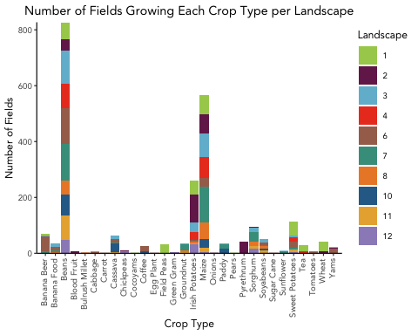

ggsave("A_crops_grown.png", plot = A_crops_grown, device = "png", path = "~/Documents/Bren/GP/3Graphs/Descriptives/",  
 width = 6, height = 4.5, units = c("in"),  
 dpi = 300)

###Cause of Post-Harvest Food Loss

A_food_loss <-   
 ggplot(filter(hh_fieldcrop, ag5a_21 != "NA", country == 'RWA'), aes(x= ag5a_21, fill=factor(landscape_no)))+  
 geom_bar(stat = "count", position = 'stack')+  
 theme_vsr()+  
 theme(axis.text.x = element_text(angle = 90, hjust = 1), plot.title = element_text(hjust = 0.5))+  
 xlab ("Cause of Food Loss")+  
 ylab("Number of Fields")+  
 ggtitle("Cause of Post-Harvest Food Loss by Landscape")+  
 scale_fill_manual(name="Landscape", labels=c("1", "2", "3", "4", "6", "7", "8", "10", "11", "12"), values = c("#a6cd5b", "#752559", "#72bad3", "#eb4024", "#a66f5b", "#449d8b", "#eb8932", "#2c6b96", "#e8af3c", "#9c8dc3"))+  
 scale_x_discrete(expand=c(0.03,0))+  
 scale_y_continuous(expand=c(0,0))  
  
A_food_loss

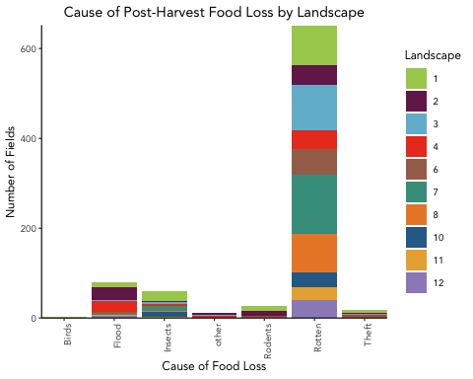

ggsave("A_food_loss.png", plot = A_food_loss, device = "png", path = "~/Documents/Bren/GP/3Graphs/Descriptives/",  
 width = 3.5, height = 4.5, units = c("in"),  
 dpi = 300)

###Soil quality by landscape

#Soil quality by landscape  
A_soil_quality <- ggplot(data = filter(joined_df, ag3a_10 != "NA"), aes(landscape_no, fill=ordered(ag3a_10))) +  
 geom_bar(stat="count", position = "fill")+  
 theme(plot.title = element_text(hjust = 0.5, face="bold"), legend.title=element_text(face="bold"), axis.title=element_text(face="bold"))+  
 xlab("Landscape")+  
 ylab("Soil Quality (as reported by farmers)")+  
 ggtitle("Soil Quality By Landscape")+  
 scale_fill_manual(name="Soil Quality", labels =c("Good", "Average", "Bad"), values = c("#449d8b", "#e8af3c", "#eb4024")) +  
 theme_vsr()+  
 scale_y_continuous(expand=c(0,0))  
  
ggsave("A_soil_quality.png", plot = A_soil_quality, device = "png", path = "~/Documents/Bren/GP/3Graphs/Descriptives/",  
 width = 4.5, height = 3, units = c("in"),  
 dpi = 300)

###Reason for Intercropping

# Reason for intercropping  
A_reason_inter <- ggplot(data=filter(joined_df, ag4a_05 != "NA"), aes(x=ag4a_05, fill=landscape_no))+  
 geom_bar(stat="count")+  
 xlab("Reason for Intercropping")+  
 ylab("Count")+  
 ggtitle("Household Survey of Reported Reasons for Intercropping")+  
 scale_fill_manual(name="Landscape", labels=c("1", "2", "3", "4", "6", "7", "8", "10", "11", "12"), values = c("#a6cd5b", "#752559", "#72bad3", "#eb4024", "#a66f5b", "#449d8b", "#eb8932", "#2c6b96", "#e8af3c", "#9c8dc3"))+  
 scale_y_continuous(expand=c(0,0))+  
 theme_vsr()  
  
A_reason_inter

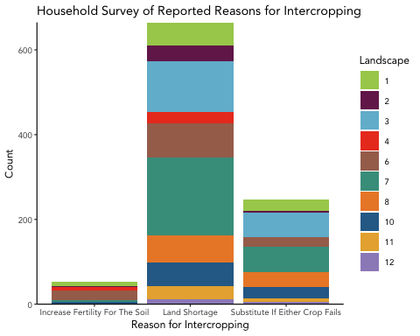

ggsave("A_reason_inter.png", plot = A_reason_inter, device = "png", path = "~/Documents/Bren/GP/3Graphs/Descriptives/",  
 width = 6, height = 3.5, units = c("in"),  
 dpi = 300)

###Use of inputs by landscape and round

####Inorganic Fertilizer

#.404686  
  
A_crop_inorg_fert <- ggplot(data=joined_df, aes(x=ag3a_07_1, y=(ag3a_47/ag4a_08), fill=ag3a_46))+  
 geom_bar(stat="identity")+  
 xlab("Crop type")+  
 ylab("Total amount of inorganic fertilizer applied (kg)")+  
 ggtitle("Inorganic Fertilizer Use by Main Crop Type (Both Rounds)")+  
 theme_vsr()+  
 theme(axis.text.x = element_text(angle = 90, vjust = .4, hjust = 1))+  
 scale_y_continuous(expand=c(0,0))+  
 scale_fill_manual(name ="Fertilizer type", values = wes_palette("Darjeeling1"))  
  
A_crop_inorg_fert

## Warning: Removed 1982 rows containing missing values (position_stack).

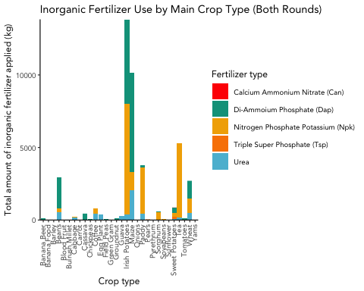

ggsave("A_crop_inorg_fert.png", plot = A_crop_inorg_fert, device = "png", path = "~/Documents/Bren/GP/3Graphs/Descriptives/",  
 width = 6.25, height = 4, units = c("in"),  
 dpi = 300)

## Warning: Removed 1982 rows containing missing values (position_stack).

A_landscape_inorg_fert <- ggplot(data=joined_df, aes(x=landscape_no, y=ag3a_47, fill=round))+  
 geom_bar(stat="identity",position="stack")+  
 xlab("Landscape")+  
 ylab("Total amount of inorganic fertilizer applied (kg)")+  
 ggtitle("Inorganic Fertilizer Use by Landscape and Round")+  
 scale_y_continuous(expand=c(0,0))+  
 scale_x_discrete(labels=c("1", "2", "3", "4", "6", "7", "8", "10", "11", "12"))+  
 theme_vsr()+  
 scale_fill_manual(values =c("#72bad3", "#e8af3c"), name = "Round")  
  
A_landscape_inorg_fert

## Warning: Removed 1982 rows containing missing values (position_stack).

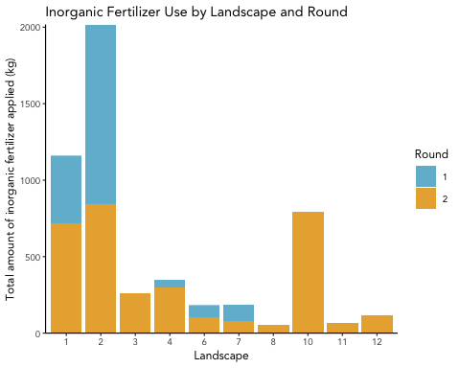

ggsave("A_landscape_inorg_fert.png", plot = A_landscape_inorg_fert, device = "png", path = "~/Documents/Bren/GP/3Graphs/Descriptives/",  
 width = 4.5, height = 3.5, units = c("in"),  
 dpi = 300)

## Warning: Removed 1982 rows containing missing values (position_stack).

####Organic Fertilizer

A_crop_org_fert <- ggplot(data=joined_df, aes(x=ag3a_07_1, y=(ag3a_40/ag4a_08), fill=ag3a_39a))+  
 geom_bar(stat="identity")+  
 xlab("Crop type")+  
 ylab("Total amount of organic fertilizer applied (kg)")+  
 ggtitle("Organic Fertilizer Use by Main Crop Type (Both Rounds)")+  
 theme_vsr()+  
 theme(axis.text.x = element_text(angle = 90, vjust = .4, hjust = 1))+  
 scale_y_continuous(expand=c(0,0))+  
 scale_fill_manual(name ="Fertilizer type", values = wes_palette("Darjeeling1"))  
  
A_crop_org_fert

## Warning: Removed 1262 rows containing missing values (position_stack).

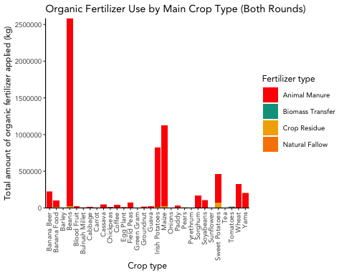

ggsave("A_crop_org_fert.png", plot = A_crop_org_fert, device = "png", path = "~/Documents/Bren/GP/3Graphs/Descriptives/",  
 width = 5.7, height = 4, units = c("in"),  
 dpi = 300)

## Warning: Removed 1262 rows containing missing values (position_stack).

A_landscape_org_fert <- ggplot(data=joined_df, aes(x=landscape_no, y=ag3a_40, fill=round))+  
 geom_bar(stat="identity",position="stack")+  
 xlab("Landscape")+  
 ylab("Total amount of organic fertilizer applied (kg)")+  
 ggtitle("Organic Fertilizer Use by Landscape and Round")+  
 scale_y_continuous(expand=c(0,0))+  
 scale_x_discrete(labels=c("1", "2", "3", "4", "6", "7", "8", "10", "11", "12"))+  
 theme_vsr()+  
 scale_fill_manual(values =c("#72bad3", "#e8af3c"), name = "Round")  
  
A_landscape_org_fert

## Warning: Removed 1262 rows containing missing values (position_stack).

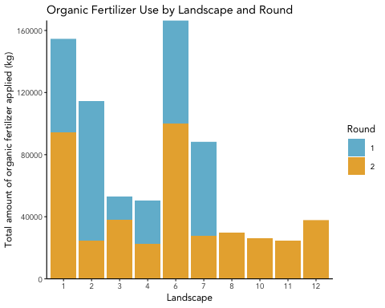

ggsave("A_landscape_org_fert.png", plot = A_landscape_org_fert, device = "png", path = "~/Documents/Bren/GP/3Graphs/Descriptives/",  
 width = 4.7, height = 3.5, units = c("in"),  
 dpi = 300)

## Warning: Removed 1262 rows containing missing values (position_stack).

####Pesticides

A_crop_pest <- ggplot(data=joined_df, aes(x=ag3a_07_1, y=(ag3a_60_1/ag4a_08), fill=ag3a_59))+  
 geom_bar(stat="identity")+  
 xlab("Crop type")+  
 ylab("Total amount of pesticides applied (kg)")+  
 ggtitle("Pesticide Use by Main Crop Type (Both Rounds)")+  
 theme_vsr()+  
 theme(axis.text.x = element_text(angle = 90, vjust = .4, hjust = 1))+  
 scale_y_continuous(expand=c(0,0))+  
 scale_fill_manual(name ="Pesticide type", values = wes_palette("Darjeeling1"))  
  
A_crop_pest

## Warning: Removed 2180 rows containing missing values (position_stack).

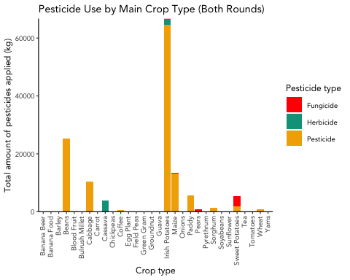

ggsave("A_crop_pest.png", plot = A_crop_pest, device = "png", path = "~/Documents/Bren/GP/3Graphs/Descriptives/",  
 width = 5.25, height = 4, units = c("in"),  
 dpi = 300)

## Warning: Removed 2180 rows containing missing values (position_stack).

A_landscape_pest <- ggplot(data=joined_df, aes(x=landscape_no, y=ag3a_60_1, fill=round))+  
 geom_bar(stat="identity",position="stack")+  
 xlab("Landscape")+  
 ylab("Total amount of pesticides applied (kg)")+  
 ggtitle("Organic Fertilizer Use by Landscape and Round")+  
 scale_y_continuous(expand=c(0,0))+  
 scale_x_discrete(labels=c("1", "2", "3", "4", "6", "7", "8", "10", "11", "12"))+  
 theme_vsr()+  
 scale_fill_manual(values =c("#72bad3", "#e8af3c"), name = "Round")  
  
A_landscape_pest

## Warning: Removed 2180 rows containing missing values (position_stack).

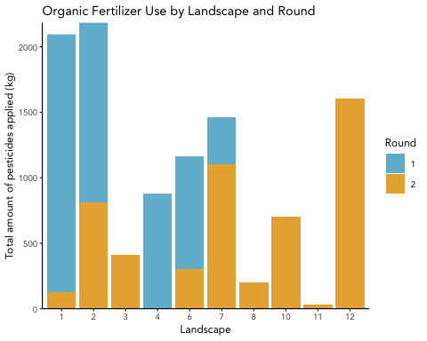

ggsave("A_landscape_pest.png", plot = A_landscape_pest, device = "png", path = "~/Documents/Bren/GP/3Graphs/Descriptives/",  
 width = 4.5, height = 3.5, units = c("in"),  
 dpi = 300)

## Warning: Removed 2180 rows containing missing values (position_stack).

#a. PESTICIDE

Pesticide Use

#Explore pesticide use

#Pesticide use (ag3a_58) (Yes/No) across everything  
ggplot(data=joined_df, aes(ag3a_58))+  
 geom_bar()+  
 xlab("Was Any Pesticide/Herbicide Used On This Field?")+  
 ylab("Number of Responses")+  
 ggtitle("Total Use of Pesticides and Herbicides (All Landscapes/Rounds)")

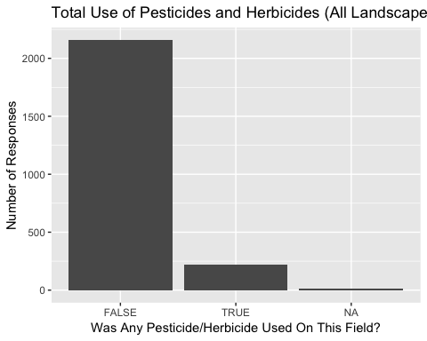

#pesticide use (Yes/No) disaggregated by round

#round 1  
pesticide_r1 <- dplyr::filter(joined_df, round == "1")  
ggplot(data=pesticide_r1, aes(ag3a_58))+  
 geom_bar()+  
 xlab("Was Any Pesticide/Herbicide Used On This Field?")+  
 ylab("Number of Responses")+  
 ggtitle("Total Use of Pesticides and Herbicides, Round 1 (All Landscapes)")

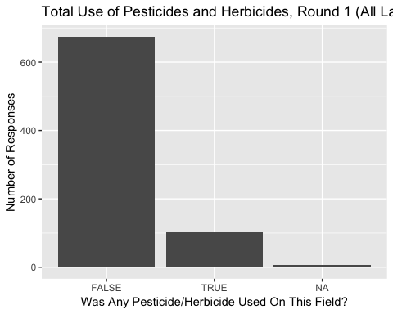

#round 2  
pesticide_r2 <- dplyr::filter(joined_df, round == "2")  
ggplot(data=pesticide_r2, aes(ag3a_58))+  
 geom_bar()+  
 xlab("Was Any Pesticide/Herbicide Used On This Field?")+  
 ylab("Number of Responses")+  
 ggtitle("Total Use of Pesticides and Herbicides, Round 2 (All Landscapes)")

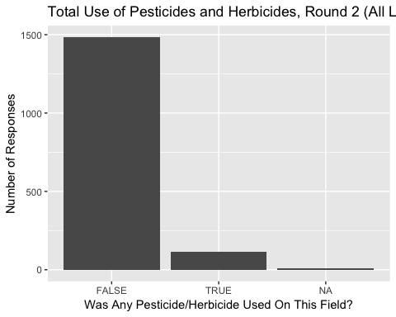

#percentages of households using pesticide (total and by round)  
table(joined_df$ag3a_58)

##   
## FALSE TRUE   
## 2161 217

#F 2158 (%), T 216 (%)  
table(round_1$ag3a_58)

##   
## FALSE TRUE   
## 675 103

#F 675 (%), T 103 (%)  
table(round_2$ag3a_58)

##   
## FALSE TRUE   
## 1486 114

#F 1483 (%), T 113 (%)

#explore types of pesticides used

#total use of pesticide (Yes/No) by type   
ggplot(data=joined_df, aes(ag3a_59))+  
 geom_bar()+  
 xlab("Main type of pesticide/herbicide")+  
 ylab("Number of Responses")+  
 ggtitle("Total Use of Types of Pesticides and Herbicides (All Landscapes/Rounds)")

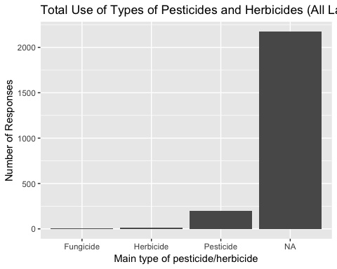

#remove the NA's (people who did not use pesticide)  
pesticide_sans_na <- dplyr::filter(joined_df, ag3a_59 != "na")  
  
#total use of pesticide by type, minus NA's  
ggplot(data=pesticide_sans_na, aes(ag3a_59))+  
 geom_bar()+  
 xlab("Main type of pesticide/herbicide")+  
 ylab("Number of Responses")+  
 ggtitle("Total Use of Types of Pesticides and Herbicides (All Landscapes/Rounds)")

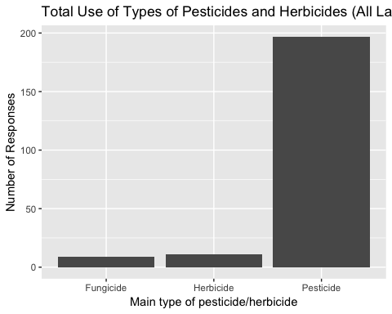

#conclusion: predominantly pesticides, little herbicide or fungicide

#explore the amount of pesticide used in kg

#note some missing data for the amount of pesticide used  
  
#####  
#total amount of pesticide used in kg, by landscape and round  
ggplot(data=joined_df, aes(x=landscape_no, y=pesticide_use_kg, fill=round))+  
 geom_bar(stat="identity",position=position_dodge())+  
 xlab("Landscape")+  
 ylab("Amount of Pesticide Used (Kg)")+  
 ggtitle("Use of Pesticide by Landscape and Round")

## Warning: Removed 19 rows containing missing values (geom_bar).

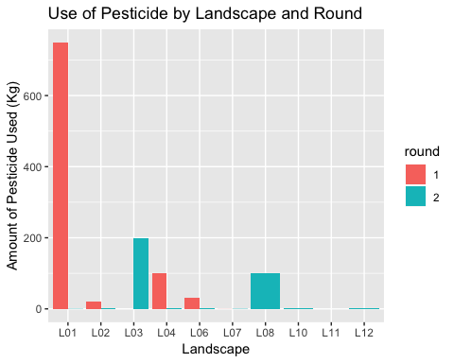

#Landscape 1 round 1 is so high due to 1 750kg entry. Might be an outlier, let's remove.  
table(joined_df$pesticide_use_kg)

##   
## 0 0.002 0.01 0.02 0.025 0.03 0.05 0.1 0.15 0.2 0.25 0.3   
## 2161 2 4 3 2 1 8 44 2 2 14 4   
## 0.5 0.75 1 1.5 2 3 4 5 8 10 20 30   
## 18 1 41 9 21 14 1 4 2 1 2 1   
## 70 75 100 200 750   
## 1 7 2 2 1

pesticide_outlier <- dplyr::filter(joined_df, pesticide_use_kg == "750")  
pesticide_remove_outliers <- dplyr::filter(joined_df, pesticide_use_kg < 750)  
  
#same graph, but with the outlier in landscape 1, round 1 removed  
ggplot(data=pesticide_remove_outliers, aes(x=landscape_no, y=pesticide_use_kg, fill=round))+  
 geom_bar(stat="identity",position=position_dodge())+  
 xlab("Landscape")+  
 ylab("Pesticide Use (Kg)")+  
 ggtitle("Use of Pesticide by Landscape and Round (> 749 Kg Removed)")

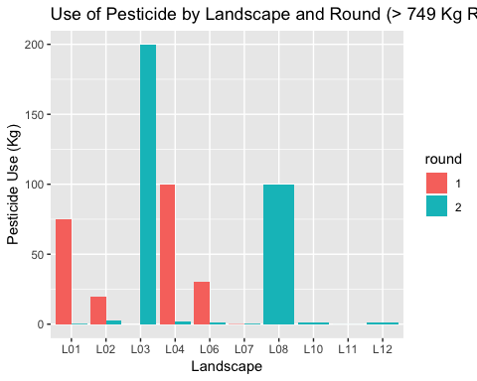

#explore proportion of amount of pesticide used by type, landscape

#proportion of different types of pesticide by landscape  
ggplot(data=joined_df, aes(x=landscape_no, y=pesticide_use_kg, fill=ag3a_59))+  
 geom_bar(stat="identity",position = "fill")+  
 xlab("Landscape")+  
 ylab("Proportion of Type of Pesticed Used")+  
 ggtitle("Type of Pesticide by Landscape (Both Rounds)")

## Warning: Removed 19 rows containing missing values (position_stack).

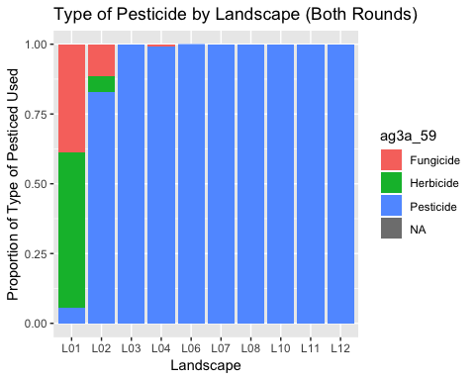

#same graph, outlier removed  
ggplot(data=pesticide_remove_outliers, aes(x=landscape_no, y=pesticide_use_kg, fill=ag3a_59))+  
 geom_bar(stat="identity",position = "fill")+  
 xlab("Landscape")+  
 ylab("Proportion of Type of Pesticed Used")+  
 ggtitle("Type of Pesticide by Landscape (Both Rounds, Outlier Removed)")

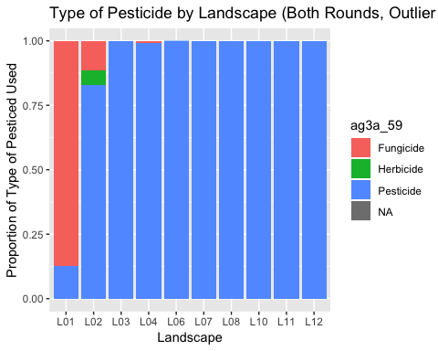

#explore total pesticide used (kg) by main crop type

#pesticide use (kg) by main crop type  
ggplot(data=joined_df, aes(x=ag3a_07_1, y=pesticide_use_kg))+  
 geom_bar(stat="identity")+  
 xlab("Main Crop on Field")+  
 ylab("Amount of Pesticide Used (All Types, Kg)")+  
 ggtitle("Pesticide Use by Main Crop Type (Both Rounds)")+  
 theme(axis.text.x = element_text(angle = 45, hjust = 1))

## Warning: Removed 19 rows containing missing values (position_stack).

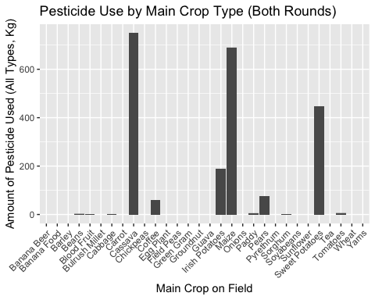

#pesticide use by main crop type, pesticide type  
ggplot(data=joined_df, aes(x=ag3a_07_1, y=pesticide_use_kg, fill=ag3a_59))+  
 geom_bar(stat="identity")+  
 xlab("Main Crop on Field")+  
 ylab("Amount of Pesticide Used (Kg)")+  
 ggtitle("Pesticide Use by Type and Main Crop Type (Both Rounds)")+  
 theme(axis.text.x = element_text(angle = 45, hjust = 1))

## Warning: Removed 19 rows containing missing values (position_stack).

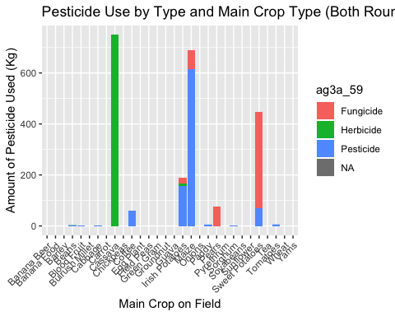

#b. ORGANIC FERTILIZER

#explore fert use (Yes/No)

##BOTH ROUNDS#####  
table(joined_df$ag3a_39)

##   
## FALSE TRUE   
## 967 1411

#did you use organic fertilizer on this field?  
#40% False, 60% True  
  
ggplot(data=joined_df, aes(ag3a_39))+  
 geom_bar()+  
 xlab("Was Any Organic Fertilizer Used On This Field?")+  
 ylab("Number of Responses")+  
 ggtitle("Total Use of Organic Fertilizer (All Landscapes/Rounds)")

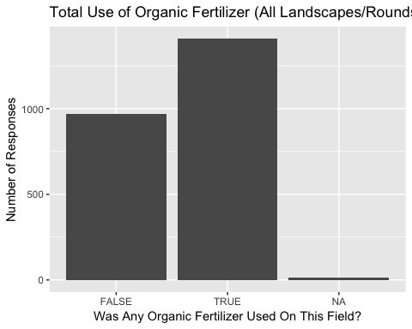

##ROUND 1#####  
table(round_1$ag3a_39)

##   
## FALSE TRUE   
## 329 449

#did you use organic fertilizer on this field?  
#42% False, 58% True  
  
ggplot(data=round_1, aes(ag3a_39))+  
 geom_bar()+  
 xlab("Was Any Organic Fertilizer Used On This Field?")+  
 ylab("Number of Responses")+  
 ggtitle("Total Use of Organic Fertilizer, Round 1 (All Landscapes)")

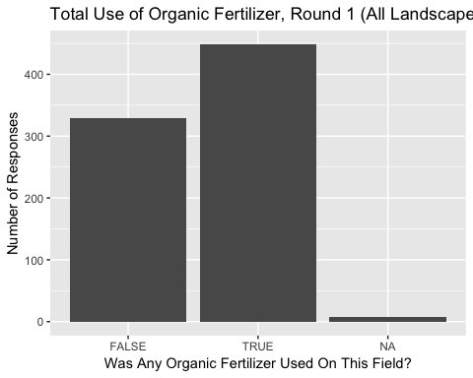

##ROUND 2#####  
table(round_2$ag3a_39)

##   
## FALSE TRUE   
## 638 962

#did you use organic fertilizer on this field?  
#40% False, 60% True  
  
ggplot(data=round_2, aes(ag3a_39))+  
 geom_bar()+  
 xlab("Was Any Organic Fertilizer Used On This Field?")+  
 ylab("Number of Responses")+  
 ggtitle("Total Use of Organic Fertilizer, Round 2 (All Landscapes)")

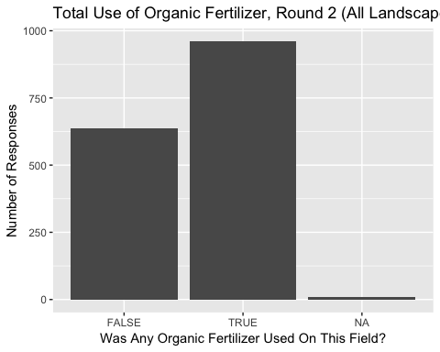

#explore types of org fert (ag3a_39a)

#table of types of organic fertilizer  
table(joined_df$ag3a_39a)

##   
## Animal Manure Biomass Transfer Crop Residue Natural Fallow   
## 1100 2 28 2

#Animal Manure: 97%  
  
#Total use of organic fertilizer by type  
ggplot(data=joined_df, aes(ag3a_39a))+  
 geom_bar()+  
 xlab("Main Source of Organic Fertilizer")+  
 ylab("Number of Responses")+  
 ggtitle("Total Use of Source of Organic Fertilizer (All Landscapes/Rounds)")

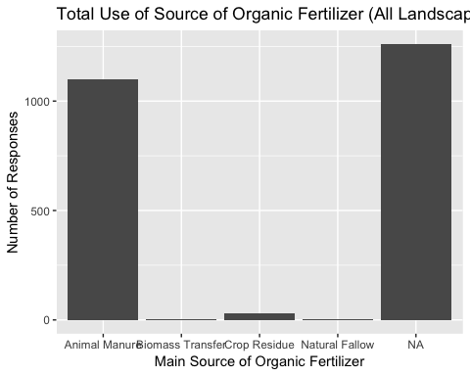

#explore amount of org fert used (kg)

#total amount of fertilizer used in kg, by landscape and round  
ggplot(data=joined_df, aes(x=landscape_no, y=ag3a_40, fill=round))+  
 geom_bar(stat="identity",position="stack")+  
 xlab("Landscape")+  
 ylab("Organic Fertilizer Use (Kg)")+  
 ggtitle("Organic Fertilizer Use by Landscape and Round")+  
 theme_vsr()

## Warning: Removed 1262 rows containing missing values (position_stack).

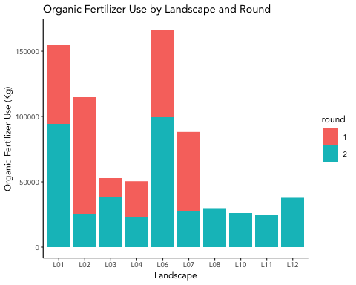

#explored amount of org fert used (kg) by crop

#organic fertilizer used by main crop, organic fertilizer type  
ggplot(data=joined_df, aes(x=ag3a_07_1, y=ag3a_40, fill=ag3a_39a))+  
 geom_bar(stat="identity")+  
 xlab("Main Crop on Field")+  
 ylab("Amount of Organic Fertilizer Used (Kg)")+  
 ggtitle("Organic Fertilizer Use by Main Crop Type (Both Rounds)")+  
 theme(axis.text.x = element_text(angle = 45, hjust = 1))

## Warning: Removed 1262 rows containing missing values (position_stack).

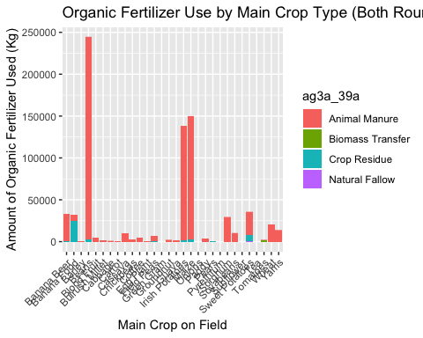

#c. INORGANIC FERTILIZER

Explore use of inorganic fertilizer (Yes/No)

table(joined_df$ag3a_45)

##   
## FALSE TRUE   
## 1965 412

#17% used inorganic fertilizer (both rounds, all landscapes)  
  
#Use of in-fert across all landscapes/rounds  
ggplot(data=joined_df, aes(ag3a_45))+  
 geom_bar()+  
 xlab("Was Any Inorganic Fertilizer Used On This Field?")+  
 ylab("Number of Responses")+  
 ggtitle("Total Use of Inorganic Fertilizer (All Landscapes/Rounds)")

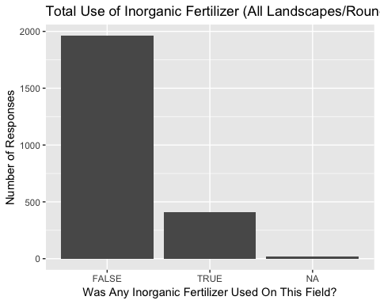

### Use in round 1 ###  
  
table(round_1$ag3a_45)

##   
## FALSE TRUE   
## 649 128

#16% used inorganic fert in round 1  
  
ggplot(data=round_1, aes(ag3a_45))+  
 geom_bar()+  
 xlab("Was Any Inorganic Fertilizer Used On This Field?")+  
 ylab("Number of Responses")+  
 ggtitle("Total Use of Inorganic Fertilizer, Round 1 (All Landscapes)")

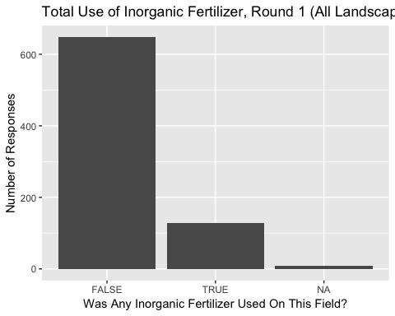

### Use in round 2 ###  
  
table(round_2$ag3a_45)

##   
## FALSE TRUE   
## 1316 284

#18% used inorganic fert in round 2  
  
ggplot(data=round_2, aes(ag3a_45))+  
 geom_bar()+  
 xlab("Was Any Inorganic Fertilizer Used On This Field?")+  
 ylab("Number of Responses")+  
 ggtitle("Total Use of Inorganic Fertilizer, Round 2 (All Landscapes)")

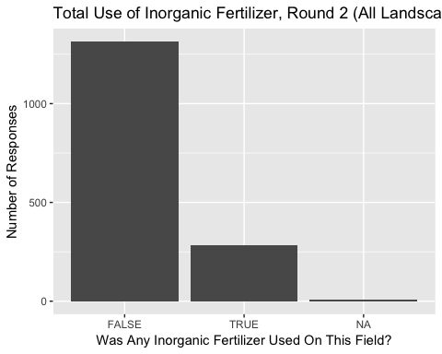

### Mean amount of inorganic fertilizer used ###  
  
mean(joined_df$ag3a_47, na.rm = TRUE)

## [1] 12.56311

#mean inorg fert used: 16 Kg

#Explore types of inorganic fertilizer

#table of types of inorganic fertilizer  
table(joined_df$ag3a_46)

##   
## Calcium Ammonium Nitrate (Can) Di-Ammoium Phosphate (Dap)   
## 1 171   
## Nitrogen Phosphate Potassium (Npk) Triple Super Phosphate (Tsp)   
## 165 6   
## Urea   
## 69

#remove NA entries for infert  
infert_type_df <- dplyr::filter(joined_df, ag3a_46 != "NA")  
  
#plot types of infert  
ggplot(data=infert_type_df, aes(ag3a_46))+  
 geom_bar()+  
 xlab("Main Type of Inorganic Fertilizer Used")+  
 ylab("Number of Responses")+  
 ggtitle("Total Use of Type of Inorganic Fertilizer (All Landscapes/Rounds)")+  
 theme(axis.text.x = element_text(angle = 10, hjust = 1))

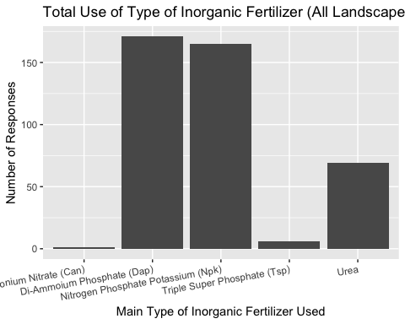

#Explore amount of inorganic fertilizer used by landscape and round

#total amount of fertilizer used in kg, by landscape and round  
ggplot(data=joined_df, aes(x=landscape_no, y=ag3a_47, fill=round))+  
 geom_bar(stat="identity",position="stack")+  
 xlab("Landscape")+  
 ylab("Inorganic Fertilizer Use (Kg)")+  
 ggtitle("Inorganic Fertilizer Use by Landscape and Round")

## Warning: Removed 1982 rows containing missing values (position_stack).

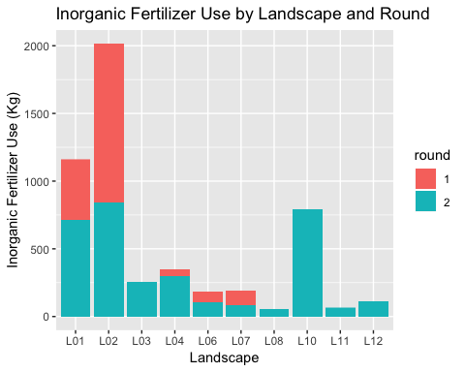

#Proportion of type of inorganic fertilizer used by landscape  
ggplot(data=joined_df, aes(x=landscape_no, y=ag3a_47, fill=ag3a_46))+  
 geom_bar(stat="identity",position = "fill")+  
 xlab("Landscape")+  
 ylab("Proportion of Type of Inorganic Fertilizer Used")+  
 ggtitle("Type of Inorganic Fertilizer by Landscape (Both Rounds)")

## Warning: Removed 1982 rows containing missing values (position_stack).

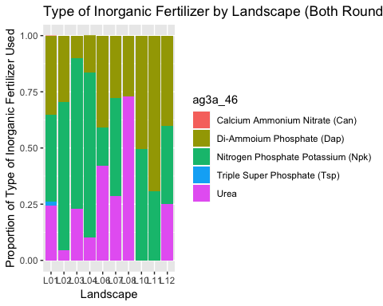

#Explore inorganic crop use by main crop type, fertilizer type

ggplot(data=joined_df, aes(x=ag3a_07_1, y=ag3a_47, fill=ag3a_46))+  
 geom_bar(stat="identity")+  
 xlab("Main Crop on Field")+  
 ylab("Amount of Inorganic Fertilizer Used (Kg)")+  
 ggtitle("Inorganic Fertilizer Use by Main Crop Type (Both Rounds)")+  
 theme(axis.text.x = element_text(angle = 45, hjust = 1))

## Warning: Removed 1982 rows containing missing values (position_stack).

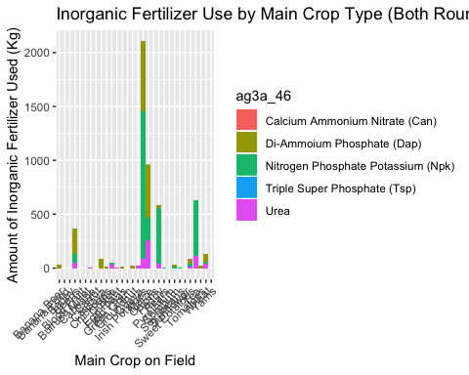

#d. Quantity of Crop Harvest

#Sum kg for crops   
totalharvest_graph <- aggregate(ag4a_15 ~ crop_name, fieldcrop, sum)   
area_harvestgraph <- aggregate(kg_perha_planted ~ crop_name, joined_df, sum)  
  
#Quantity of Crop Harvest (kg)  
ggplot(totalharvest_graph, aes(x= crop_name, y= ag4a_15))+  
 geom_bar(stat = "identity")+  
 theme(axis.text.x = element_text(angle = 90, hjust = 1, vjust = 0.3))+  
 xlab ("Crop")+  
 ylab("Total Harvest (kg)")+  
 ggtitle("Quantity of Crop Harvest (kg)")

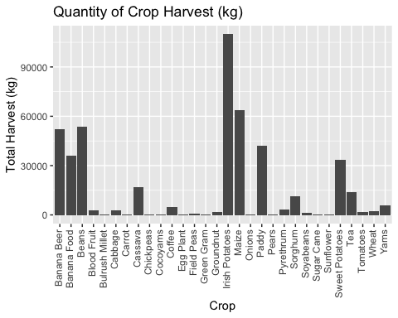

#Quantity of Harvest by kg/Hectare  
ggplot(area_harvestgraph, aes(x= crop_name, y= kg_perha_planted))+  
 geom_bar(stat = "identity")+  
 theme(axis.text.x = element_text(angle = 90, hjust = 1, vjust = 0.3))+  
 xlab("Crop Name")+  
 ylab("Kilograms of Harvest per Hectare Planted")+  
 ggtitle("Quantity of Crop Harvest (kg/hectare planted)")

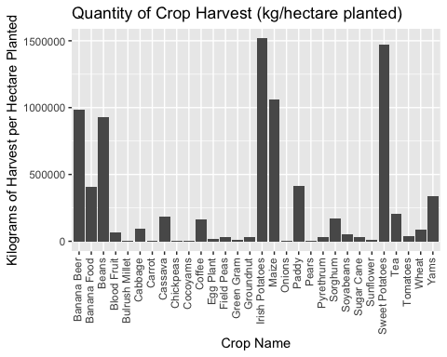

#Count of Total Crop Harvest by Landscape  
ggplot(fieldcrop, aes(x= crop_name, fill=factor(landscape_no)))+  
 geom_bar(stat = "count", position = 'stack')+  
 theme(axis.text.x = element_text(angle = 90, hjust = 1, vjust = 0.3), plot.title = element_text(hjust = 0.5, face="bold"), legend.title=element_text(face="bold"), axis.title=element_text(face="bold"))+  
 xlab ("Crop")+  
 ylab("Total Harvest (kg)")+  
 ggtitle("Quantity of Total Crop Harvest by Landscape")+  
 scale_fill_discrete(name = "Landscape",  
labels = c("Nyungwe", "Volcanoes", "Akagera", "Gishwati", "Muhanga-Kamonyi", "Bugesera"))

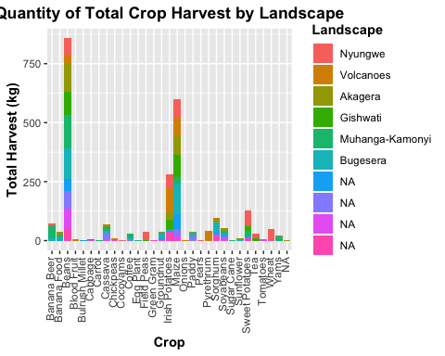

#Crop Yield by Landscape (kg/hectare planted)  
ggplot(joined_df, aes(x= crop_name, y= kg_perha_planted, fill=factor(landscape_no)))+  
 geom_bar(stat = "identity", position = 'stack')+  
 theme(axis.text.x = element_text(angle = 90, hjust = 1, vjust=.3), plot.title = element_text(hjust = 0.5, face="bold"), legend.title=element_text(face="bold"), axis.title=element_text(face="bold"))+  
 xlab ("Crop")+  
 ylab("Yield of Harvest (kg/ha planted)")+  
 ggtitle("Yield by Crop Type")+  
 scale_fill_discrete(name = "Landscape",  
labels = c("Nyungwe", "Volcanoes", "Akagera", "Gishwati", "Muhanga-Kamonyi", "Bugesera"))

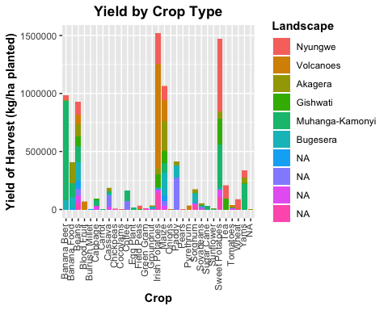

#Isolate landscape dfs and make graphs by landscape. Both rounds included in these graphs  
fieldcrop_L01 <- dplyr::filter(fieldcrop, country == 'RWA', ag4a_15_unit == 'Kg', ag4a_15 != "na", landscape_no =='L01')  
fieldcrop_L02 <- dplyr::filter(fieldcrop, country == 'RWA', ag4a_15_unit == 'Kg', ag4a_15 != "na", landscape_no =='L02')  
fieldcrop_L03 <- dplyr::filter(fieldcrop, country == 'RWA', ag4a_15_unit == 'Kg', ag4a_15 != "na", landscape_no =='L03')  
fieldcrop_L04 <- dplyr::filter(fieldcrop, country == 'RWA', ag4a_15_unit == 'Kg', ag4a_15 != "na", landscape_no =='L04')  
fieldcrop_L06 <- dplyr::filter(fieldcrop, country == 'RWA', ag4a_15_unit == 'Kg', ag4a_15 != "na", landscape_no =='L06')  
fieldcrop_L07 <- dplyr::filter(fieldcrop, country == 'RWA', ag4a_15_unit == 'Kg', ag4a_15 != "na", landscape_no =='L07')  
fieldcrop_L08 <- dplyr::filter(fieldcrop, country == 'RWA', ag4a_15_unit == 'Kg', ag4a_15 != "na", landscape_no =='L08')  
fieldcrop_L10 <- dplyr::filter(fieldcrop, country == 'RWA', ag4a_15_unit == 'Kg', ag4a_15 != "na", landscape_no =='L10')  
fieldcrop_L11 <- dplyr::filter(fieldcrop, country == 'RWA', ag4a_15_unit == 'Kg', ag4a_15 != "na", landscape_no =='L11')  
fieldcrop_L12 <- dplyr::filter(fieldcrop, country == 'RWA', ag4a_15_unit == 'Kg', ag4a_15 != "na", landscape_no =='L12')  
  
totalharvest_L01 <- aggregate(ag4a_15 ~ crop_name, fieldcrop_L01, sum) # sum kg for crops   
totalharvest_L02 <- aggregate(ag4a_15 ~ crop_name, fieldcrop_L02, sum) # sum kg for crops   
totalharvest_L03 <- aggregate(ag4a_15 ~ crop_name, fieldcrop_L03, sum) # sum kg for crops   
totalharvest_L04 <- aggregate(ag4a_15 ~ crop_name, fieldcrop_L04, sum) # sum kg for crops   
totalharvest_L06 <- aggregate(ag4a_15 ~ crop_name, fieldcrop_L06, sum) # sum kg for crops   
totalharvest_L07 <- aggregate(ag4a_15 ~ crop_name, fieldcrop_L07, sum) # sum kg for crops   
totalharvest_L08 <- aggregate(ag4a_15 ~ crop_name, fieldcrop_L08, sum) # sum kg for crops   
totalharvest_L10 <- aggregate(ag4a_15 ~ crop_name, fieldcrop_L10, sum) # sum kg for crops   
totalharvest_L11 <- aggregate(ag4a_15 ~ crop_name, fieldcrop_L11, sum) # sum kg for crops   
totalharvest_L12 <- aggregate(ag4a_15 ~ crop_name, fieldcrop_L12, sum) # sum kg for crops   
  
#Quantity of harvest by landscape  
ggplot(totalharvest_L01, aes(x= crop_name, y= ag4a_15))+  
 geom_bar(stat = "identity")+  
 xlab ("Crop")+  
 ylab("Total Harvest (kg)")+  
 ggtitle("Quantity of Crop Harvest for Nyungwe")+  
 theme(axis.text.x = element_text(angle = 90, hjust = 1), plot.title = element_text(hjust = 0.5, face="bold"), legend.title=element_text(face="bold"), axis.title=element_text(face="bold"))

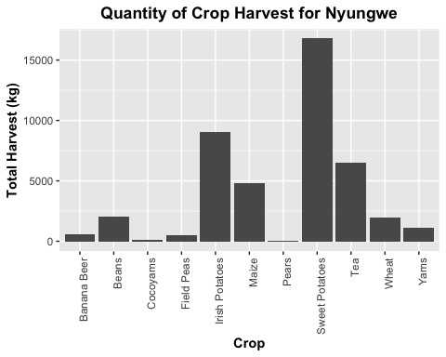

ggplot(totalharvest_L02, aes(x= crop_name, y= ag4a_15))+  
 geom_bar(stat = "identity")+  
 xlab ("Crop")+  
 ylab("Total Harvest (kg)")+  
 ggtitle("Quantity of Crop Harvest for Volcanoes")+  
 theme(axis.text.x = element_text(angle = 90, hjust = 1), plot.title = element_text(hjust = 0.5, face="bold"), legend.title=element_text(face="bold"), axis.title=element_text(face="bold"))

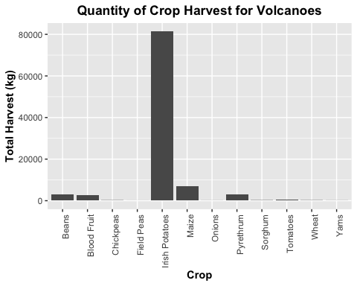

ggplot(totalharvest_L03, aes(x= crop_name, y= ag4a_15))+  
 geom_bar(stat = "identity")+  
 xlab ("Crop")+  
 ylab("Total Harvest (kg)")+  
 ggtitle("Quantity of Crop Harvest for Akagera")+  
 theme(axis.text.x = element_text(angle = 90, hjust = 1), plot.title = element_text(hjust = 0.5, face="bold"), legend.title=element_text(face="bold"), axis.title=element_text(face="bold"))

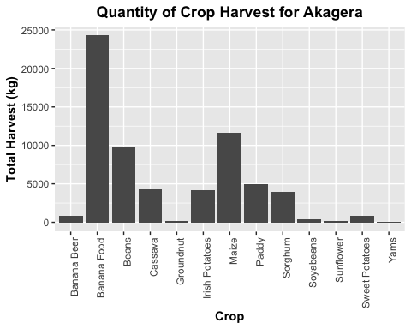

ggplot(totalharvest_L04, aes(x= crop_name, y= ag4a_15))+  
 geom_bar(stat = "identity")+  
 xlab ("Crop")+  
 ylab("Total Harvest (kg)")+  
 ggtitle("Quantity of Crop Harvest for Gishwati")+  
 theme(axis.text.x = element_text(angle = 90, hjust = 1), plot.title = element_text(hjust = 0.5, face="bold"), legend.title=element_text(face="bold"), axis.title=element_text(face="bold"))

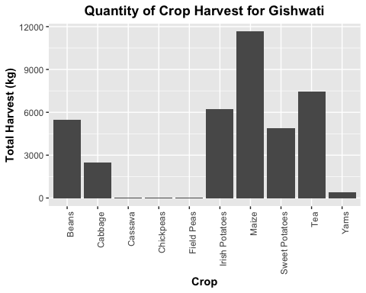

ggplot(totalharvest_L06, aes(x= crop_name, y= ag4a_15))+  
 geom_bar(stat = "identity")+  
 xlab ("Crop")+  
 ylab("Total Harvest (kg)")+  
 ggtitle("Quantity of Crop Harvest for Muhanga-Kamonyi")+  
 theme(axis.text.x = element_text(angle = 90, hjust = 1), plot.title = element_text(hjust = 0.5, face="bold"), legend.title=element_text(face="bold"), axis.title=element_text(face="bold"))

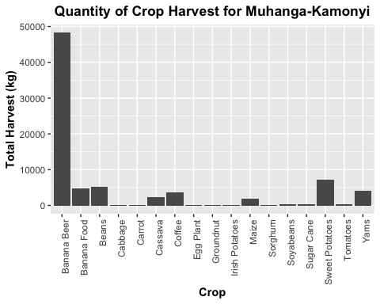

ggplot(totalharvest_L07, aes(x= crop_name, y= ag4a_15))+  
 geom_bar(stat = "identity")+  
 xlab ("Crop")+  
 ylab("Total Harvest (kg)")+  
 ggtitle("Quantity of Crop Harvest for Bugesera")+  
 theme(axis.text.x = element_text(angle = 90, hjust = 1), plot.title = element_text(hjust = 0.5, face="bold"), legend.title=element_text(face="bold"), axis.title=element_text(face="bold"))

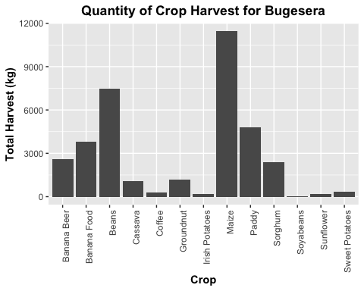

ggplot(totalharvest_L08, aes(x= crop_name, y= ag4a_15))+  
 geom_bar(stat = "identity")+  
 xlab ("Crop")+  
 ylab("Total Harvest (kg)")+  
 ggtitle("Quantity of Crop Harvest for L08")+  
 theme(axis.text.x = element_text(angle = 90, hjust = 1), plot.title = element_text(hjust = 0.5, face="bold"), legend.title=element_text(face="bold"), axis.title=element_text(face="bold"))

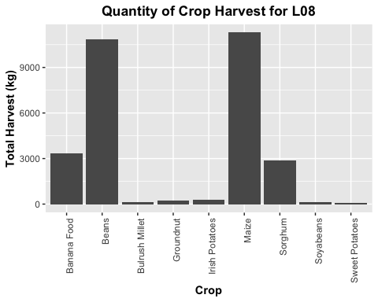

ggplot(totalharvest_L10, aes(x= crop_name, y= ag4a_15))+  
 geom_bar(stat = "identity")+  
 xlab ("Crop")+  
 ylab("Total Harvest (kg)")+  
 ggtitle("Quantity of Crop Harvest for L10")+  
 theme(axis.text.x = element_text(angle = 90, hjust = 1), plot.title = element_text(hjust = 0.5, face="bold"), legend.title=element_text(face="bold"), axis.title=element_text(face="bold"))

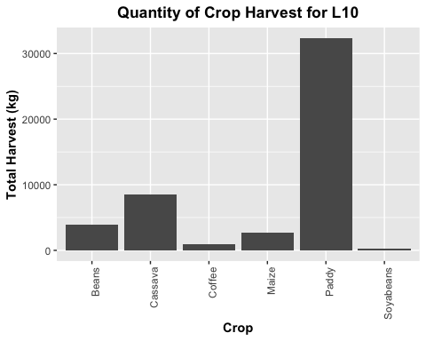

ggplot(totalharvest_L11, aes(x= crop_name, y= ag4a_15))+  
 geom_bar(stat = "identity")+  
 xlab ("Crop")+  
 ylab("Total Harvest (kg)")+  
 ggtitle("Quantity of Crop Harvest for L11")+  
 theme(axis.text.x = element_text(angle = 90, hjust = 1), plot.title = element_text(hjust = 0.5, face="bold"), legend.title=element_text(face="bold"), axis.title=element_text(face="bold"))

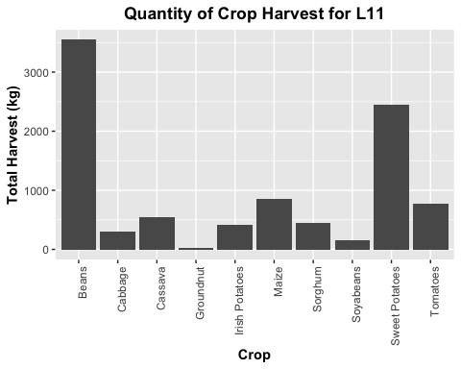

ggplot(totalharvest_L12, aes(x= crop_name, y= ag4a_15))+  
 geom_bar(stat = "identity")+  
 xlab ("Crop")+  
 ylab("Total Harvest (kg)")+  
 ggtitle("Quantity of Crop Harvest for L12")+  
 theme(axis.text.x = element_text(angle = 90, hjust = 1), plot.title = element_text(hjust = 0.5, face="bold"), legend.title=element_text(face="bold"), axis.title=element_text(face="bold"))

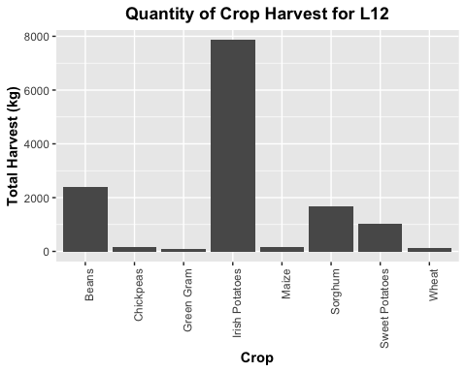

#e. Reason for Intercropping

library(RColorBrewer)  
  
  
   
ggplot(data=filter(joined_df, ag4a_05 != "NA"), aes(x=ag4a_05))+  
 geom_bar(stat="count")+  
 xlab("Reason for Intercropping")+  
 ylab("Frequency")+  
 ggtitle("Household Survey of Reported Reasons for Intercropping")+  
 scale_fill_manual(values=c("firebrick1", "darkorange", "deepskyblue3"))+  
 theme_minimal()

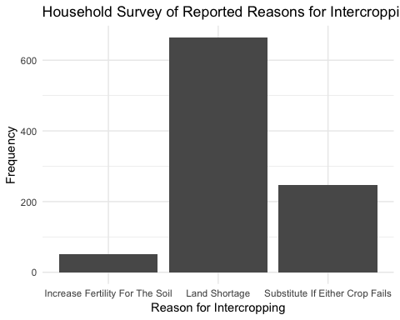

plot

## function (x, y, ...)   
## UseMethod("plot")  
## <bytecode: 0x7f91da4e4fb8>  
## <environment: namespace:graphics>

#ag4a_05 - What is the reason for this intercropping?

#f. Soil Quality

#intercrop subset  
jdf_intercrop <- filter(joined_df, crop_name == "Irish Potatoes" | crop_name == "Maize" | crop_name == "Sorghum" | crop_name == "Sweet Potatoes" | crop_name == "Banana Beer" | crop_name == "Banana Food" | crop_name == "Beans" | crop_name == "Field Peas")  
  
#Soil quality as a function of intercropping  
ggplot(data = filter(jdf_intercrop, ag3a_10 != "NA"), aes(ag4a_04, fill=ordered(ag3a_10, levels=c("Good", "Average", "Bad")))) +  
 geom_bar(stat="count", position = "fill")+  
 theme(plot.title = element_text(hjust = 0.5, face="bold"), legend.title=element_text(face="bold"), axis.title=element_text(face="bold"))+  
 xlab("Plot Was Intercropped?")+  
 ylab("Soil Quality (as reported by farmers)")+  
 ggtitle("Soil Quality as a Function of Intercropping")+  
 scale_fill_discrete(name="Soil Quality", labels =c("Good", "Average", "Bad"))

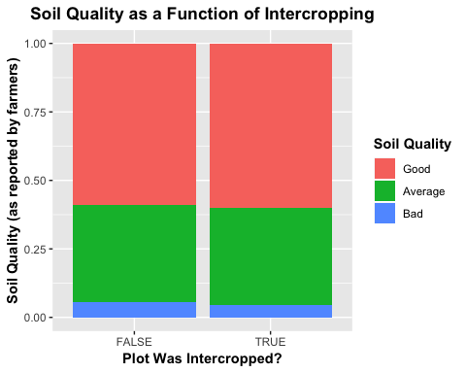

#Soil quality by landscape  
ggplot(data = filter(joined_df, ag3a_10 != "NA"), aes(landscape_no, fill=ordered(ag3a_10))) +  
 geom_bar(stat="count", position = "fill")+  
 theme(plot.title = element_text(hjust = 0.5, face="bold"), legend.title=element_text(face="bold"), axis.title=element_text(face="bold"))+  
 xlab("Landscape")+  
 ylab("Soil Quality (as reported by farmers)")+  
 ggtitle("Soil Quality By Landscape")+  
 scale_fill_discrete(name="Soil Quality", labels =c("Good", "Average", "Bad"))

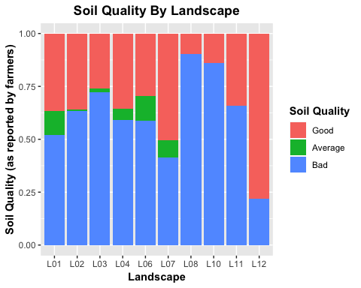

#g. Crop residue use

#Crop residue use in Rwanda  
ggplot(filter(hh_fieldcrop, country == 'RWA', ag5a_24 != "NA"), aes(ag5a_24)) + geom_histogram(stat = "count", bins = 20) +  
 ggtitle("Crop residue use") + theme(axis.title.x=element_blank(), axis.text.x = element_text(angle = 90, hjust = 1, vjust=.3), plot.title = element_text(hjust = 0.5, face="bold"), legend.title=element_text(face="bold"), axis.title=element_text(face="bold"))

## Warning: Ignoring unknown parameters: binwidth, bins, pad

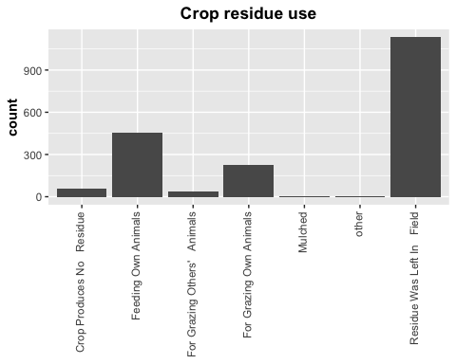

#Crop residue use as a function of country  
ggplot(filter(hh_fieldcrop, ag5a_24 != "NA"), aes(ag5a_24)) + geom_histogram(stat = "count", bins = 20) +  
 ggtitle("Crop residue use") + theme(axis.title.x=element_blank(), axis.text.x = element_text(angle = 90, hjust = 1, vjust=.3), plot.title = element_text(hjust = 0.5, face="bold"), legend.title=element_text(face="bold"), axis.title=element_text(face="bold"))+facet_grid(.~country)

## Warning: Ignoring unknown parameters: binwidth, bins, pad

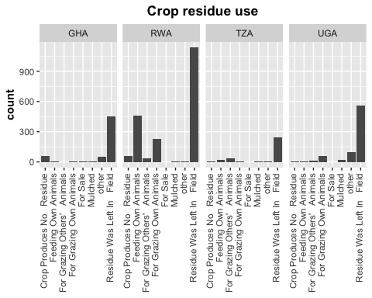

#Crop residue use by landscape in Rwanda  
ggplot(filter(hh_fieldcrop, country == 'RWA', ag5a_24 != "NA"), aes(x= ag5a_24, fill=factor(landscape_no)))+  
 geom_bar(stat = "count", position = 'stack')+  
 theme_classic()+  
 theme(axis.text.x = element_text(angle = 60, hjust = 1), plot.title = element_text(hjust = 0.5, face="bold"), legend.title=element_text(face="bold"), axis.title=element_text(face="bold"))+  
 xlab ("Crop residue use")+  
 ylab("Count")+  
 ggtitle("Crop residue use by Landscape")+  
 scale_fill_discrete(name = "Landscape")

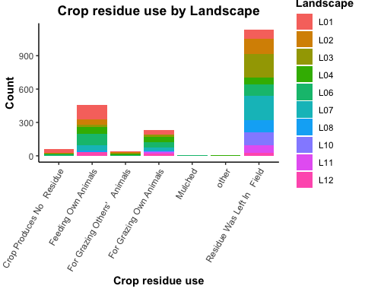

#h. Food Loss

#histogram food loss in Rwanda  
ggplot(filter(hh_fieldcrop, ag5a_21 != "NA", country == 'RWA'), aes(ag5a_21)) + geom_histogram(stat = "count", bins = 20) +  
 ggtitle("Cause of Food Loss") + theme(axis.title.x=element_blank(), axis.text.x = element_text(angle = 90, hjust = 1, vjust=.3), plot.title = element_text(hjust = 0.5, face="bold"), legend.title=element_text(face="bold"), axis.title=element_text(face="bold"))

## Warning: Ignoring unknown parameters: binwidth, bins, pad

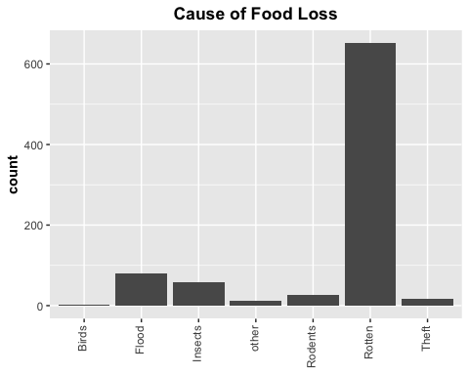

#histogram food loss ~ country  
ggplot(filter(hh_fieldcrop, ag5a_21 != "NA"), aes(ag5a_21)) + geom_histogram(stat = "count", bins = 20) +  
 ggtitle("Cause of Food Loss") + theme(axis.title.x=element_blank(), axis.text.x = element_text(angle = 90, hjust = 1, vjust=.3), plot.title = element_text(hjust = 0.5, face="bold"), legend.title=element_text(face="bold"), axis.title=element_text(face="bold"))+facet_grid(.~country)

## Warning: Ignoring unknown parameters: binwidth, bins, pad

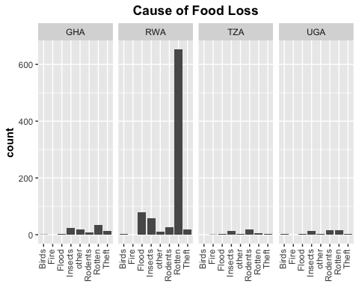

#histogram food loss ~ landscape  
ggplot(filter(hh_fieldcrop, ag5a_21 != "NA", country == 'RWA'), aes(ag5a_21)) + geom_histogram(stat = "count", bins = 20) +  
 ggtitle("Cause of Food Loss") + theme(axis.title.x=element_blank(), axis.text.x = element_text(angle = 90, hjust = 1, vjust=.3), plot.title = element_text(hjust = 0.5, face="bold"), legend.title=element_text(face="bold"), axis.title=element_text(face="bold"))+facet_grid(.~landscape_no)

## Warning: Ignoring unknown parameters: binwidth, bins, pad

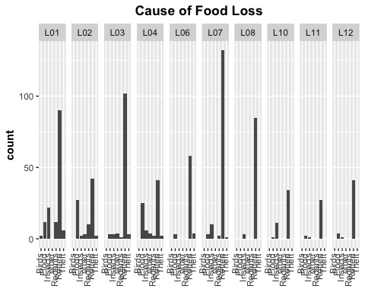

#stacked bar graph food loss ~ landscape  
ggplot(filter(hh_fieldcrop, ag5a_21 != "NA", country == 'RWA'), aes(x= ag5a_21, fill=factor(landscape_no)))+  
 geom_bar(stat = "count", position = 'stack')+  
 theme_classic()+  
 theme(axis.text.x = element_text(angle = 45, hjust = 1), plot.title = element_text(hjust = 0.5, face="bold"), legend.title=element_text(face="bold"), axis.title=element_text(face="bold"))+  
 xlab ("Cause of Food Loss")+  
 ylab("Count")+  
 ggtitle("Cause of Post-Harvest Food Loss by Landscape")+  
 scale_fill_discrete(name = "Landscape")

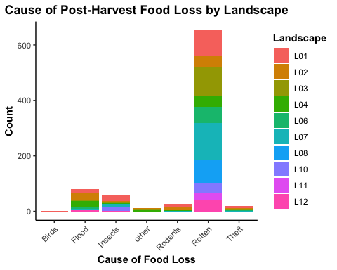

#stacked bar graph food loss ~ country  
ggplot(filter(hh_fieldcrop, ag5a_21 != "NA"), aes(country, fill=ordered(ag5a_21))) +  
 geom_bar(stat="count", position = "fill")+  
 theme(plot.title = element_text(hjust = 0.5, face="bold"), legend.title=element_text(face="bold"), axis.title=element_text(face="bold"))+  
 xlab("Country")+  
 ylab("Percentage of Total Loss")+  
 ggtitle("Cause of Post-Harvest Food Loss by Country")+  
 scale_fill_discrete(name="Cause of Food Loss")

