**Assignment 5**

**Overview:** This is a continuation to the previous assignment, this part of the assignment is aimed at understanding advanced SQL functions, subqueries, set operations, and DDL/DML commands in Oracle SQL.

1. Oracle SQL Functions
   * **Single-Row Functions:** Use functions like UPPER, LOWER, TRIM, SUBSTR, and LENGTH to manipulate character data.
     + Get the length of each student's name

**Answer:**

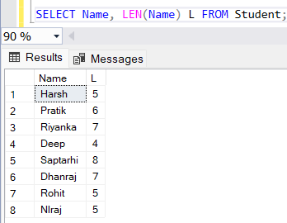

* + - Convert student names to uppercase

**Answer:**

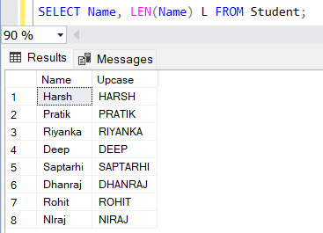

* + - Convert course names to lowercase

**Answer:**

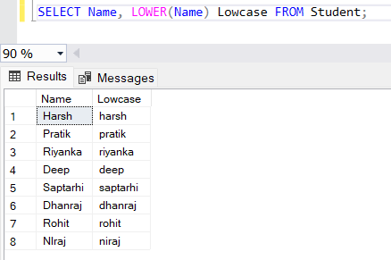

* + - Trim any extra spaces from the name of the student

**Answer:**

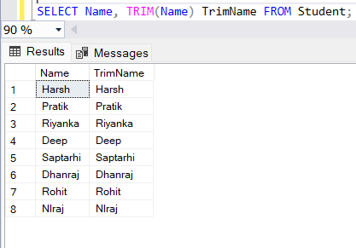

* + - Extract the first 3 characters from course names

**Answer:**

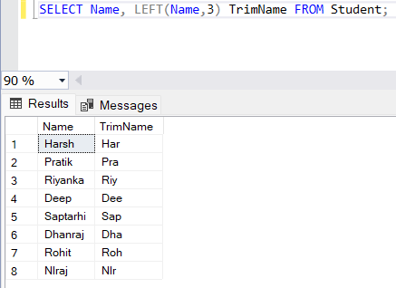

* **Date and Numeric Functions:** Use functions like SYSDATE, TO_DATE, and ROUND to work with date and numeric data.
  + Retrieve the current system date

**Answer:**

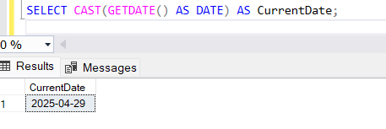

* + Convert a string into a date (e.g., student birthdate in 'DD-Mon-YYYY' format)

**Answer:**

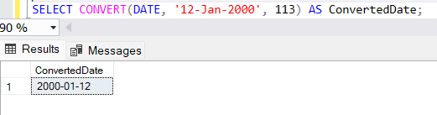

* + Round the total price of a course (e.g., rounded to two decimal places)

**Answer:**

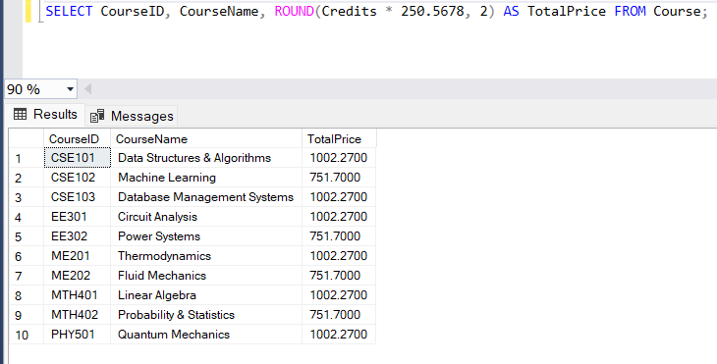

* **Nested Functions:** Write queries using nested functions.
  + Find the length of the uppercase version of the student's name

**Answer:**

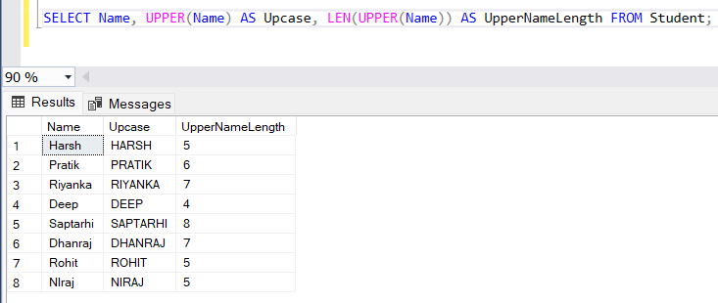

* + Convert the student's birthdate to a string and then extract the year from it

**Answer:** 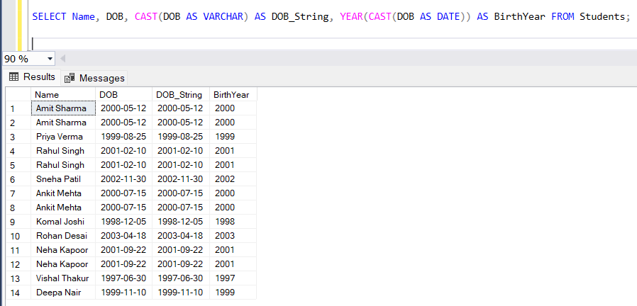

* **Conversion Functions:** Use functions like TO_CHAR, NVL, NULLIF, and COALESCE to convert or handle NULL values in queries.
  + Convert the course credits to a string and display it with ' credits'

**Answer:**

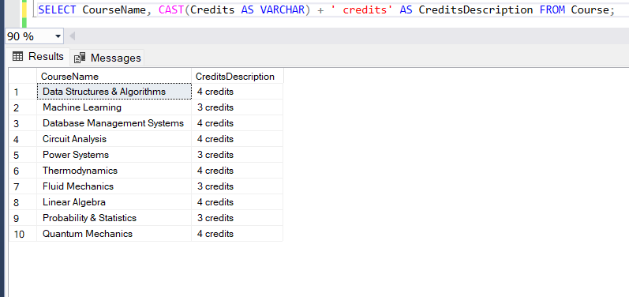

* + Replace NULL with 'Not Available' in faculty department information

**Answer:**

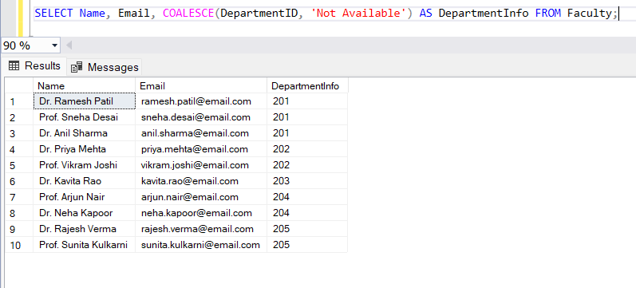

* + Use NULLIF to avoid division by zero (if Credits = 0)

**Answer:**

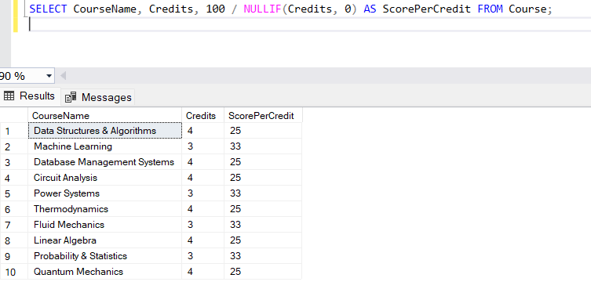

* + Use COALESCE to return the first non-null value (for a student's optional email)

**Answer:**

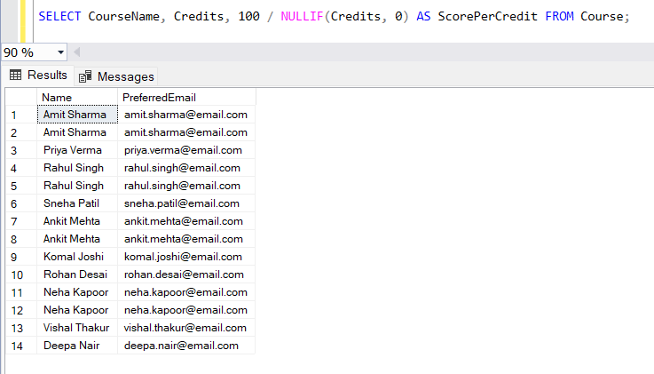

1. Subqueries:
   * **Single-Row and Multiple-Row Subqueries:** Write subqueries to retrieve a single or multiple rows.
     + Retrieve the name of the student enrolled in the course with ID 101

**Answer:** 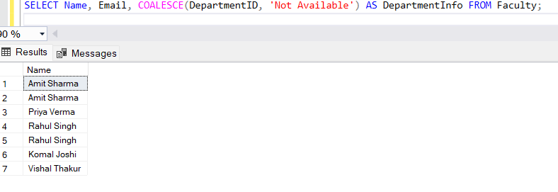

* + - Retrieve names of students enrolled in courses with IDs 101, 102, or 103

**Answer:**

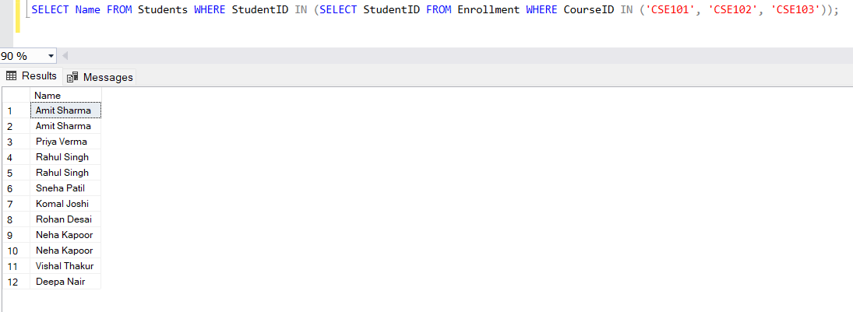

* **Multiple Column Subqueries:** Use subqueries that return multiple columns.
  + Retrieve students enrolled in a specific course (subquery returns multiple columns)

**Answer:**

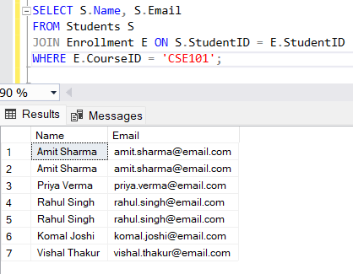

1. DDL and DML Commands:
   * **Data Definition Language (DDL):** Create, alter, and drop tables using the CREATE, ALTER, and DROP commands.
     + Use TRUNCATE command to delete the data inside Student table

**Answer:**

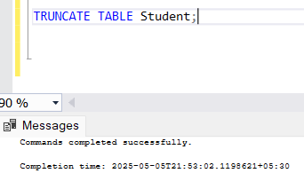

* + - Drop the Student table

**Answer:**

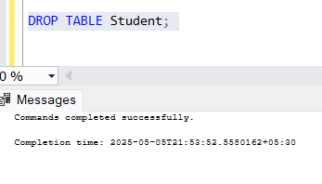

* + - Create the same table for Student, as it was originally

**Answer:**

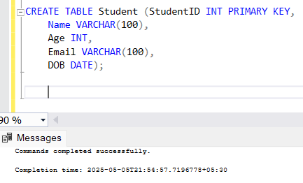

* + - Rename the table to Stud_details and again to Student

**Answer:**

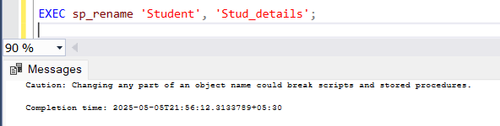

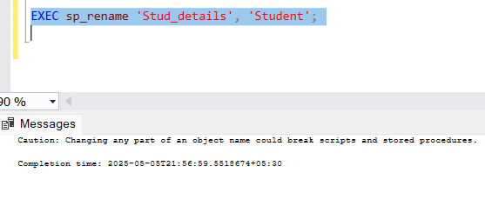

* + - Alter the Student table to add a new columns for City, State.

**Answer:**

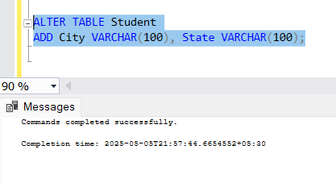

* **Data Manipulation Language (DML):** Insert, update, and delete records in tables.
  + Completely experiment using these, Implement a couple of queries for each.

**Answer:**

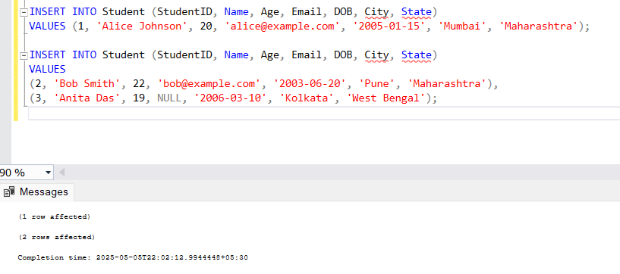

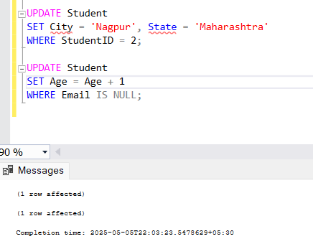

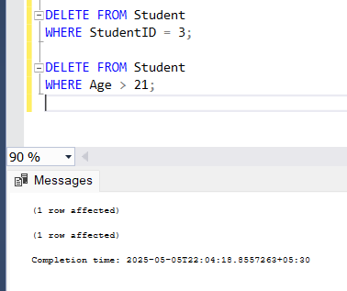

1. Deliverables (How and what to submit):
   * Students should take complete screenshots or log the output from their SQL queries executed on the database.
     + Provide output for each query you write (e.g., a screenshot of the result).
     + Make sure the test results correspond to the queries, showing that the queries return the expected results.
     + Submit the screenshots/logs as part of the .zip file or as separate images in the submission.
     + Comments should also include any assumptions or considerations (e.g., if specific data is missing or if there are any optimizations).