# A Quantitative Model for Optimizing Academic Anesthesiology Recruitment: A Short Report

**To the Editor,**

The recruitment and retention of anesthesiology faculty in academic medical centers has become increasingly challenging amid a highly competitive labor market[1][2]. We propose a novel, quantitative model for optimizing recruitment offers by conceptualizing the relationship between compensation and recruitment success as a sigmoidal dose-response curve, drawing upon pharmacological principles.

## Methods

The model is based on a sigmoidal function analogous to those used in pharmacology to describe dose-response relationships. The core equation is:

$$P(\text{Recruitment})=\frac{a}{1+exp(-b(x-(c-k)))}$$

where *x* is compensation, *a* is the maximum recruitment probability, *b* is the slope, *c* is the inflection point, and *k* is a quantifiable “culture factor.” The model was implemented in Python (see [recruitment_model_app.py](recruitment_model_app.py:1) freely available on our github), and the figure was generated using simulated data based on parameters from the literature. A process for fitting the model parameters from real-world recruitment data has been developed (see [fit_parameters.py](fit_parameters.py:1) freely available on our github).

## Results

The model demonstrates the non-linear relationship between compensation and recruitment probability (Figure 1). The curve is relatively flat at low and high compensation levels, with a steep increase in probability within a critical range. The model also illustrates the significant impact of the “culture factor,” which can shift the curve laterally. A positive culture allows for successful recruitment at lower compensation levels, while a negative culture necessitates higher compensation to achieve the same probability.

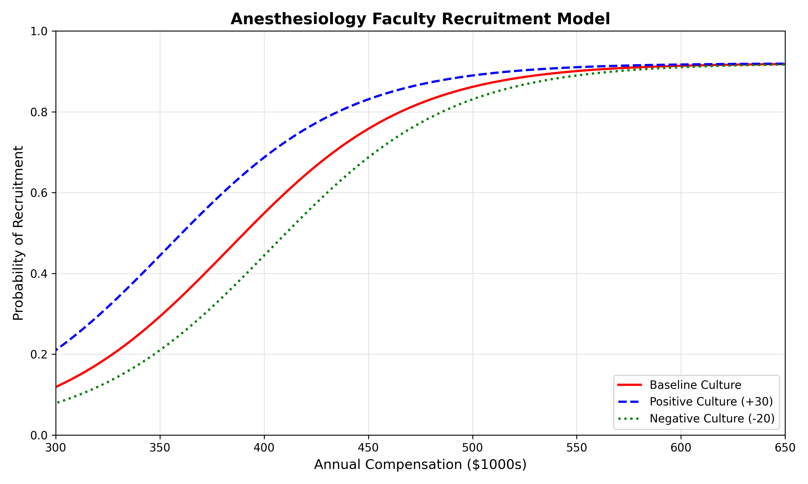 **Figure 1: The Dose-Response Recruitment Curve.** The model illustrates the relationship between compensation and recruitment probability based on simulated data. The baseline curve (red, k=0) shows the probability based on compensation alone. A positive departmental culture (blue, k=30) shifts the curve left, achieving higher recruitment probability at lower compensation. A negative culture (green, k=-20) shifts it right, requiring higher compensation for the same probability. Parameters used for simulation: a=0.92, b=0.023, c=383.

## Discussion

This model provides a data-driven framework for academic departments to balance financial stewardship with effective talent acquisition. While the model is currently theoretical and awaits validation with institutional data, it offers a promising approach for navigating the complexities of academic anesthesiology recruitment. Future work will focus on fitting the model to real-world recruitment data, incorporating regional cost-of-living adjustments, and exploring how the model may vary across different faculty tracks and subspecialties. By quantifying the impact of departmental culture, the model highlights the importance of investing in intrinsic motivation and job satisfaction as a strategic tool for recruitment and retention[3][4].

## 

1. https://earnbetter.com/jobs/click/01JS8E0R1M0D2GDWBZ8165E3SM/?utm_source=perplexity
2. https://www.asahq.org/about-asa/newsroom/news-releases/2024/06/anesthesia-workforce-shortage-poses-threat-to-health-care
3. https://jnae.scholasticahq.com/article/140529
4. https://dpianes.com/the-crucial-role-of-anesthesia-management-in-recruiting-and-retaining-top-tier-anesthesiologists-and-certified-registered-nurse-anesthetists/