1. **Problem Statement**

Create a command line utility that will compute a score for a list of first names, The list of names will be provided as a text file. The full path to the names file will be specified as a command line argument. The names file will contain a single line of quoted, comma-separated names. To score a list of names, you must sort it alphabetically and sum the individual scores for all the names. To score a name, sum the alphabetical value of each letter (A=1, B=2, C=3, etc...) and multiply the sum by the name’s position in the list (1-based).

1. **System Design**

The system design revolves around 2 key J2EE design patterns and it resolved most of the system wide design issues and it is flexible and extensible to adopt to future demand and requirements.

* Factory Pattern
* Strategy Pattern

The following diagram depicts the core classes in the application and its interactions.

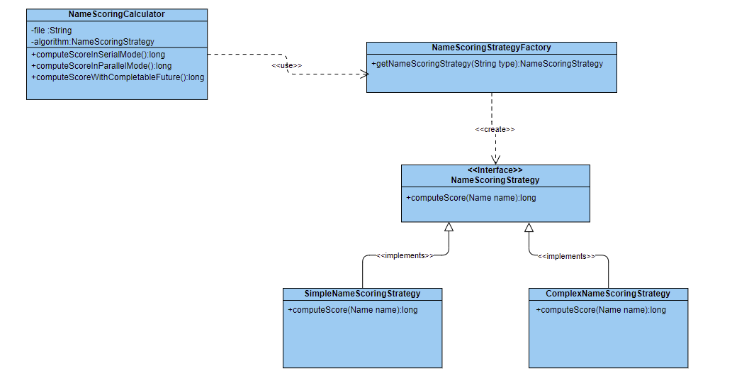

**To Test in Command Line**

Check out the git project and go to the work space location and run like below command

set **CLASSPATH**=C:\Users\THANISSHKA\eclipse-workspace\OCCNameScoringApplication\target\classes;%CLASSPATH%

C:\Users\THANISSHKA\eclipse-workspace\OCCNameScoringApplication\target\classes>java com.occ.name.scoring.utility.NameScoringMain C:\\Users\\THANISSHKA\\Downloads\\OCC_Take_Home_Coding_names1.txt

**To Test in Post Man Utility**

**Note :**  please check-out and run the application as spring boot application and access the below end-point with valid parameters.

<http://localhost:8090/api/names/score>

Input : namesFile <<upload names file>>

algorithmType simple

