CREATE TABLE users( id INT(11) UNSIGNED NOT NULL AUTO_INCREMENT PRIMARY KEY,
username TEXT NOT NULL,
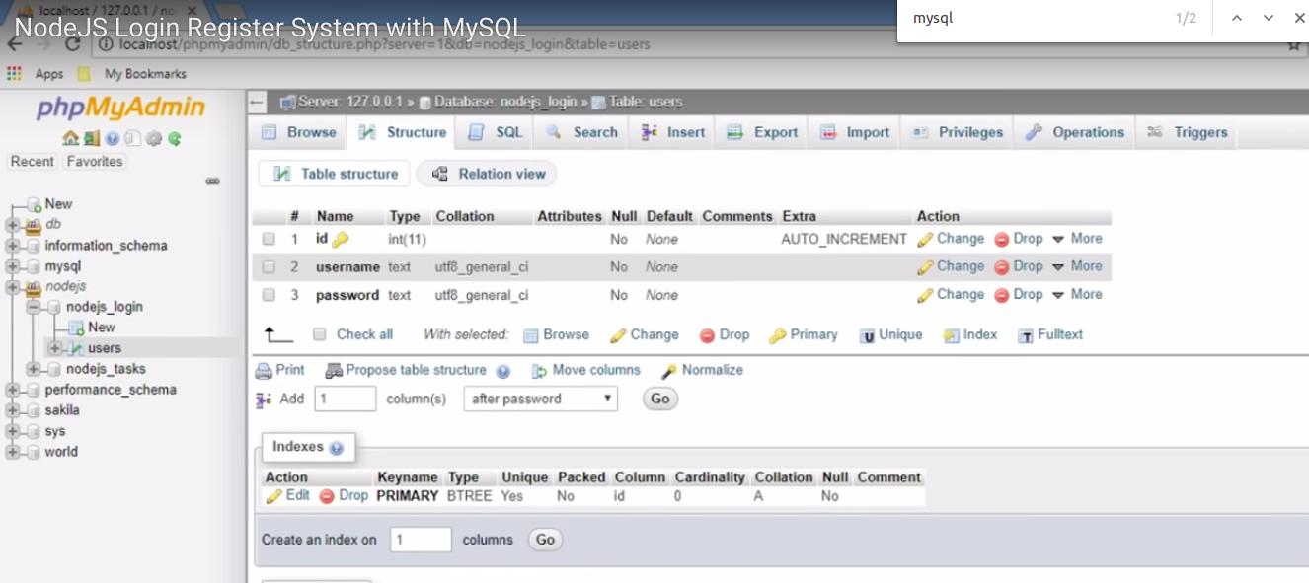
password TEXT NOT NULL);

use nodejs_login;

DESCRIBE users;

Show tables;

drop table users;

