N64 Wireless IR Remote Controlled TekBot

1. Directions For Use

- Flip the switch on the N64 controller to the on position (left).
- Press and hold switch 1 (S1) on the controller D Logic Board to reset the controller circuit.
- Flip the switch on the TekBot to the on position.
- Press and hold switch (S1) on the TekBot D Logic Board to reset the receiver circuit.
- Point the IR transmitter on the remote towards the IR receiver on the TekBot and use the direction buttons on the N64 to move the TekBot. If the IR signal is lost, the TekBot will begin to move backwards.

2. Technical Overview

The N64 remote controlled TekBot utilizes two D Logic Boards to transmit IR signals from the D Logic board mounted on the back of the N64 controller to the D Logic Board mounted on the TekBot. The N64 Controller was hacked so that the D Logic Board could have access to the internal clock that is used by the N64 controller in order to maintain synchronization between the two devices. Both the on-board D Logic Board and the N64 are powered by the 9V battery that is mounted to the back of the controller. The switch on the front of the controller turns both the controller and D Logic Board on when the switch is in the left position.

3. IR Transmitter Digital Logic (See Figure 1.1)

The clock divider generates the three clock signals that are derived from the clock on the N64. The clock on the N64 is 2 MHz, so the clock signals that are generated by the clock divider are 1 MHz, 500 kHz, and 250 kHz.

The Logic Low and Logic High modules use the count from the two bit counter to generate the low and high asynchronous pulses that are needed to generate the signal that triggers the controller to respond with its controller status.

The Signal Generator is essentially a mux that uses the count as its select. It simply chooses the Logic High and Logic Low inputs at the correct time in order to generate the controller status signal.

The Shift Register continually samples the Serial_IO line and shifts bits to the left. The data from the shift register is never directly sent to the decoder, so the shift register can always sample the serial line without interfering with the output of the decoder.

The Flip Flop latches onto the data from the shift register and sends it to the decoder. The IO Select module sends the signal to the Flip Flop to latch the shift register data when it has determined that the first 16 bits from the serial response from the controller has been loaded into the shift register.

The IO Select is the most important module in the design. It is in charge of the timing of the whole circuit, and if the timing of this module is off for any reason, it will cause the rest of the N64 controller remote to malfunction. This controls the timing of the following modules
- Mux: it determines when the CPLD is allowed to drive the serial wire and when the N64 controller is allowed to drive the wire.
- IR Transmitter: signals to the IR Transmitter module that it should transmit the current state of the decoder output over IR.
- Flip Flop: signals to the Flip Flop that it should latch onto the state of the shift register.
- 4 Bit Counter: keeps the 4 bit counter in sync with the rest of the circuit.

The Mux controls what drives the serial line. When the select is high, it allows the CPLD to drive the serial line and lets the N64 controller drive the serial line at all other times.

4. IR Receiver Digital Logic (See Figure 1.2)

The Inverter simply inverts the signal that comes from the IR receive pin. It is necessary to invert the signal because the IR drives the IR receive line low when a 1 is received, which inverts the signal that is sent on from the transmitter. This inverter converts the IR input the originally intended signal.

The Shift Register continually samples the serial line and shifts bits to the left. The data from the shift register is never directly sent to the motor control board, so the shift register can always sample the serial line without interfering with the output that is sent to the motor control board.

The IR Listener listens to the incoming serial from the IR for the start signal. When the start signal (10100) is received from the remote, the IR Listener activates the 3 Bit Counter. It won't begin listening for new transmissions until 4 clock cycles after it determines that it has received the start signal.

The 3 Bit Counter generates the signal that tells the Flip Flop when to latch onto the data that is in the Shift Register. The 3 Bit Counter idles at 0 until the IR Listener grounds the reset pin. Then it begins counting up from 0.

The Flip Flop latches onto the directions that are put out by the shift register. The timing of the circuit should be such that the Flip Flop only latches onto the data from the shift register when the four direction bits are present.
5. Figures
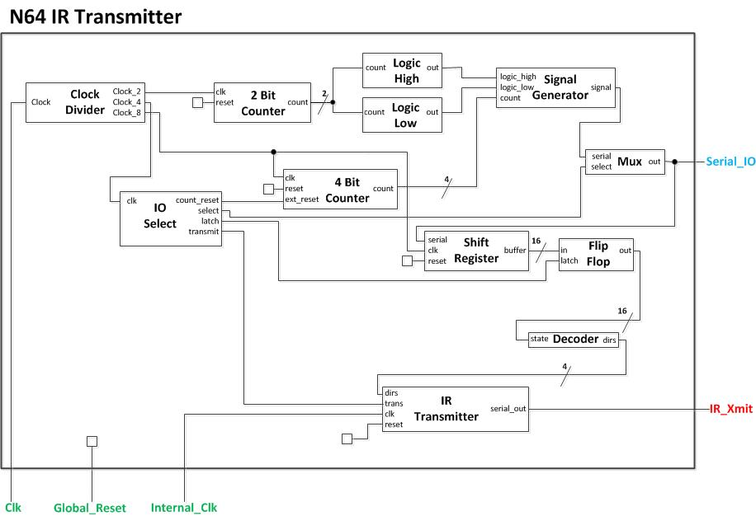
Figure 1.1: N64 IR Transmitter Block Diagram

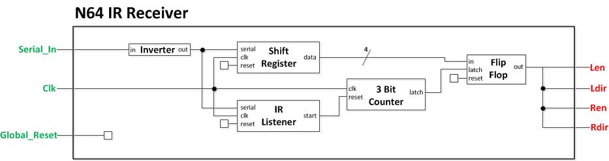
Figure 1.2: N64 IR Receiver Block Diagram

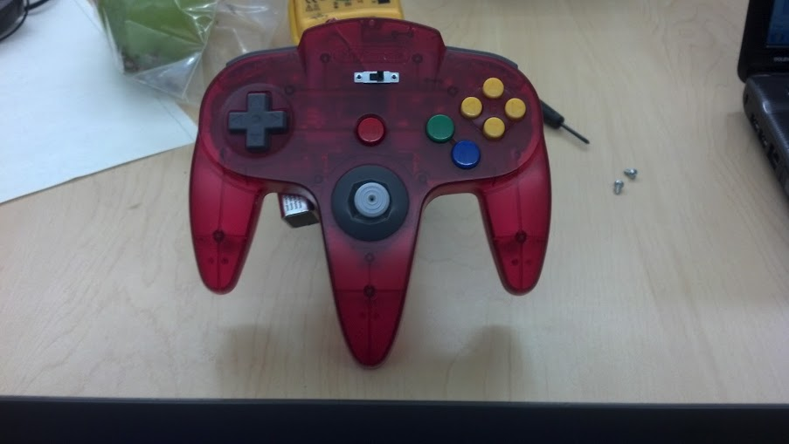
Figure 1.3: N64 Controller Front View

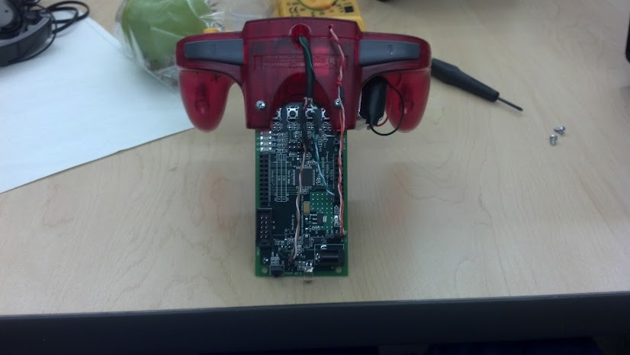
Figure 1.4: N64 Controller Rear View

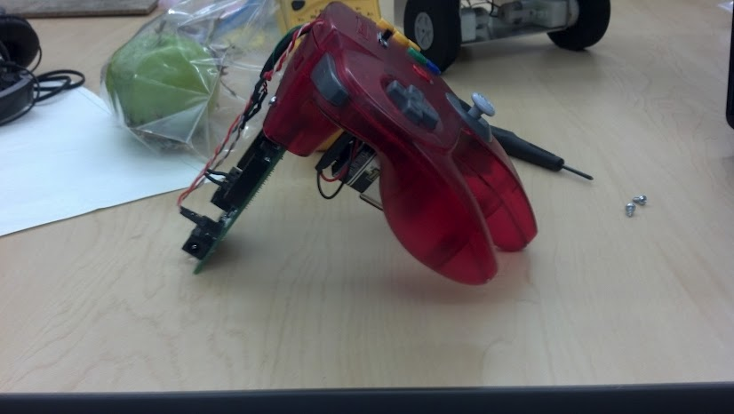
Figure 1.5: N64 Controller Side View

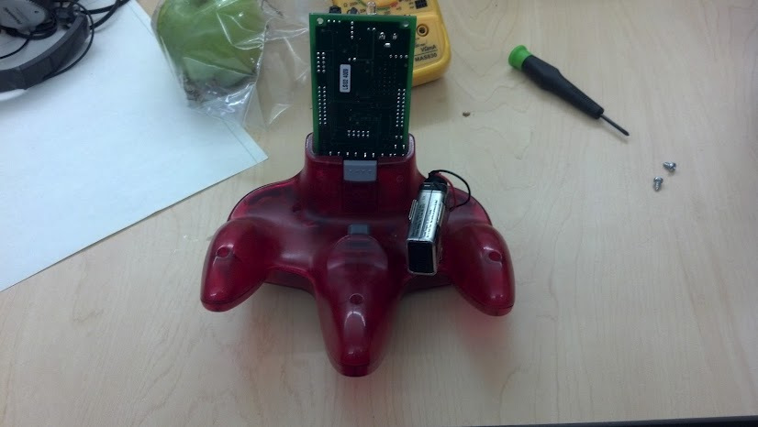
Figure 1.6: N64 Controller Bottom View

