The project repo can also be accessed via https://github.com/rlr524/dev-128-project-one
Program Execution 1:
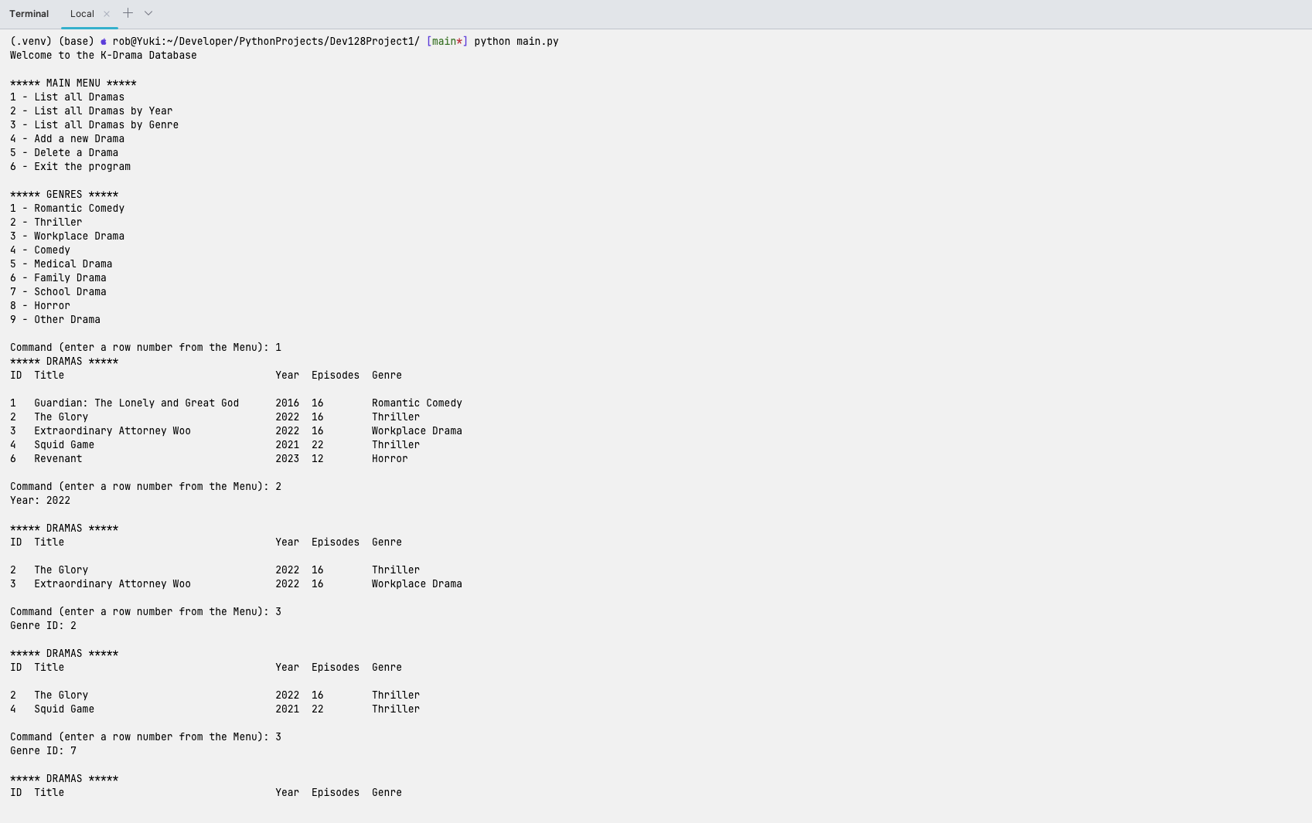

Program Execution 2:
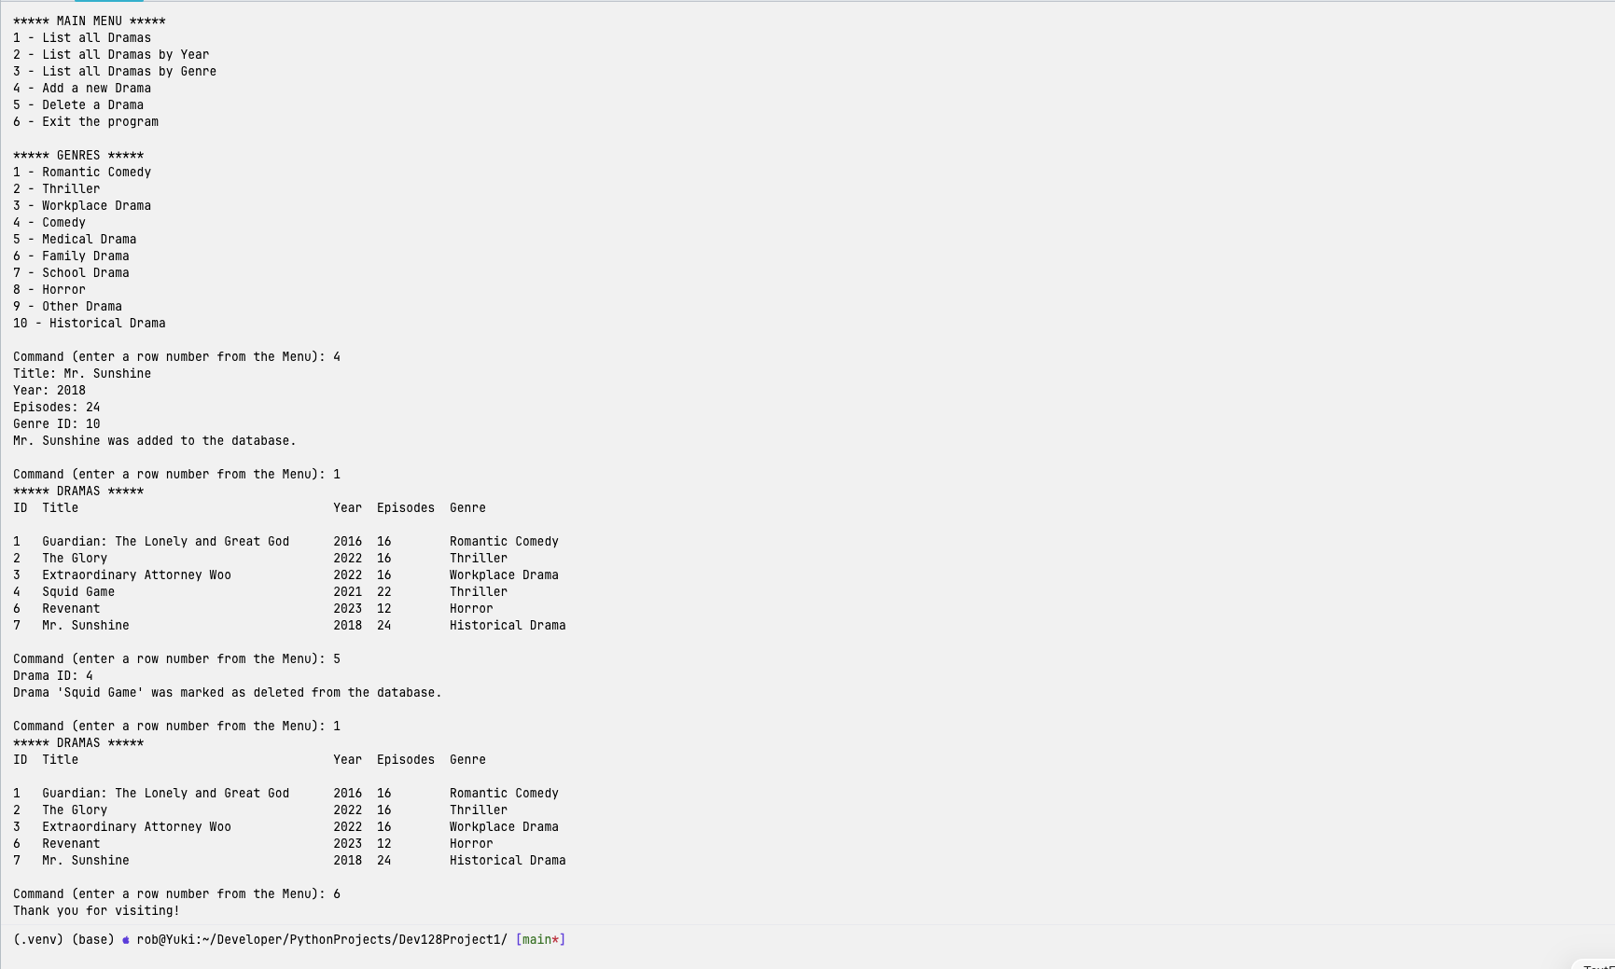

Demonstrate persistence:
