**A Step-by-Step Guide to Using the Revised NIOSH Lifting Equation:**

‍

The Recommended Weight Limit:

The Recommended Weight Limit (RWL) represents the weight that most healthy workers could handle without injury. The formula for Recommended Weight Limit calculation includes various factors like the load, distance components, angles and frequency - are each given a numeric value.

‍

‍

Calculating our Recommended Weight Limit will repeat a 3-step process for each task variable. Committing these simple steps to memory will make the entire process smoother, easier - and far more accurate.

‍

The Lifting Index

‍

The Lifting Index (LI) provides insight into the level of risk associated with manual lifting tasks. A LI value of 1.0 or less indicates a low risk to healthy employees, while a LI greater than 1.0 suggests a higher risk for some individuals. As the LI increases, so does the potential for injury.

‍

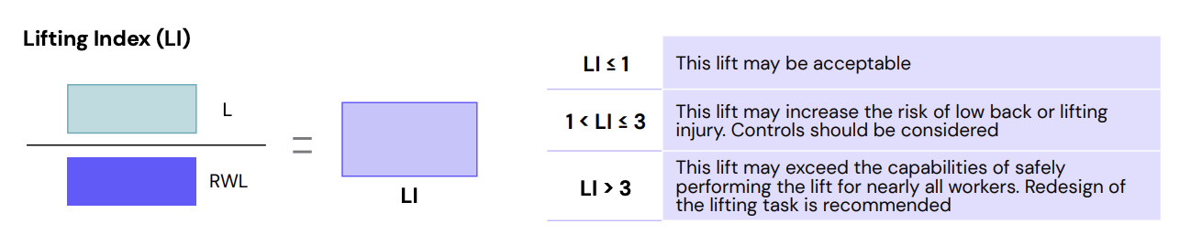

‍

Calculating our Lifting Index requires dividing the load weight of whatever is being lifted by the Recommended Weight Limit to determine the level of risk.

‍

NIOSH Equation Task Variables

In the NIOSH Lifting Equation, a fixed load constant (LC) of 51 pounds is utilized, representing the maximum recommended load weight for lifting under ideal conditions. Additionally, the equation integrates various task variables, represented as coefficients or multipliers (M = multiplier), to adjust the load constant and derive the Recommended Weight Limit (RWL) for the specific lifting task.

‍

Key task variables essential for RWL calculation include:

* H = Horizontal location of the object relative to the body
* V = Vertical location of the object relative to the floor
* D = Vertical distance the object is moved
* A = Asymmetry angle or twisting requirement
* F = Frequency and duration of lifting activity
* C = Coupling or quality of the worker's grip on the object

Additionally, to compute the Lifting Index (LI), the following task variables are also required:

* Average weight of the objects lifted
* Maximum weight of the objects lifted

‍

Calculate RWL and LI Using NIOSH Lifting Equation

‍

RWL = HM x VM x DM x AM x FM x CM x LC (51)

‍

Start by first collecting field measurements for each component in the equation. Then perform these 3 simple steps - again and again:

‍

PLUG each field measurement variable into its dedicated conversion table.

‍

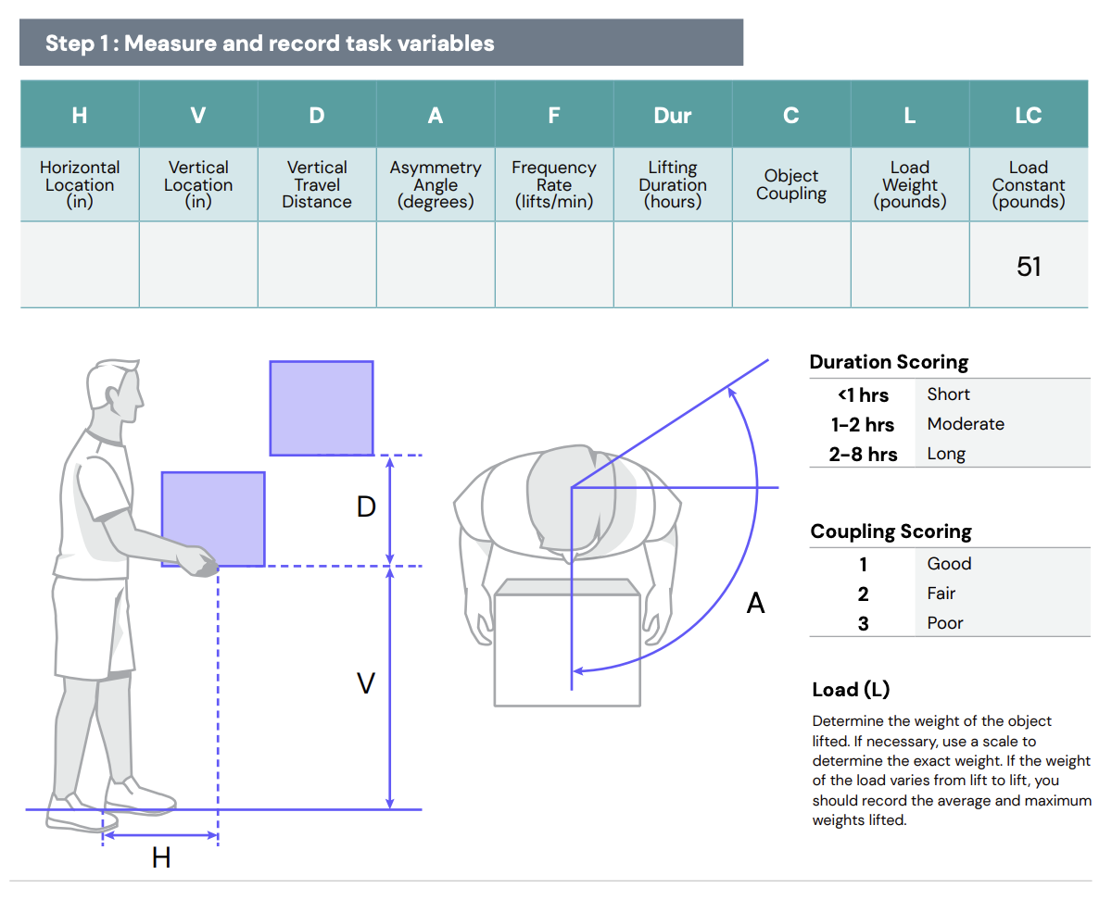

PLUCK each variable’s conversion multiplier from its respective conversion table.

‍

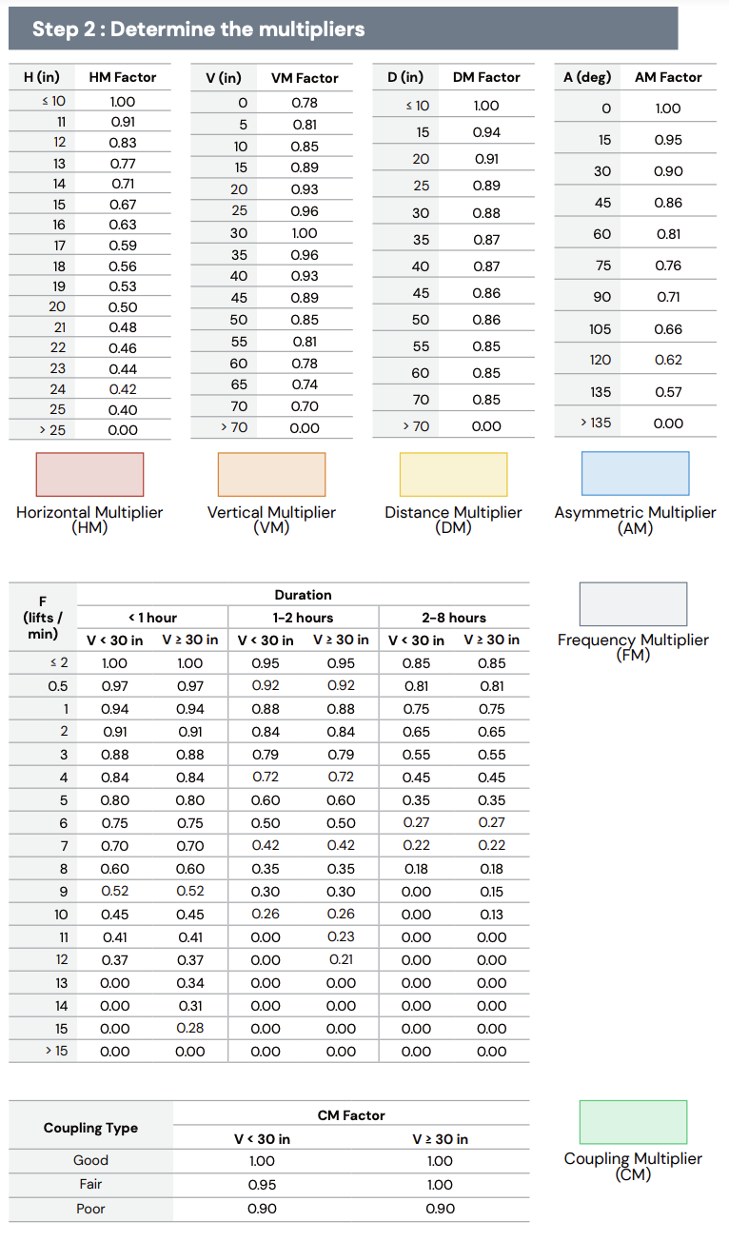

‍

PLUG each variable’s conversion multiplier into the Recommended Weight Limit equation.

‍

‍

Remember to follow this approach for each component - to ensure accuracy and to speed the calculation. Now let's see how this works in action.

‍

Example: Calculating the Horizontal Multiplier

‍

For a task requiring a horizontal reach of 17”, use our 3-step procedure.

‍

**PLUG - the 17” horizontal reach field measurement INTO the horizontal conversion table.**

‍

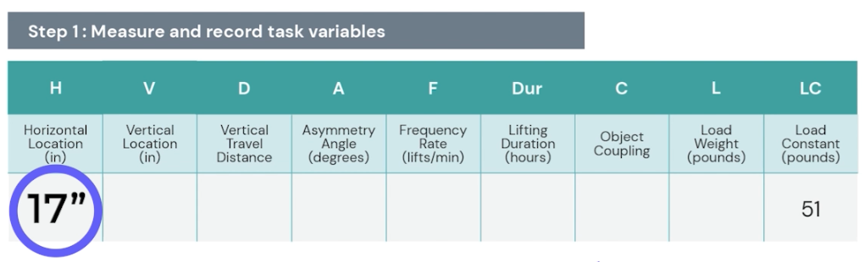

‍

**PLUCK - the horizontal multiplier FROM the horizontal conversion table.**

‍

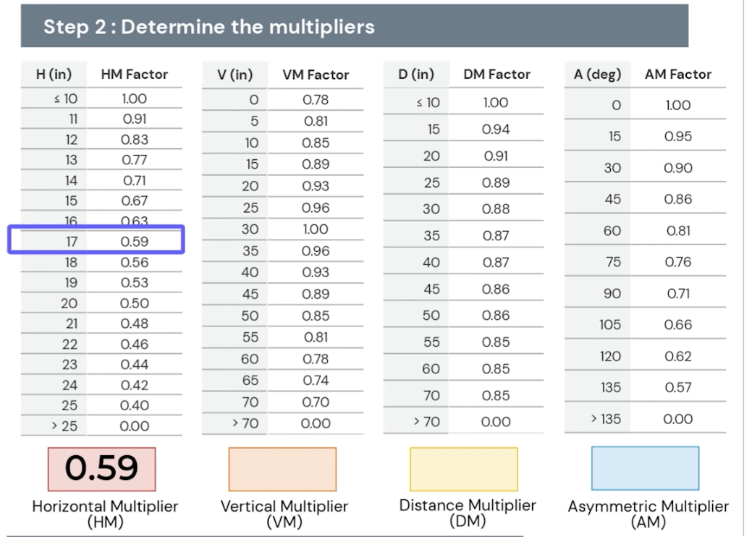

‍

**PLUG - the horizontal multiplier - in this case, 0.59 - INTO the equation.**

‍

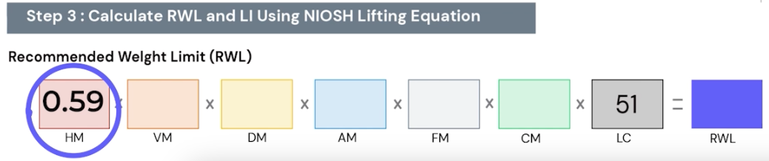

‍

Example: Calculating the Recommended Weight Limit

‍

This process is repeated for each of the remaining variable multipliers. Once all of our task variables have been converted, we run our calculation to get the Recommended Weight Limit. For our example - that recommendation is 5.80 lb.

‍

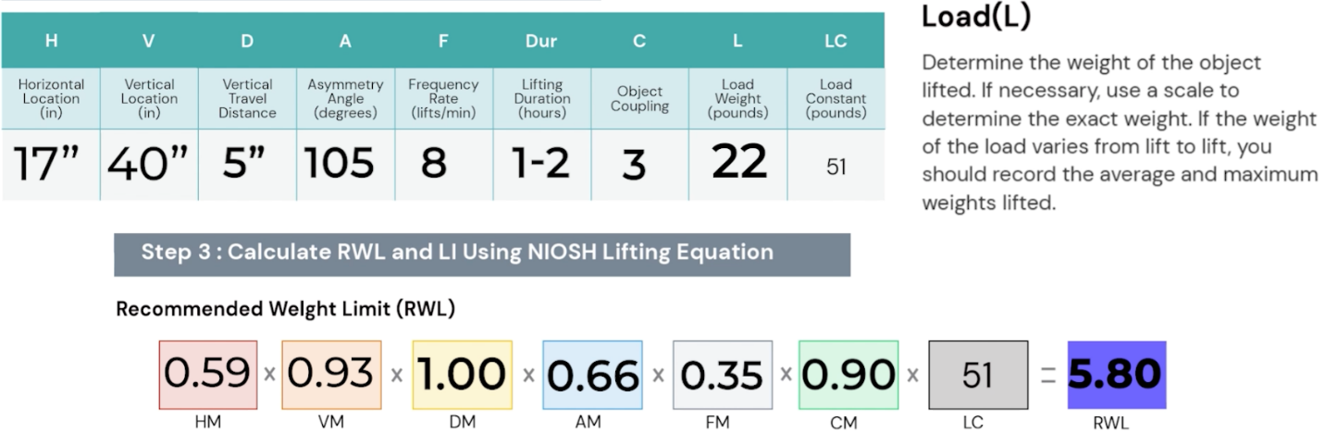

‍

Example: Calculating the Lifting Index

Our final task variable is to add the load weight of the actual boxes. For our example the weight is 22 lbs

‍

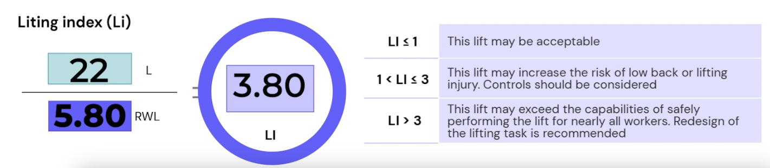

‍

* This 22 lb value is the numerator on our Lifting Index equation.
* The denominator of our calculation - is our 5.8 lb Recommended Weight Limit.
* We divide our actual 22 lb load weight by our Recommended 5.8 lb Weight Limit.
* The quotient - in this case, 3.8 - is our Lifting Index.

‍

Our Lifting Index Priority Scale tells us this lift may exceed the capabilities to safely perform the lift for nearly all workers. Redesign of this lifting task is highly recommended.

‍

Utilizing the NIOSH Lifting Equation

The outputs of the NIOSH Lifting Equation serve as invaluable assets in ergonomic risk management:

1. Guiding Task Design: Identify weaknesses in task design and prioritize ergonomic improvements.
2. Estimating Injury Risk: Gauge the relative physical stress and injury risk associated with lifting tasks, enabling targeted interventions.
3. Prioritizing Redesign Efforts: Rank jobs based on LI values to prioritize ergonomic redesign efforts effectively.

‍

TuMeke's Innovative Approach: Automating NIOSH Equation Using AI

At TuMeke Ergonomics, we go beyond conventional methods. Through cutting-edge AI and computer vision technologies, we make using the Revised NIOSH Lifting Equation faster, simpler and easier than ever before. With just a recording of a task being performed and a few clicks, you can conduct assessments, calculate risk, and achieve results seamlessly.

‍

Conclusion

In summary, the Revised NIOSH Lifting Equation is a vital tool for enhancing workplace safety and ergonomics. By utilizing RWL and LI, it offers a practical approach to assessing manual lifting tasks. Its systematic framework helps identify design weaknesses, estimate injury risks, and prioritize interventions. Therefore, incorporating this equation into ergonomic assessments is crucial for organizations dedicated to safeguarding their workforce and optimizing productivity.

‍