What is a REBA Assessment?

The Rapid Entire Body Assessment, or REBA, is a systematic method used to evaluate the ergonomic risks associated with various tasks. It examines the posture and movement of workers to identify potential musculoskeletal issues and prioritize interventions for risk reduction.

‍

Why Are REBA Assessments Important?

REBA assessments are crucial for maintaining a safe and healthy work environment. By identifying ergonomic hazards early on, businesses can prevent workplace injuries, improve productivity, and enhance employee well-being. Prioritizing tasks based on REBA scores allows organizations to allocate resources efficiently and address high-risk activities promptly.

‍

A Step-by-Step Guide to Conducting a REBA Assessment:

‍

Getting Ready:

Before beginning the assessment, interview the worker to understand the job tasks and observe their movements during work cycles. Identify difficult postures/tasks, sustained postures, or those involving high force loads and assess multiple positions/tasks within the work cycle.

‍

Neck, Trunk, and Leg Analysis:

‍

Neck Position:

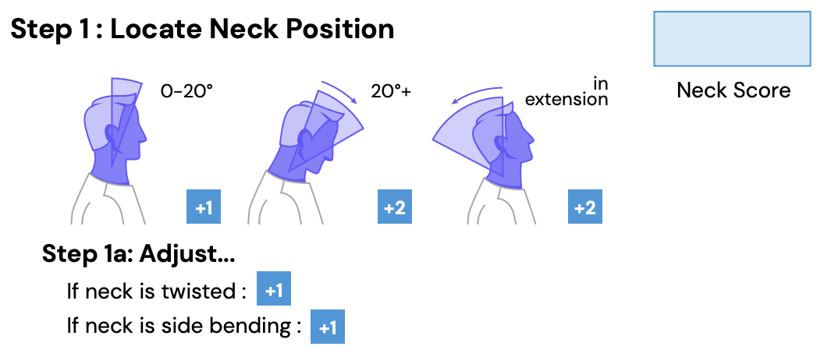

- Assess neck extension, twisting, and side bending.

- Measure angle of extension and consider adjustments for twisting or lateral extension.

- Example: Score 1 for minimal extension, no twisting or side bending; Score 3 for significant extension with twisting or lateral extension.

‍

Trunk Position:

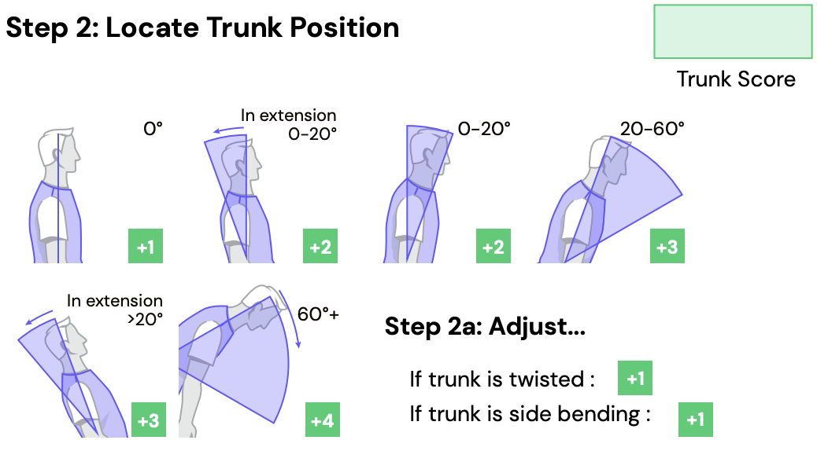

- Evaluate trunk extension and side bending.

- Determine degree of extension and consider adjustments for twisting or lateral extension.

- Example: Score 1 for minimal extension, no twisting or side bending; Score 5 for significant extension with twisting or lateral extension.

‍

Legs:

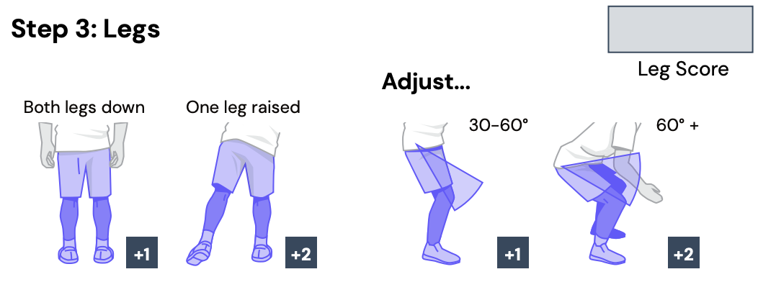

- Assess weight-bearing and knee extension.

- Determine if weight is bilateral (both legs down) or unilateral (one leg raised) and degree of knee extension.

- Example: Score 1 for bilateral weight-bearing, minimal knee extension; Score 4 for unilateral weight-bearing and significant knee extension.

‍

Force/Load Analysis:

‍

Posture Score:

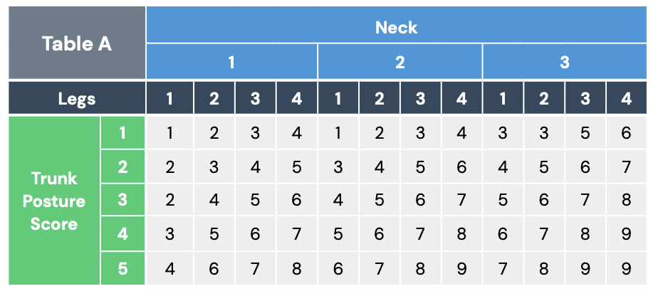

- Using values from steps 1-3 above, locate score in Table A

‍

Force/Load Score:

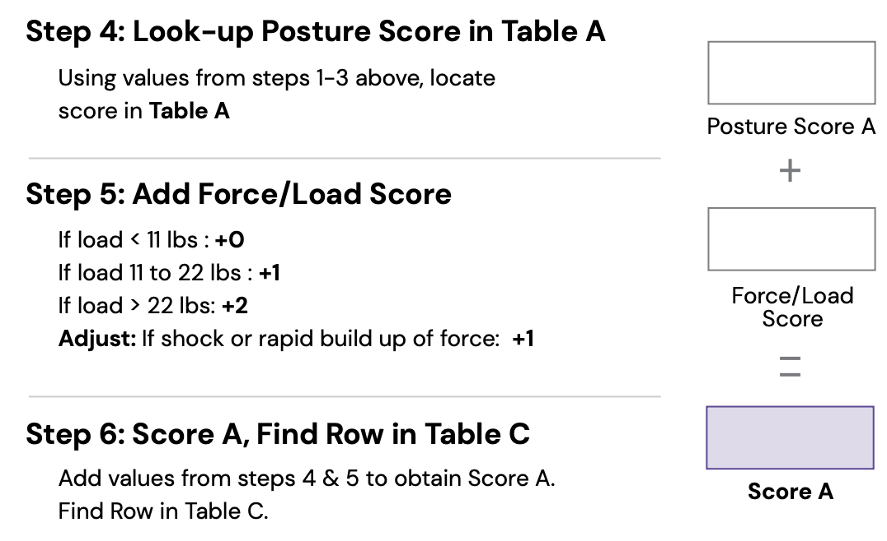

- Evaluate force/load required for the task.

- Determine weight of objects being manipulated and presence of shock force.

- Example: Score 0 for minimal force/load, no shock force; Score 2 for heavy load with sudden exertion.

‍

Find Score A:

- Add values from steps 4 & 5 to obtain Score A.

‍

Arm and Wrist Analysis:

‍

Upper Arm Position:

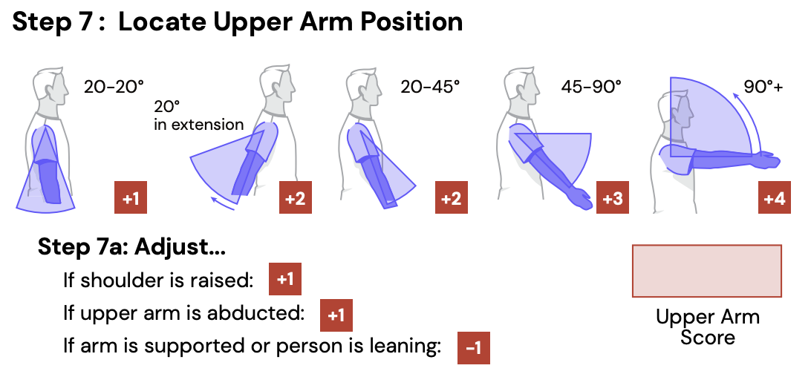

- Assess shoulder extension, abduction, and elevation.

- Determine degree of extension and arm position.

- Example: Score 1 for minimal extension, arm by side; Score 6 for significant extension, arm raised above shoulder.

‍

Lower Arm Position:

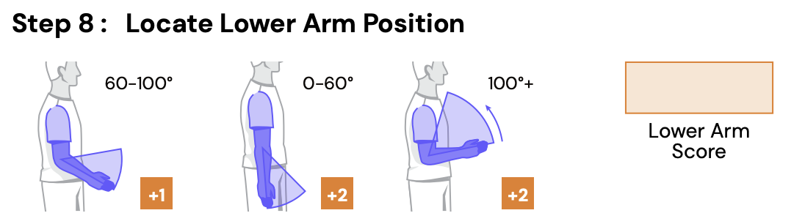

- Evaluate elbow extension.

- Determine angle of extension.

- Example: Score 1 for minimal extension, straight forearm; Score 2 for significant extension, bent forearm.

‍

Wrist Position:

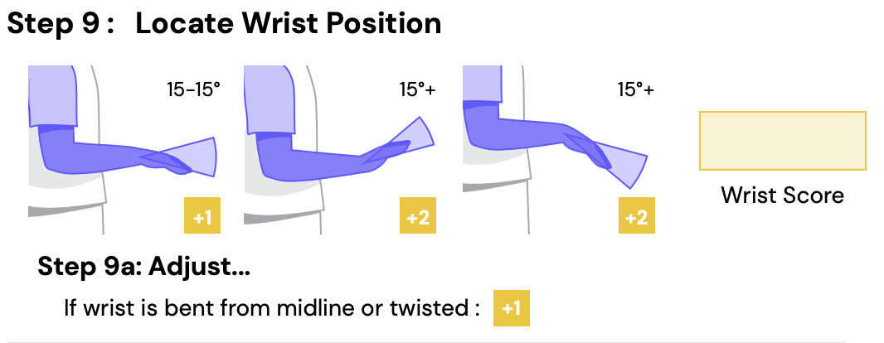

- Assess wrist extension and deviation/twisting.

- Determine degree of extension and presence of deviation or twisting.

- Example: Score 1 for minimal extension, no deviation; Score 3 for significant extension with noticeable deviation or twisting.

‍

Coupling Analysis:

‍

Posture Score:

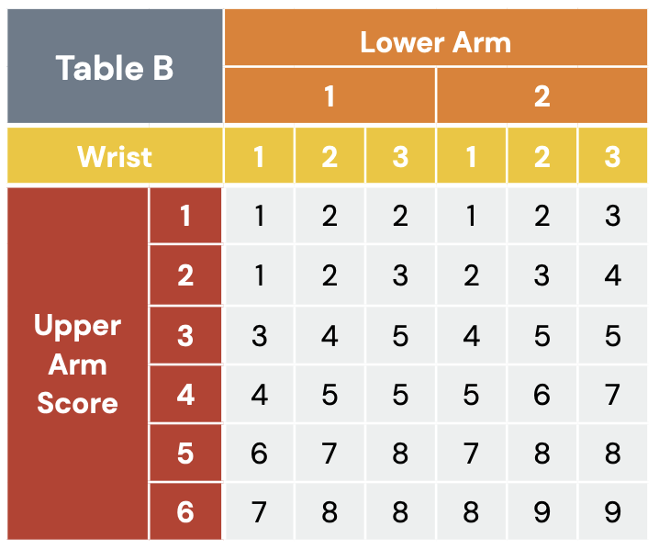

- Using values from steps 7-9 above, locate score in Table B

‍

Coupling Score:

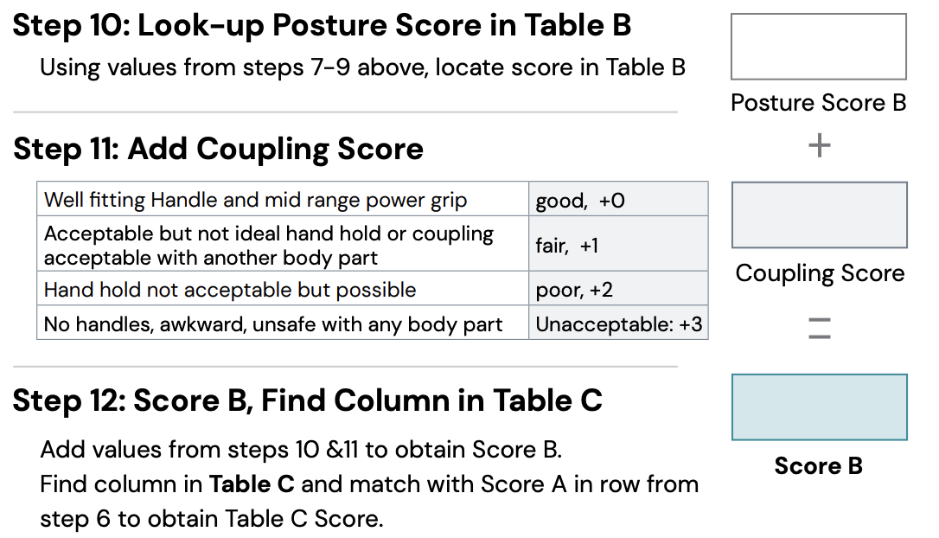

- Evaluate the quality of coupling, considering factors such as handle grip and safety.

- Example: Score 0 for a well fitting handle; Score 2 for hand holding is not acceptable but possible.

‍

Find Score B:

- Add values from steps 10 & 11 to obtain Score B.

‍

Activity Score:

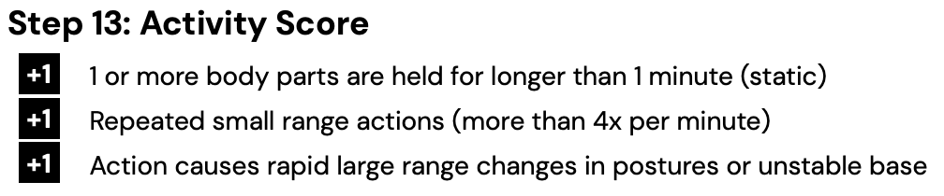

- Determine if the task involves repeated small range actions, which may increase risk.

‍

‍

Calculate Results:

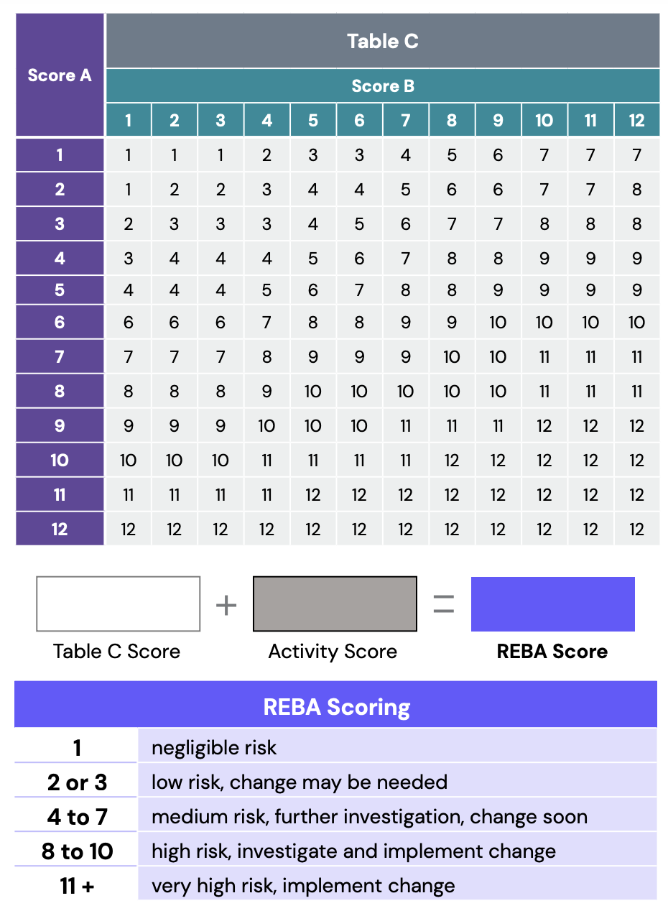

After completing all entries, calculate the results by finding the value in Table C that intersects Score A and Score B, plus the Activity Score.

The minimum REBA Score is 1 and the maximum REBA Score is 15. Aim for a REBA score of 4 or lower, with a Risk Index of 1.0 or less indicating nominal risk to employees' health. As the Risk Index increases, so does the level of MSD risk, highlighting the importance of designing tasks to minimize risk.

‍

Utilizing REBA Scores: Maximizing the Value

‍

Once you've obtained a REBA score through, it's crucial to leverage this information effectively. Here are three key ways you can make the most of your REBA score:

‍

Prioritizing Interventions:

Use REBA scores to prioritize tasks for intervention, focusing on those with the highest risk levels to mitigate ergonomic hazards effectively.

‍

Assessing Effectiveness of Interventions:

Measure the effectiveness of interventions by conducting post-intervention REBA assessments. A decrease in the REBA score indicates a reduction in ergonomic risk following intervention implementation.

‍

Promoting Worker Health and Safety:

Share REBA scores and findings with workers to raise awareness about ergonomic risks associated with their tasks. Encourage workers to adopt ergonomic practices and techniques that reduce the likelihood of musculoskeletal disorders. Incorporate REBA scores into safety initiatives and training programs to foster a culture of safety within the organization.

‍

TuMeke Ergonomics: Automating REBA Assessments with AI and Computer Vision

At TuMeke Ergonomics, we revolutionize REBA assessments by leveraging cutting-edge AI and computer vision technologies. Our automated solutions streamline the assessment process, reducing time, effort, and costs associated with collecting, evaluating, and actioning on ergonomic risk information. Simply record or upload a video of a task being performed, and our software will run a REBA assessment and provide a risk score in seconds.

‍

Conclusion

Incorporating REBA assessments into your workplace practices is essential for promoting employee health and productivity. With TuMeke Ergonomics' innovative solutions, you can elevate your approach to ergonomic risk management, ensuring a safer and more ergonomic work environment for all. Reach out to us today to learn more about how we can support your organization's ergonomic goals.

‍