**What is an RSI Assessment?**

The RSI (Revised Strain Index) ergonomics assessment is a systematic evaluation process used to identify and mitigate risks associated with repetitive movements and poor posture in the workplace.

This assessment aims to prevent injuries that can occur due to repetitive tasks, awkward positions, and other ergonomic hazards.

‍

[[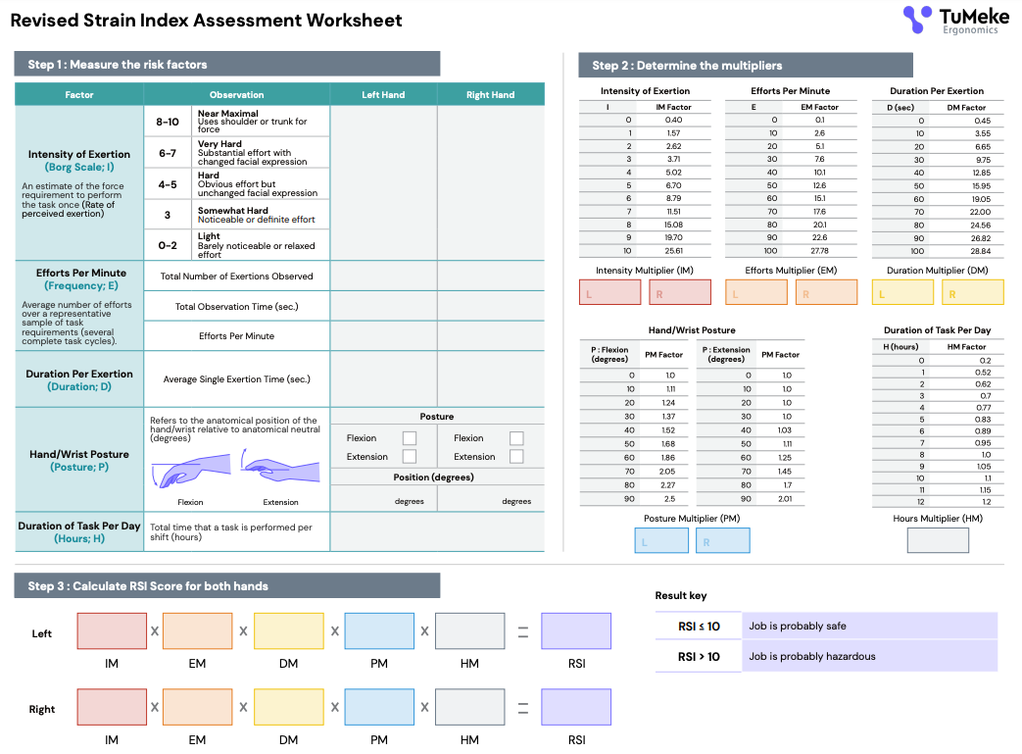](https://7488314.fs1.hubspotusercontent-na1.net/hubfs/7488314/Infosheets/RSIA-worksheet-final.pdf)](https://7488314.fs1.hubspotusercontent-na1.net/hubfs/7488314/Infosheets/RSIA-worksheet-final.pdf" \t "_blank)

[[](https://7488314.fs1.hubspotusercontent-na1.net/hubfs/7488314/Infosheets/RSIA-worksheet-final.pdf)](https://7488314.fs1.hubspotusercontent-na1.net/hubfs/7488314/Infosheets/RSIA-worksheet-final.pdf" \t "_blank)

‍

The Importance of the RSI Ergonomics Assessment:

1. Injury Prevention: By identifying and addressing ergonomic risks, employers can prevent injuries.
2. Improved Productivity: Workers who are comfortable and not experiencing pain or discomfort are likely to be more productive and efficient.
3. Employee Well-being: Ensuring a healthy work environment contributes to overall employee well-being, reducing absenteeism and improving job satisfaction.
4. Regulatory Compliance: Many regions have regulations and guidelines related to workplace ergonomics. Conducting regular assessments helps ensure compliance with these laws, avoiding potential fines and legal issues.
5. Cost Savings: Preventing injuries through proper ergonomic assessments can save significant costs related to medical treatments, workers' compensation claims, and lost productivity.
6. Enhanced Workplace Culture: Demonstrating a commitment to employee health and safety can improve morale and foster a positive workplace culture.

By proactively addressing ergonomic risks, organizations can create safer, more comfortable work environments that support the health and productivity of their employees.

How To Perform an RSI Ergonomics Assessment:

1. Measure the Risk Factors

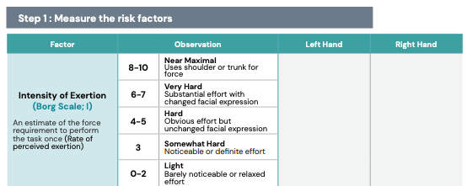

Evaluate the effort scale (Borg Scale) and assign a score between 0-10.

2. Determine the Multipliers

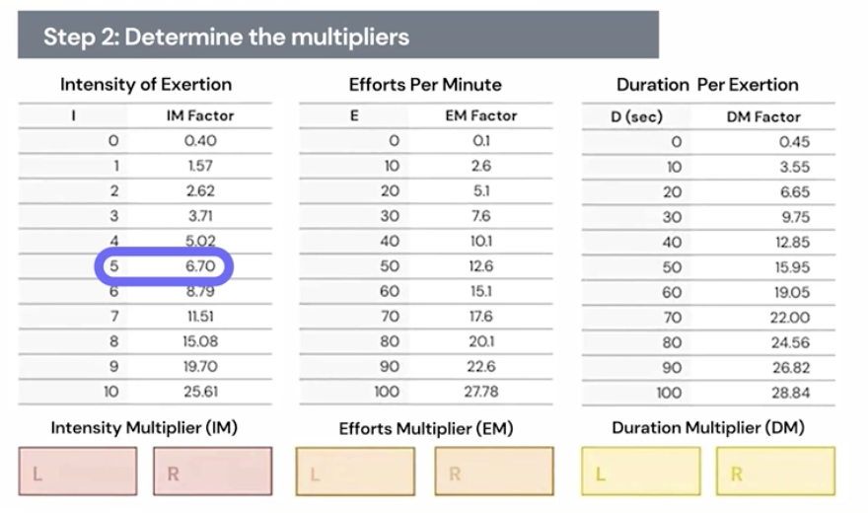

Look for corresponding conversion factor for intensity.

‍

3. Calculate RSI Score for both hands

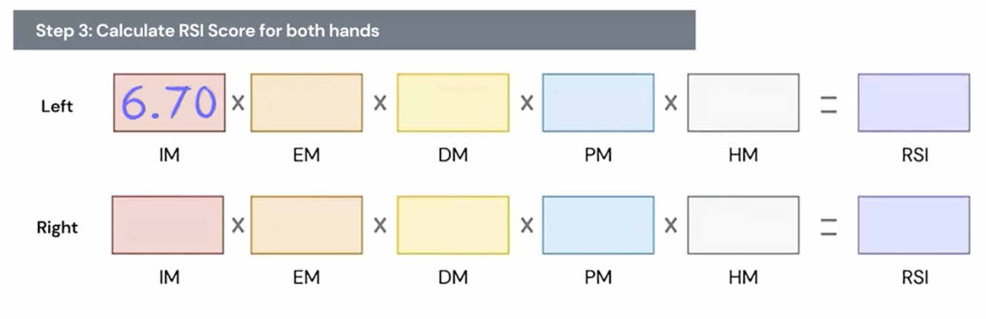

Input the associated IM Factor from the previous conversion factor and repeat steps 1-3 for other hand.

‍

4. Calculate Efforts Per Minute (Frequency)

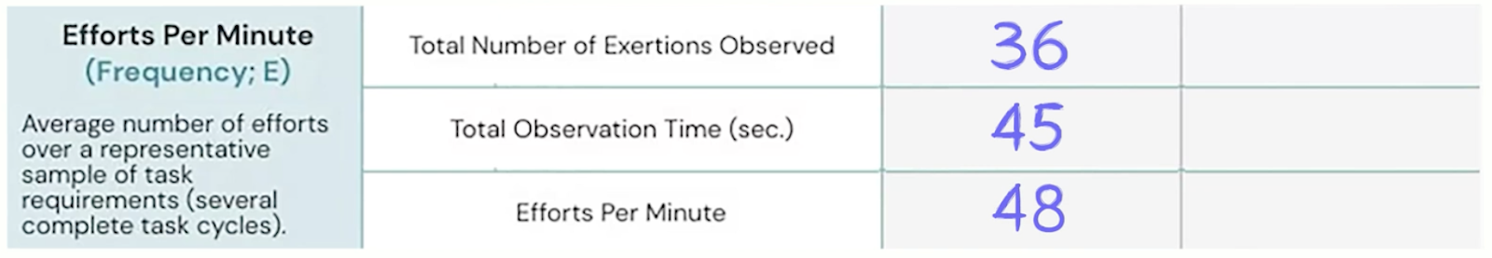

Enter in time and repetitions of activity accordingly.

5. Associate the Multipliers

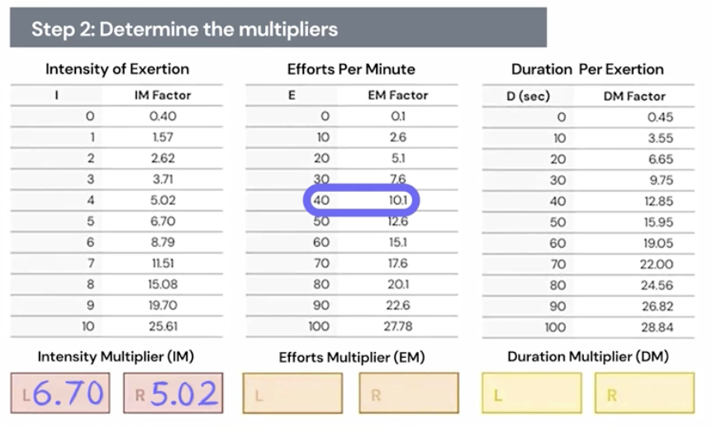

Drop in conversion factor into Efforts Multiplier (EM) boxes, repeat for both hands.

‍

6. Calculate Duration Per Exertion

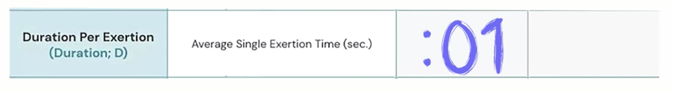

Count how many repetitions occur per second, and associate with corresponding conversion factor in the conversion table and enter into the Duration Multiplier (DM) calculation boxes for left and right hands.

‍

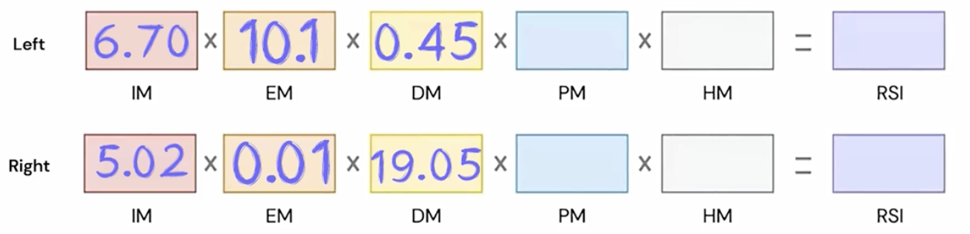

‍

7. Assess Hand/Wrist Posture

‍

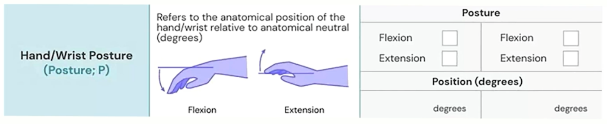

Enter score of flexion and extension in the table and find the associated number in the conversion table and bring it into the calculation table.

‍

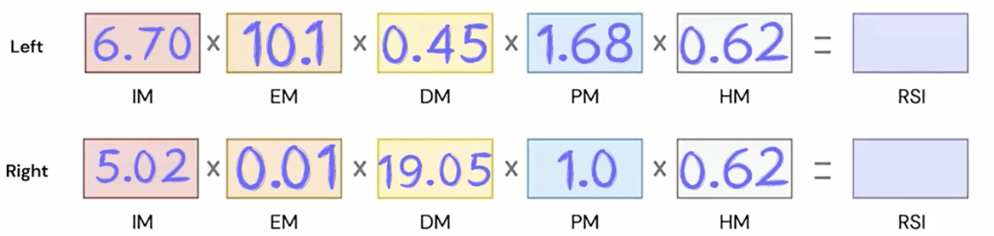

‍

8. Run the Numbers to get final Calculation of RSI Score

‍

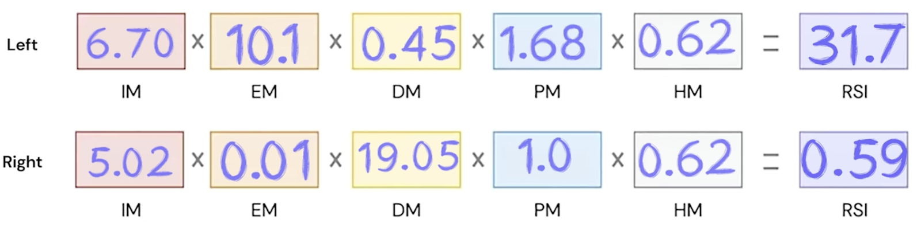

‍

9. Leverage Results Key in Lower Right Hand Corner

‍

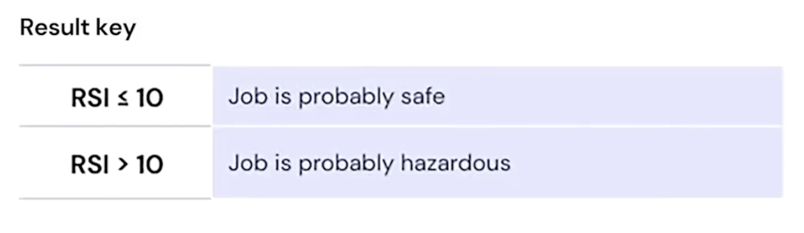

Anything over 10 is a potential hazard. Formulate potential interventions, and review the effectiveness of the intervention.

Utilizing RSI Scores: Maximizing the Value

RSI scores provide a quantitative measure of the risk of injuries in various tasks and workstations. Effectively utilizing these scores can help organizations prioritize interventions, allocate resources efficiently, and track the impact of ergonomic improvements.

Here’s how to maximize the value of RSI scores:

1. Interpret RSI Scores Accurately

* Understand the Scoring System
  + Know what the scores represent and how they are calculated. Higher scores typically indicate a higher risk of RSI.
* Categorize Risk Levels
  + Divide the scores into categories (e.g., low, medium, high risk) to make it easier to prioritize actions.

2. Prioritize Interventions Based on Scores

* Address High-Risk Areas First
  + Focus immediate efforts on tasks and workstations with the highest RSI scores, as these pose the greatest risk to employee health.
* Plan for Medium and Low-Risk Areas
  + Develop a phased approach to address medium and low-risk areas. This ensures comprehensive risk management over time.

3. Develop Targeted Solutions

* Tailor Interventions to Specific Risks
  + Use the detailed data from RSI assessments to design specific ergonomic solutions for each high-risk area.
  + For example, if high RSI scores are due to awkward postures, consider redesigning workstations or providing adjustable furniture.
* Implement Quick Wins
  + Identify and implement quick, low-cost solutions that can immediately reduce RSI scores, such as adjusting monitor heights or rearranging tools.

4. Monitor and Evaluate Impact

* Track RSI Scores Over Time
  + Regularly reassess RSI scores to monitor the effectiveness of interventions.
  + Compare pre- and post-intervention scores to evaluate the impact of changes made.
* Adjust Strategies as Needed
  + If RSI scores do not improve as expected, reassess the situation and modify your intervention strategies.
  + Continually refine your approach based on feedback and new data.

5. Engage Employees in the Process

* Educate and Train Employees
  + Provide training on the importance of ergonomics and how to recognize and report ergonomic risks.
  + Encourage employees to participate in identifying problem areas and suggesting improvements.
* Foster a Culture of Continuous Improvement
  + Create an environment where employees feel comfortable discussing ergonomic issues and proposing solutions.
  + Regularly solicit feedback from employees on the effectiveness of implemented changes.

6. Leverage Technology and Tools

* Use Ergonomic Software
  + Employ ergonomic assessment software like [TuMeke](https://www.tumeke.io/) to streamline the data collection, scoring, and analysis process.
  + Use these tools to generate detailed reports and visualizations of RSI scores and trends.
* Integrate with Other Workplace Systems
  + Integrate RSI data with other workplace health and safety systems to provide a comprehensive view of employee well-being.
  + Use data analytics to identify patterns and correlations between RSI scores and other workplace factors.

7. Report and Communicate Findings

* Share Results with Management
  + Provide regular updates to management on RSI scores, the status of interventions, and the impact on employee health and productivity.
  + Highlight the return on investment (ROI) of ergonomic interventions in terms of reduced injuries and increased productivity.
* Keep Employees Informed
  + Communicate the outcomes of RSI assessments and the steps being taken to address identified risks.
  + Transparency fosters trust and encourages continued employee engagement.

8. Compliance and Best Practices

* Ensure Regulatory Compliance
  + Use RSI scores to demonstrate compliance with occupational health and safety regulations.
  + Document the assessment process and outcomes to provide evidence during inspections or audits.
* Benchmark Against Industry Standards
  + Compare your RSI scores and ergonomic practices with industry benchmarks to identify areas for improvement.
  + Adopt best practices from industry leaders to enhance your ergonomic program.

By effectively utilizing RSI scores, organizations can create a proactive and responsive ergonomic program that minimizes injury risks, enhances employee well-being, and boosts overall productivity.

‍