What is a RULA Assessment?

The **Rapid Upper Limb Assessment,** or RULA, is a vital tool designed to evaluate ergonomic risks associated with upper extremities during work tasks. It assesses body posture, force, and repetition, offering a systematic approach to identifying potential musculoskeletal issues.

‍

Why Are RULA Assessments Important?

RULA assessments play a crucial role in safeguarding workers' health and well-being by pinpointing tasks that may lead to muscle fatigue or discomfort. By identifying ergonomic risks early on, businesses can implement targeted interventions to mitigate these risks, fostering a safer and healthier work environment.

‍

A Step-by-Step Guide to Conducting a RULA Assessment:

‍

Getting Ready:

Start by interviewing the worker to understand their job tasks and observe their movements and postures during work cycles. Focus on evaluating the most challenging postures, those sustained for the longest time, or those involving the highest force loads.

‍

Arm & Wrist Analysis:

‍

Upper Arm Position:

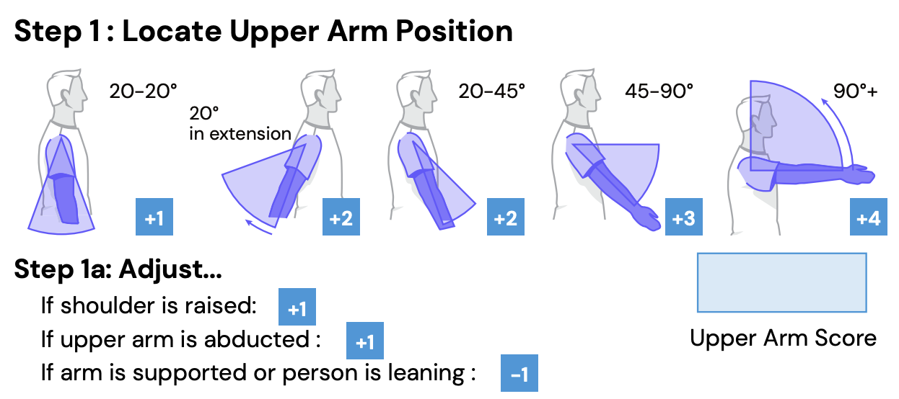

- Evaluate shoulder flexion or extension, considering adjustments for shoulder elevation or abduction.

- Score between 1-6 based on the degree of movement.

- Example: If the shoulder is flexed slightly less than 90 degrees, score +3 with an additional adjustment for shoulder abduction.

‍

Lower Arm Position:

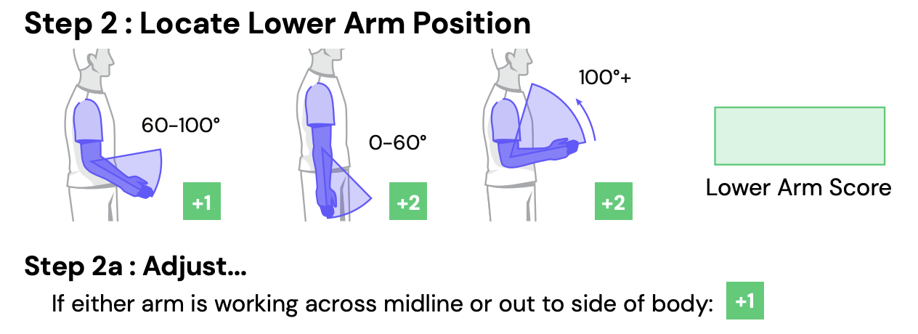

- Assess elbow flexion or bending, considering adjustments if the arm works across the midline.

- Score between 1-3 based on the degree of movement.

- Example: If the elbow is flexed slightly less than 60 degrees, score +2 with no adjustment for midline movement.

‍

Wrist Position:

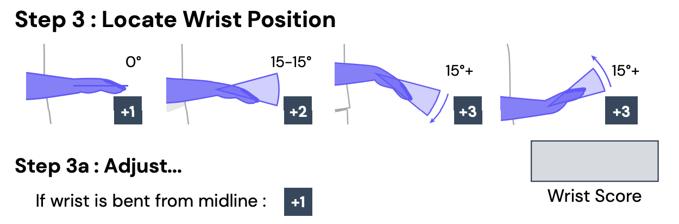

- Evaluate wrist flexion or extension, with potential adjustments for wrist deviation.

- Score between 1-4 based on the degree of movement.

- Example: If the wrist is flexed greater than 15 degrees, score +3 with an adjustment for wrist deviation.

‍

Wrist Twist:

- Determine the degree of forearm pronation or supination.

- Score depending on the degree of twist.

- Example: If the wrist is twisted in the mid-range, make the appropriate selection.

‍

Muscle Use & Force/Load Analysis (Arm & Wrist):

- Assess muscle use if the posture is mainly static or if action repeats frequently.

- Select the appropriate load range based on the weight and frequency of the task.

‍

Neck, Trunk, and Leg Analysis:

‍

Neck Position:

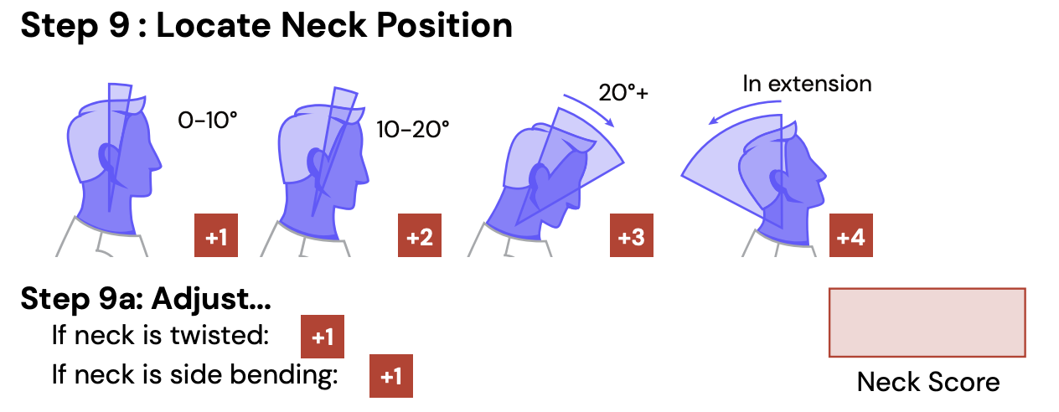

- Evaluate neck flexion or extension, considering adjustments for twisting or side bending.

- Score between 1-6 based on the degree of movement.

- Example: If the neck position is between 10-20 degrees with observed side bending, make the appropriate selections.

‍

Trunk Position:

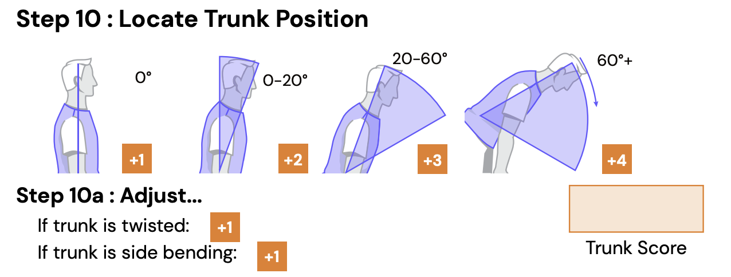

- Assess trunk flexion or extension, with adjustments for twisting or side bending.

- Score between 1-6 based on the degree of movement.

- Example: If the trunk is flexed more than neutral up to 20 degrees, without significant twisting or side bending, make the appropriate selections.

‍

Legs:

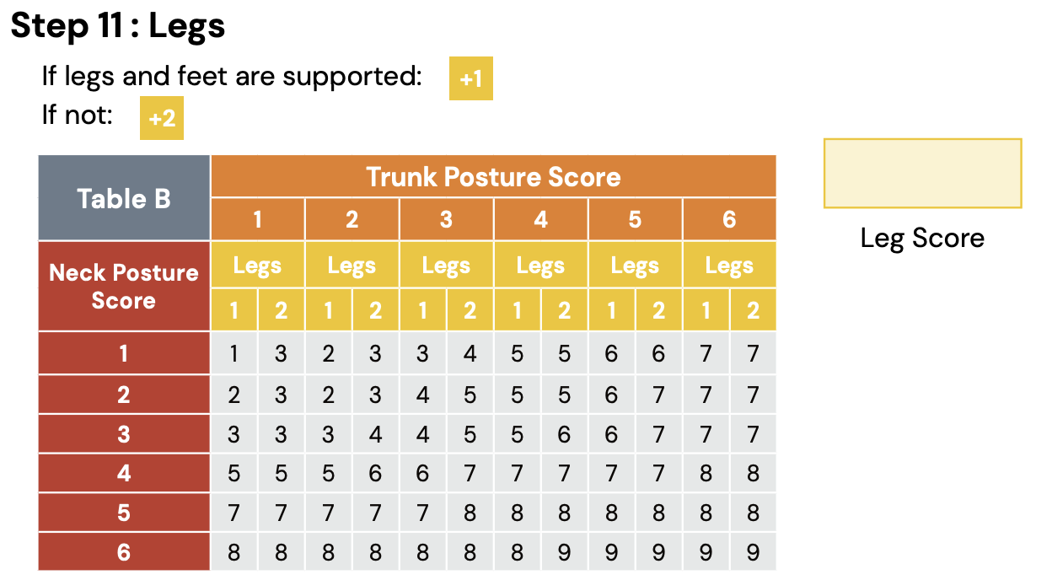

- Evaluate if legs and feet are supported with even weight distribution.

- Score +1 if supported; +2 if not supported or uneven distribution.

‍

Muscle Use & Force/Load Analysis (Neck, Trunk & Legs):

- Assess muscle use and select the appropriate load range similar to the arm and wrist analysis.

‍

Calculate Results:

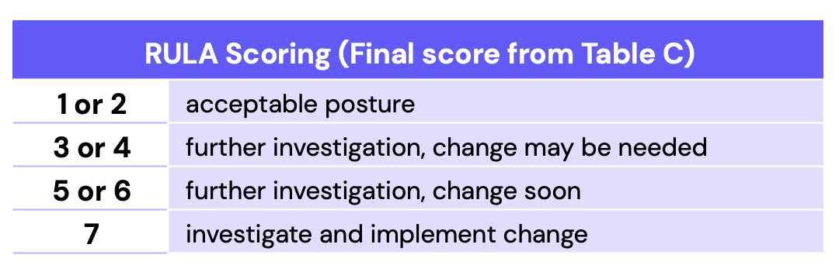

After completing all entries, calculate the results. A score of 1 to 2 indicates low risk, while higher scores indicate increased risk requiring further investigation and intervention.

‍

Utilizing RULA Scores: Maximizing the Value

‍

Once you've obtained a RULA score, it's crucial to leverage this information effectively. Here are three key ways you can make the most of your RULA score:

‍

Prioritizing Interventions:

Identify tasks with elevated ergonomic risks, indicated by higher RULA scores. Focus on addressing these tasks first to maximize the impact of interventions. By allocating resources efficiently based on RULA scores, you can ensure that critical areas of concern are addressed promptly.

‍

Assessing Effectiveness of Interventions:

Monitor changes in ergonomic risks over time by conducting regular RULA assessments. Compare RULA scores before and after interventions to evaluate their effectiveness in reducing ergonomic risks. Adjust interventions as needed based on the outcomes of RULA assessments to achieve better results.

‍

Promoting Worker Health and Safety:

Share RULA scores and findings with workers to raise awareness about ergonomic risks associated with their tasks. Encourage workers to adopt ergonomic practices and techniques that reduce the likelihood of musculoskeletal disorders. Incorporate RULA scores into safety initiatives and training programs to foster a culture of safety within the organization.

‍

TuMeke Ergonomics: Automating RULA Assessments with AI and Computer Vision

At TuMeke Ergonomics, we revolutionize RULA assessments by leveraging cutting-edge AI and computer vision technologies. Our automated solutions streamline the assessment process, reducing time, effort, and costs associated with collecting, evaluating, and actioning on ergonomic risk information. Simply record or upload a video of a task being performed, and our software will run a RULA assessment and provide a risk score in seconds.

‍

Conclusion

Incorporating RULA assessments into your workplace practices is essential for promoting employee health and productivity. With TuMeke Ergonomics' innovative solutions, you can elevate your approach to ergonomic risk management, ensuring a safer and more ergonomic work environment for all. Reach out to us today to learn more about how we can support your organization's ergonomic goals.