**Create volumes :**

sudo docker volume create --name jenkins_vision

**Run Jenkins with volume :**

sudo docker run -ti --name=jenkins_vision -d -p 8086:8080 -v [jenkins_vision:/volume_data/jenkins_vision](http://jenkins_vision/volume_data/jenkins_vision) jenkinsci/blueocean:latest

**To run this container as Root :**

sudo docker exec -u 0 -it jenkins_vision bash  *[ This is needed if we need to install something inside the container for example to run "*apt-get update" "apt-get install gcc" (compiler) ]

**Stop any container :**

sudo docker container ls [ find id ]

sudo docker stop <<container_id>>

**Start the container again without loosing data:**

Sudo docker start -ai jenkins_vision [ jenkins_vision is container_id]

---------------------------

# [Docker useful commands](http://confluence:8090/confluence/display/WAT/Docker+useful+commands)

Sudo docker volume ls [ List all volumes ]

sudo docker ps --filter=volume=<<volume_name>> [ find connected container for this volume ]

sudo docker volume rm <<volume_name>> [ Remove the volume ]

if volume can not be removed [ because container is attached, and its hidden]

-----------------------

sudo docker ps -a [ list all hidden container in docker, and find that with container id]

sudo docker container rm <<container_id>>

Now run : sudo docker volume rm <<volume_name>> [ Remove the volume ]

Sudo docker rmi <<Image_id>> [ Remove image ]

-----

[Listing Images

Listing containers

Listing volumes

look where the volume is connected to ]

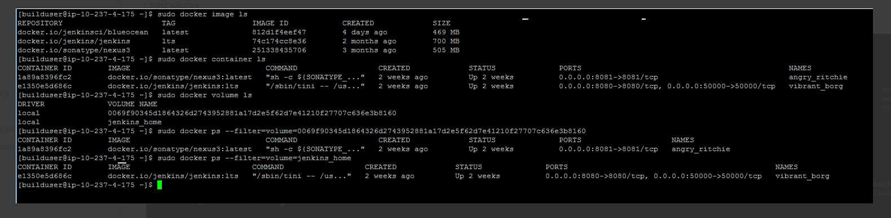

-------------------

$ df [ disk information ]

$ lsblk [ drive detail ]

$ sudo docker mount /dev/xvdb [ mount disc to machine ]

$ sudo docker info [ give information about docker ]

$ sudo docker system df

$ docker system df -v

$ docker system df -v --verbose

----