登录view 未定

选课view 学科表选修表

查看自己选课的功能view = 顺便查自己成绩。 选修表学科表

查看自己要进行的考试 选修表->考试安排表 get

开始考试view 要到点才行

我的select语句

<! -- 选课view start--> √
@GetMapping("/subjects") URL
所有查询返回的对象中的属性基本如图，具体自己控制台看一下
<select id = "选课阶段，查询所有课程" resultType="VO(学科id，学科名，老师名字)">
SELECT subject_id as '课程序号',t_subject.`name` AS '课程名称',t_teacher.`name` AS '教师名字' FROM `t_subject`,t_teacher where t_subject.teacher_id = t_teacher.teacher_id
</select>
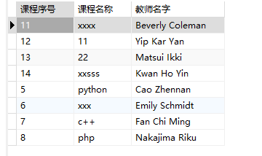

//后端可能不需要别名？
//无别名版本
SELECT subject_id ,t_subject.`name` ,t_teacher.`name` as 't_name' FROM `t_subject`,t_teacher where t_subject.teacher_id = t_teacher.teacher_id
</select>

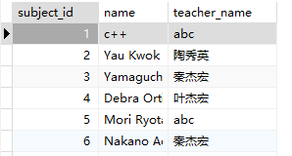

加一个筛选老师的输入框。 一个是加载页面时的全搜索，另一个是 点击筛选按钮执行的筛选sqlquery。 √
@GetMapping("/subjects/{name}") url中拼接参数
<select id = "跟上面一样" resultType="VO(课程序号，课程名称，教师名字)" parameter=" ">
SELECT subject_id ,t_subject.`name` ,t_teacher.`name` as 't_name' FROM `t_subject`,t_teacher //同上

<where>
<if test = "true">
and t_subject.teacher_id = t_teacher.teacher_id
</if>

<if test = "tea_name != null and tea_name !=''">
and t_name = #{tea_name}
</if>

</where>
</select>

<-- 选修学科查询结束>

<!--添加到选修表> √
@PostMapping ("/electives") 传入对象如下
public ResultModel add(ElectiveDTO electiveDTO)
public class ElectiveDTO {
private Integer student_id;
private Integer score; //不需要传
private Integer subject_id;

<insert id="add名" parameterType=" 选修该课程">
insert into t_electives (student_id,subject_id) values(#{student_id},#{subject_id})
</insert>

//数据库报错，就是，有可能是唯一性问题，一个人不能选同一个课程。

查看自己所选课程，顺便查自己成绩 view。 √
@GetMapping("/electives/{id}")url中拼接参数：学生id

<select id = "查看我选修的课程" resultType="VO(学科id，学科名，老师名字，分数)" >
select t_electives.subject_id,t_subject.`name` as 'cource_name',t_teacher.`name` as 'teacher_name' , score from t_electives,t_subject,t_teacher where t_subject.subject_id = t_electives.subject_id and t_subject.teacher_id = t_teacher.teacher_id and student_id = #{student_id}

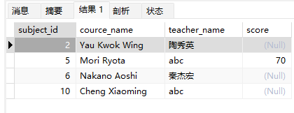

</select>

< 退选课程> √
@DeleteMapping ("/electives") //删除选课记录（退选）
public ResultModel deleteById(ElectiveDTO electiveDTO)DTO同上，还是请使用POST请求+_method属性的方式发DELETE请求

<delete id="退选" parameterType="退选该课程（与选修一样的格式）">
delete from t_electives where student_id = #{id} and subject_id=#{subject_id}
</delete>

<!-- 我的考试安排--> √
@GetMapping("/examArrangements/{id}")返回值如下图
<select id = "查看我的考试" resultType="VO(学科名，试卷名，room，starttime，endtime)" >
select t_subject.`name` as 'course_name' , t_exam_schedule.exam_name ,room,start_time,end_time from t_electives,t_exam_schedule,t_subject where t_electives.subject_id = t_exam_schedule.course_id and t_electives.subject_id = t_subject.subject_id and student_id = #{student_id}
</select>
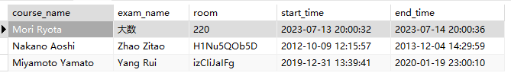

<! 开始考试界面> 返回null，就说-没有考试，不然，就显示试卷内容
@GetMapping("/questions/{id}")返回值如下图
select type,title,t_question.option as 'content',score from t_question where subject_id in(
select subject_id from t_exam_schedule,t_electives
where t_exam_schedule.course_id = t_electives.subject_id
and t_electives.student_id = (传参) and NOW() >= start_time AND NOW() <= end_time)

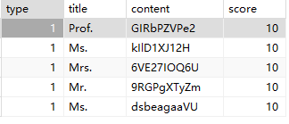

个人信息的查询和修改
查询
<select id="findAll" resultType="studentVO" parameterType="int">
select * from t_student where student_id = #{student_id}
</select>
@GetMapping("/students/{id}")传过去的数据只是一个对象，不是List
public ResultModel<StudentVO> findAll(@PathVariable("id")int id)

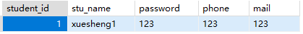
修改
<update id="updateSome" parameterType="Student">
update t_student set phone=#{phone},mail=#{mail}
<if test="password != null">,password=#{password}</if>
where student_id = #{student_id}
</update>
@PutMapping("/students")
public ResultModel updateSome(StudentDTO studentDTO)

最好密码不能为空，密码为空时后台不会对数据库中的密码列进行修改，学号和姓名学生不能自己修改，因此不用传
public class StudentDTO {
private Integer student_id;
private String name;
private String password;
private String phone;
private String mail;

