Jfdsahafsdf

As

Df

Sd

F

Asdfs

Df

Df

Sdfa

Sdf

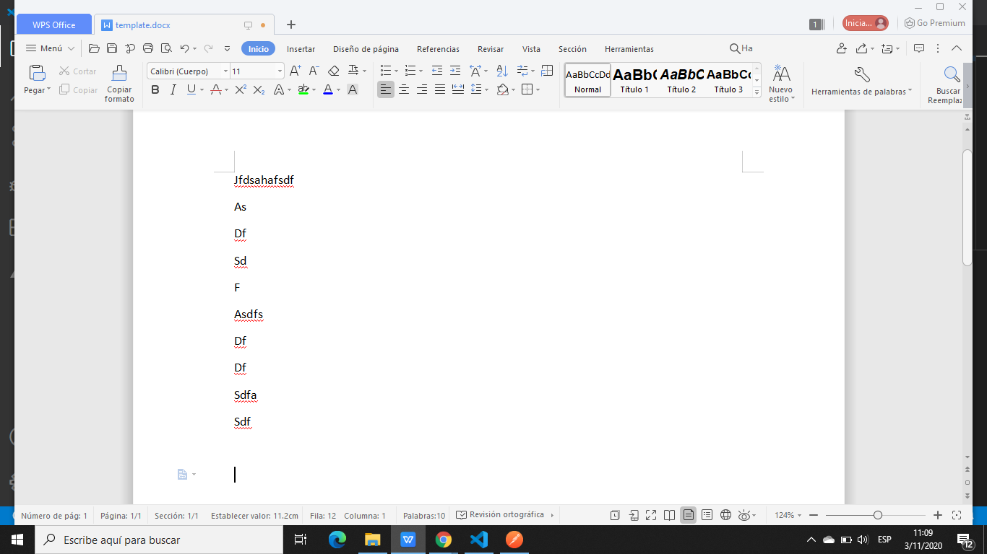

enterprise

2.0

NEPE LOCO , SE LA COME DOBLADA :V

GAP CHILE