Software Design Document

Medical Ultrasound Interpretation Pipeline (Task 1.1)

Clinical Decision Tool for Automatic Interpretation of Medical Ultrasound B-Mode and M-mode Images

Submitted under NASA Ames / USAISR MOA

An Integrated Tool for Image Processing, Data Augmentation and Machine Learning Model Development for Automated Interpretation of Medical Ultrasound Images

Version 1.0

Revision History
Version | Summary of Changes | Date
0.1 (TL) | Internal Pipeline Components (Python/Octave Engine) | 12/17/17
1.0 (TL) | Updated for Python Implementation on Titan Server | 1/17/18
1.1 (TL) | Updated with models built on Azure Government Cloud | 3/10/18

Table of Contents
Table of Contents ii
Listing of Figures ii
Listing of Tables ii
1 Introduction 2
1.1 Project Overview 3
1.2 Document Purpose and Goals 4
1.3 Document Scope 4
1.4 Document Organization 4
2 Pipeline Overview 4
2.1 Information Retrieval 5
2.2 Preprocessing 5
2.3 Data Augmentation 6
2.4 Model Generation 7
2.5 Medical Data Interpretation 7
3 User Interface 7
4 Software Architecture 8
5 Support for Later Upgrading 9
5.1 Different Methods for Interfacing with the Program 9
5.2 Different File Formats and Modalities 9
5.3 Diagnosis for additional anatomical structures 10
5.4 Support for additional pathologies 10
6 Integration with other Devices 10
7 References 10
8 Appendix 11

Listing of Figures
Figure 1: Overall System Pipeline 4
Figure 2: Image Preprocessing Artifact Removal 5
Figure 3. Example Image through Preprocessing Module. 6
Figure 4: Data Augmentation and Contrast Enhancement 7

Listing of TablesIntroduction
This document specifies a Medical Ultrasound Interpretation Pipeline design that provides support for automatic analysis and diagnosis of thoracic ultrasound data capture. The pipeline will be used as part of an on-board software system that provides medical augmented intelligence for both planned and emergent clinical care aboard deep space exploration missions.

Project Overview
The current space flight medical scenario relies heavily on telemedicine and ground clinical support. A challenge for missions beyond low Earth orbit is to minimize the impact of potential delays between transmission and receipt of expert medical advice. The delay may be such that remote medical team members will need to proceed with temporary measures, e.g. to stem internal bleeding, stabilize a bone fracture or administer therapeutics.

The Medical Ultrasound Interpretation Pipeline software is developed as part of the Automated Medical Operations (AMO) project under the Game Changing Development Program. The technology aims to mitigate medical misdiagnosis incidence, particularly when crewmembers operate outside their specialty training, as well as to guide and assist during clinical procedures. The software will provide the capability to triage and eventually to assign degrees of urgency to a medical scenario. The circumstances enable computerized biomedical support systems to potentially advance medical decision making capability. These systems can be designed and trained to accurately interpret certain clinical findings within a confidence interval as well as identify latent adverse health events. The AMO system offers a unique mix of medical image assessment, anatomical feature interpretation, and differential diagnosis advice.

The design described in this document satisfies the requirements partially specified in the AMO Requirements Document.

The software pipeline, shown in Figure 1 consists of the following components:

- Information Retrieval module: reads a master spreadsheet, acquires images and video clips, creates training and test folders, and populates training and test subfolders of disease state with approximately the same number of image data products.
- Preprocessing module: applies contrast histogram equalization, object labeling and smoothing filters to eliminate image artifacts.
- Data Augmentation module: synthetically enhances pathology preserving medical images to mitigate overfitting during the model training phase.
- Model Generation module: creates an Artificial Intelligence model that uses raw and augmented training data to gain knowledge. After which this component mimics the interpretation and decision making capability of a radiologist.
- Medical Data Interpretation module: Applies a trained deep learning model on an independent test set and generates clinical interpretation outcomes. The resulting diagnosis for the binary case will be “positive” or “negative” plus a confidence percentage.

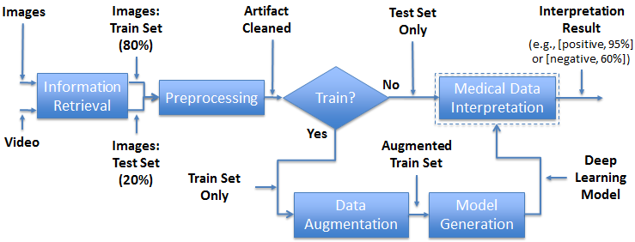
Figure 1: Overall System Pipeline

Document Purpose and Goals
This document serves as the blueprint for the software development and implementation of the Medical Ultrasound Interpretation Pipeline developed by the AMO project.

Document Scope
This document covers design and functional description of the Medical Ultrasound Interpretation Pipeline software components. The software executable will be available for the following platforms:
- a stand-alone Windows or Linux based system
- in a Flexible Ultrasound biosensor device as embedded software
This document does not cover design for other hardware/software platforms.

Document Organization
The document organization for subsequent sections is as follows: Overview of the end-to-end modular pipeline consisting of medical image retrieval, preprocessing, synthetic augmentation, model training and test set interpretation. In addition, the user interface and software model architecture, both of which perform important functions, are discussed in subsequent sections.

Pipeline Overview
The medical ultrasound interpretation pipeline engine is multipurpose and responsible for image acquisition, processing, clinical decision model building and patient medical condition diagnosis. The following subsections provide details for each module in Figure 1: Overall System Pipeline.

Information Retrieval
This class module acquires ultrasound data product images and video loops, defines environment variables, extracts video frames as well as creates train and test set partition folders.

Preprocessing
A function flow diagram for the preprocessing module class is illustrated in Figure 2: Image Preprocessing Artifact Removal. The module operates on images supplied by the information retrieval module.

The operations of the preprocessing module are illustrated in Figure 3.Error: Reference source not found. The original image is shown in Figure 3a. First, histogram equalization (3b) and thresholding (3c) are applied to create an object image. Morphological opening, closing, and hole filling are used to refine the object image (3d). Next, objects of small size are removed, leaving only key image information (3e). After this initial background removal has taken place, the image is analyzed for line artifacts in the image data. These lines are located using Sobel filtering (3f) and thresholding (3g). The lines are then blended into the image by replacing the line pixel values with those of neighboring pixels and smoothing them with a Gaussian filter (3h).

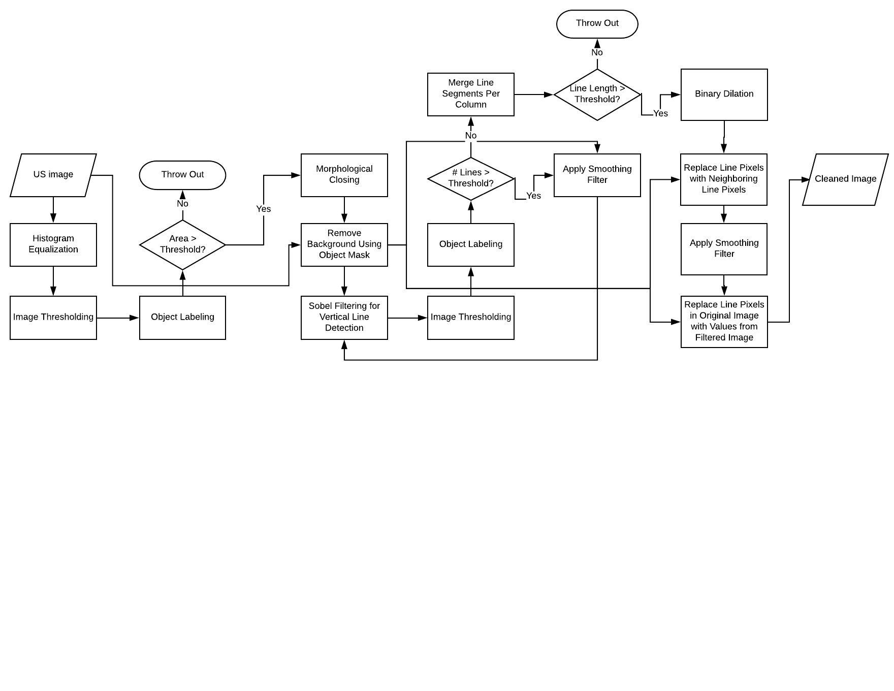
Figure 2: Image Preprocessing Artifact Removal

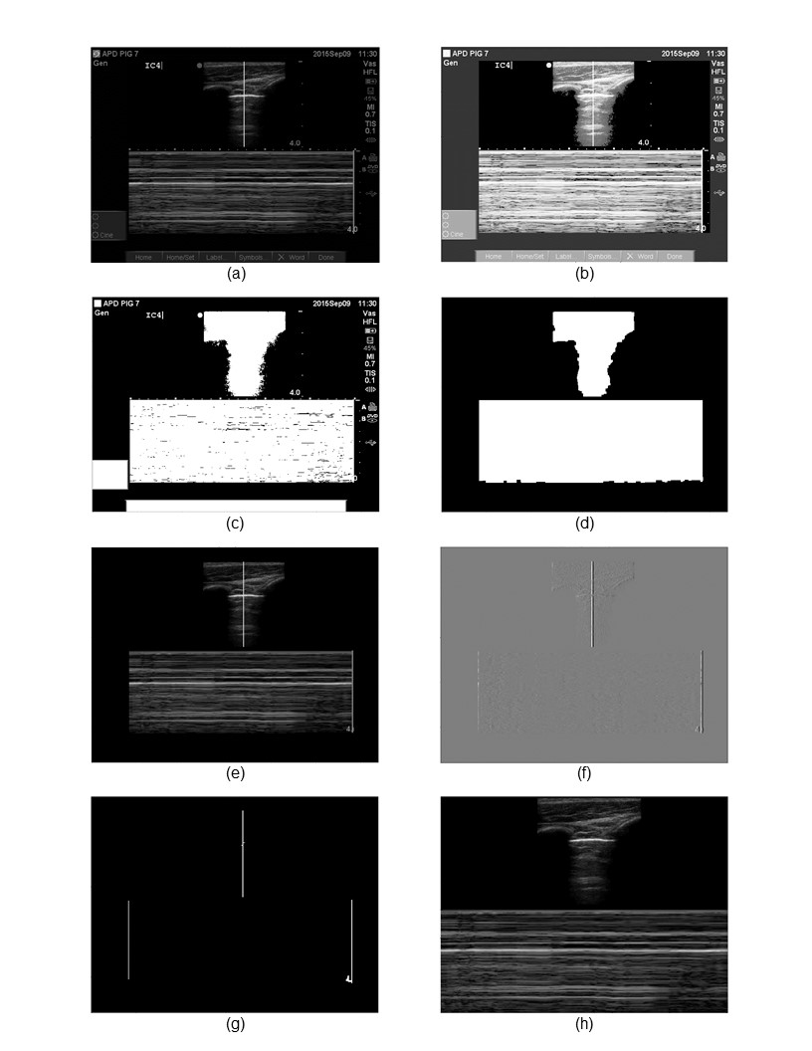
Figure 3. Example Image through Preprocessing Module.
- Original Image, (b) Image after Histogram Equalization, (c) Image after Thresholding, (d) Image after Morphological Operations, (e) Image with Background Objects Removed, (f) Image after Sobel Filtering in X-direction, (g) Image after Thresholding, (h) Final Image with Lines Blended.

Data Augmentation
The training image data products used to train our deep neural network AI model required considerable time and labor to obtain. Data augmentation artificially inflates the training set with label (pathology) preserving transformations. Varying degree rotations, x-axis translation, horizontal/vertical flips, noise injection, and image blurring via Gaussian filtering with random standard deviation were used to inflate the original corpus. In addition, sequences of these affine transformations produced images that were more complex. Contrast limited adaptive histogram equalization was applied to enhance the grayscale of each raw training data product. Calculations were performed to determine the correct number of generated augmentation required to achieve category parity, see Figure 3.
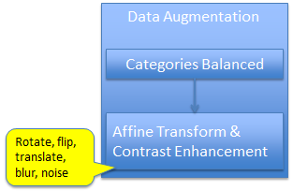
Figure 4: Data Augmentation and Contrast Enhancement

Model Generation
A deep neural network (DNN) with multiple hidden layers between input and output layers was used to model complex non-linear relationships present in sonographic medical images. Data flows from the input layer to the output layer without looping back. A model is generated such that the image is expressed as a layered composition of primitives. The deep layers allow composition of features from lower layers, potentially modeling complex data with fewer parameters than a shallower network.

Medical Data Interpretation
A test image data product is fed into the DNN, and a cascade of multiple layers of nonlinear processing units extracts features and performs transformations. The DNN uses a greedy layer-by-layer method to disentangle abstractions and choose features that improve image ground-truth prediction concurrence. Probabilistic interpretation involving inference, as well as optimization concepts of training and testing related to data distribution fitting and model generalization, characterizes the DNN.

User Interface
The following describes the input interface and output interface for the user interface.
Console based text, feature visualization.
The AMO medical analytics team will develop product interfaces for software-development purposes. However, the expertise and resources do not reside in the group to deliver such interfaces for general product users. The Medical Data Architecture team, which may house AMO analytics software, has expressed interest in developing user interfaces for basic text-based results and feature visualization.

Software Architecture
The following architectural diagram details a 16 layered deep neural network used to build one of our diagnostic models, see Figure 4.
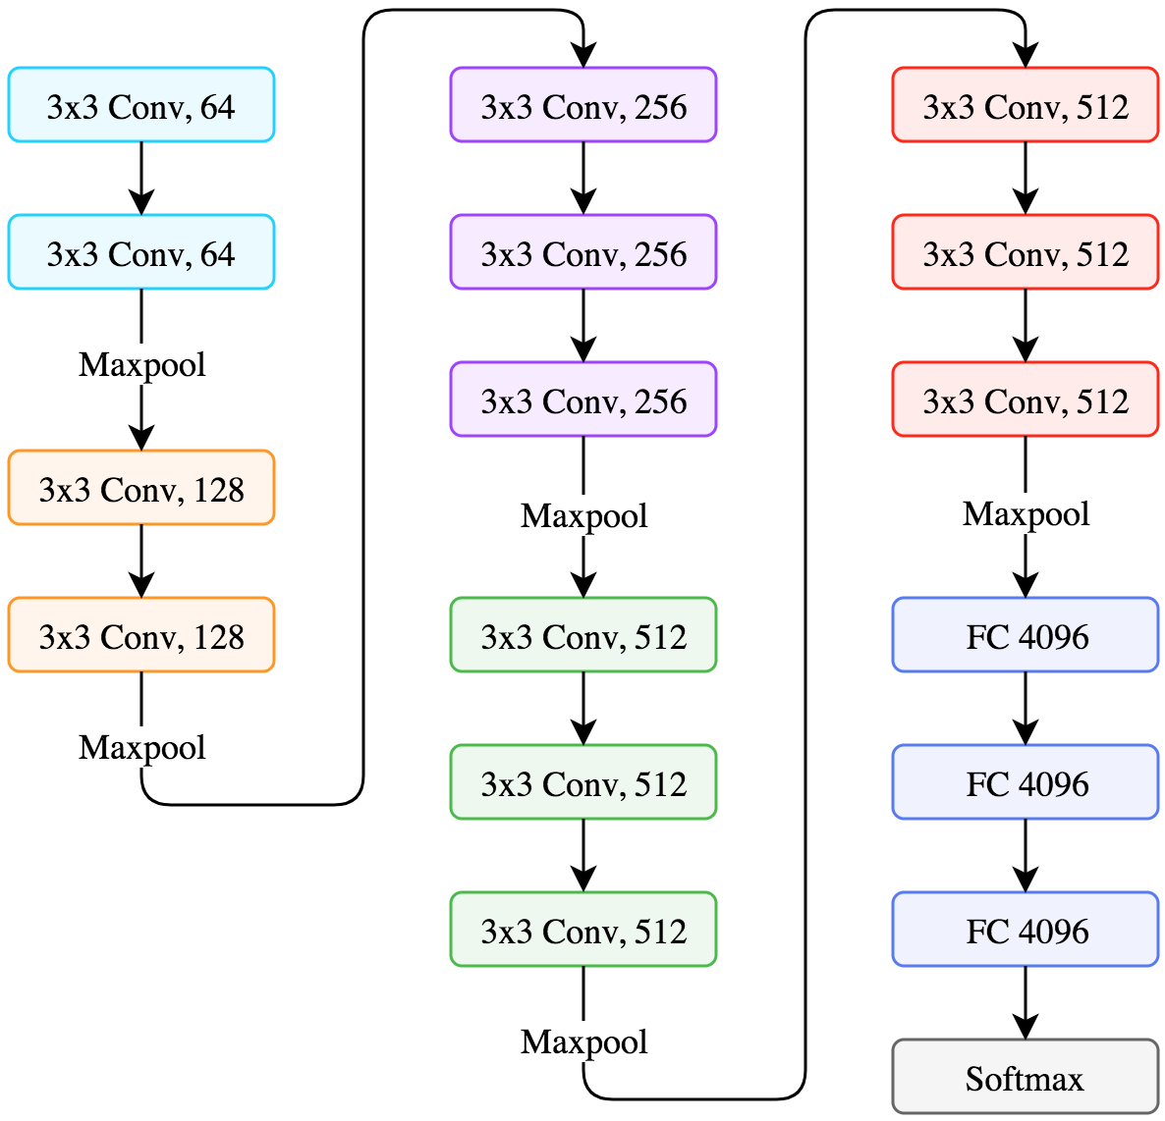
Figure 4: Description of Layers

The architecture consists of convolutional (“Conv”) layers that detect varying levels of image features and fully connected (“FC”) layers that perform high-level reasoning.
Pooling (“Maxpool”) combines the outputs of neuron clusters at oe layer into a single neuron in the next layer. The final layer is a classifier (“Softmax”) that gives probability of occurrence for each medical condition label being interpreted.

Figure 5 displays the network full view at the image level and specifies the nonlinear activation functions (“ReLU”) that determine neuron firing.

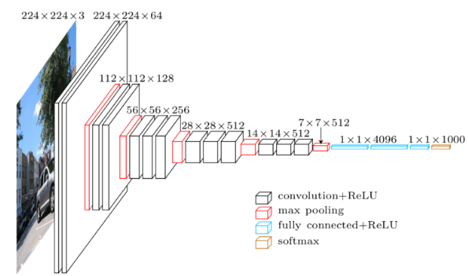

Figure 5: Full View of Network

Support for Later Upgrading

Different Methods for Interfacing with the Program
At the time of document preparation, the trained diagnostic models are intended to be embedded into a General Electric (GE) ultrasound device. The models will be integrated with computerized diagnostic assistant software developed by our primary collaborator, the US Army Institute of Surgical Research. The GE device automatically uses the model and presents interpretation results on its display screen. The AMO team intends to investigate the usefulness of image feature visualizations gathered from various points during the model prediction process. Methods for interfacing with the program model to determine and control visualization displays may become an important tool addition.

Different File Formats and Modalities
The medical images analyzed have been ultrasound b-mode and m-mode modality types.
The file formats include jpeg, bitmap, and mp4. The international space station collects medical images with several additional devices that are pragmatic for microgravity environment usage. The AMO team will develop models and support medical analytics of fundoscopic and ocular coherence tomographic image modalities. Additional data product file formats, such as audio video interleave and DICOM, will also be supported.

Diagnosis for additional anatomical structures
Pneumothorax medical images and video loops have been the focus of the AMO analytics activities to date. The medical conditions list details a hierarchy of common astronaut illness and physical anatomy injury. Given the variety of anatomical structures commonly affected during space exploration, we anticipate the need for future augmented intelligence software to have broader coverage.

Support for additional pathologies
Similarly, we anticipate the need for future augmented intelligence software to cover a broader range of pathologies.

Integration with other Devices
AMO plans to use embedded decision models and biosensors within HoloLens Augmented Reality framework (in concert with JSC and USAISR) which will provide near real-time feedback to crew on ultrasound transducer placement during a medical event. Refer to the AMO HoloLens integration, design and test documentation for further details.

References

Appendix

