10 page
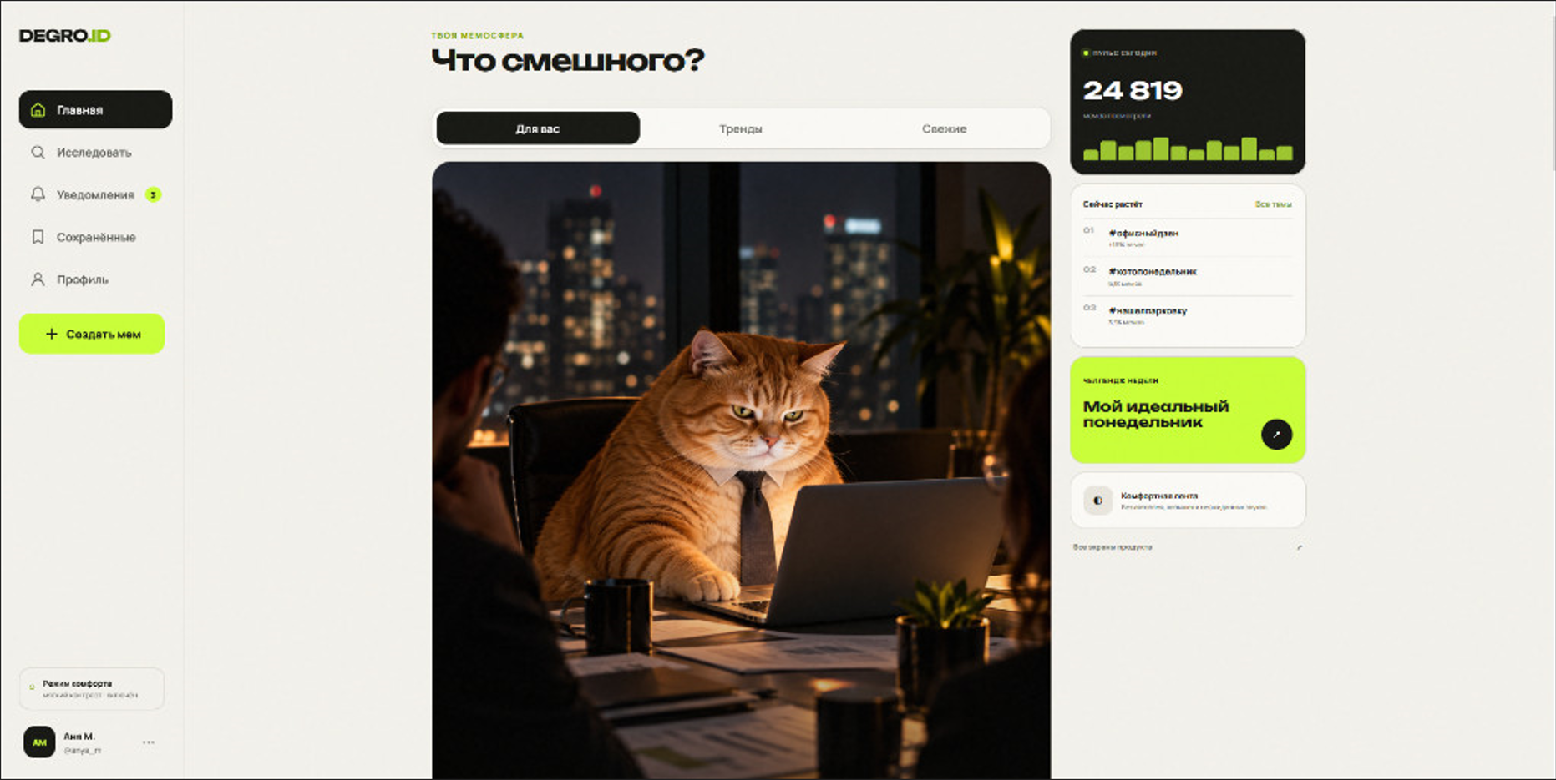

12 layout

15 layout__sidebar sidebar
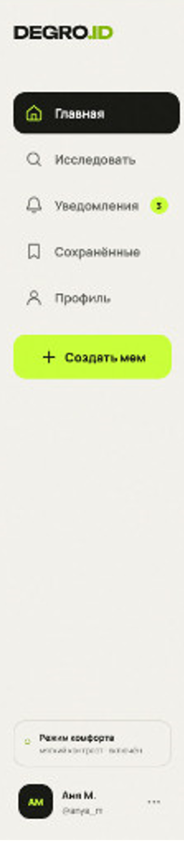
17 logo; logo__text


21 navigation; navigation__list
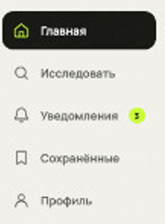

23 navigation__item navigation__item_active
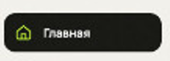

navigation__link
25 navigation__icon
26 navigation__text

29 navigation__item
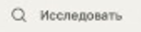

57 Button button_primary create-bautton
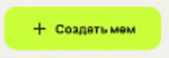

58 button__icon
59 button__text
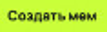

62 sidebar__footer
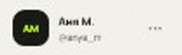
63 user-profile
64 user-profile__avatar
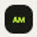
65 user-profile__info
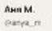
66 user-profile__name
67 user-profile__username
69 user-profile__menu
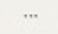

//////////////////////////////////////
76 layout__main main
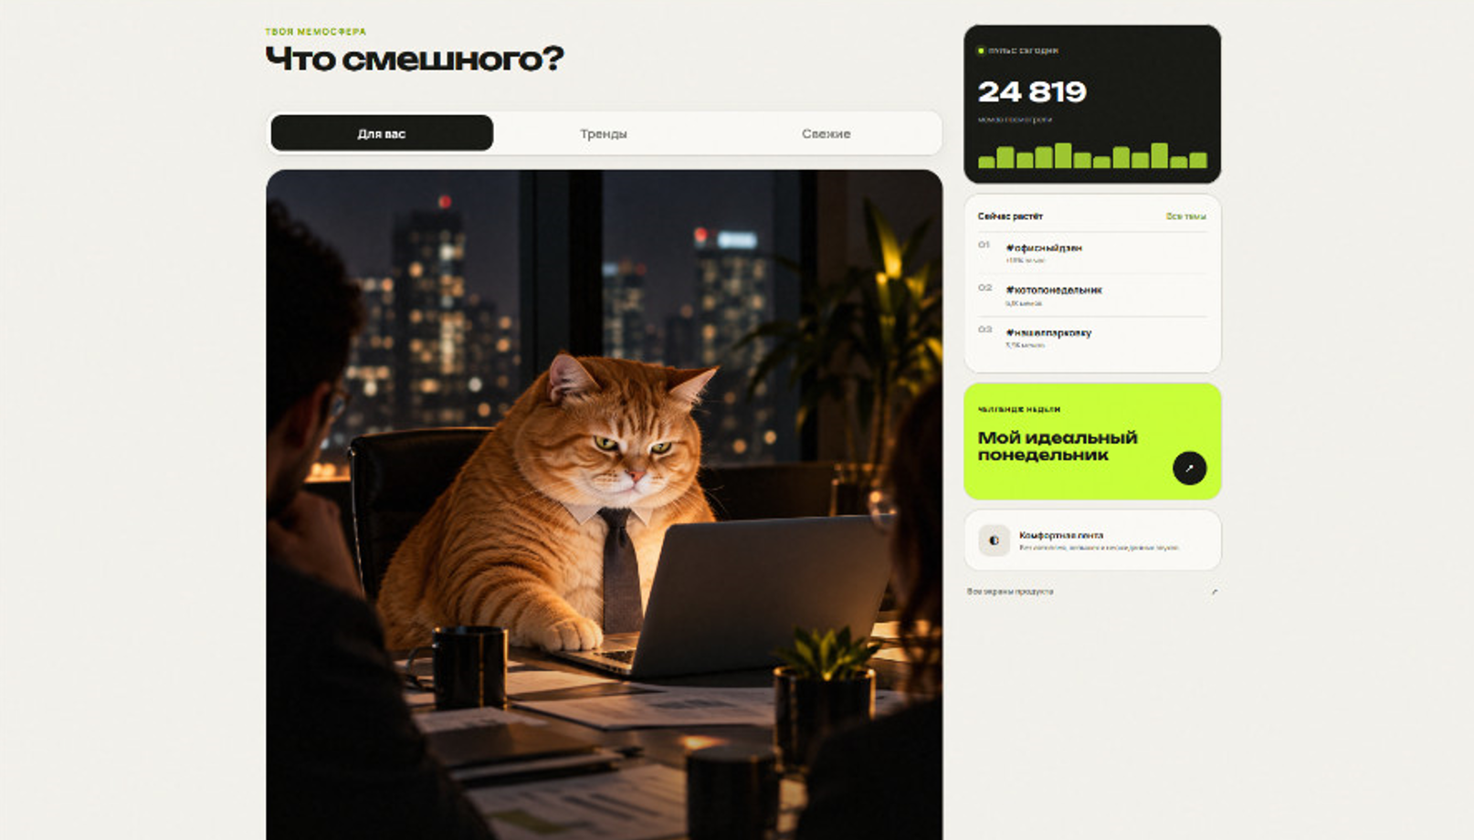
78 feed
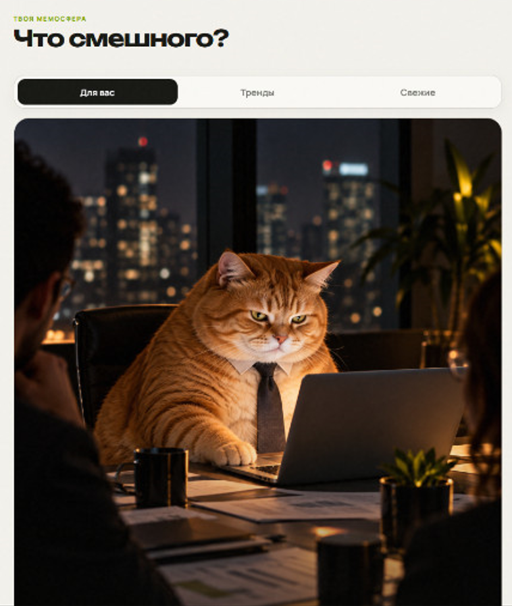

80 feed__header
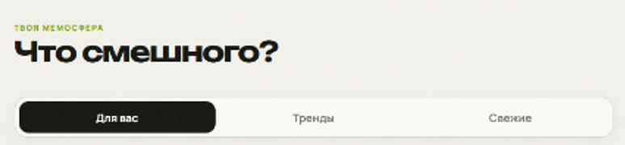
81 feed__heading
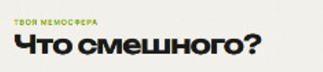
82 feed__eyebrow
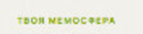
83 feed__title
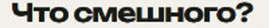

86 tabs
87 tabs__item tabs__item_active
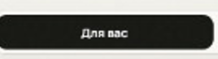
88 tabs__item
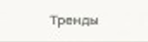

93 feed__list
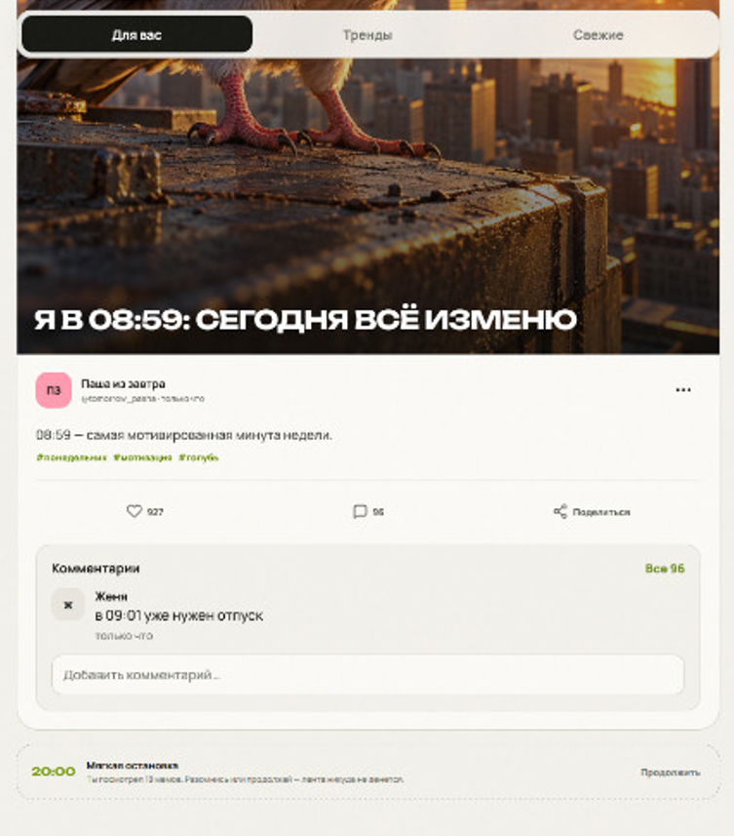

96 meme-card
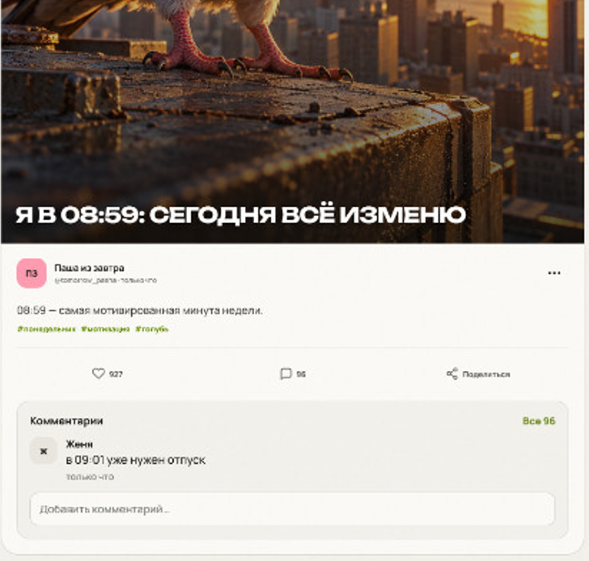

98 meme-card__media
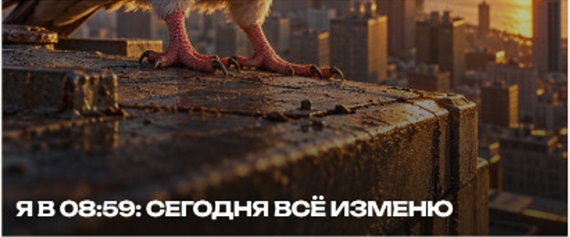
99 meme-card__image

100 meme-card__title

103 meme-card__content
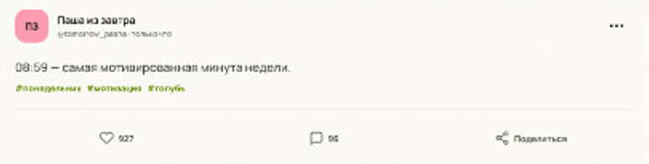
105 meme-card__header
106 meme-card__author
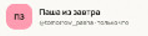
107 meme-card__avatar
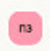
109 meme-card__author-info
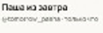
110 meme-card__author-name
111 meme-card__meta
115 meme-card__menu
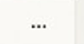

118 meme-card__description

120 meme-card__tags
121 meme-card__tag

125 meme-card__actions
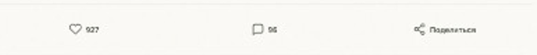
126 meme-card__action meme-card__action_like
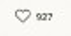
127 meme-card__action-icon
128 meme-card__action-count

131 meme-card__action meme-card__action_comments
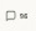

136 meme-card__action meme-card__action_share

138 meme-card__action-label

143 comments
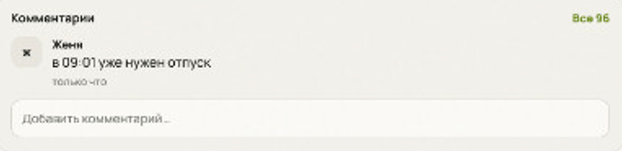
145 comments__header
146 comments__title
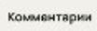
147 comments__all

150 comments__list

