OUTLINE

1. Add files to path
2. Direct GUI to data files
3. Manipulate output figures

ADD FILES TO MATLAB PATH

1. Locate folder with all files
2. Add to path by either command line or MATLAB interface (right-click folder in MATLAB and choose ‘Add to path > Selected folder subfolders’):

addpath(‘<directory of GUI files>’)

Do this without <> but with single quotes ‘’

-or-

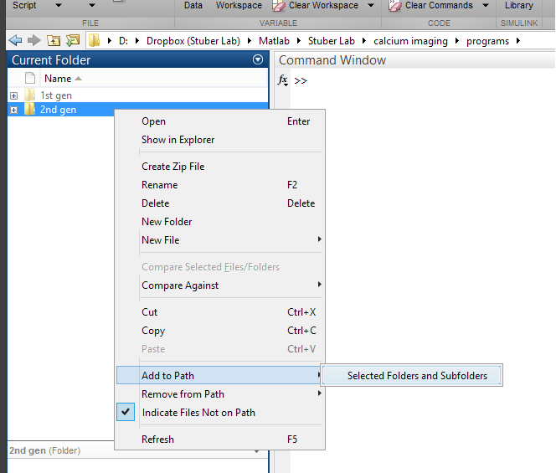

SETUP GUI

1. Run sdGUI.m
   1. Type into command window ‘sdGUI’
   2. Or right click file in MATLAB interface and select ‘Run’
2. Load responses.

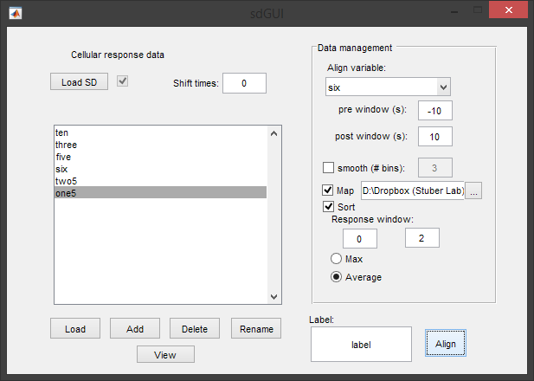

* 1. File can be .txt ~~or .mat~~.
     1. First column in file should be timestamps of recording (frames)
     2. Subsequent columns contain responses of each cell

1. Load session variables (nosepoke, lick, etc.)



**e**

**d**

**c**

**b**

**a**

* 1. Load button
     1. Use if data is in a .mat file. File should have separate Matlab variable for each session variable. Each Matlab variable should be a vector of timestamps corresponding to occurrences of the corresponding session variable.
  2. Add
     1. Use if data is currently in Matlab workspace (or can be evaluated in the command line). This will add session variables one at a time. GUI will prompt for name of session variable and timestamps corresponding to session variable.
  3. Delete
     1. Remove any session variables previously loaded/defined. Clicking button will delete selected variable from list box.
  4. Rename
     1. Renames selected session variable
  5. View
     1. Opens new window with values of selected session variable.

1. Choose variable to align data to



* 1. Select session variable to align cell responses to. Define a window relative to occurrences of selected session variable in the pre and post boxes. Use negative numbers if you want a timepoint before the occurrence of the selected session variable for alignment.

1. Other options



**a**

**b**

**c**

**d**

* 1. Smooth
     1. Smooths cell responses by averaging number of data points around defined by number in box.
  2. Map
     1. Creates cell map of data. Retrieves image files from directory defined to right. Use button to locate directory or type in directory. Cells will be colored according to response defined below.
  3. Sort
     1. Arranges/orders cells by response defined below.
  4. Response
     1. Define a response metric for each cell. This is calculated by either a maximum or average of the cells response within a window relative to the occurrence of the selected session variable for alignment. This window is defined in the two boxes (similar to how previous window was defined with pre and post timepoints).

1. Align



**b**

**a**

* 1. Name for dataset
  2. Do it.

OUTPUT

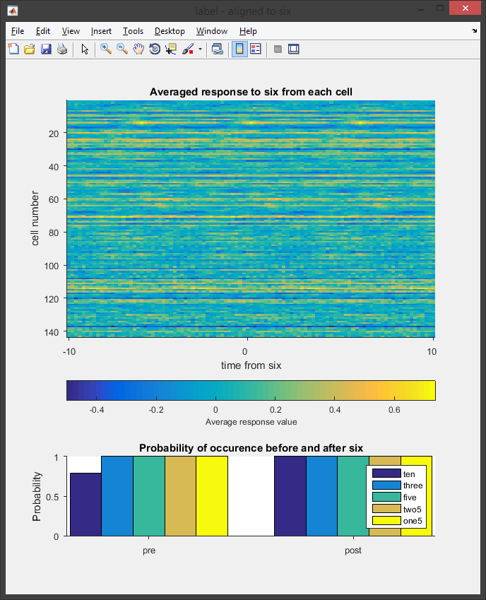

Probability that other session variables will occur before or after (within the defined window) selected session variable chosen for alignment.

Response from each cell to aligned to selected session variable averaged across all occurrences of variable. Response for a particular cell is coded in color across a row. X-axis = time, y-axis = individual cells.

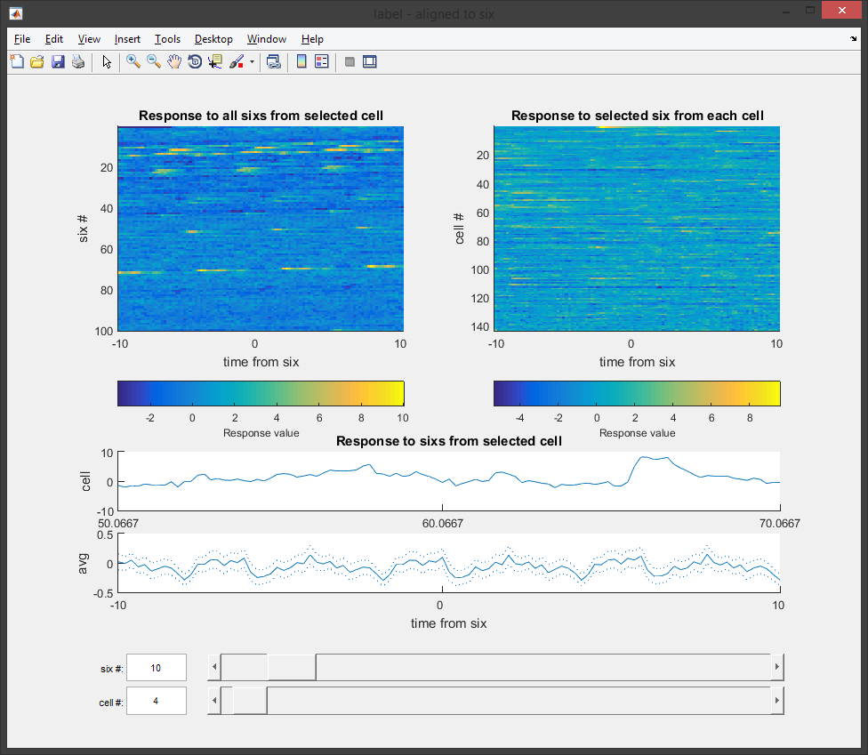

Choose individual occurrence of session variable to focus

Choose individual cell to focus

Average response from chosen cell to all occurrences of session variable

Response from chosen cell to chosen occurrence of session variable

Response to occurrence of selected session variable chosen below from all cells

Response to each occurrence of selected session variable from cell chosen below

Figures can be right-clicked to open more options

1. Send to workspace
   1. Sends data from figure to MATLAB workspace for reading and manipulation
   2. GUI will prompt to name variable
2. Save data
   1. Saves data from figure into .txt or .mat file.
   2. GUI will prompt to name file and path to save.
3. Open in new window
   1. Opens figure in new window to single it out.
   2. Figure can be saved this way without other graphics.

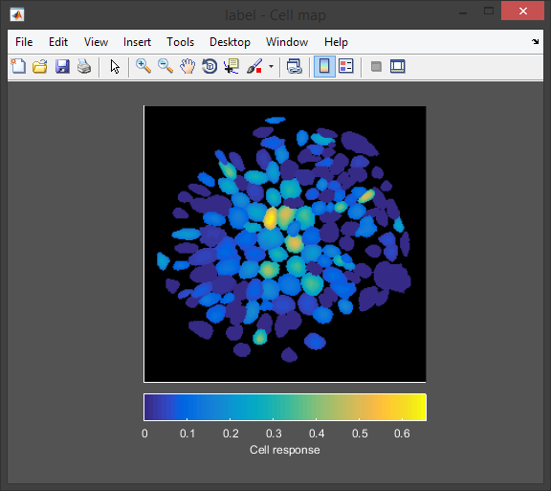

Color determined by magnitude of ‘response’ (defined by cells activity within response window as either average or max).