Create a new MAF app

Use AMPA to create New MAF Business Object from REST service

For that I use the RAML file

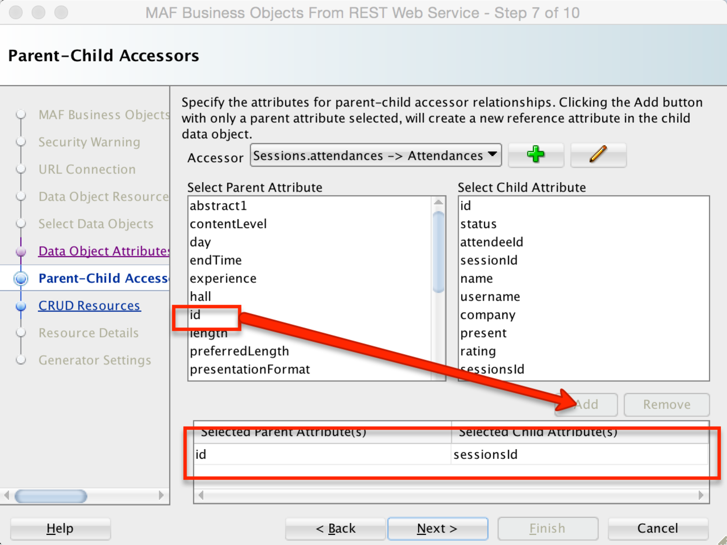

After that, set the headers for each request to be the same as:

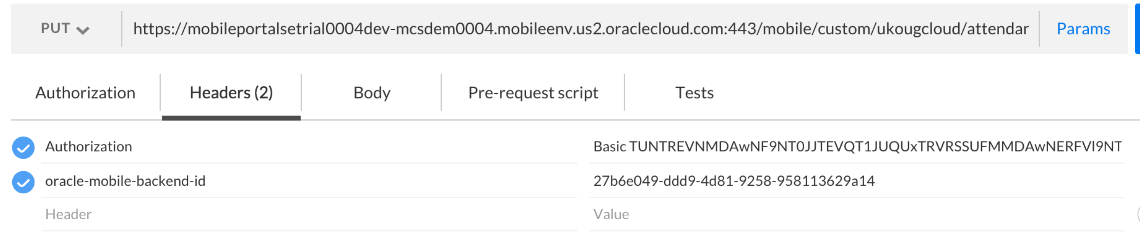

After the BO are finished, I create datacontrols

Then, create the basic UI

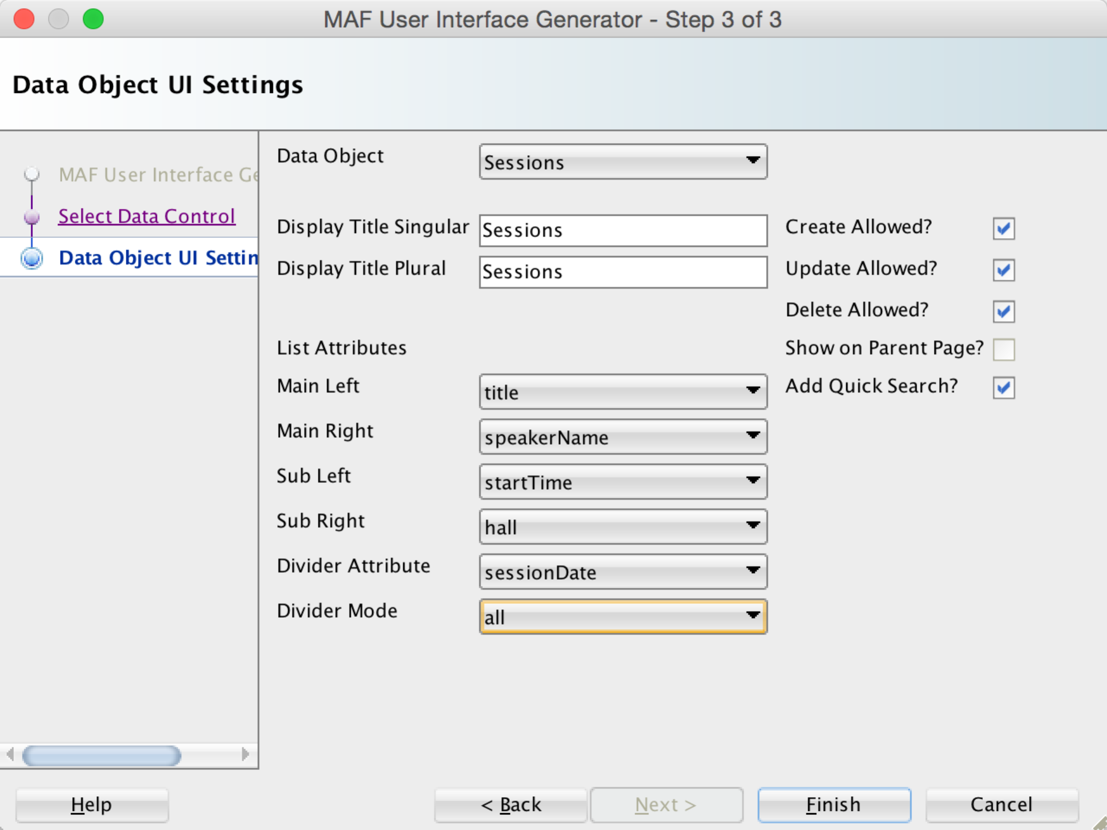

## MCS platform API’s

http://download.oracle.com/otn_hosted_doc/maf/mafmcsutility-api-doc-082015.pdf

## Notifications

1. enable pushPlugin
2. In de LifeCycleListener:

public void start()

{

// Add push notification listener

EventSource evtSource = EventSourceFactory.getEventSource(

EventSourceFactory.NATIVE_PUSH_NOTIFICATION_REMOTE_EVENT_SOURCE_NAME);

evtSource.addListener(new NativePushNotificationListener());

}

1. Een nieuwe class maken (NativePushNotificationListener)

## Local Notifications

<https://blogs.oracle.com/mobile/entry/how_to_implement_ibeacon_in>

1. enable pushPlugin
2. In de LifeCycleListener:

public void start()

{

// Add local push notification listener

EventSource evtSource = EventSourceFactory.getEventSource(

EventSourceFactory.NATIVE_LOCAL_NOTIFICATION_EVENT_SOURCE_NAME);

evtSource.addListener(new NativeLocalNotificationListener());

}

1. Een nieuwe class maken (NativePushNotificationListener)