2017

Alan Grant, Rebecca Luttmer, and Jeremy Stephens

4/30/2017

Audemes User Manual



**Contents**

[Purpose of this Document 2](#_Toc481339892)

[Document History 2](#_Toc481339893)

[1. What are Audemes? 3](#_Toc481339894)

[1.1. What are Audemes? 3](#_Toc481339895)

[1.2. Why use Audemes? 3](#_Toc481339896)

[1.3. What is our Project? 3](#_Toc481339897)

[1.4. Project Players 3](#_Toc481339898)

[1.5. Support 4](#_Toc481339899)

[2. Using the Audemes Website 5](#_Toc481339900)

[2.1. Connecting to the Audemes Website 5](#_Toc481339901)

[2.2. Website Layout and Navigation 6](#_Toc481339902)

[3. Using the Audemes Dictionary 8](#_Toc481339903)

[3.1. Searching the Dictionary 8](#_Toc481339904)

[3.1.1. Category Search 8](#_Toc481339905)

[3.1.2. Search by word or Phrase 9](#_Toc481339906)

[3.2. Browsing the Results 9](#_Toc481339907)

[4. Playing the Audemes Games 11](#_Toc481339908)

[4.1 The Atomic Guessing Game 11](#_Toc481339909)

[4.1.1. How to play 11](#_Toc481339910)

# **Purpose of this Document**

The purpose of this document is to describe to an end user how to use the American Printing House for the Blind Audemes website. The audemes website can be found at <https://audemes.aphtech.org>.

# **Document History**

|  |  |  |  |
| --- | --- | --- | --- |
| **Version** | **Date Submitted** | **Drafter** | **Description** |
| 1.0 | Sunday, April 30, 2017 | Grant, Luttmer Stephens | Finished first version of document. |

# **What are Audemes?**

## **What are Audemes?**

Pronounced “awe deems”, audemes are brief audio illustrations that combine sounds to form aural symbols which represent ideas, things, actions, and situations. As an example, the audeme for the phrase “cat nap” could be represented by combining the sound of a cat’s meow with the sound of a person snoring.

## **Why use Audemes?**

Audemes have been found to be useful for education of both the blind and visually impaired, as well as students with normal vision. Professor Stephen Mannheimer of Indiana University – Purdue University Indianapolis (IUPUI) has been performing research with audemes since 2007. Professor Mannheimer’s research with IUPUI has shown that students who are educated using audemes in conjunction with standard materials show better test scores as well. These students also express a higher positivity towards learning science and math subjects.

## **What is our Project?**

In 2016 Professor Mannheimer and the American Printing House for the Blind (APH) partnered with students and faculty from Indiana University Southeast (IUS) to update the existing audemes website. The existing product was unorganized as well as being unfriendly for visually impaired users: the primary target for audemes. Our group was tasked with redesign and deployment of a new more accessibility oriented website.

## **Project Players**

* Product Owner
  + Larry Skutchan – APH Director of Technology Product Research
* Product Sponsors
  + Professor Stephen Mannheimer – IUPUI
  + Dr. Ronald Finkbine – IUS
* Development Team
  + Alan Grant – IUS student
  + Rebecca Luttmer – IUS student and APH employee
  + Jeremey Stephens – IUS student

## **Support**

For support contact the APH.

**American Printing House for the Blind, Inc.**  
1839 Frankfort Avenue  
Louisville, Kentucky 40206-0085  
U.S.A.

**Phone:** 502-895-2405  
**Toll-Free** **Customer and Technical Support**: **800-223-Fax:** 502-899-2284

# **Using the Audemes Website**

## **Connecting to the Audemes Website**

To connect to the audemes website simply use any modern internet browser and got to <https://audemes.aphtech.org>. From here you can access everything the site has to offer. In the future, once more community driven aspects are in place, there may be a need for accounts and further authentication. However, at present these features are not in place.

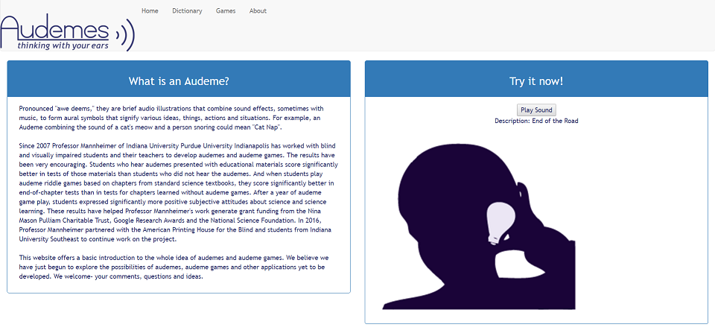When first connecting to the audemes website you will land on the site’s home page (Figure 1). This home page conveys some information about audemes and the project as well as providing access to a sample audeme. The website can be navigated by those with normal vision using the mouse. It is also screen reader friendly and can be navigated with the tab button. With the screen reader enabled tabbing to different buttons and portions of the page will relay info to the user via digitized text to voice.

Figure 1: Audemes website homepage.

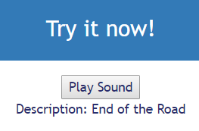To access the sample audeme activate the “Play Sound” button on the righthand side of the home page. This will play the “End of the Road” audeme. Figure 2 shows a zoomed in picture of this button.

Figure 2: Zoomed in button for sample audeme.

## **Website Layout and Navigation**

C:\Users\Alan\AppData\Local\Microsoft\Windows\INetCache\Content.Word\nav_bar.png

Figure 3: Site navigation bar.

The website is currently laid out as four distinct pages. These pages are the “Home”, “Dictionary”, “Games”, and “About” pages. Each of these pages can be accessed by using the static navigation bar (Figure 3) at the top of each page.

* **Home Page**

The home page is the landing page for the site and is described in more detail in section 2.1 Connecting to the Audemes Website.

* **Dictionary Page**

The Dictionary page provides a user interface for searching the library of audemes available on the website. It is described in more detail in section 3. Using the Audemes Dictionary.

* **Games Page**

The Games page provides a landing page where users can access audemes based games. There is currently only one game available, but more are planned for future versions of the website. It is described in more detail in section 4. Playing the Audemes Games.

* **About page**

The About page provides information about some of the people involved in the project.

# **Using the Audemes Dictionary**

## **Searching the Dictionary**



Figure 4: The search interface for the audemes dictionary.

The searchable dictionary of audemes is accessible by activating the “Dictionary” button on the navigation bar. This takes you to the search interface (Figure 4). This dictionary contains audemes of many different types. It includes audemes which represent a simple idea, often called atomic audemes. It also includes audemes consisting of multiple atomic audemes which represent phrases and more complex ideas.

The dictionary is searchable in two ways: category search and word or phrase search. These two searches are described in more detail in the subsections below.

### **Category Search**

**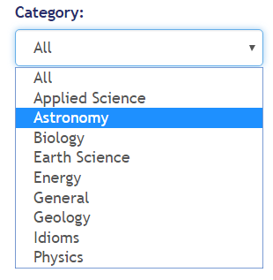**

The search interface provides a dropdown menu for searching by category (Figure 5). The provided categories are: all, applied science, astronomy, biology, earth science, energy, general, geology, idioms, and physics.

To use the category menu with a mouse simply click to bring up the menu and then click the category you wish to search. It is also possible to access the menu by tabbing to it and using the down arrow to move through the provided categories.

Figure 5: Search interface category dropdown menu.

Once a category is selected activate the “Go” button to get your search results.

### **Search by word or Phrase**



To use the search interface’s word or phrase search navigate to the search input box (Figure 6) using the mouse or the tab key. Once there simply type in the word or phrase you wish to search for. Once done typing activate the “Go” button or press the enter key to get your search results.

Figure 6: Word or phrase search input box.

## **Browsing the Results**

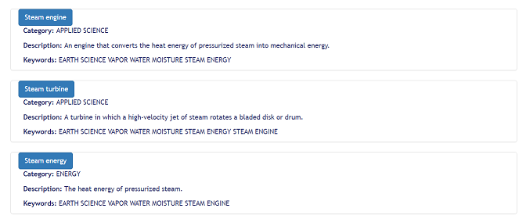

Figure 7: Sample audeme dictionary search results.

Once you’ve performed your search the results will be returned and displayed on the page (Figure 7). To browse the results, you can use the tab key to move between results, scroll through the page using the mouse wheel, browser scroll bar, or use some other method.

Search results are blocked out into individual audemes. Each block contains a button which, when activated will play the audeme. Also, included in each block are the category, a short description, and a list of keywords associated with the audeme.

# **Playing the Audemes Games**

By activating the Games button on the navigation bar, you will be taken to the Games page. This page provides a jumping point for playing audemes games. There is currently only one audemes game available, “The Atomic Guessing Game”. However, there are plans to implement more games in the future.

## **The Atomic Guessing Game**

The Atomic Guessing Game is a simple to play audemes game meant as an introduction to using and working with audemes. To access the game simply activate the “Next” button after arriving on the Games page. This will take you to the interface for playing the game (Figure 8).



Figure 8: Guessing game interface.

### **How to play**

The game is meant to be simple and straightforward to play. The idea is that you’re given a series of atomic audemes which, when combined, make a more complex audeme. The goal is to guess what that complex audeme is from listening to the atomic audemes.

C:\Users\Alan\AppData\Local\Microsoft\Windows\INetCache\Content.Word\guessing_game_atomics.png

Figure 9: Atomic audemes for the Guessing Game.

These atomic audemes (Figure 9) are located on the left side of the interface. Each audeme is given a button and activating that button will play the audeme. Once you have listened to all the audemes or if you think you know the answer already then choose your answer from the answer choices (Figure 10) on the right side of the interface.

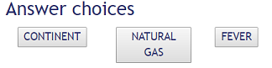

Figure 10: Guessing game answer choices.

If you have selected the correct answer you will be notified by a celebratory audio cue. This is a website for the visually impaired after all. You will also be given another audeme to guess.

If your answer is incorrect you will also be given an appropriate audio cue. In this situation, a hint will be revealed in the space between the atomic audemes and the answer choices. This hint should help you figure out the answer. You have as many attempts as needed to get the correct answer and there is no scoring system on this game.

If, at any point, you wish to move to a new audeme, simply click on the “Next” button. This will pull a random audeme from the library for you to guess.

**END DOCUMENT**