CSIA_AllFish_Tables

Welicky et al.

6/29/2021

## R Markdown

This is an R Markdown document. Markdown is a simple formatting syntax for authoring HTML, PDF, and MS Word documents. For more details on using R Markdown see <http://rmarkdown.rstudio.com>.

When you click the **Knit** button a document will be generated that includes both content as well as the output of any embedded R code chunks within the document. You can embed an R code chunk like this:

library(dplyr)

## Warning: package 'dplyr' was built under R version 3.6.2

##   
## Attaching package: 'dplyr'

## The following objects are masked from 'package:stats':  
##   
## filter, lag

## The following objects are masked from 'package:base':  
##   
## intersect, setdiff, setequal, union

library(kableExtra)

## Warning: package 'kableExtra' was built under R version 3.6.2

##   
## Attaching package: 'kableExtra'

## The following object is masked from 'package:dplyr':  
##   
## group_rows

library(knitr)  
load("models.Rdata")

## Including Plots

You can also embed plots, for example:

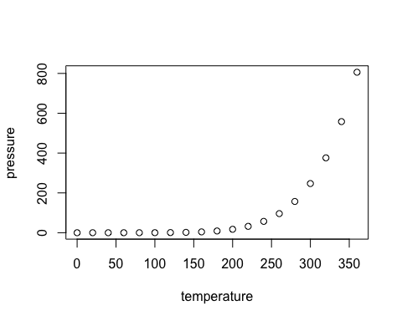

Note that the echo = FALSE parameter was added to the code chunk to prevent printing of the R code that generated the plot.