Supporting Documentation

My web application went under many steps to be created, ranging from normalisation within the CSV file to calculating all of the different statistics of the seating count using python.

The first step I had to take was to normalise the results we were given. We were provided with a brief on Minerva, along with a CSV file with all of the 2019 electoral roll results. At first glance, these results looked to be formatted appropriately – each column only had one type of information in it (the names were split into two columns instead of being together in one) and was ready to use. However, it contained no primary keys, and no specific IDs for each of the categories.

The first thing I did was use Lucid Chart to create a diagram of how I wanted to normalise my table, as this helped me visualise where the data should be split accordingly, what categories required custom IDs and which categories I could remove completely if needed. Here is the chart I created:

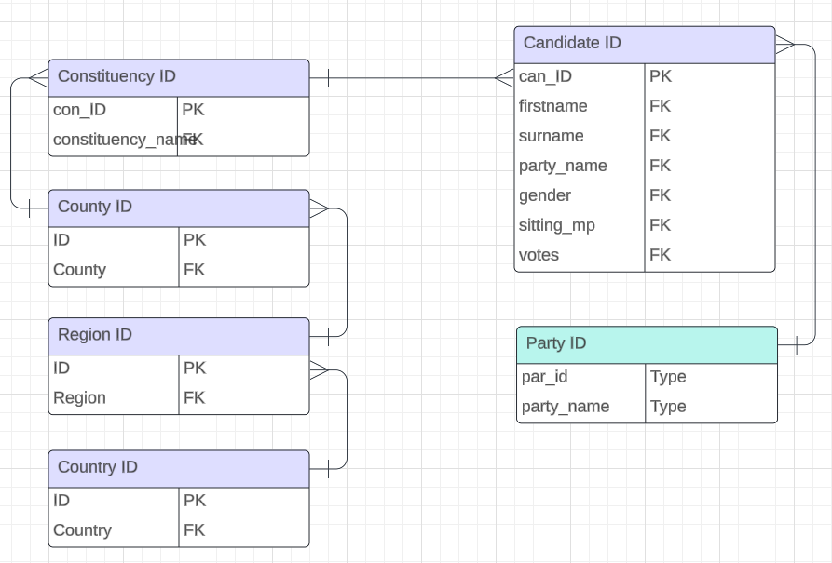

This chart clearly demonstrates the use of primary keys and foreign keys, and also shows the different tables I will split my information into on my CSV file later on in the project.

The next step of this was the table creation in excel. I opened the original CSV file and followed the original demonstration I made for myself via Lucid Chart. I did this in excel so that once the information is imported from excel into MySQL Workbench / Python, I can select the specific columns I want to import into the Table Data Import Wizard found in MySQL Workbench.

Along with this, I had to give everything a unique ID in excel so that each snippet of information can be identified via the finalised table which will be created later via the python calculations. This means all information can be tracked down accordingly due to each entry having a unique ID. Here is a snippet of the CSV file which was edited in excel:

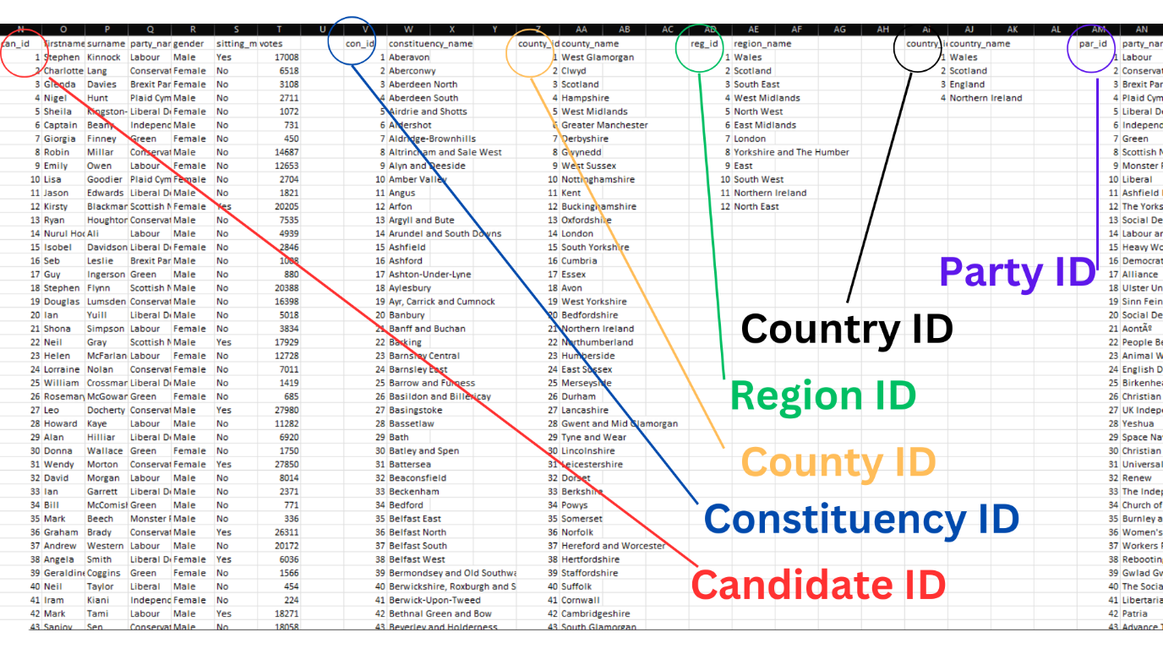

This clearly shows the usage of different tables to categorise the data and grant each category with a unique identification, which will be of use later in the document.

Once the data had been normalised, I then moved on to MySQL Workbench. The first task I had to fulfil was to set up a new schema for the document, which I named “politics_database”. Python will be used later to link this together with the rest of the information. I then proceeded to use the Data Table Import Wizard to bind my CSV document with the schema used from MySQL Workbench. Upon further studying, I realised that I didn’t technically need to use MySQL Workbench for as much as I thought I did. The initial plan was to use MySQL Workbench to create a bunch of stored procedures and methods of calculating the data, then I realised that Python is the real calculator of the assignment, so in the end, I mainly just used MySQL Workbench to pull the CSV file into a place where Python can then take it and do calculations with it.

As mentioned earlier, I used the Table Data Import Wizard to get my CSV file into MySQL Workbench, and then into Python. A crucial button for me was to click the “drop table if exists” button during this process. This is because I was making many amendments to my table after the first import of my original table. This button would clear the previously used table and use the new one.

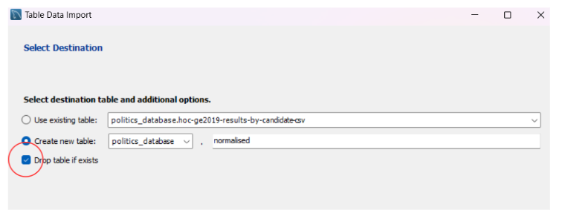

After following through with the rest of the Table Data Import Wizard, I then used a simple SQL command to see if my database would run via MySQL Workbench, to ensure I had imported the CSV correctly. Throughout this project there was a lot of testing, but this was the main command used in MySQL Workbench, as I had many versions of my table to test. Along with this, I also changed the feature which states “Limit to 1000 rows” and set this to 5000 instead, as the results were over 3000 lines long, so if I was to select all results, it would only present around a third of the total results.

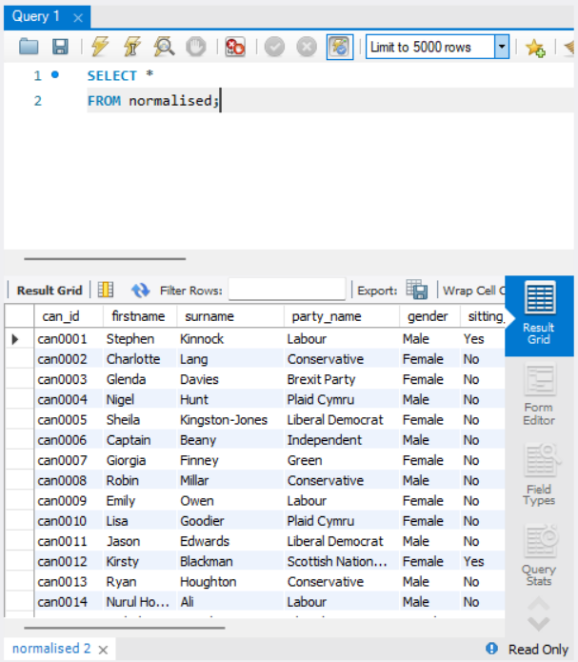
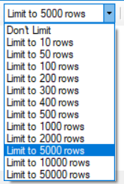

From here, I then proceeded to figure out how I should import my data into Python, to process all of the different calculations to which I can find out specific parameters, such as seat allocation, percentage of seats, percentage of popular votes etc. The first step of this was to connect the database to the python code, which required a snippet of python to do.

First of all, I imported mysql.connector and flask. The mysql.connector allows python to access any databases that are made via MySQL, allowing my document to read the document that I had imported into MySQL Workbench. After this, I had to declare a connection between the two programs. The SQL database and python file had to be connected so that I am able to import all the data from the table using commands later in the code. Here is the snippet of code used to do all of this:

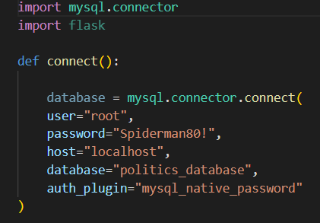

As can be seen in the image, I have added some key information, such as the user of the database (in this case it’s simply ‘root’), the unique password I provided my database with, the host declared in the database, the name of the database (i.e the name of the schema where the database was sent), and also auth_plugin, which allows a MySQL server to use Windows to authenticate a connection between the two.

From this, I then proceeded to figure out how to create my table via python. I knew this would take a lot of trial and error, and along with this, there would a bunch of repeating lines / pieces of code that look very similar to each other. The first thing I had to do was create a table using python. I followed some commands provided to us from Minerva and then tweaked them to fit my version of the code I am using (as the solution was provided for sqlite, but we were using workbench). I then used a series of cur.execute commands to create 6 different tables for each of the different categories listed in my csv file. These were tables for candidates, parties, constituencies, counties, regions and countries. Here is a snippet of the code used to create a table for the candidates.

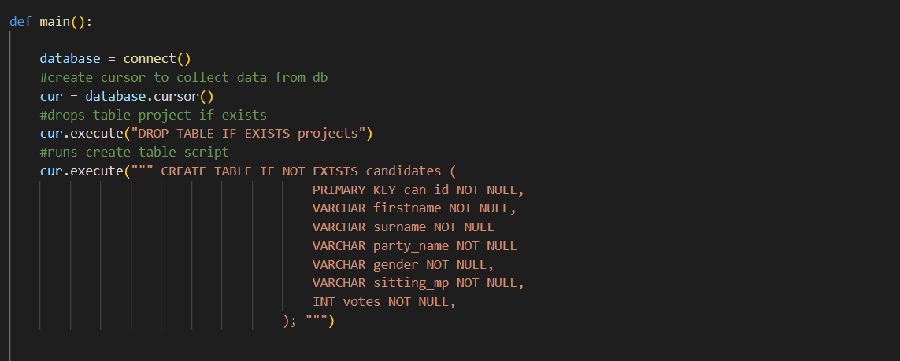

After this, I simply had to repeat what I did with this table, but five more times, in a much more condensed manner for the other five different categories I wanted to include.
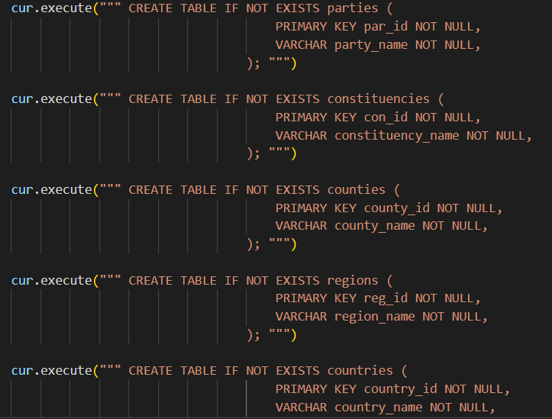

The next stage I went through was to attempt to present the most votes via constituency for a First Past the Post system. I am unsure if it works but when attempting to present it in a table I have found success via my own machine using an extension on Visual Studio Code, known as SQLite 3 Editor. Here is the code with some explanation:

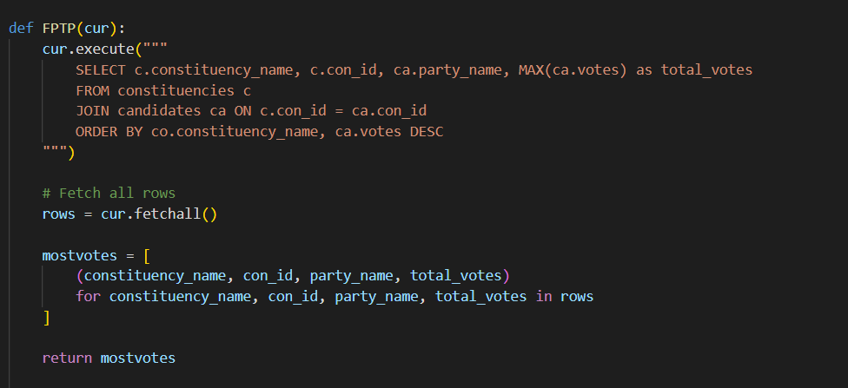

The aim of this code is to present each constituency with the most votes. The cur.execute selects constituency_name, con_id, party_name, caps the votes using a MAX votes system (to identify which party had the most votes) and stores it as total_votes.

From there it takes the information from “constituencies” using the ‘c’ as an alias from the constituencies table I had previously created in the code (and the ‘ca’ as an alias from the candidates table), and orders the votes by constituency_name and votes descending (displaying the highest voted constituencies first.

Then I use a fetchall to grab all rows, and calculate the most votes by taking constituency_name, the ID for it, party name and total votes. This is done via a tuple system, and the mostvotes return at the end turns all of the information into a more readable and displayable list.

Upon completing this, I then decided to add this snippet of code above return mostvotes:

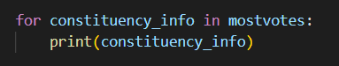

I thought this would then present the information into the terminal, but this seems to not be the case. Unfortunately this line was not successful and therefore I have removed it from my final product, leaving this section at somewhat of an awkward point.

Next up, we have the code to calculate the simple proportional representation, and also the code to calculate the threshold version of this too. First of all, I had to declare “Proportional” as a cur, so that was my immediate starting point. From there, I got working on the calculation of what information actually needed gathering from my database. Here is a snippet of the first section of my calculations:

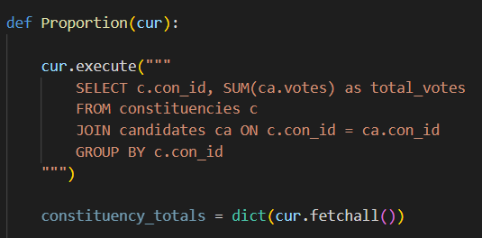

To break this down simply, I am joining together the constituencies and candidates tables and using a sum to calculate the total number of votes. I had to conduct some further research from here, and found out it would be useful to create a dictionary for storing the number of votes per constituency, using the “dict” command. This is inserted into my fetchall line as “fetchall” is extracting all of the information for the “dict” to then store into a dictionary, where con_ID is being used as keys and the votes are being used as values within these keys. This took varying amounts of research to figure out, but I resorted to using Google for Education as a source of some research.

Following on from this, I then had further calculations which were used to work out the rest of the calculation for proportional form.

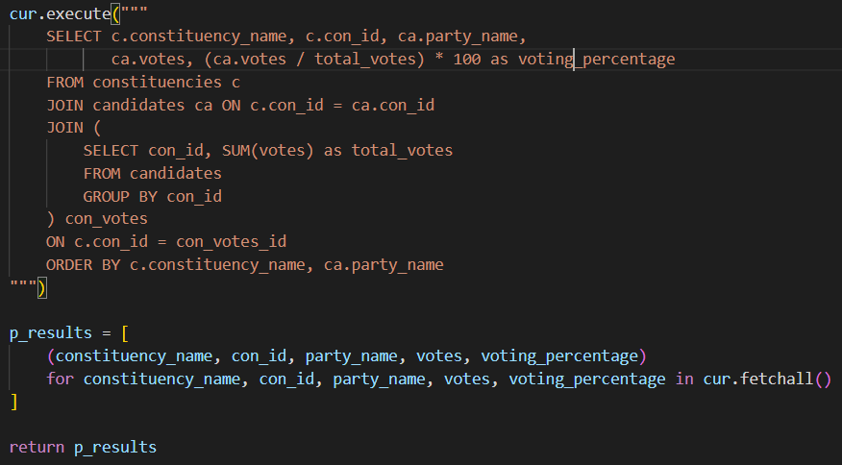
This calculation takes the data for each constituency (constituency name, ID, party name, votes, and vote percentage), then the con_votes calculates the total votes per constituency, which enables the main calculation to figure out vote percentage for each party in each constituency.

From there, p_results is created as it is made to store the tuples from the next few lines of code. Tuples work in a similar way to lists, except information stored in a tuple is not changeable, making it perfect to store data such as electoral roll results, which shouldn’t be manipulated with anyway. Each tuple will store information such as the name of the constituency, ID, party names represented, votes, and the vote percentage too. The full list of proportional results is then returned with the return p_results.

In order to add the 5% threshold, I only had to add one simple line of code, which allows the python to filter out the results, so if a party has gained less than 5% of the total votes, they will not be granted any seats.

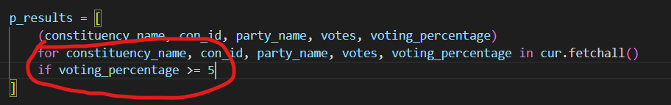

The biggest reflection on this project I can think about for myself is the procrastination when looking at how to learn python. There are endless amounts of resources online, including those from w3schools, stack overflow, google education etc. I was extremely anxious to get stuck in, but happy I did! Albeit my code may not function as intended, I am happy I have been able to attempt creating a database, and also learned a lot about MySQL along the way.

I also feel extremely comfortable with normalising data, which can be shown with my normalised CSV file which was imported to MySQL.

A crucial change I made during the process was reformatting my entire table. At first, I actually attempted to complete the project with no normalisation – which I later found out was incredibly silly. Upon first glance, the document looks normalised, but from further research, I found out that normalising it was required – to give everything a custom ID for categorisation, ease of use and user visibility too.

From a mathematical perspective, the electoral systems are varying in complexity. I have not delved deep into the depths of using d’hondt, largest remainder etc, but even the difference between proportional representation and FPTP were significant enough to notice the difference between the two. Proportional representation allows for a more equalised government, where coalitions can happen between certain thresholds of votes, but can also lead to formations of weak government power who lack team skill within a coalition. FPTP can be biased also though, with the conservatives only getting around 35% of the votes but gaining 50% of the seats.

References
https://developers.google.com/edu/python/dict-files#:~:text=Python%27s%20efficient%20key%2Fvalue%20hash,value2%2C%20...%20%7D.

