Hola Intercom Design

# Revision History

* 09/01/2017: 1st draft
* 09/18/2017: Added buddy_id to cloud api
* 10/02/2017: Added echo request and reply messages

# Firmware

## Ownership

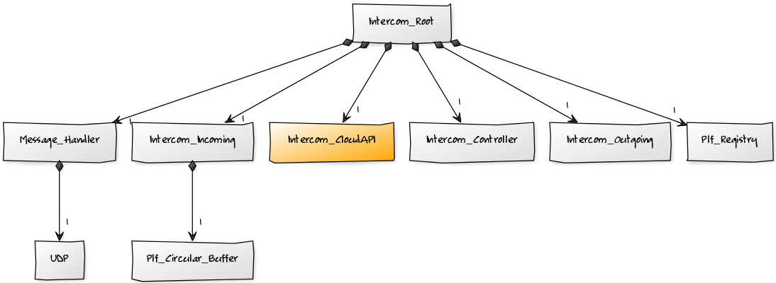

## Root

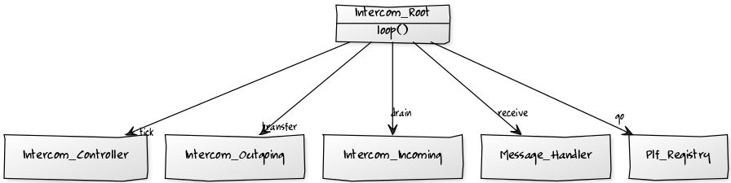

## Intercom Incoming

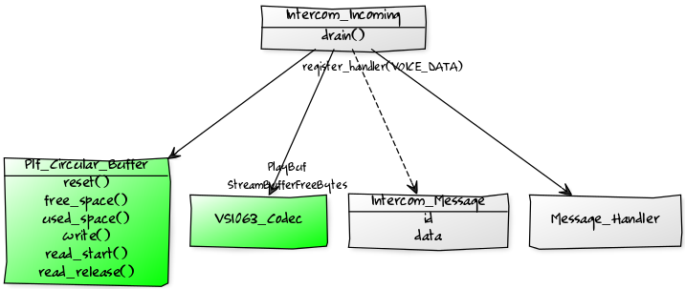

## Intercom Outgoing

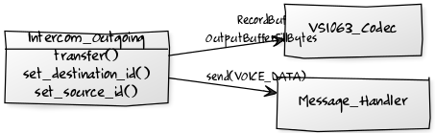

## Intercom Controller

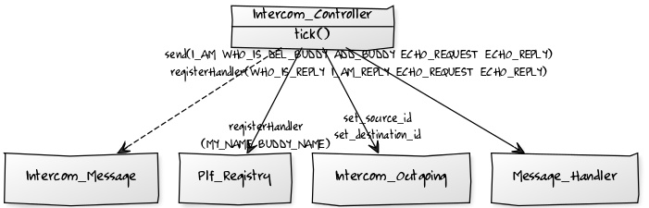

## Codec

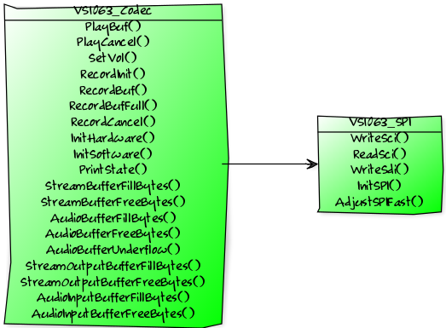

## Message Handler

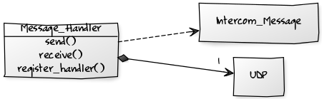

## Messages

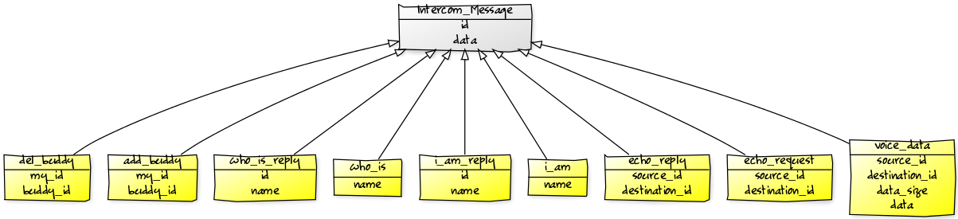

## Intercom Cloud API

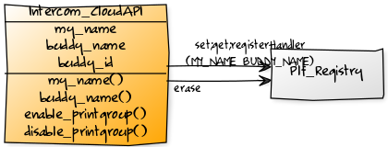

# Server Side

**MSG_TABLE**

msg_id -> msg_handler_fun

**Intercom_name_to_id_table**

Intercom_name -> intercom_id

**Intercom_id_to_intercom_table**

Intercom_id -> intercom

**Message_Handler**

**Send()**

**Receive()**

socket

**Intercom**

**sendTo()**

**addBuddy()**

**delBuddy()**

Msg_voice_data_handler

Msg_i_am_  
handler

Msg_who_is_  
handler

Add_buddy_  
handler

del_buddy_  
handler

1..1

n..1

1..1

Msg_echo_request_data_handler

Msg_echo_reply_data_handler