Hola Intercom Software Guide

# Revision History

* 09/01/2017: 1st draft
* 09/18/2017: Added buddy_id to cloud api
* 10/02/2017: Added echo request and reply messages
* 10/16/2017: Added 3rd party components and updated messages
* 10/24/2017: Added manuf_config.py. Updated message handler, messages and cloud_api
* 10/25/2017: Added pin assignments. Added MAX17043 Particle Library
* 10/30/2017: Added restarted parameter to i_am message
* 10/31/2017: Added battery_lvl to cloud api. Cloud api now ticks.
* 11/21/2017: Added S1509 I/O Expander.
* 11/27/2017: Added multiple buddy support.
* 11/28/2017: Documented and applied coding convention
* 11/28/2017: Described object roles.
* 11/28/2017: Pin Assignment fixes
* 11/28/2017: Plf_TickerBase class introduced
* 11/29/2017: Added Trace&Debug section
* 12/7/2017: Added volume control
* 12/15/2017: Added battery checker
* 1/4/2018: Added ratetune print group. Intercom_Incoming is now a Ticker class.
* 1/9/2018: Added stuff() method to circularBuffer.
* 1/9/2018: Added COMM_START/STOP+ACK messages
* 1/9/2018: Added recordRequest to Intercom_Outgoing. Renamed transfer() method to run().
* 1/9/2018: Added codec patch version
* 1/11/2018: Added FSM diagrams

# Version Control

<https://github.com/rlysens/particleIntercom/>

# Third Party Components

Draw.io:

<https://www.draw.io/>

VS1063 codec patch 2.01:

<http://www.vlsi.fi/en/support/software/vs10xxpatches.html>

SparkFun_MAX17043_Particle_Library: <https://github.com/sparkfun/SparkFun_MAX17043_Particle_Library.git>

SparkFunSX1509 Library:

<https://github.com/sparkfun/SparkFun_SX1509_Arduino_Library>

LCM: <https://lcm-proj.github.io/> (in source tree)

Name-gen (in source tree)

XTEA: mbedtls-2.5.1

XTEA Python: <https://pypi.python.org/pypi/xtea/0.4.0> (in source tree)

particle.py (in source tree)

* Pytz.py
* Dateutil
* Requests
* pexpect

# Shell Commands

particle call Intercom1 en|dis_prntgrp messages/stats/ratetune/default

particle serial monitor COM3/COM4

python build.py --device Intercom1/Intercom2/all [--flash]

copypython2amazon.bat

copyjson2amazon.bat

ssh2amazonec3.bat

python manuf_config.py [-h,--help] [-c,--skip_claim] [-f,--skip_flash] [-i,--image_filename <image_filename>]

Finds and claims connected devices, sets up Wifi, flashes reference fw image and configures name, buddy name and secret key.

# Pin Assignments

Photon pin assignments:

A5 = SI to codec

A4 = SO to codec

A3 = SCK to codec

A2 = xDCS to codec

A1 = xRESET to codec

A0 = DREQ to codec

DAC = xCS to codec

D0 = SDA to MAX17043 fuel gauge IC and to sx1509 i/o expander

D1 = SCL to MAX17043 fuel gauge IC and to sx1509 i/o expander

D2 = xRST to sx1509 i/o expander

SX1509 I/O Expander pin assignments:

0 = Battery check button

1 = Buddy 0 button

2 = Buddy 1 button

3 = Buddy 2 button

4 = Buddy 0 LED

5 = Buddy 1 LED

6 = Buddy 2 LED

8 = Vol.Dec.

9 = Vol.Inc.

10 = LED Bar 0

11 = LED Bar 1

12 = LED Bar 2

13 = LED Bar 3

14 = LED Bar 4

# Firmware Coding Convention

* CamelCase
* Types start with capital
* Functions and variables start with lowercase, e.g. topIndex
* Typedefs end with _t, e.g. RegisterEntry_t
* Pointers end with p, e.g. registry
* Private members have leading underscore, e.g. _registryp
* #defines are all caps and underscores, e.g. MAX_KEY_VAL
* ‘Namespace’-like prefixes are separated with an underscore, e.g. Intercom_Outgoing, intercom_outgoing
* Filenames are lowercase with underscores
* _s may be used as string postfix
* When interacting with 3rd party code, the 3rd party coding convention may be used.

# Firmware Design

## Ownership

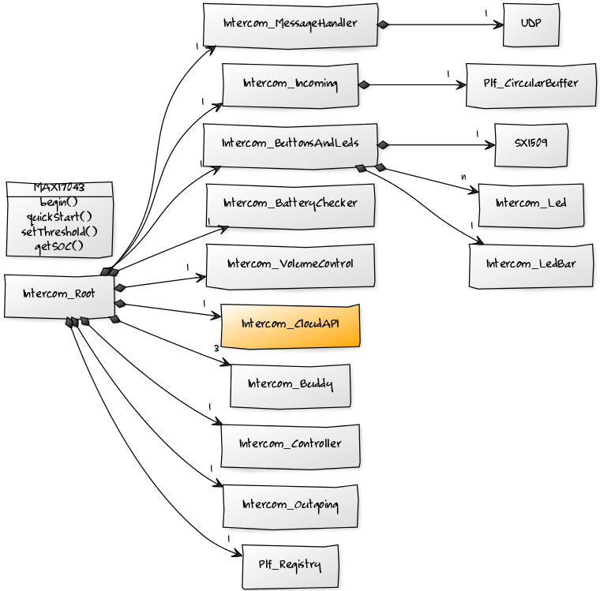

## Intercom_Root

Intercom_Root is the root of the Intercom object tree.

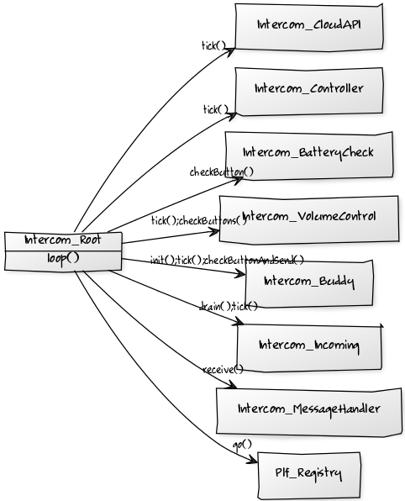

## Intercom_Incoming

Intercom_Incoming is in charge of the incoming datapath logic.

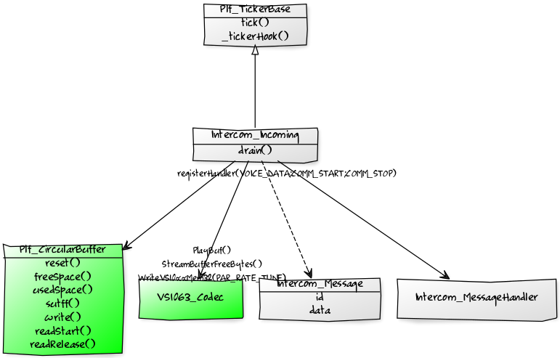

## 

## Intercom Outgoing

Intercom_Outgoing is in charge of the outgoing datapath logic.

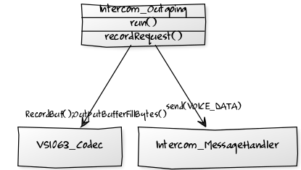

## 

## Intercom_Controller

Intercom_Controller handles the control plane logic that is not Buddy specific.

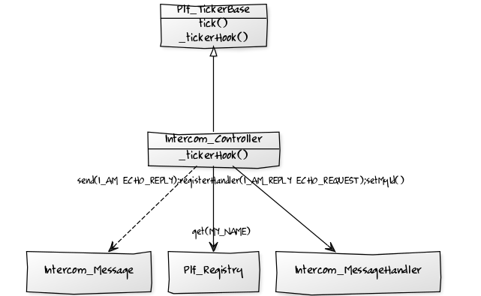

## 

## Intercom_Buddy

Intercom_Buddy handles all buddy related control plane logic and user I/O.

## https://yuml.me/778a3820.png

## 

## 

## Volume Control

Manages volume control buttons and led bar.

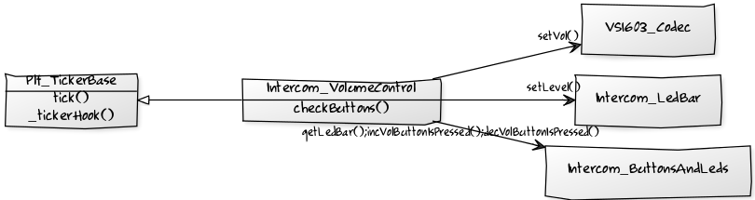

## 

## Battery Checker

Manages battery check button and led bar.

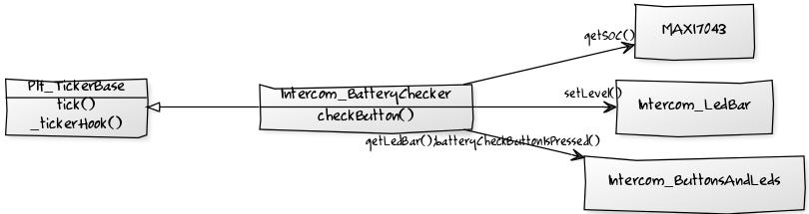



## Codec

Voice codec logic with back-end SPI interaction factored out into a separate module.

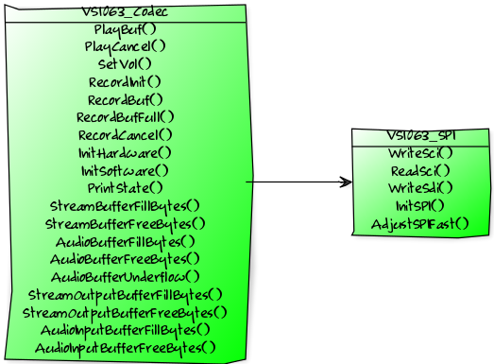

## Intercom Message Handler

Sends, receives and dispatches Intercom messages.

## https://yuml.me/10cbff84.png

## Messages

Note that the message channel is not considered reliable. Messages can get lost and the message protocols must be robust against occasional message loss.

All messages except i_am are encrypted using XTEA block cipher. The secret key is configured into the device at manufacturing time. 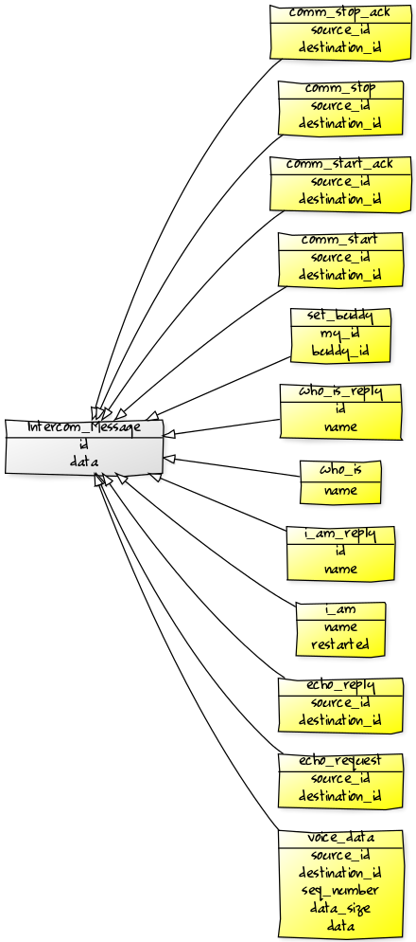

## Intercom_CloudAPI

Intercom_CloudAPI represents the API toward the cloud/Hola App.

X=0, 1 or 2

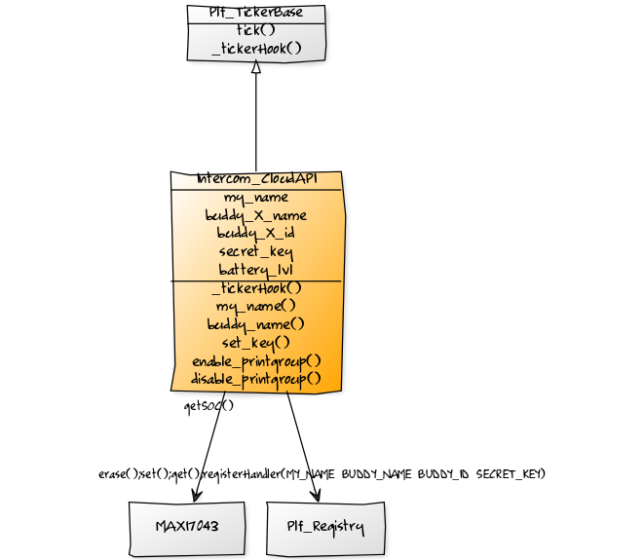

## Intercom_ButtonsAndLeds

Intercom_ButtonsAndLeds encapsulates interaction with buttons and leds. Uses the SX1509 I/O extender library.

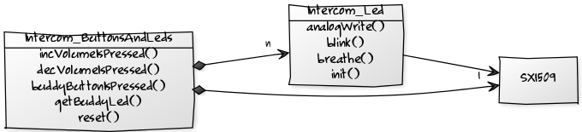

## Trace & Debug

* Tracing: plf_utils.h has a Trace print API (PLF_PRINT) with printgroups that can be enabled/disabled via the cloudAPI.
* Asserts: plf_assert in plf_utils.h
* Error return codes: Each module has a unique MODULE_ID to be used as a base for error return codes (e.g. return –(MODULE_ID+1)).
* Event Counting: See plf_even_counter.h

# Registry Keys

REG_KEY_MY_NAME persistent

REG_KEY_BUDDY_X_NAME persistent

REG_KEY_BUDDY_X_ID volatile

REG_KEY_SECRET_KEY persistent

X=0, 1 or 2

# Server Side

Message_Handler is the central object. Intercom_name_to_id table and interom_id_to_intercom table are used for Intercom name to id mapping and looking up corresponding Intercom objects.

**MSG_TABLE**

msg_id -> msg_handler_fun

**Intercom_name_to_id_table**

Intercom_name -> intercom_id

**Intercom_id_to_intercom_table**

Intercom_id -> intercom

**Message_Handler**

**Send()**

**Receive()**

socket

**Intercom**

**sendTo()**

**setBuddy()**

**getEncoderCryptoCodec()**

**getDecoderCryptoCodec**

Msg_voice_data_handler

Msg_i_am_  
handler

Msg_who_is_  
handler

Set_buddy_  
handler

1..1

n..1

1..1

Msg_echo_request_data_handler

Msg_echo_reply_data_handler

# Manuf_config.py

**Credentials.json**

**Name_key.json**

**Manuf_config.py**

Particle.py

Name_key_gen.py

Namegen.py