**Smart Car Controlling System**

(Project making Steps)

**Step1:** Setup all the Hardware material on the Vero Board and tight it using screw.Connec

**Step 2:** Now Connect the Jumper wire according to the circuit diagram.

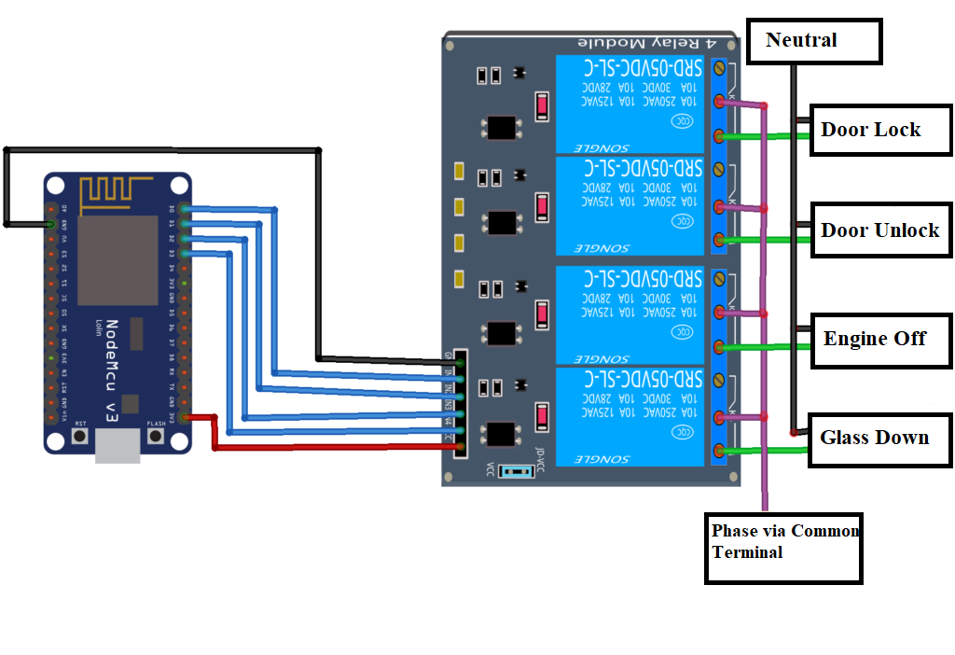

**Step 3:** Now attach the USB cable to NodeMcu to PC.

**Step 4:** Download all library and package given in (requirement.txt) placed it in the Arduino IDE folder location.

**Step 5:** Now open the Arduino IDE

**Step 6:** Download the NodeMcu esp8266 (latest version) board package from board manager section.

**Step 7:** Now open Tools from Menu bar 🡪 Boards 🡪 esp8266 board(2.7.4) 🡪Select NodeMcu 1.0 (ESP-12E module)

**Step 8:** Now select the Port (mainly coming **com3**).

**Step 9:** Install Blynk application 🡪 Login using facebook🡪Collect auth token sent to registered email id with the facebook.

**Step 10:** After login configure the Blynk put switches according to requirement name them and select Digital input and set 1 to 0 and turn mode to Push and set the pin number (E.g., D0, D1…) according to the diagram. Implement same thing for other switches.

**Step 11:** Now its code time write the code prefer (Arduino code.txt). Please write the Auth Token number, SSID, Password carefully.

**Step 12:** Compile the code, if successfully compiled then upload it.

**Step 13:** Turn On your mobile hotspot and click the run button on top of the Blynk app.

**Step 14:** Check whether the device is connected or not.

**Step 15.** Check press Button on the Blynk that you have created.

**Step 16:** Give the power to NodeMCU using Power Adapter.

**Step 17.** Now relay is ON/OFF according to the input. Now Turn Off the device

**Congratulations, Your Device is ready for use**

🡪Pack this Module by using physical case.

🡪Install in the car with proper wiring as per instructions.

🡪 Give the power to NodeMcu by switch on the ignition of the car. Now connect the car module using Blynk app.

🡪Now Device is ready to use (by using Blynk application manually).

**Advanced Features Added**

You can control your car by Voice Command using Google Assistant.

To implement this feature, we have to configure some settings. Follow the steps below:

**Step1:** Create Account in IFTTT plateform.

**Step2:** Login the account and sel